Test Plan Testing

Main Menu:
Main menu section has several screens as part of it so I have split up testing for each screen.

Main Menu Screen -
What Needs Testing? | Is Input Required? | Expected Result | Actual Result | Fix
Start Button | Clicking with the mouse | Runs main menu animation and Switches screen to the Start screen | As expected | None
 | 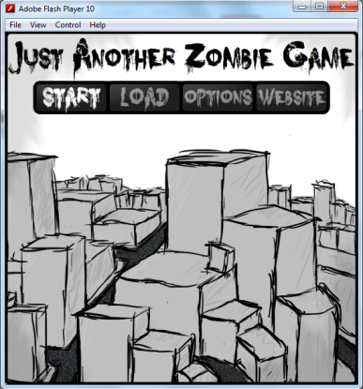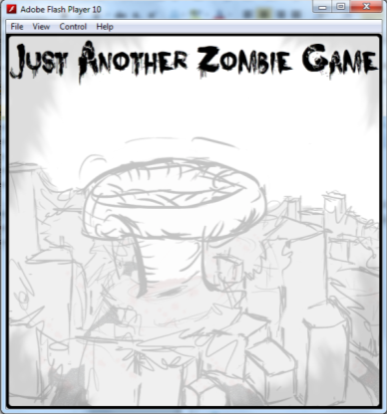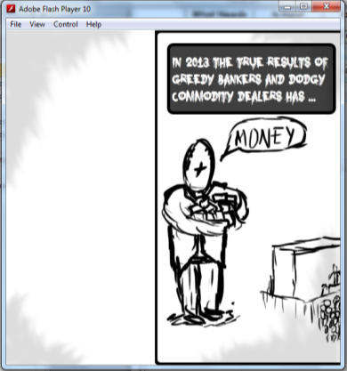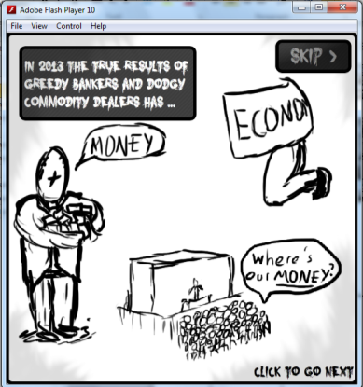
 | Hovering over with the mouse | Highlights the text within the button | As expected | None
 | 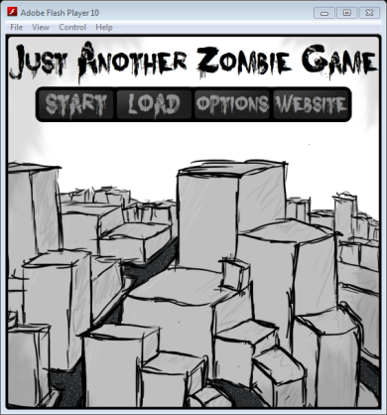
Load Button | Clicking with the mouse | Switches screen to the Load screen | As expected | None
 | 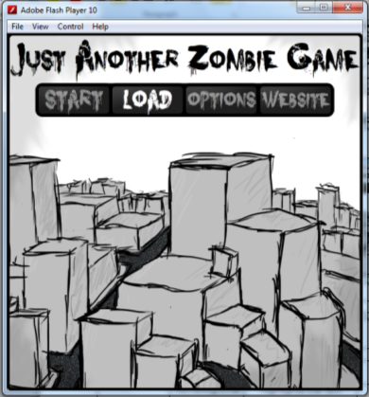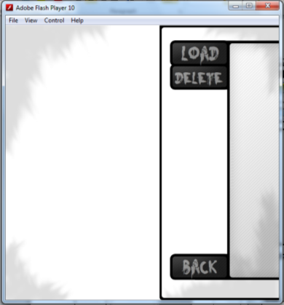
 | Hovering over with the mouse | Highlights the text within the button | As expected | None
Options Button | Clicking with the mouse | Switches screen to the Options screen | As expected | None
 | 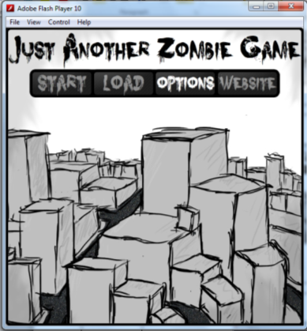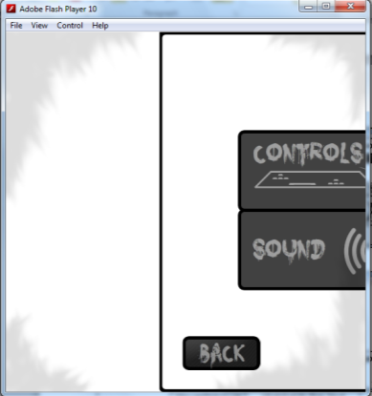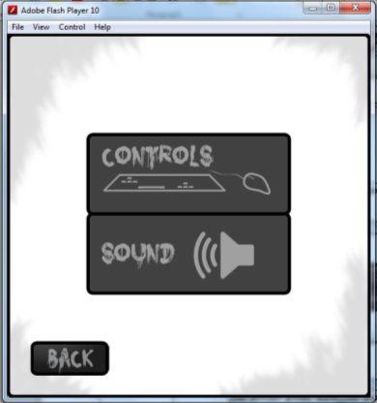
 | Hovering over with the mouse | Highlights the text within the button | As expected | None
Website button | Clicking with the mouse | The users default browser opens and goes to http://knowlesy.co.uk/ | As expected | None
 | 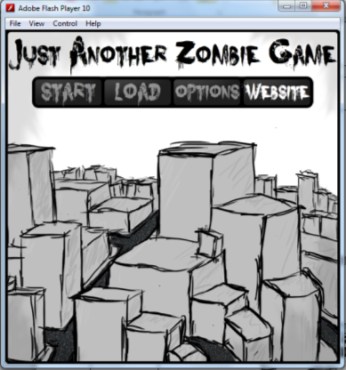
 | Hovering over with the mouse | Highlights the text within the button | As expected | None

Load Screen –
What Needs Testing? | Is Input Required? | Expected Result | Actual Result | Fix
Saves |  | No saves should be load as the demo doesn’t allow it | As expected | None
Load Button | Clicking with the mouse | Does Nothing | As expected | None
 | Hovering over with the mouse | Highlights the text within the button | As expected | None
Delete Button | Clicking with the mouse | Does Nothing | As expected | None
 | Hovering over with the mouse | Highlights the text within the button | As expected | None
Back Button | Clicking with the mouse | Returns to the Main Menu
 | 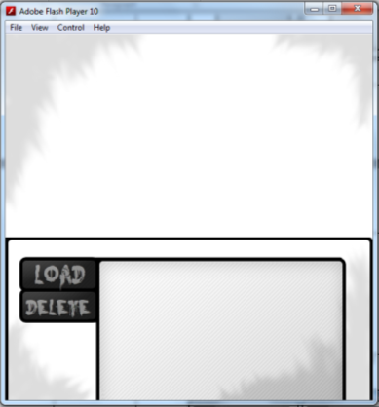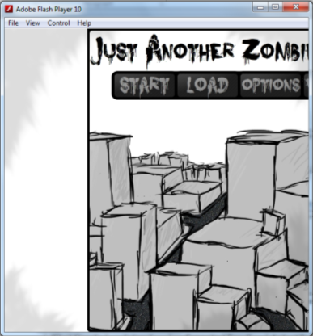
 | Hovering over with the mouse | Highlights the text within the button | As expected | None

Options Screen -
What Needs Testing? | Is Input Required? | Expected Result | Actual Result | Fix
Controls button | Clicking with the mouse | Switches screens to the Controls Screen and load in key values to text in selectable boxes | As expected | None
 | 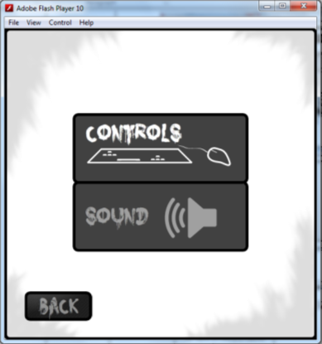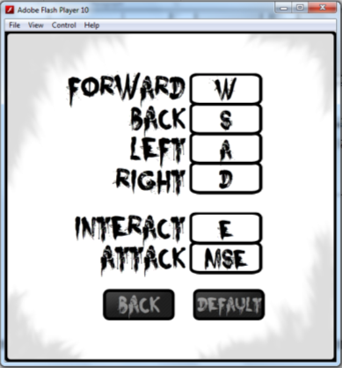
 | Hovering over with the mouse | Highlights the text within the button | As expected | None
 | 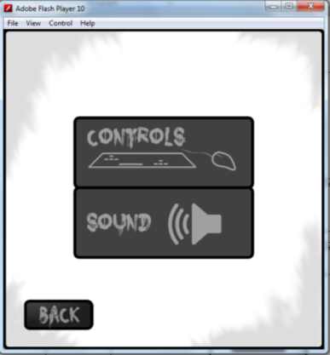
Sound Button | Clicking with the mouse | Switches screens to the Sound Screen and load in values for the sliders, positioning the sliders as well | As expected | None
 | 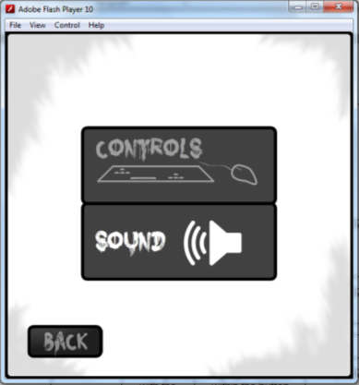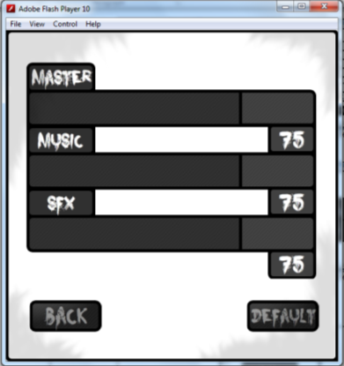
 | Hovering over with the mouse | Highlights the text within the button | As expected | None
Back button | Clicking with the mouse | Returns to the main menu screen | As expected | None
 | 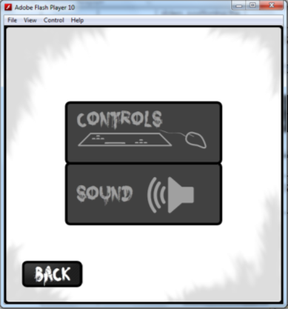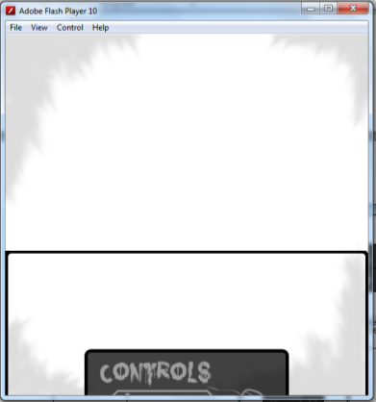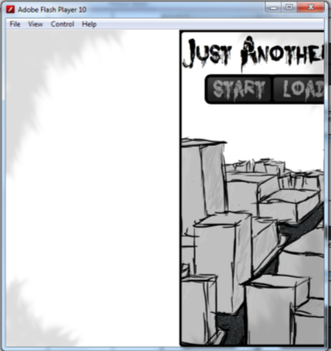
 | Hovering over with the mouse | Highlights the text within the button | As expected | None

Controls Screen -
What Needs Testing? | Is Input Required? | Expected Result | Actual Result | Fix
Forward’s Selectable box | Clicking with the mouse | The box shows that it’s been selected and allows key input | As expected | None
 | 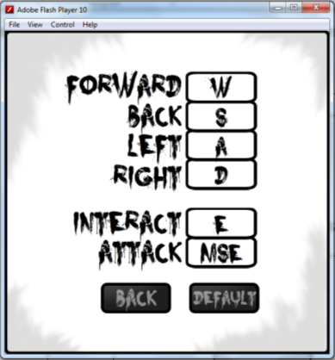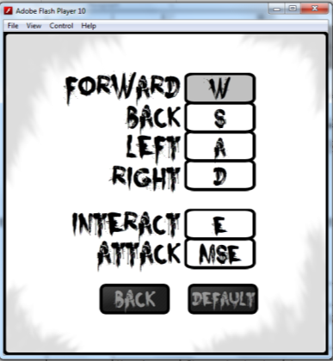
 | Any key press | Changes the text within the box and un selects the box | As expected | None
 | 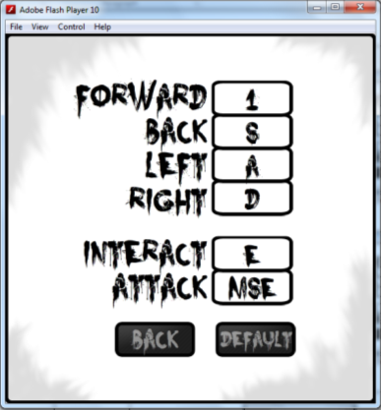
 | Hovering over with the mouse | Changes back colour to a grey | As expected | None
 | 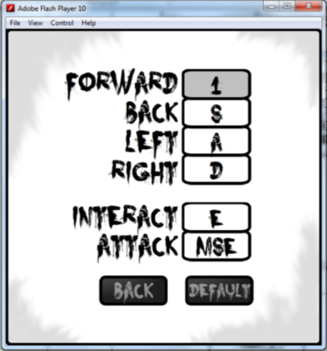
Back’s Selectable box | Clicking with the mouse | The box shows that it’s been selected and allows key input | As expected | None
 | 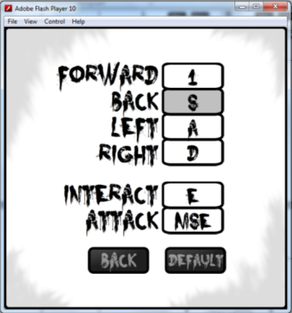
 | Any key press | Changes the text within the box and un selects the box | As expected | None
 | 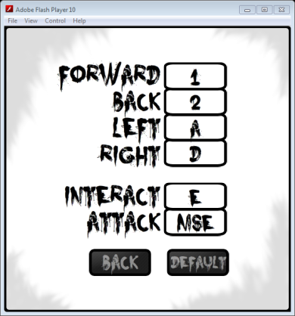
 | Hovering over with the mouse | Changes back colour to a grey | As expected | None
 | 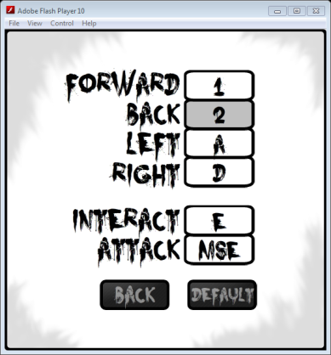
Left’s Selectable box | Clicking with the mouse | The box shows that it’s been selected and allows key input | As expected | None
 | 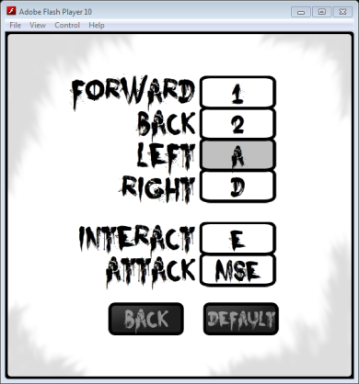
 | Any key press | Changes the text within the box and un selects the box | As expected | None
 | 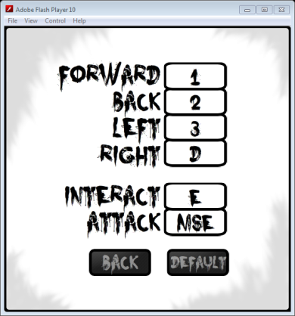
 | Hovering over with the mouse | Changes back colour to a grey | As expected | None
 | 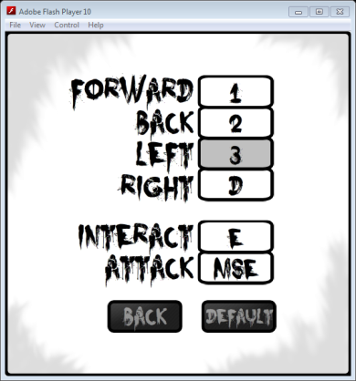
Right’s Selectable box | Clicking with the mouse | The box shows that it’s been selected and allows key input | As expected | None
 | 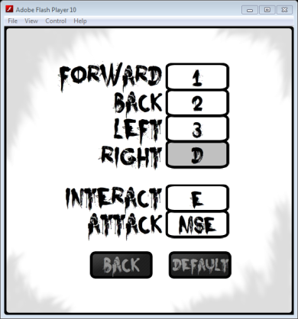
 | Any key press | Changes the text within the box and un selects the box | As expected | None
 | 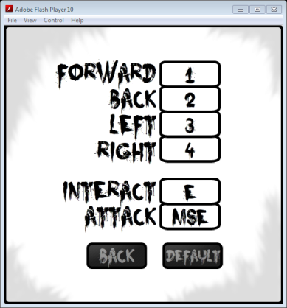
 | Hovering over with the mouse | Changes back colour to a grey | As expected | None
 | 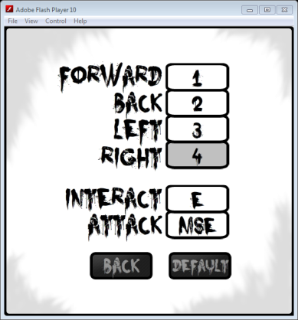
Interact’s Selectable box | Clicking with the mouse | The box shows that it’s been selected and allows key input | As expected | None
 | 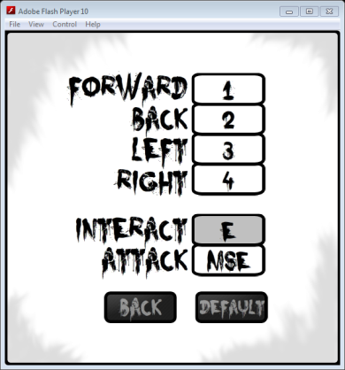
 | Any key press | Changes the text within the box and un selects the box | As expected | None
 | 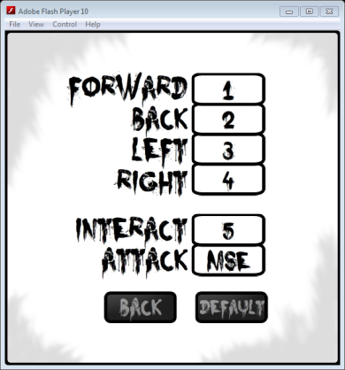
 | Hovering over with the mouse | Changes back colour to a grey | As expected | None
 | 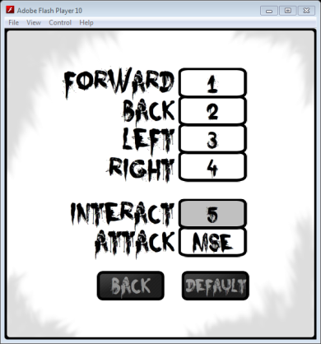
Attack’s Selectable box | Clicking with the mouse | The box shows that it’s been selected and allows key input | As expected | None
 | 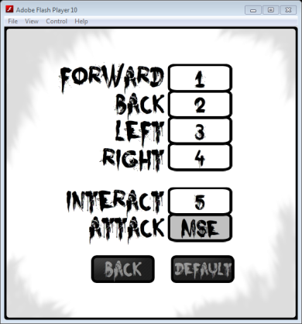
 | Any key press | Changes the text within the box and un selects the box | As expected | None
 | 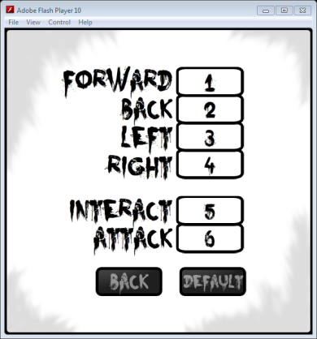
 | Hovering over with the mouse | Changes back colour to a grey | As expected | None
 | 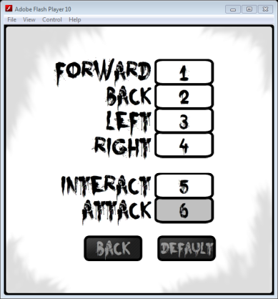
Back button | Clicking with the mouse | Saves all the text from within the selectable boxes and returns to the Options screen | As expected | None
 | 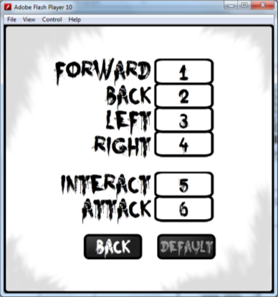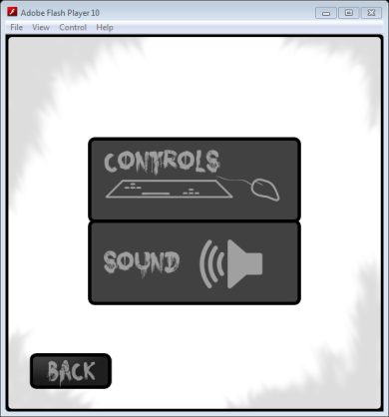
 | Hovering over with the mouse | Highlights the text within the button | As expected | None
Default button | Clicking with the mouse | Changes all the text in the selectable boxes to predefined default text (W,S,A,D,E,MSE) | As expected | None
 | 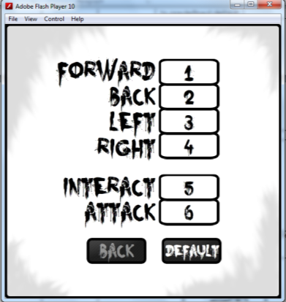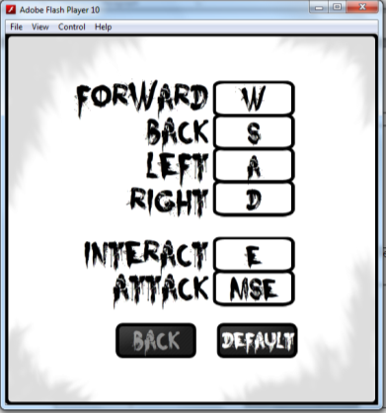
 | Hovering over with the mouse | Highlights the text within the button | As expected | None

Sound Screen –
What Needs Testing? | Is Input Required? | Expected Result | Actual Result | Fix
Master Slider | Clicking with the mouse | The slider follows the mouse until it leaves the sliders area or when the mouse is pressed again | As expected | None
 | 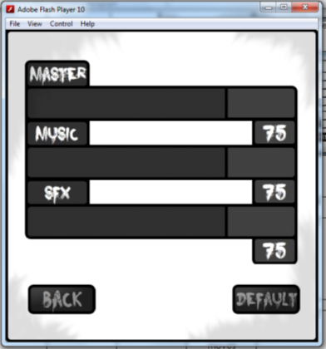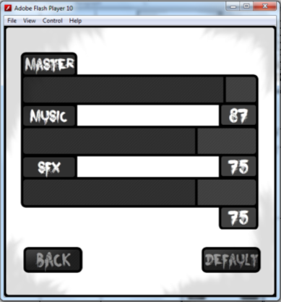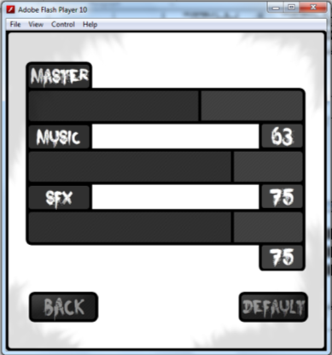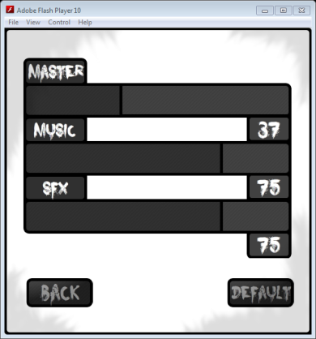
Master Slider % text |  | Updates the % of volume as the slider moves | As expected | None
 | See images from last test.
Music Slider | Clicking with the mouse | The slider follows the mouse until it leaves the sliders area or when the mouse is pressed again
 | 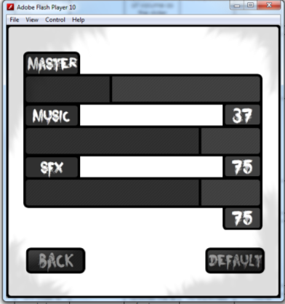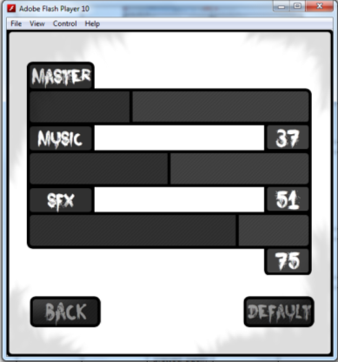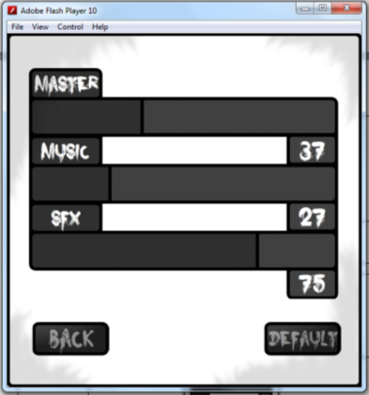
Music Slider % text |  | Updates the % of volume as the slider moves | As expected | None
 | See images from last test.
SFX Slider | Clicking with the mouse | The slider follows the mouse until it leaves the sliders area or when the mouse is pressed again | As expected | None
 | 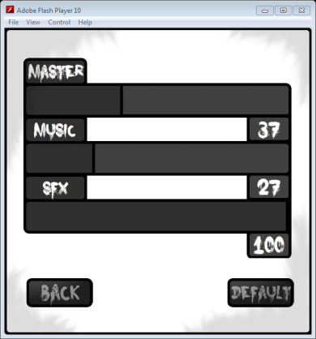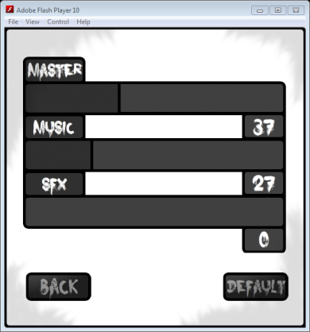
SFX Slider % text |  | Updates the % of volume as the slider moves | As expected | None
 | See images from last test.
Back button | Clicking with the mouse | Saves all slider values and returns to the Options screen | As expected | None
 | 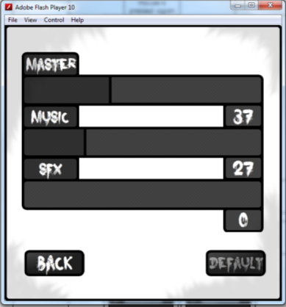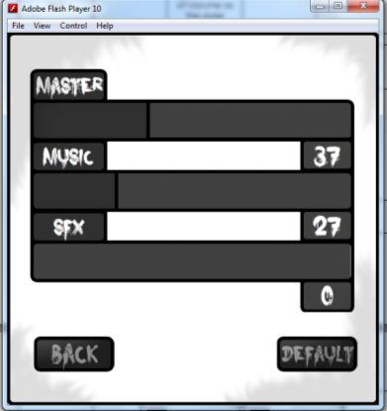
 | Hovering over with the mouse | Highlights the text within the button | As expected | None
Default button | Clicking with the mouse | Changes all the sliders positions and % text to 75 | As expected | None
 | 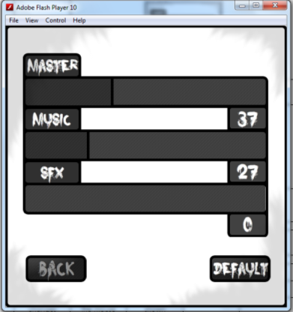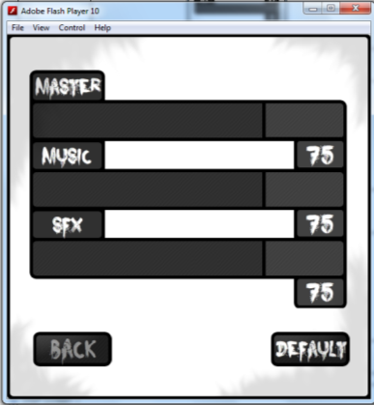
 | Hovering over with the mouse | Highlights the text within the button | As expected | None
 | 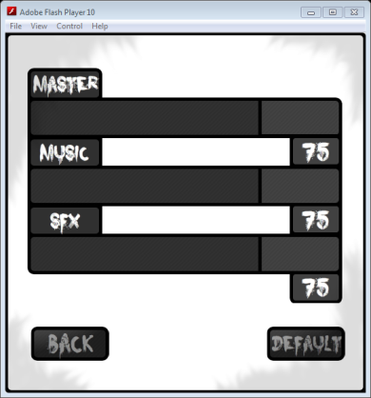

Start Screen –
What Needs Testing? | Is Input Required? | Expected Result | Actual Result | Fix
The frame changes | Clicking with the mouse | Next frame is shown | As expected | None
 | 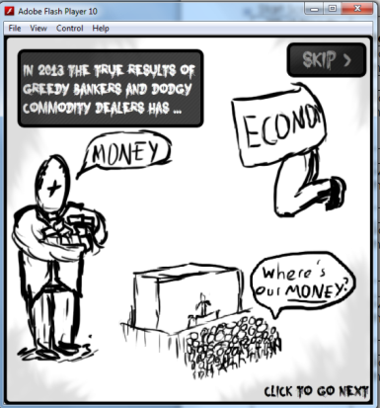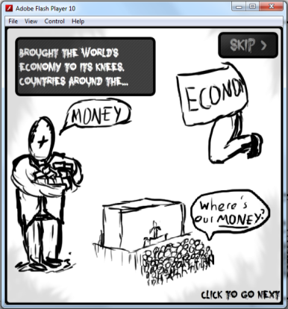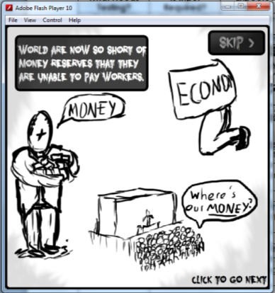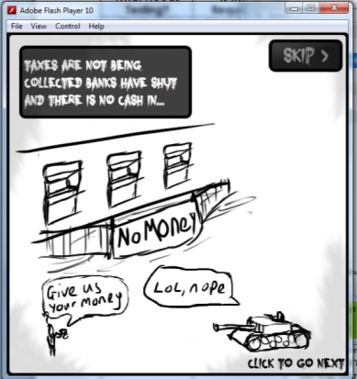
Skip button | Clicking with the mouse | Takes you to the final frame on the start screen | As expected | None
 | 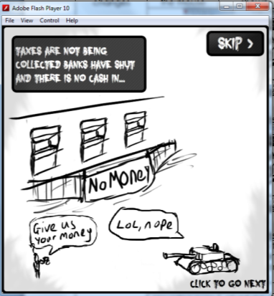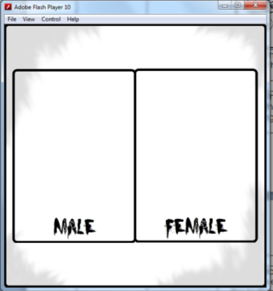
 | Hovering over with the mouse | Highlights the text within the button | As expected | None
 | 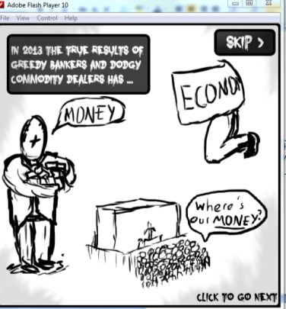
Male Button | Clicking with the mouse | Goes into the game as the player being a Male | As expected | None
 | 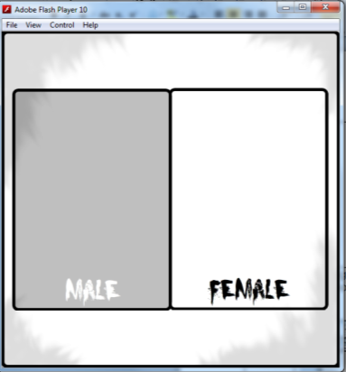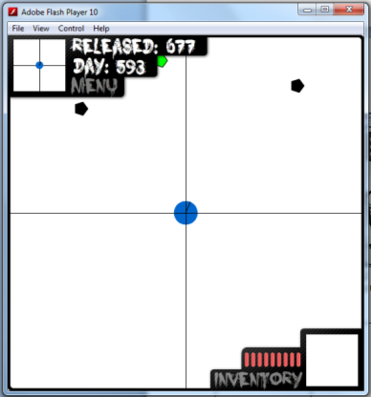
 | Hovering over with the mouse | Grey overlay appear over the button | As expected | None
 | 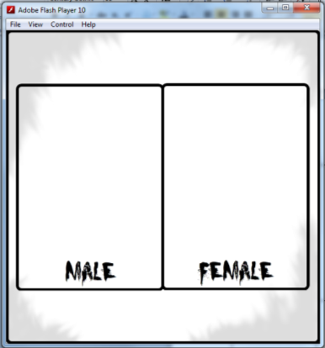
Female Button | Clicking with the mouse | Goes into the game as the player being a Female | As expected | None
 | 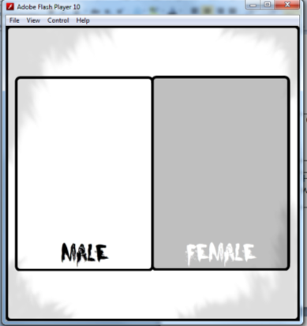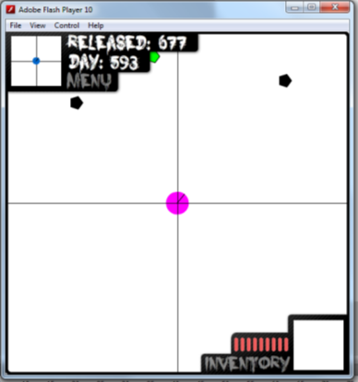
 | Hovering over with the mouse | Grey overlay appear over the button | As expected | None

Main Mechanics for the Player:

What Needs Testing? | Is Input Required? | Expected Result | Actual Result | Fix
Player rotation |  | The player should rotate to face the mouse | As expected | None
 | 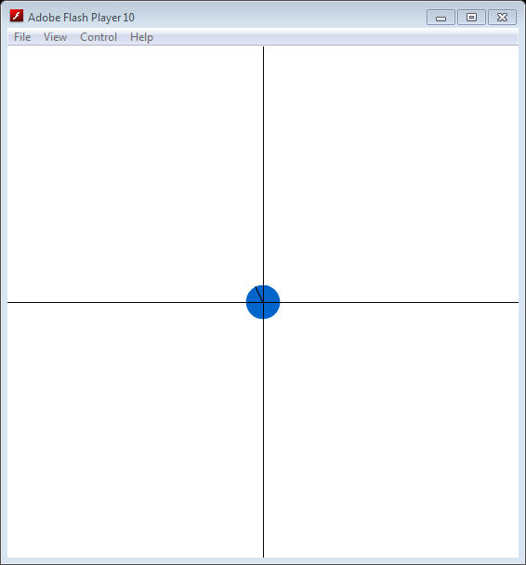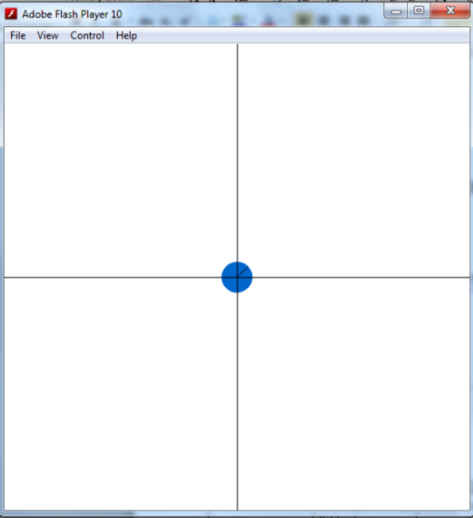
Movement | Forward key from saved key list being pressed | Everything on screen should move down the screen | As expected | None
 | 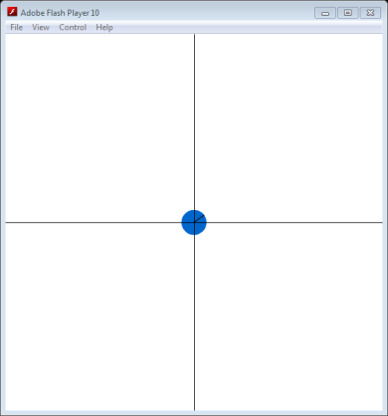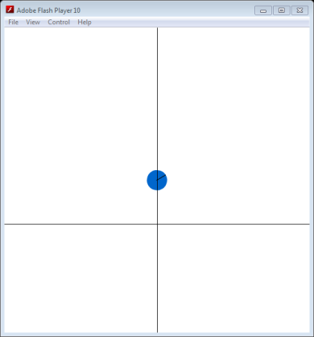
 | Back key from saved key list being pressed | Everything on screen should move up the screen | As expected | None
 | 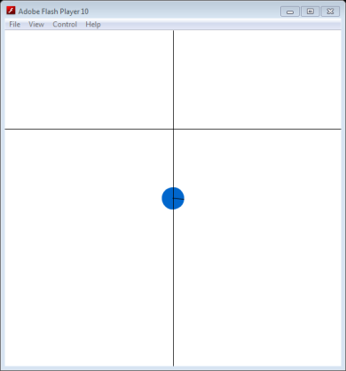
 | Left key from saved key list being pressed | Everything on screen should move right the screen | As expected | None
 | 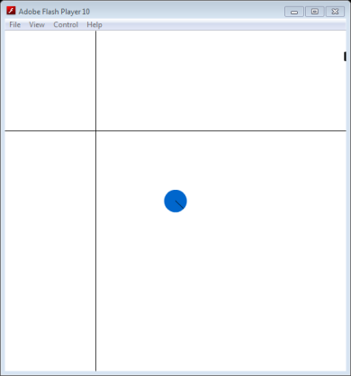
 | Right key from saved key list being pressed | Everything on screen should move left the screen | As expected | None
 | 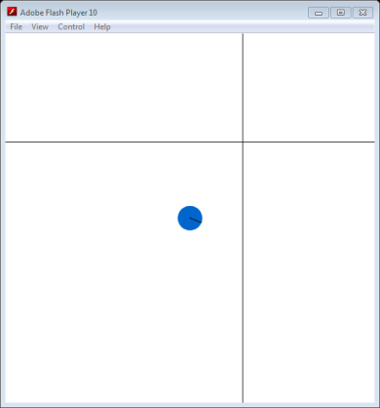
 | Interact key from saved key list being pressed | A function that does not yet exist should be called, so nothing happens | As expected | None
 | Attack key from saved key list being pressed | A function that does not yet exist should be called, so nothing happens | As expected | None

Main Mechanics for Items:
What Needs Testing? | Is Input Required? | Expected Result | Actual Result | Fix
Item pick up when player is within range of item | Interact key from saved key list being pressed | The item gets picked up | As expected | None
 | 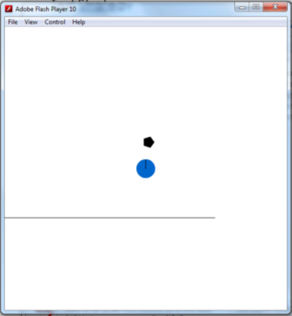

Inventory:

What Needs Testing? | Is Input Required? | Expected Result | Actual Result | Fix
Open Inventory | Down arrow (temp before HUD is installed) | The Inventory opens on screen and the game is paused | As expected | None
 | 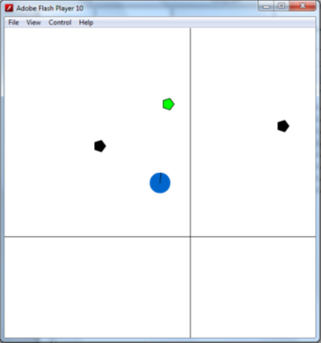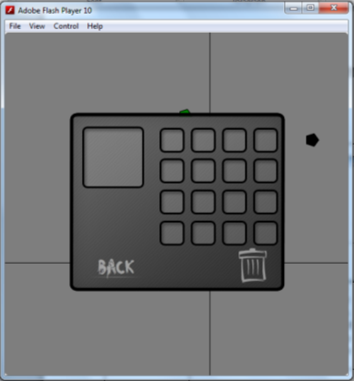
Items being able to be dragged and dropped to other slots | Mouse Press and hold | Current item goes into slot that it’s been released and if an it is already in the slot they swap | As expected | None
 | 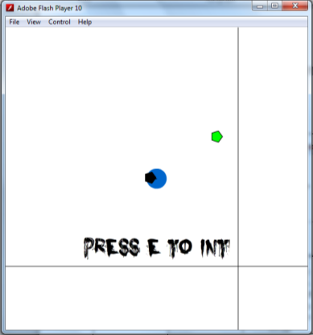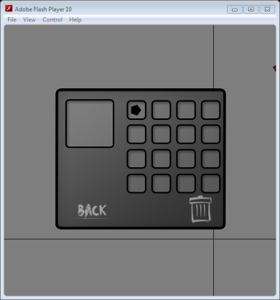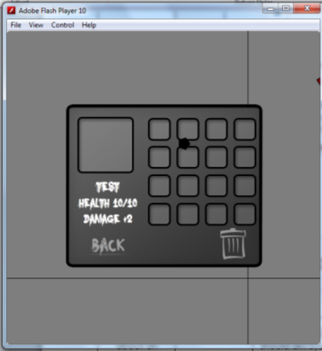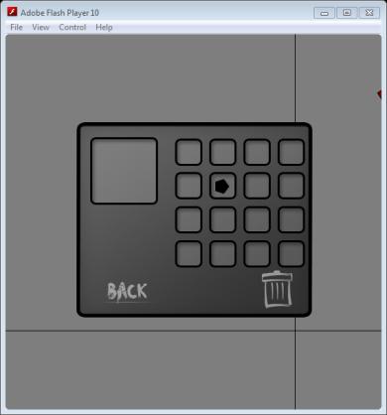
Displaying info about an item | Mouse over item | Info about the current item the mouse is over will be displayed | As expected | None
 | 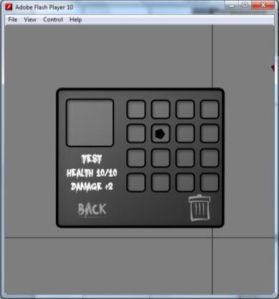
Displaying info about an current item |  | A current item should always have info about it displayed | As expected | None
 | 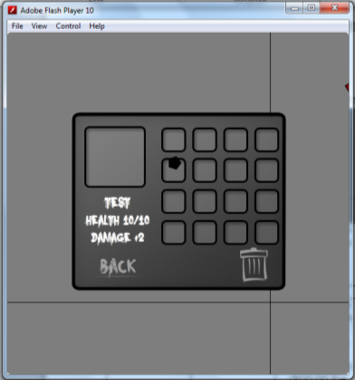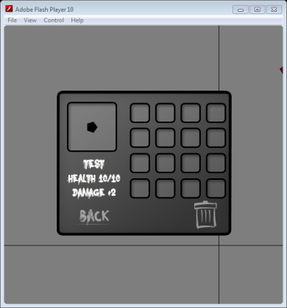
Drop item button | Mouse Press and hold | Highlights the text within the button and remove item from the inventory and drop on the ground around the player | As expected | None
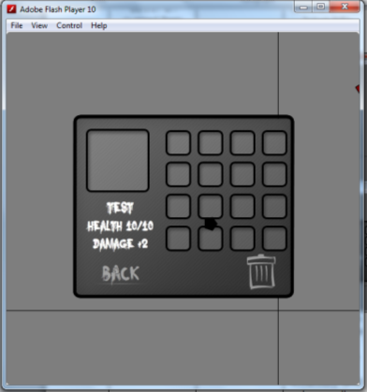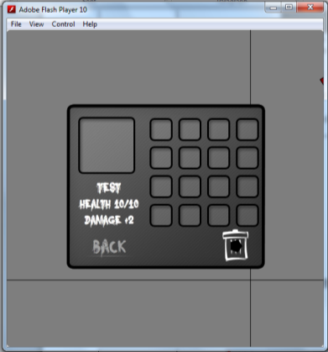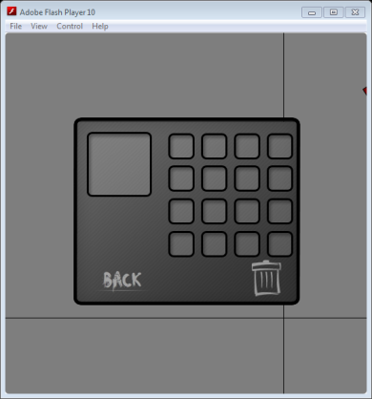
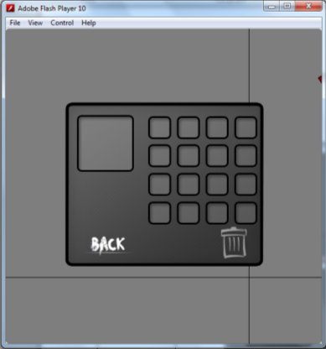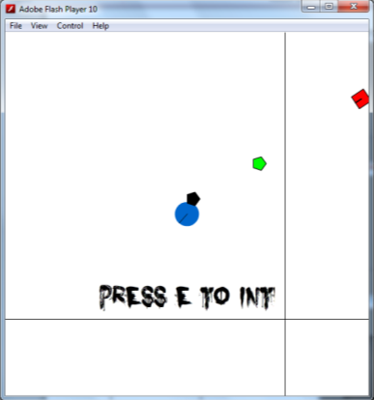
Back button | Clicking with the mouse | Saves and removes the inventory from screen and un pauses the game | As expected | None
 | 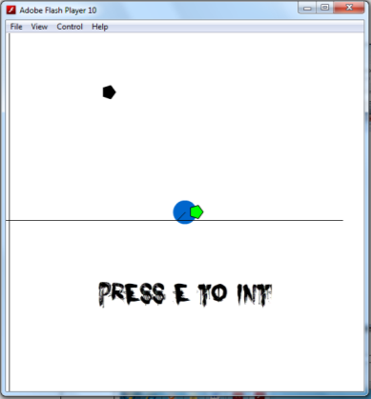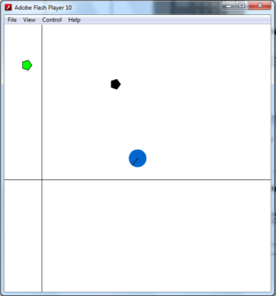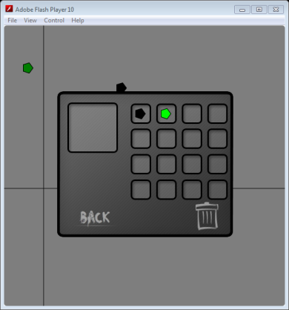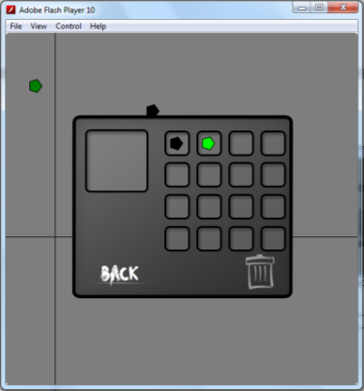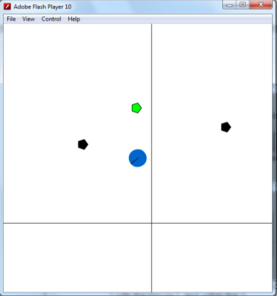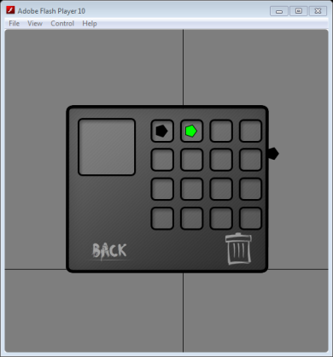
 | Hovering over with the mouse | Highlights the text within the button | As expected | None
 | 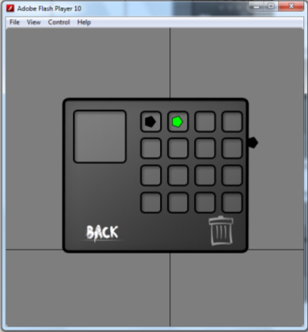

Main Mechanics for the Enemies:
I had to come back to test this once the HUD was done to show that the player was taking damage.
What Needs Testing? | Is Input Required? | Expected Result | Actual Result | Fix
Rotation |  | They should automatically face the player when in range | As expected | None
 | 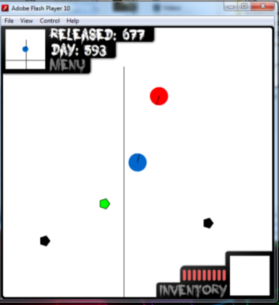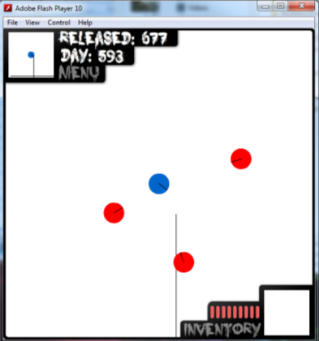
Movement |  | The enemy should move towards the player as soon as they are in range | As expected | None
 | 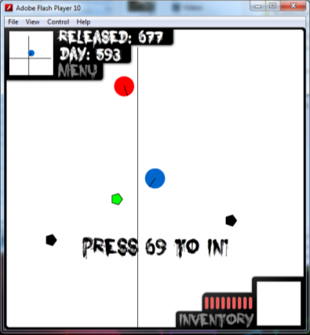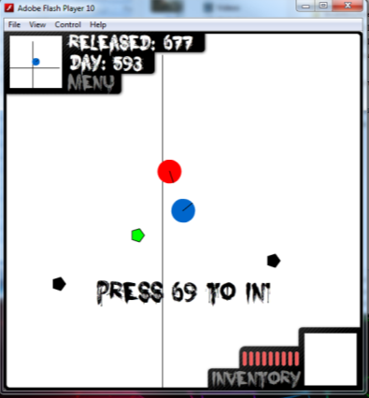
Attacking |  | They player should take damage when the distance between the player and the enemy is both their heights added together | As expected | None
 | 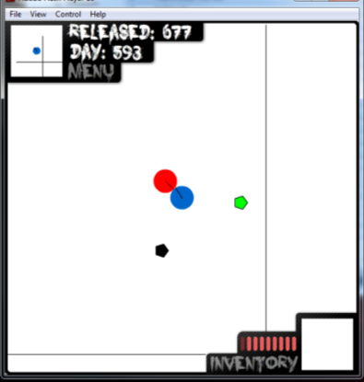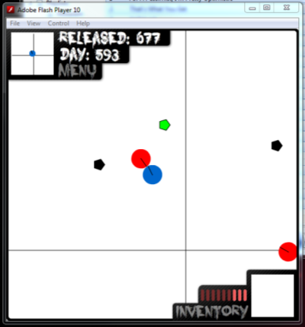
Taking damage | Attack key from saved key list being pressed | They player will damage the enemy with the current items damage points | As expected | None
 | 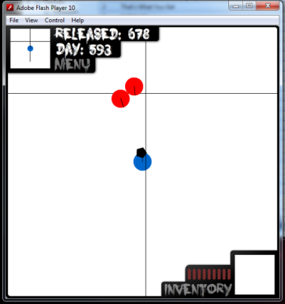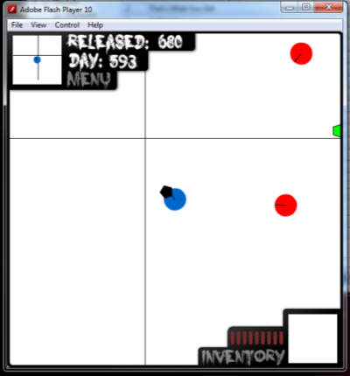
Check hitting Player |  | This will put the enemy into attack(See above) and stop the enemy from moving | As expected | None
 | 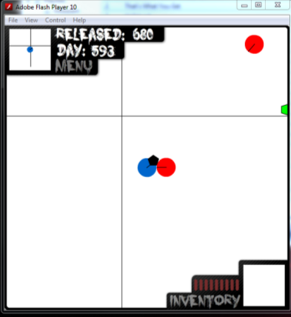
Check hitting another enemy |  | The enemies shouldn’t overlap so they stop when they collide with each other | As expected | None
 | 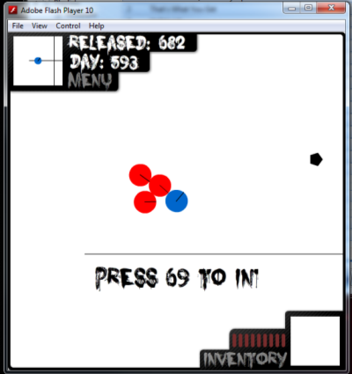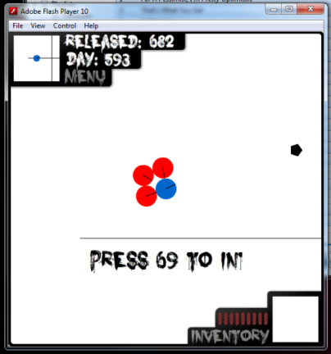

Main Mechanics for the Enemies spawning:

What Needs Testing? | Is Input Required? | Expected Result | Actual Result | Fix
Enemies spawning in intervals |  | The enemies spawn every second | As expected | None
 | 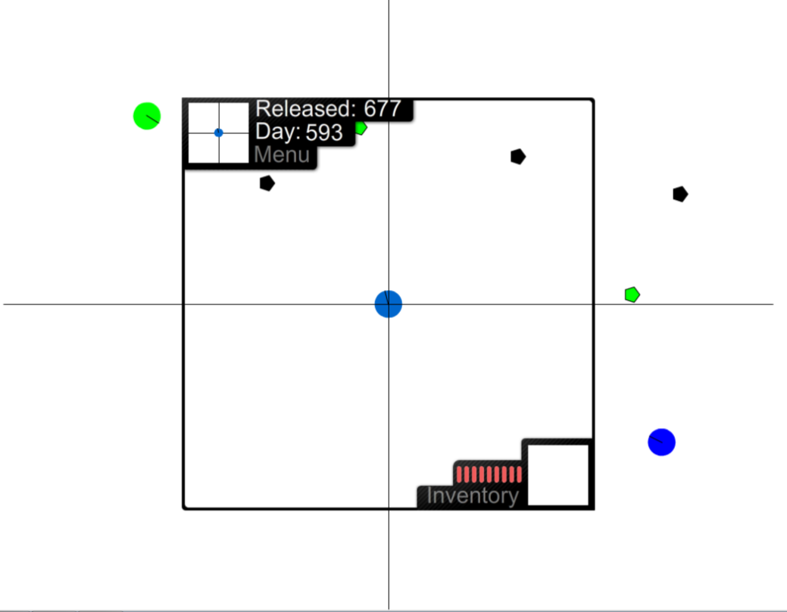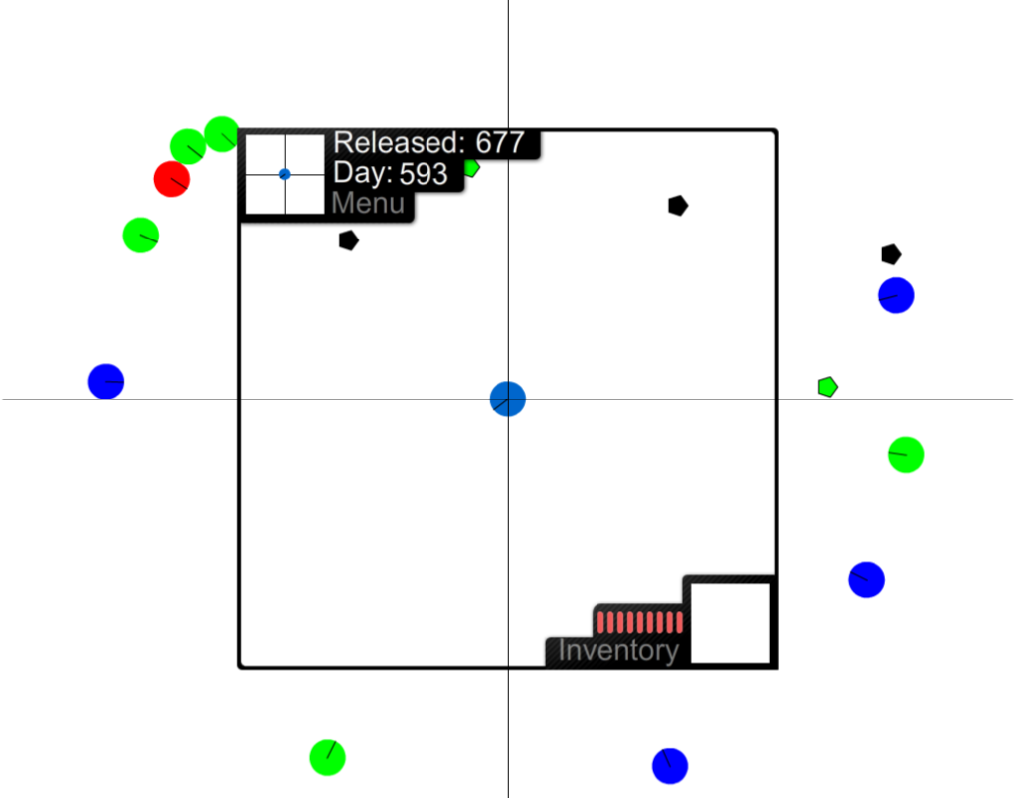
Enemies spawn off screen |  | The enemies spawn at a random position off screen | As expected | None
 | Above shows this. As you can see the HUD outline the actual screen and I’ve just expanded the screen.
Enemy types |  | Different enemy types should spawn at random | As expected | None
 | Again the top screen shots show this off. The different colours represent the three different enemy types.

HUD:
What Needs Testing? | Is Input Required? | Expected Result | Actual Result | Fix
Kill counter |  | When the player kills an enemy the counter increases by one | As expected | None
 | 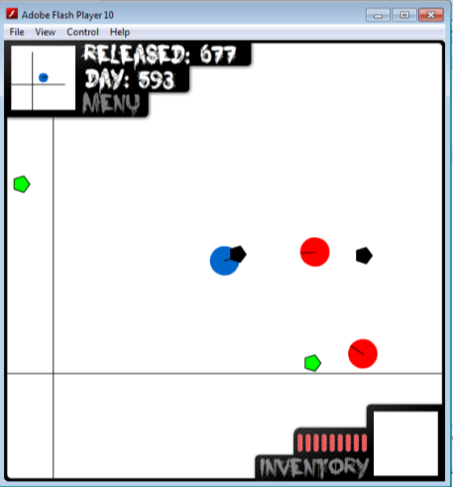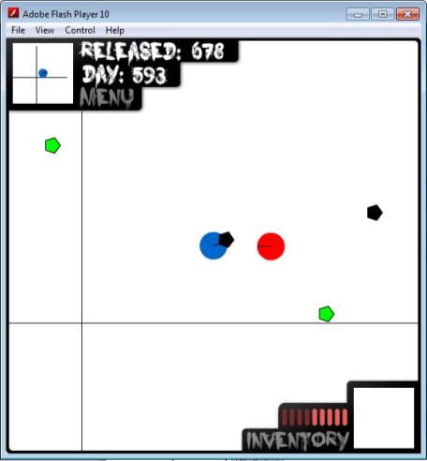
Mini map |  | The map moves as the player moves | As expected | None
 | 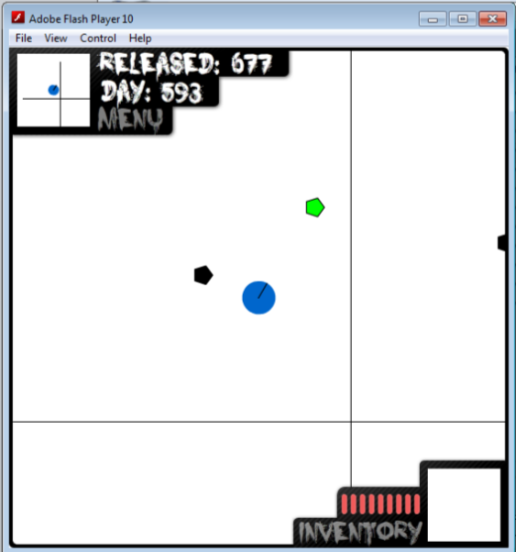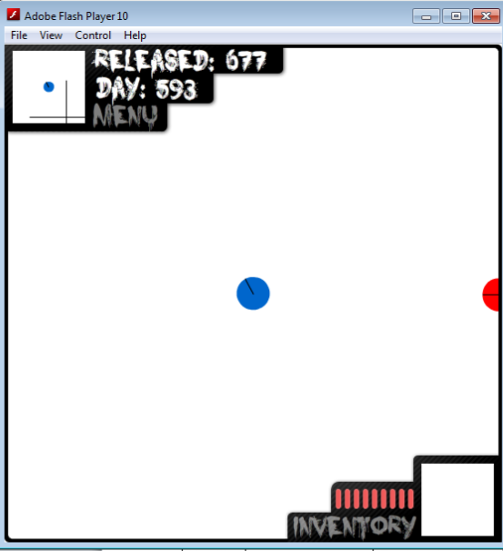
Health bar |  | The bar should show that damage has been taken | As expected | None
 | 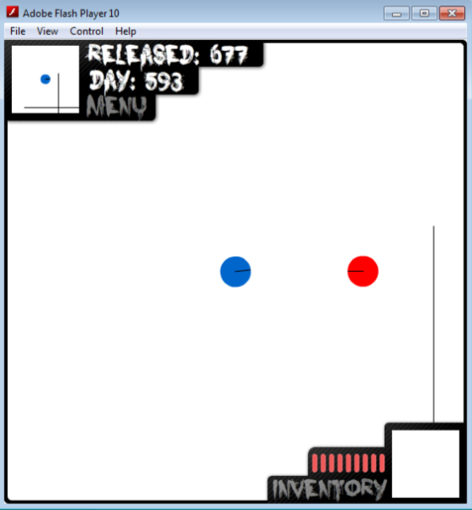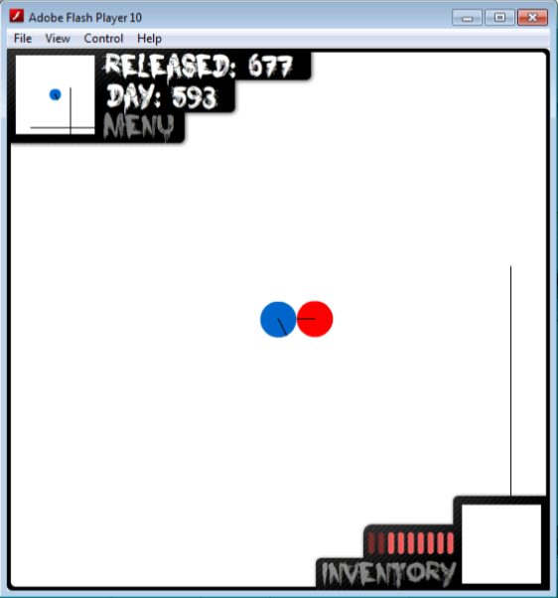
Current Item |  | An image and health should be displayed | As expected | None
 | 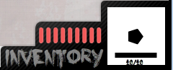
Inventory button | Clicking with the mouse | Opens inventory on top of everything and pauses the game | As expected | None
 | 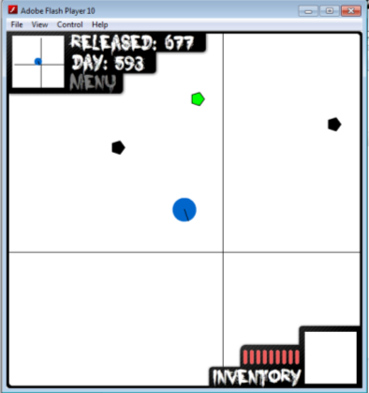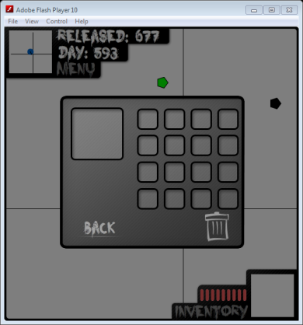
 | Hovering over with the mouse | Highlights the text within the button | As expected | None
 | 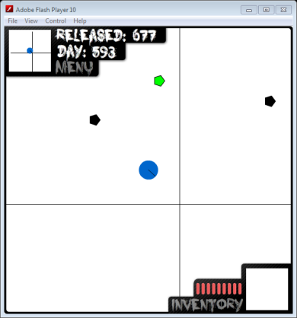
Menu Button | Clicking with the mouse | Opens In-game menu on top of everything and pauses the game | As expected | None
 | 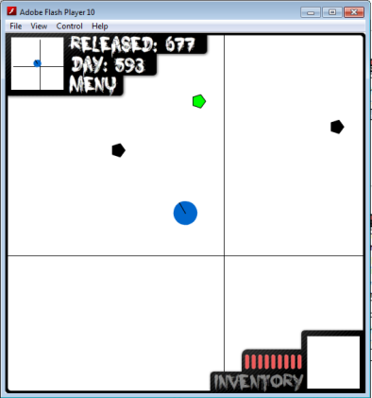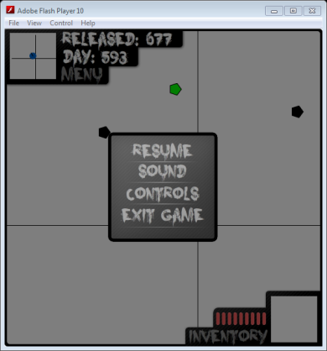
 | Hovering over with the mouse | Highlights the text within the button | As expected | None
 | 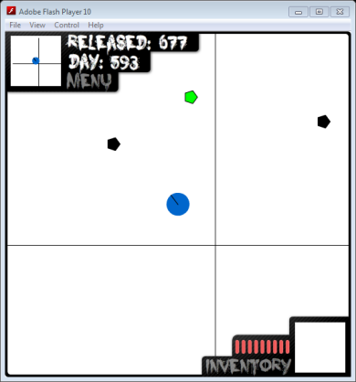

Menus accessible from the HUD:
Main Menu -
What Needs Testing? | Is Input Required? | Expected Result | Actual Result | Fix
Resume Button | Clicking with the mouse | Removes Menu and un-pauses game | As expected | None
 | 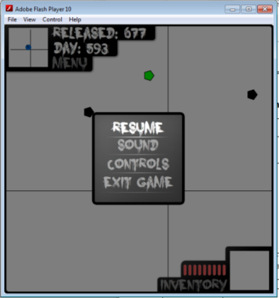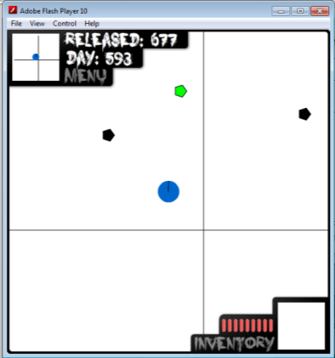
 | Hovering over with the mouse | Highlights the text within the button | As expected | None
 | 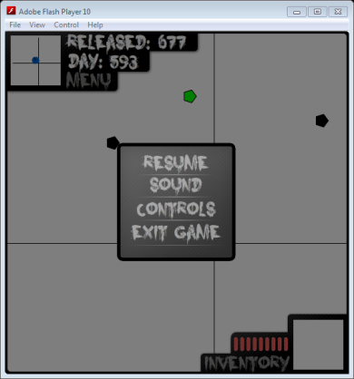
Sound Button | Clicking with the mouse | Opens the sound menu | As expected | None
 | 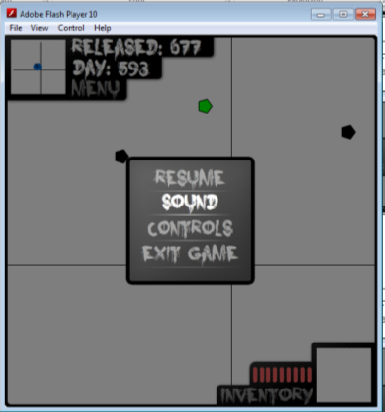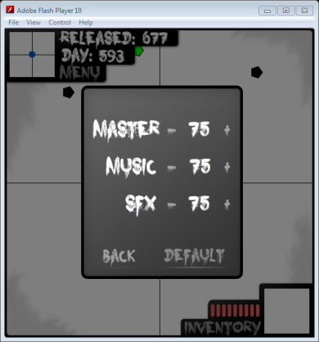
 | Hovering over with the mouse | Highlights the text within the button | As expected | None
Controls Button | Clicking with the mouse | Opens the Controls menu | As expected | None
 | 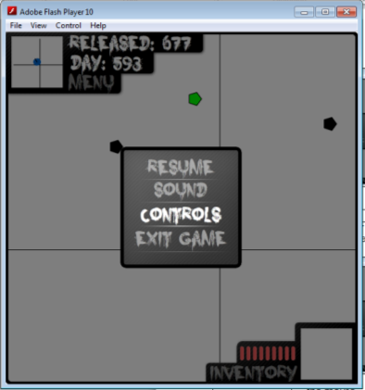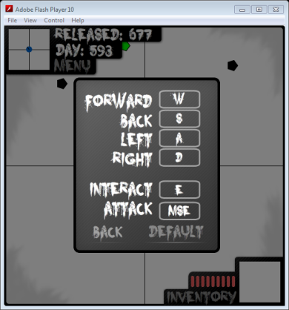
 | Hovering over with the mouse | Highlights the text within the button | As expected | None
Exit Button | Clicking with the mouse | Remove all objects off screen and opens the main menu screen | As expected | None
 | 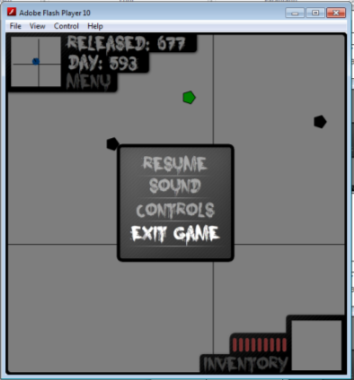
 | Hovering over with the mouse | Highlights the text within the button | As expected | None
Sound Menu-
What Needs Testing? | Is Input Required? | Expected Result |  |  | Actual Result |  | Fix
Maters plus | Mouse Press | The Mater % text should increase by 1 if < 100 and > 0 |  |  | As expected |  | None
 | 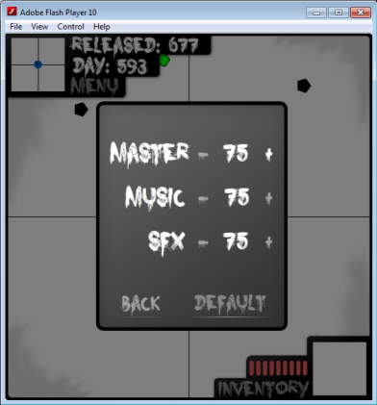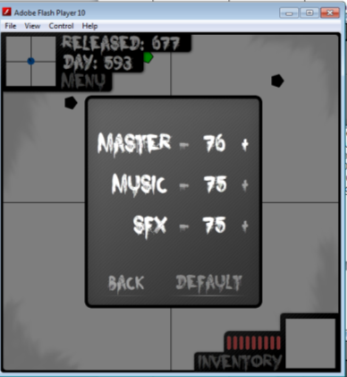
 | Mouse Press & Hold | The Mater % text should increase by 1 every 10th of a second until 100 is reached |  |  | As expected |  | None
 | 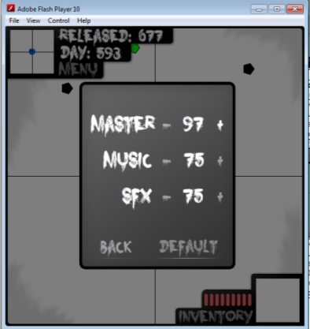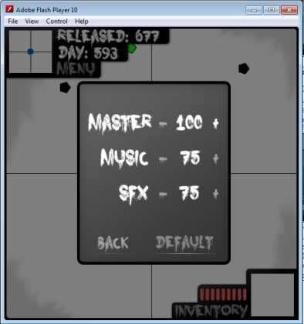
 | Hovering over with the mouse | Highlights the text within the button |  |  | As expected |  | None
 | 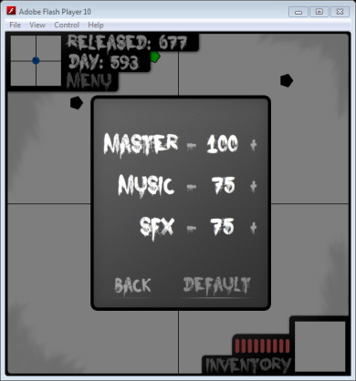
Maters Minus | Mouse Press | The Mater % text should decrease by 1 if < 100 and > 0 |  |  | As expected |  | None
 | 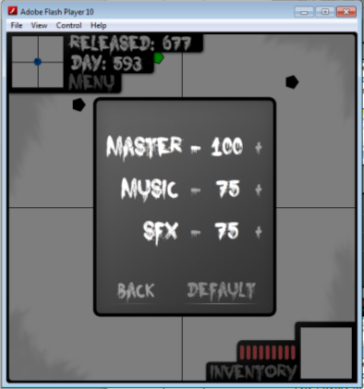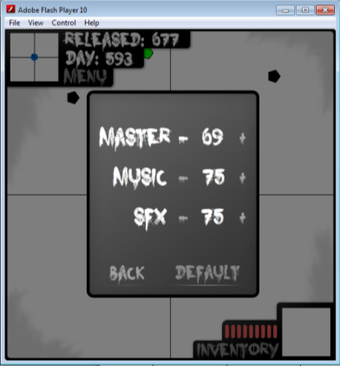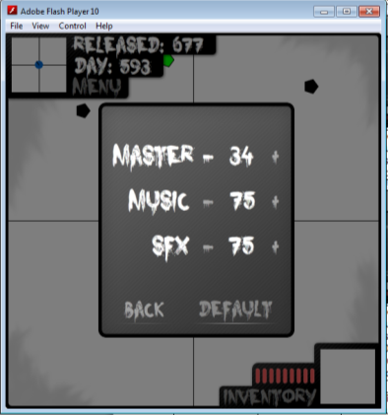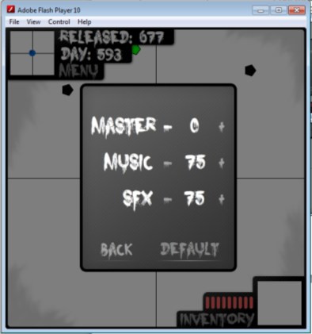
 | Mouse Press & Hold | The Mater % text should decrease by 1 every 10th of a second until 100 is reached |  |  | As expected |  | None
 | Hovering over with the mouse | Highlights the text within the button |  |  | As expected |  | None
 | 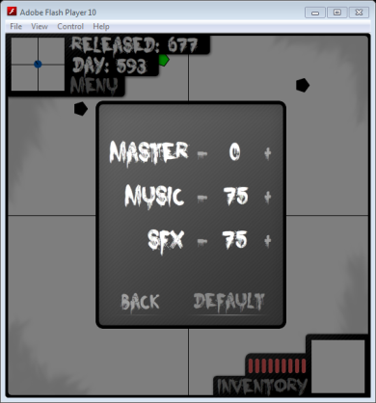
Music plus | Mouse Press | The Music % text should increase by 1 if < 100 and > 0 |  |  | As expected |  | None
 | 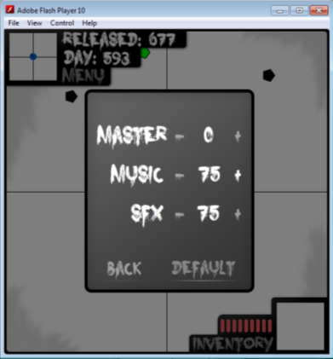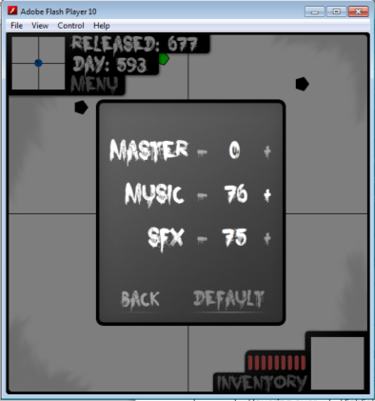
 | Mouse Press & Hold | The Music % text should increase by 1 every 10th of a second until 100 is reached |  |  | As expected |  | None
 | 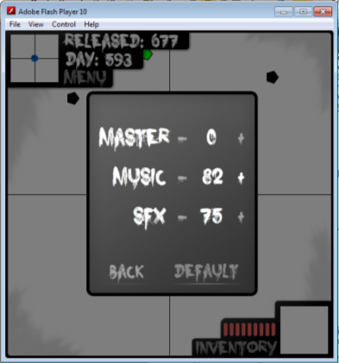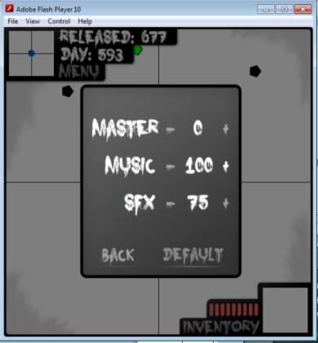
 | Hovering over with the mouse | Highlights the text within the button |  |  | As expected |  | None
 | 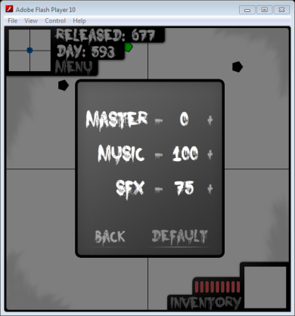`
Music Minus | Mouse Press | The Music % text should decrease by 1 |  |  | As expected |  | None
 | 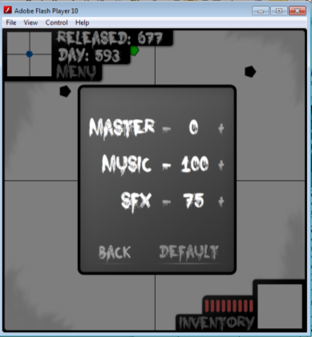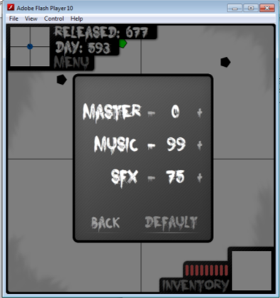
 | Mouse Press & Hold | The Music % text should decrease by 1 every 10th of a second until 0 is reached |  |  | As expected |  | None
 | 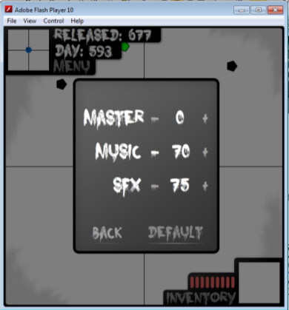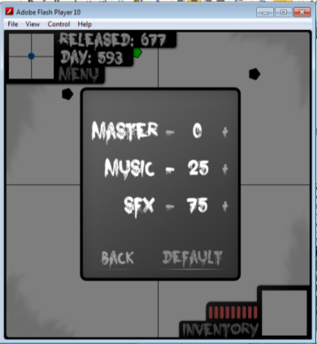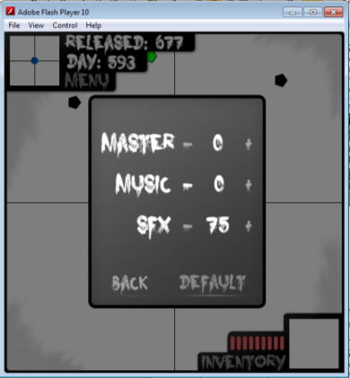
 | Hovering over with the mouse |  | Highlights the text within the button | As expected |  | None
 | 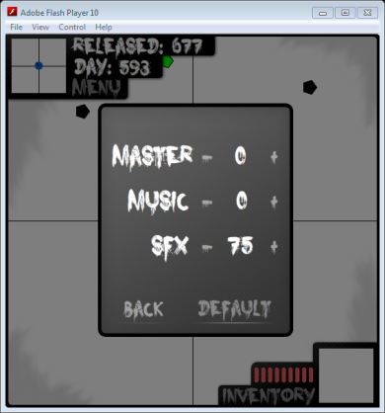
SFX plus | Mouse Press | The SFX % text should increase by 1 if < 100 and > 0 |  |  | As expected |  | None
 | 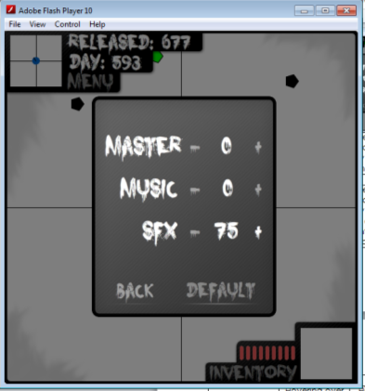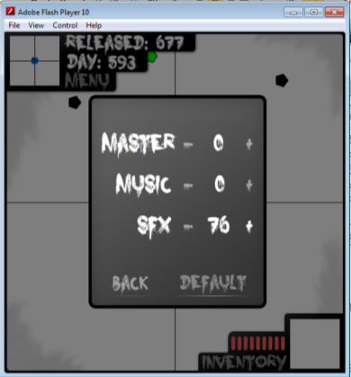
 | Mouse Press & Hold | The SFX % text should increase by 1 every 10th of a second until 100 is reached |  |  | As expected |  | None
 | 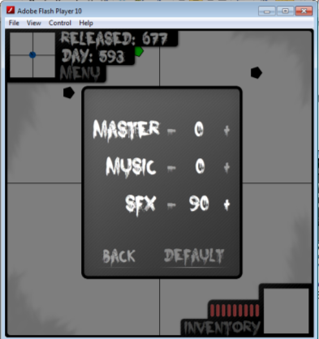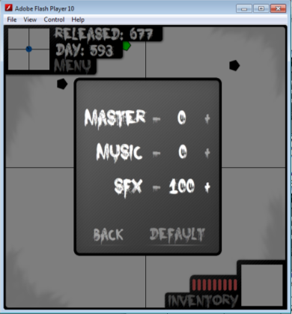
 | Hovering over with the mouse | Highlights the text within the button |  |  | As expected |  | None
 | 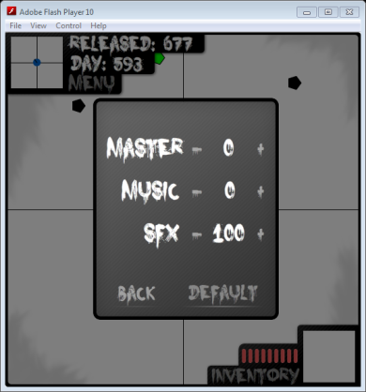
SFX Minus | Mouse Press | The SFX % text should decrease by 1 if < 100 and > 0 |  |  | As expected |  | None
 | 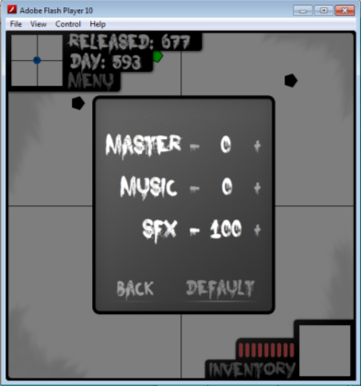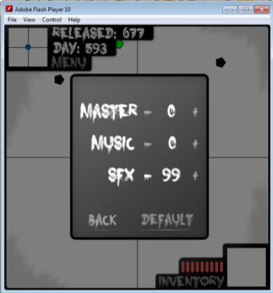
 | Mouse Press & Hold | The SFX % text should decrease by 1 every 10th of a second until 0 is reached |  |  | As expected |  | None
 | 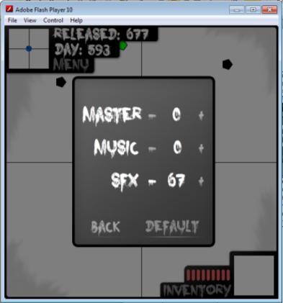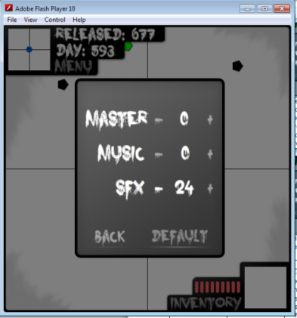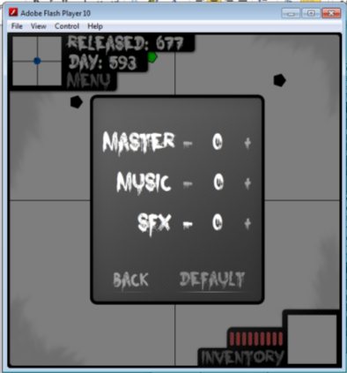
 | Hovering over with the mouse | Highlights the text within the button |  |  | As expected |  | None
 | 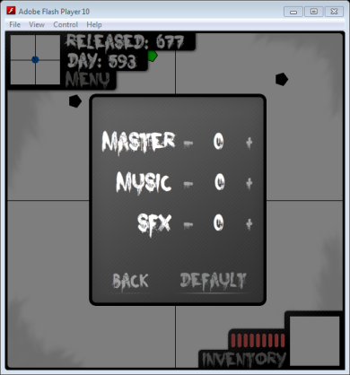
Back button | Mouse Press | Saves all the text from within the % tests on screen and returns to the Main Menu |  |  | As expected |  | None
 | 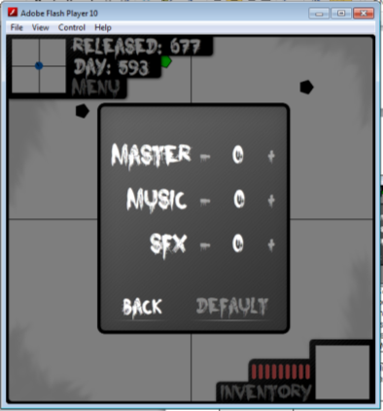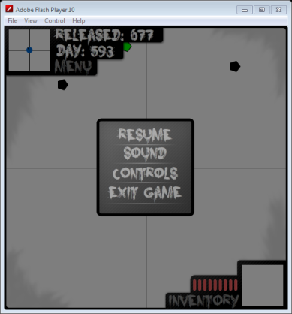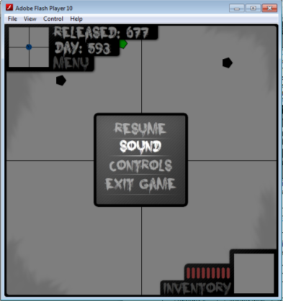
 | Hovering over with the mouse | Highlights the text within the button |  |  | As expected |  | None
Default button | Mouse Press | Sets all the % text to 75 |  |  | As expected |  | None
 | 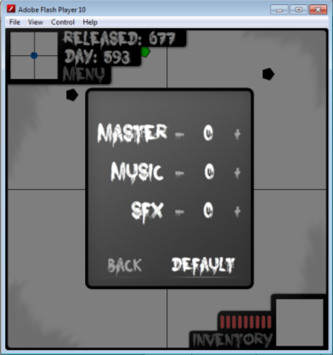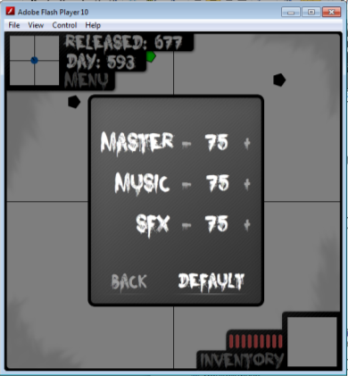
 | Hovering over with the mouse | Highlights the text within the button |  |  | As expected |  | None
 | 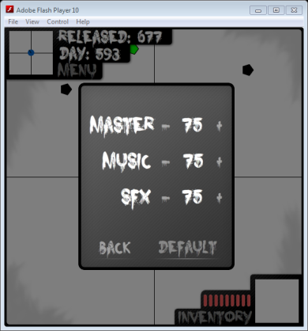
Controls Menu -
What Needs Testing? | Is Input Required? | Expected Result | Actual Result | Fix
Forward’s Selectable box | Clicking with the mouse | The box shows that it’s been selected and allows key input | As expected | None
 | 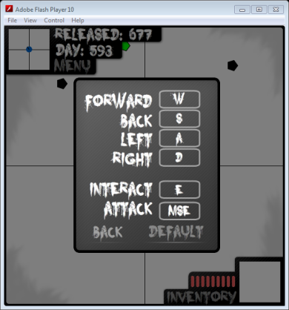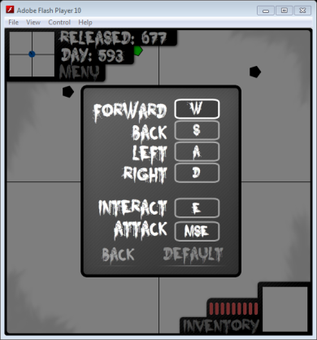
 | Any key press | Changes the text within the box and un selects the box | As expected | None
 | 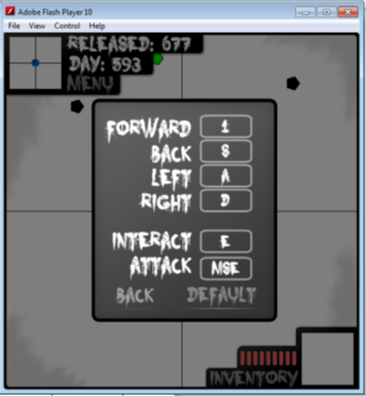
 | Hovering over with the mouse | Changes back colour to a grey | As expected | None
 | 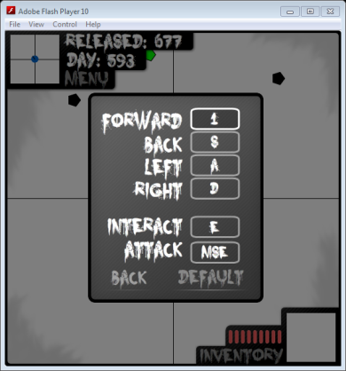
Back’s Selectable box | Clicking with the mouse | The box shows that it’s been selected and allows key input | As expected | None
 | 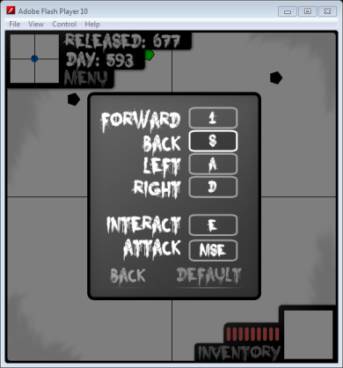
 | Any key press | Changes the text within the box and un selects the box | As expected | None
 | 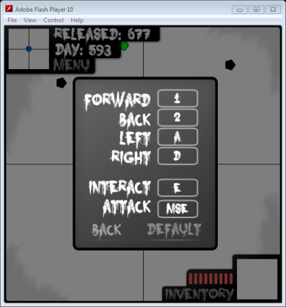
 | Hovering over with the mouse | Changes back colour to a grey | As expected | None
 | 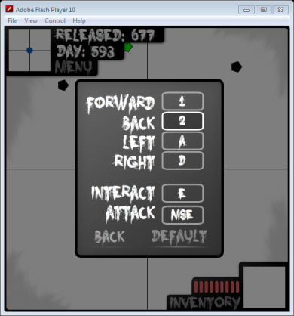
Left’s Selectable box | Clicking with the mouse | The box shows that it’s been selected and allows key input | As expected | None
 | 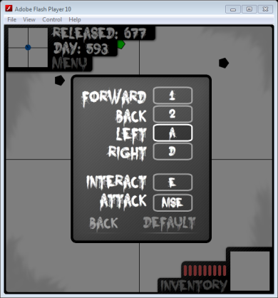
 | Any key press | Changes the text within the box and un selects the box | As expected | None
 | 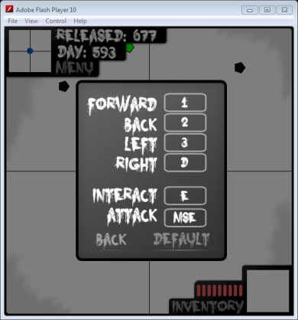
 | Hovering over with the mouse | Changes back colour to a grey | As expected | None
 | 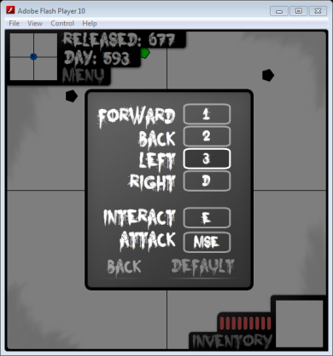
Right’s Selectable box | Clicking with the mouse | The box shows that it’s been selected and allows key input | As expected | None
 | 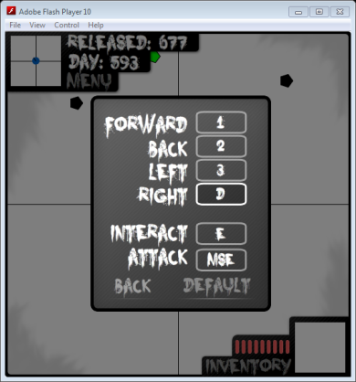
 | Any key press | Changes the text within the box and un selects the box | As expected | None
 | 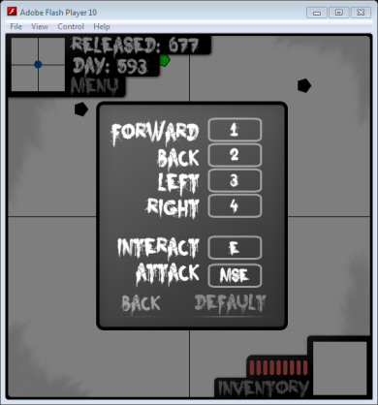
 | Hovering over with the mouse | Changes back colour to a grey | As expected | None
 | 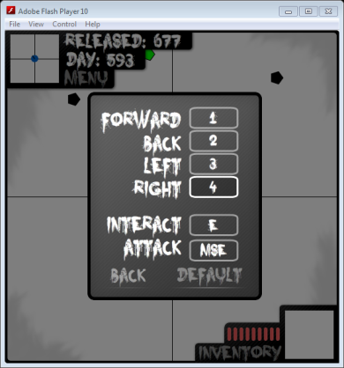
Interact’s Selectable box | Clicking with the mouse | The box shows that it’s been selected and allows key input | As expected | None
 | 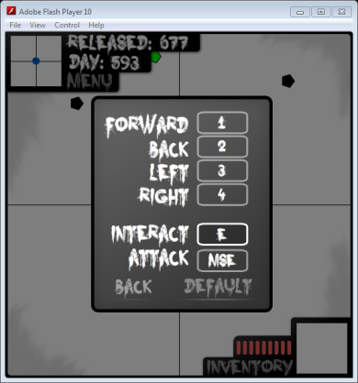
 | Any key press | Changes the text within the box and un selects the box | As expected | None
 | 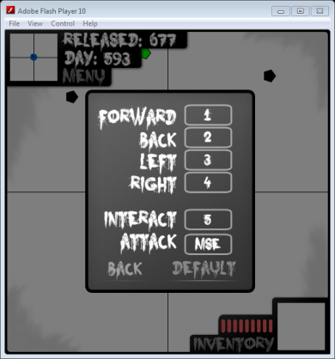
 | Hovering over with the mouse | Changes back colour to a grey | As expected | None
 | 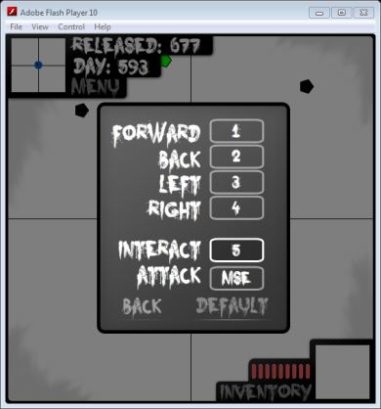
Attack’s Selectable box | Clicking with the mouse | The box shows that it’s been selected and allows key input | As expected | None
 | 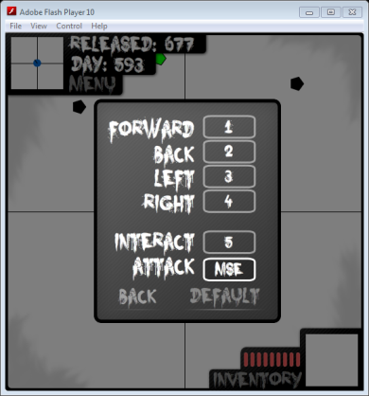
 | Any key press | Changes the text within the box and un selects the box | As expected | None
 | 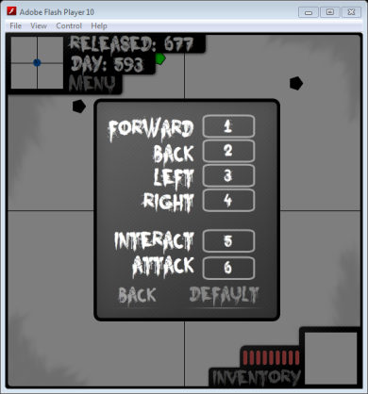
 | Hovering over with the mouse | Changes back colour to grey | As expected | None
 | 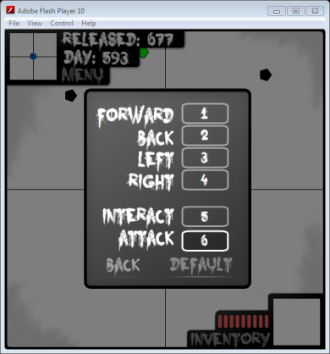
Back button | Clicking with the mouse | Saves all the text from within the selectable boxes and returns to the Main Menu | As expected | None
 | 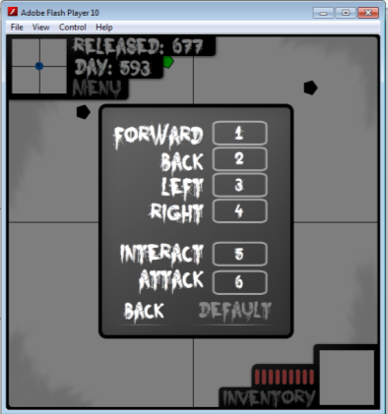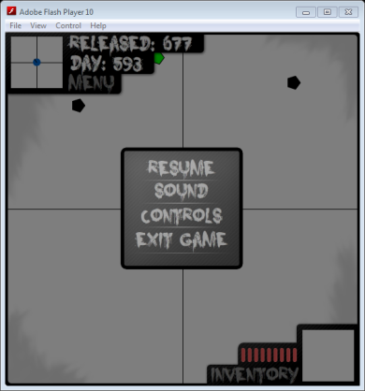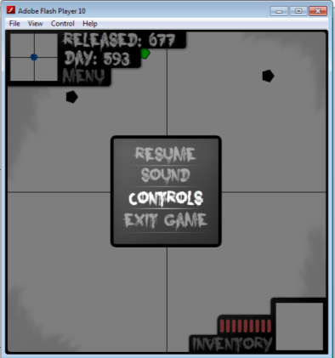
 | Hovering over with the mouse | Highlights the text within the button | As expected | None
Default button | Clicking with the mouse | Changes all the text in the selectable boxes to predefined default text (W,S,A,D,E,MSE) | As expected | None
 | 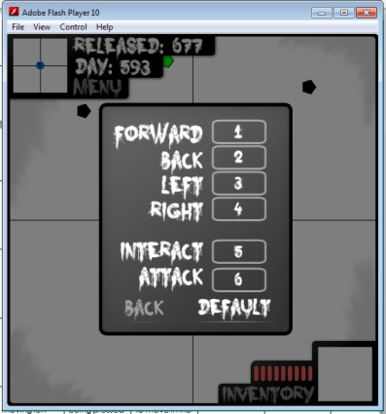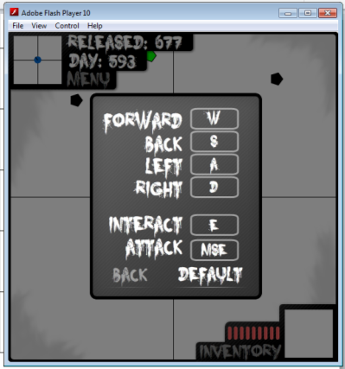
 | Hovering over with the mouse | Highlights the text within the button | As expected | None

Level boundaries:
I had to come back after putting in the graphics because the boundaries for the temp graphic are completely different.
What Needs Testing? | Is Input Required? | Expected Result | Actual Result | Fix
The player stops when moving up into house wall | Forward key from saved key list being pressed | The player won’t be able to move in the current direction when touching the wall | As expected | None
 | 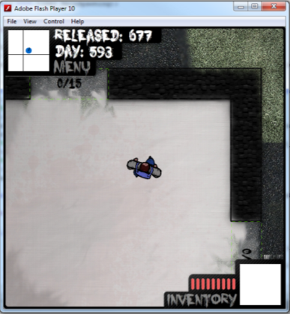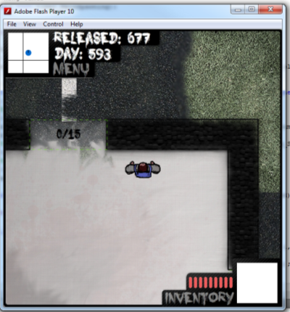
The player stops when moving down into house wall | Back key from saved key list being pressed | The player won’t be able to move in the current direction when touching the wall | As expected | None
 | d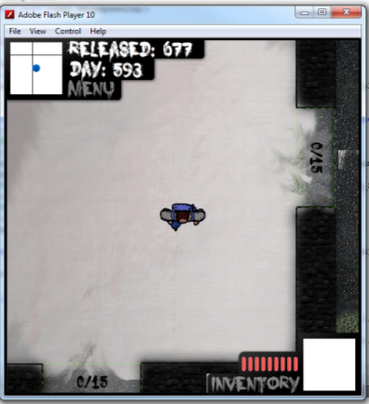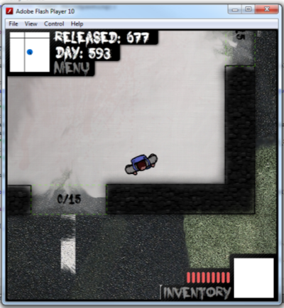
The player stops when moving left into house wall | Left key from saved key list being pressed | The player won’t be able to move in the current direction when touching the wall | As expected | None
 | 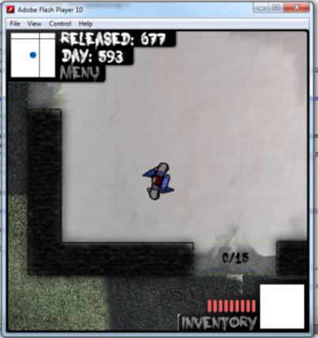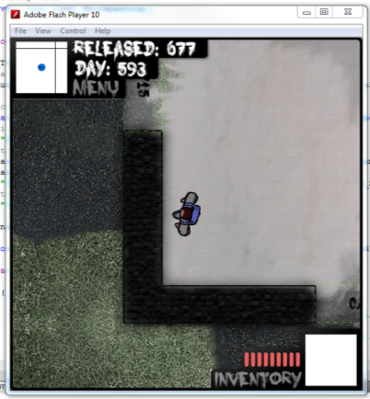
The player stops when moving right into house wall | Right key from saved key list being pressed | The player won’t be able to move in the current direction when touching the wall | As expected | None
 | 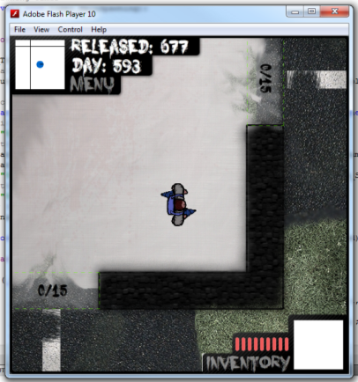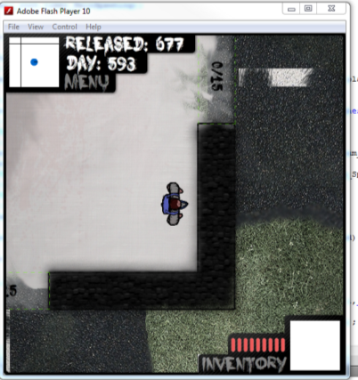
The player stops when moving up into the top of the map(1375) | Forward key from saved key list being pressed | The player won’t be able to move in the current direction when touching the boundary | As expected | None
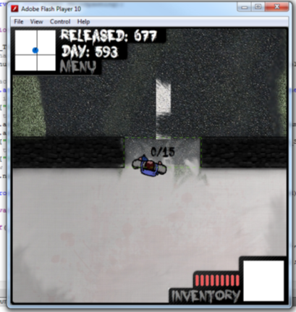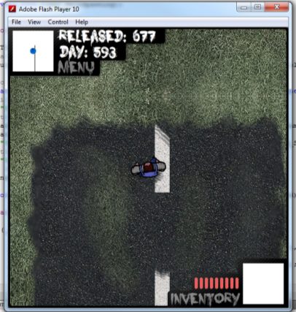
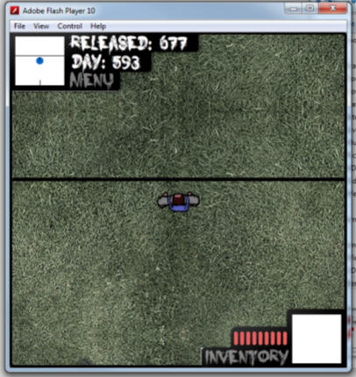
The player stops when moving down into the bottom of the map(-1375) | Back key from saved key list being pressed | The player won’t be able to move in the current direction when touching the boundary | As expected | None
 | 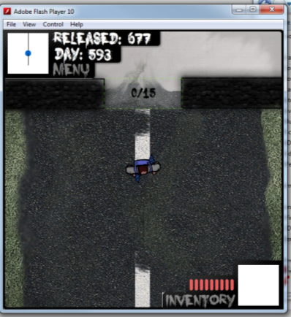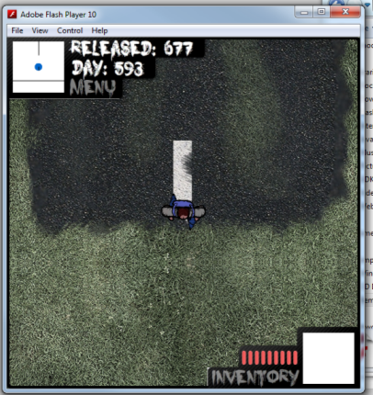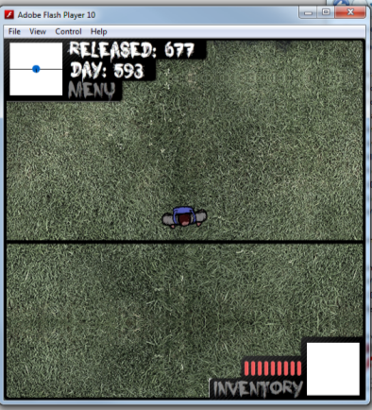
The player stops when moving left into the left boundary of the map(1375) | Left key from saved key list being pressed | The player won’t be able to move in the current direction when touching the boundary | As expected | None
 | 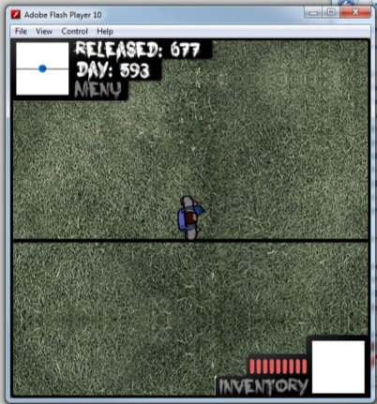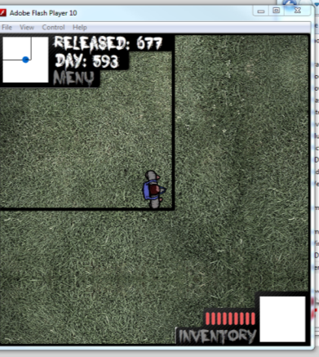
The player stops when moving right into the right boundary of the map(-1375) | Right key from saved key list being pressed | The player won’t be able to move in the current direction when touching the boundary | As expected | None
 | 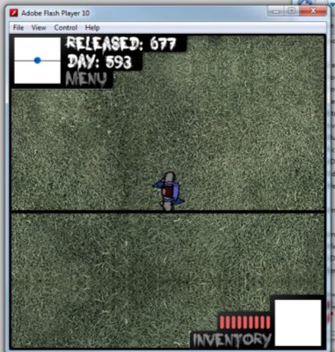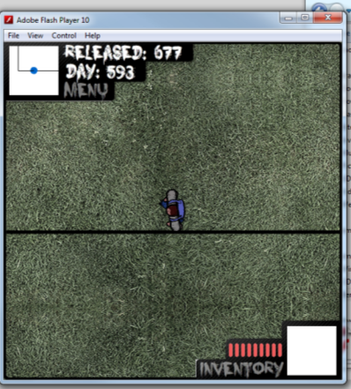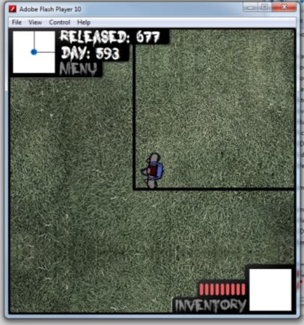

Graphics and Animations:
What Needs Testing? | Is Input Required? | Expected Result | Actual Result | Fix
Player Moving | Any directional key from saved key list being pressed | The players legs should rotate to face the direction the player is trying to move | As expected | None
 | 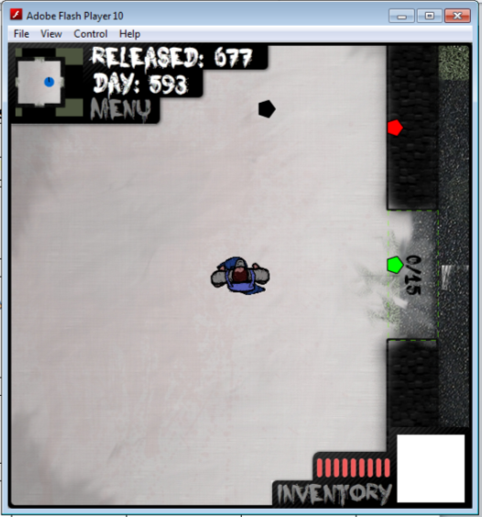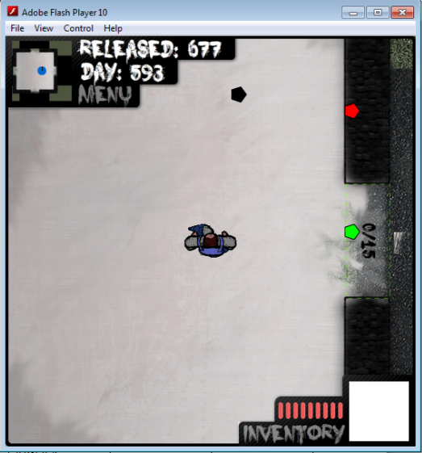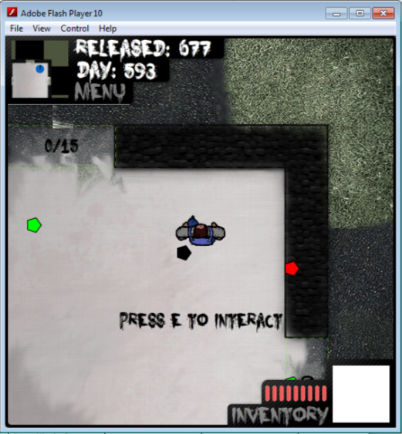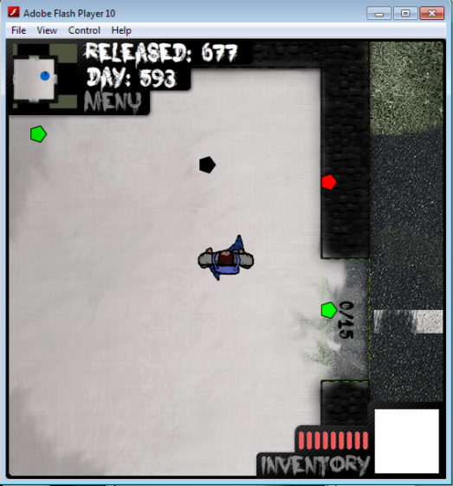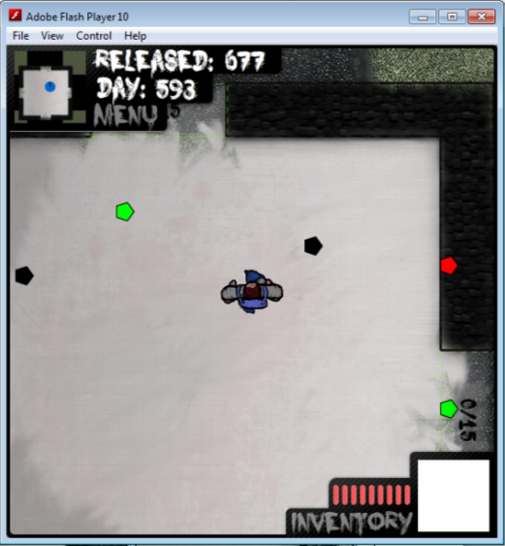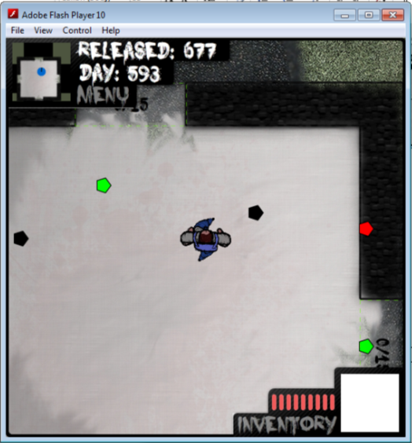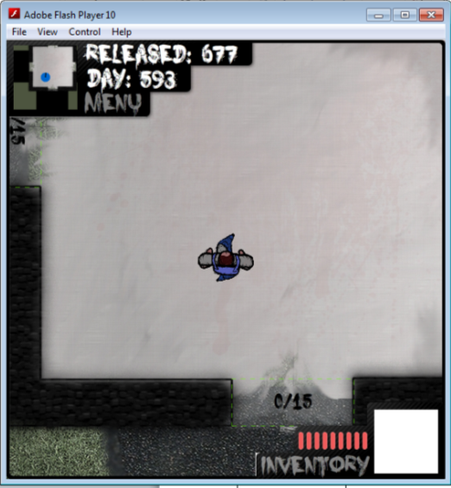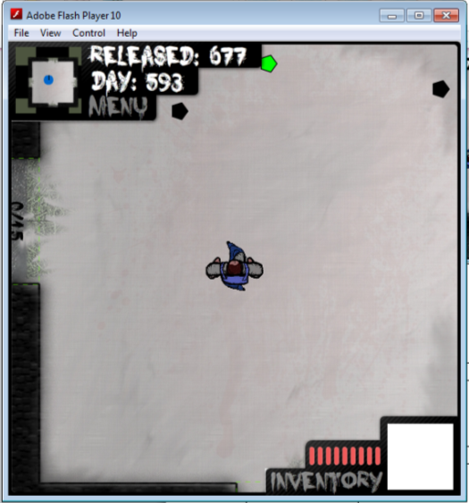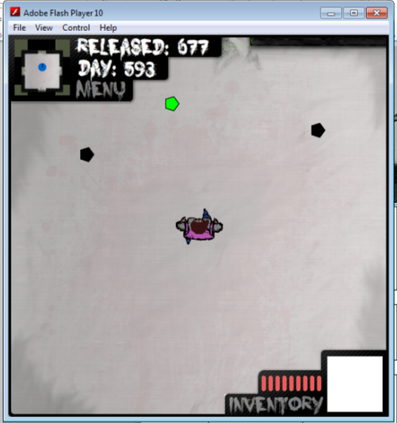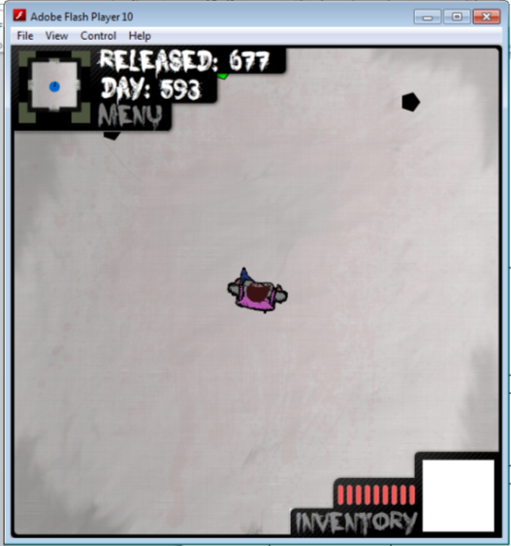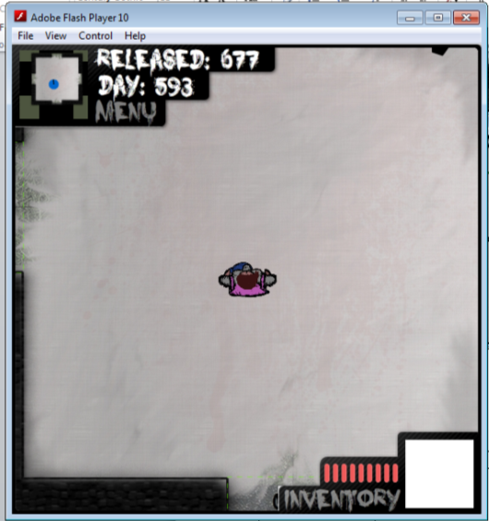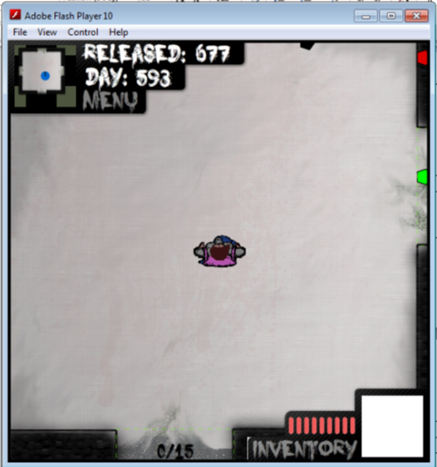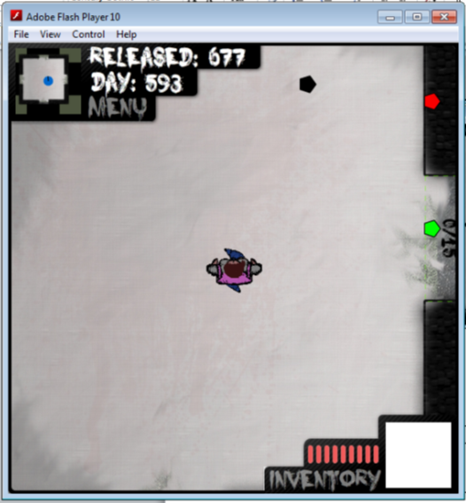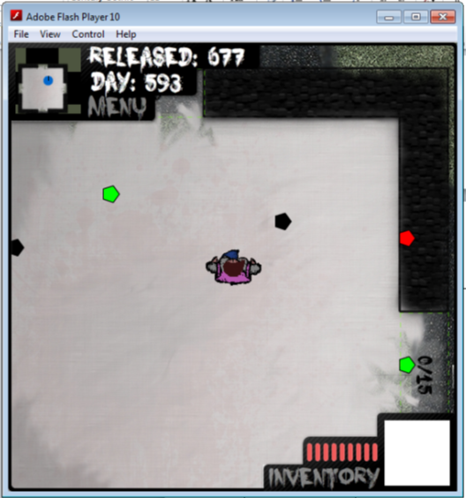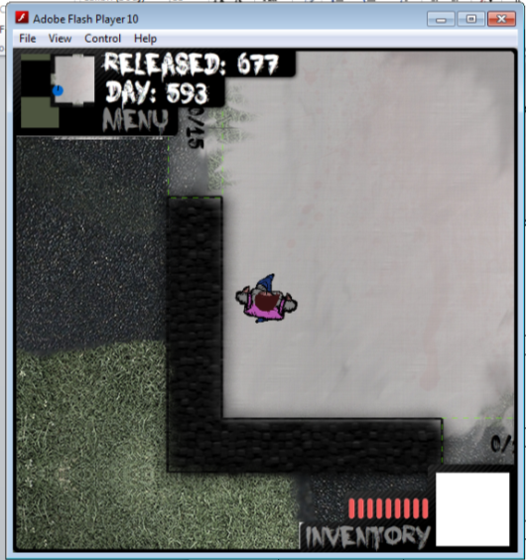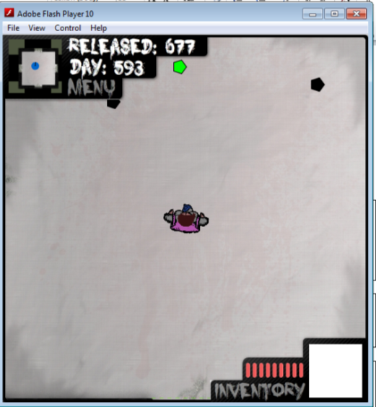
Player Attacking | Attack key from saved key list being pressed | They player should change animation state showing that it’s attacking | As expected | None
 | 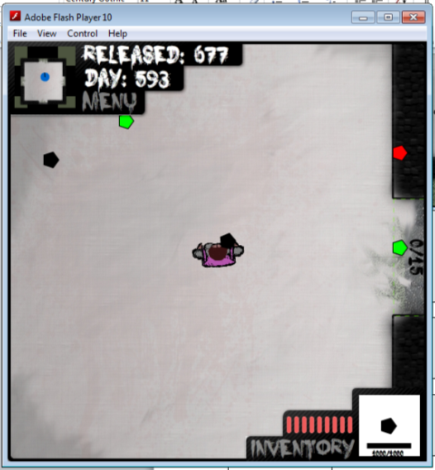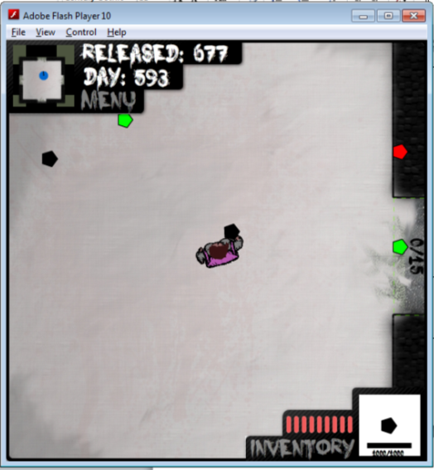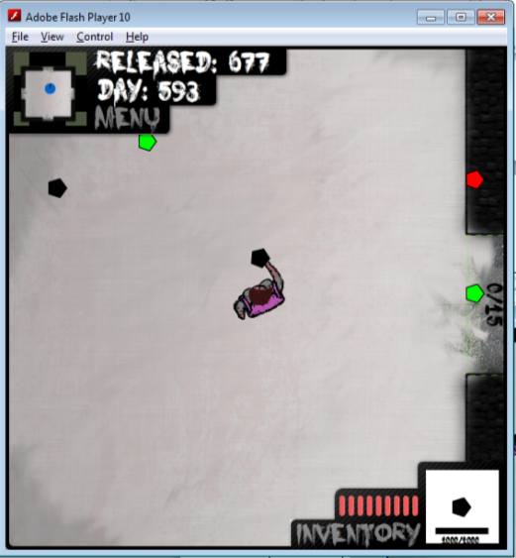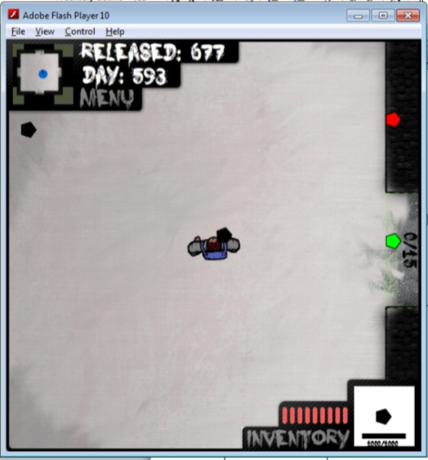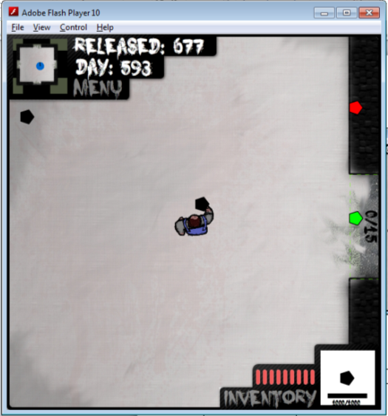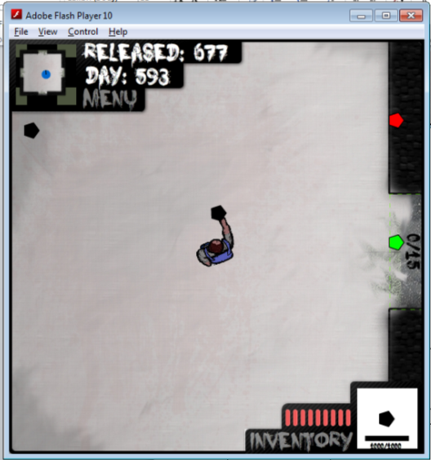
Player Dead |  | A death animation runs when player health is 0 | There is no animation. The player just stands there when they die. | A death animation needs to be made.
 | 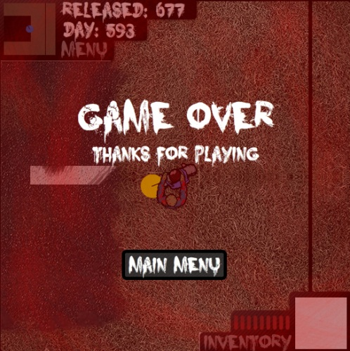
Enemy Moving |  | An animation should play to show they enemy moving | The walker and the dragger Enemy both have walking animations but the dog enemy doesn’t | An animation for the dog needs to be created and implemented
 | 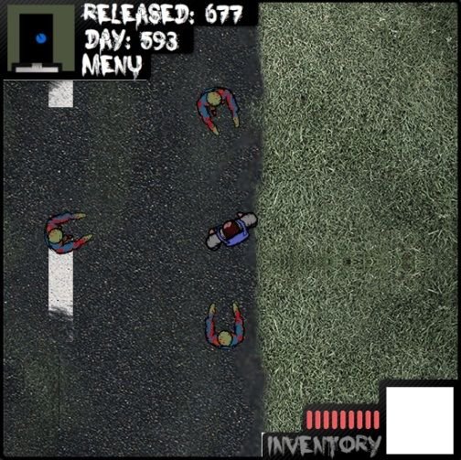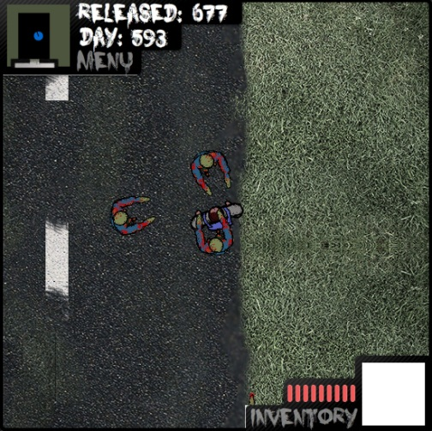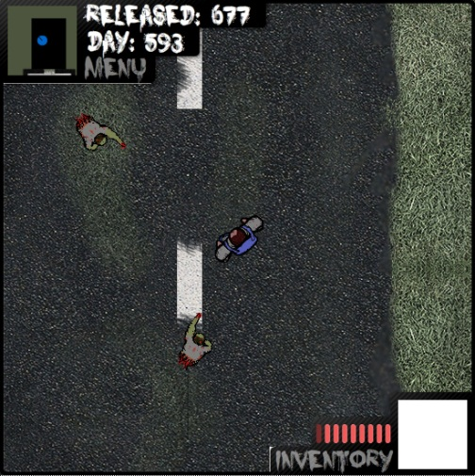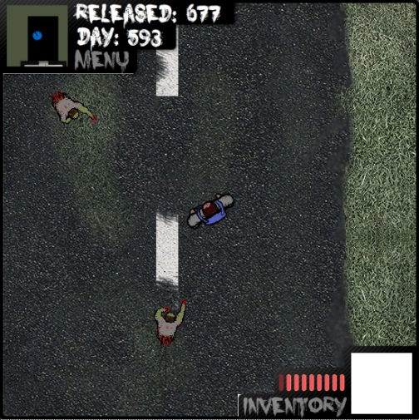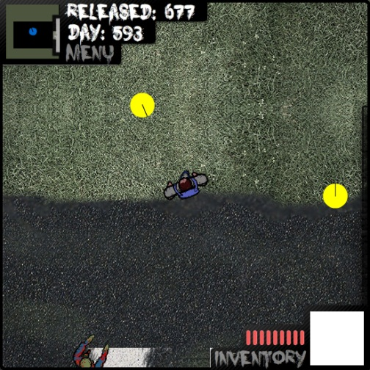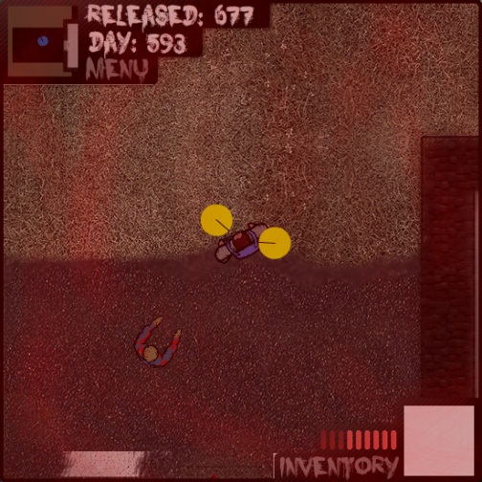
Enemy Attacking |  | Enemy Attacking animation will play when dealing damage to the player | None of the enemies have attacking animations. They just stop moving but keep the moving animation going | An animation for each of the enemies need to be created and implemented
 | 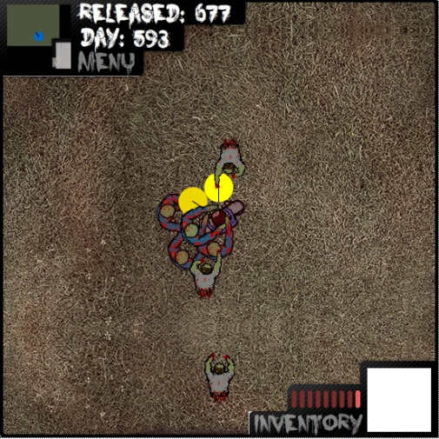
Enemy Death |  | Death animation will play to show the enemy isn’t a threat | The enemy just stop moving and fade out when they die | An animation for each of the enemies need to be created and implemented
 | 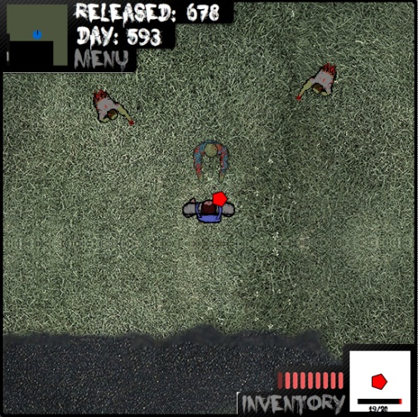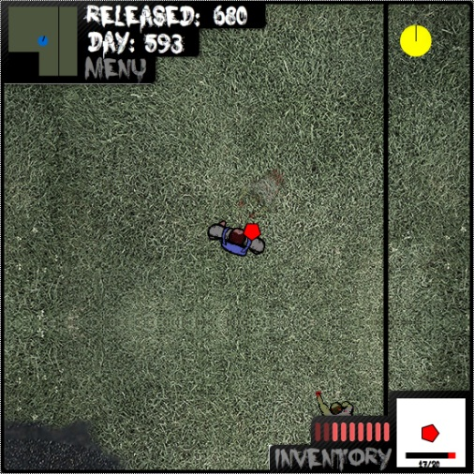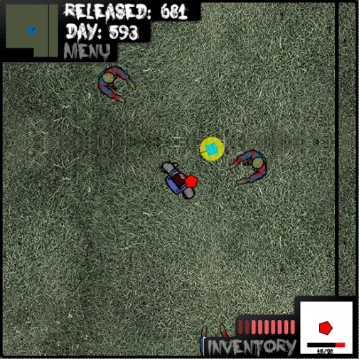

Objective Testing

Objective | Actual Result | Fix
The game must be able to work with flash player 10 and greater. This then outlines that the game must work with browsers that support flash. | When initially creating the game, Flash asks for file information and settings. This is the point in which I set the game to run with flash player 10 and greater. | None
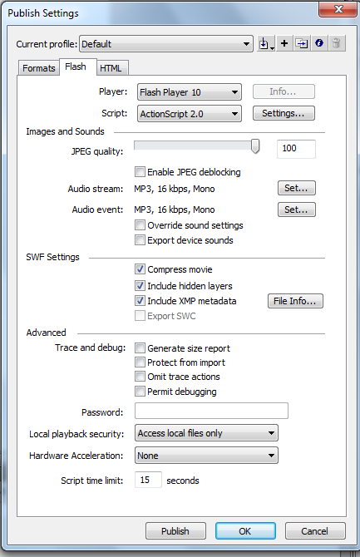
As you can see I’ve selected Flash player 10
The game must be a top down sandbox game. | From all the screenshots it’s quite obvious that the game is top down. As for the sandbox side; the player is able to walk around an open space and choose to attack enemies at will. | None
 | I would say it’s quite difficult to get a screen shot to prove my point but you can see the game is from a top down perspective and the player is free to move anywhere.
The setting of the game will be in a suburb and sticking with the idea of sand box the player will be able to travel to collect resources and complete tasks | I would say the game is not really set in a suburb but more in a field, with a little house. The player is able to go round collecting items which I would say is the same as resources. No tasks have been put into the game | The game needs to have a new map graphic put in to meet the criteria of being in a suburb. This will also mean that new boundaries will need to be created. As for the completing tasks; a menu or some sort of system would have to be put into place to manage tasks.
 | [Image showing Collecting resources]
There should be AI player within the game that impact the story line depending on how the player interacts with them | Seeing as there is no in game storyline/tasks the AI player is pretty irrelevant and thus they have not been put in. | The game would need to have tasks system I mentioned above put in. This would then bring in a need to have an AI player. The AI player would just be a derivative of the enemy class as the movement would be very similar. Some other tweaks to the code would be needed as well.
The player of the game will be able to choose the gender of the main character | The player is able to choose the gender just after the intro and before they are able to play the game. | None
 | 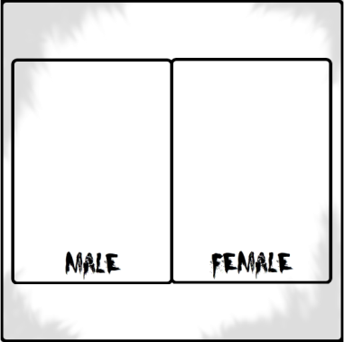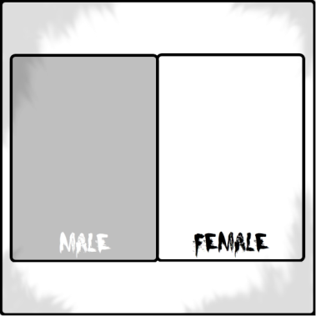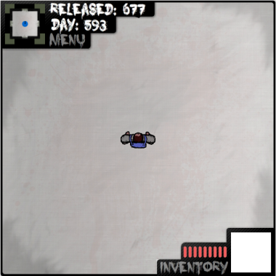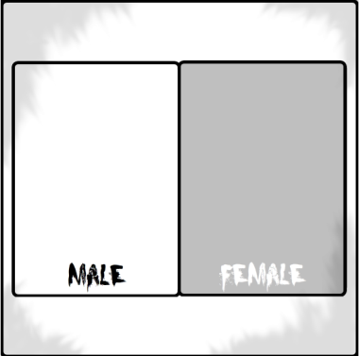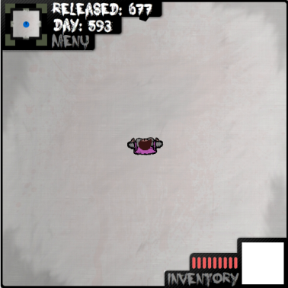
There should be a variety of zombies, not only human ones but animals as well  Dragger Type | The game contains 3 zombie types that spawn at random. The types are Walker, dragger and dog. The dog is the only enemy type that doesn’t have a graphic. | The dog enemy type needs a graphic.
Dog Type
Walker Type
The game should pick up intensity as it goes along. | The intensity doesn’t change as the game is a demo. | To meet this objective I would put in a slight change to the amount of enemies spawning and the gap between spawns when an enemy is killed.
To regain health the player must eat food they have found. | There is plenty of food items spread around the map for the player to eat. | None
The game will use a combination of mouse and keyboard to be played | The game has re-bindable keys so the player can have complete control over the keys. The mouse is also used to rotate the player. | None
Mouse

