19/02/2012
Today I am working on sorting out the save slot so when you click on one the background of the load and delete button change do show the user that they can now use the buttons
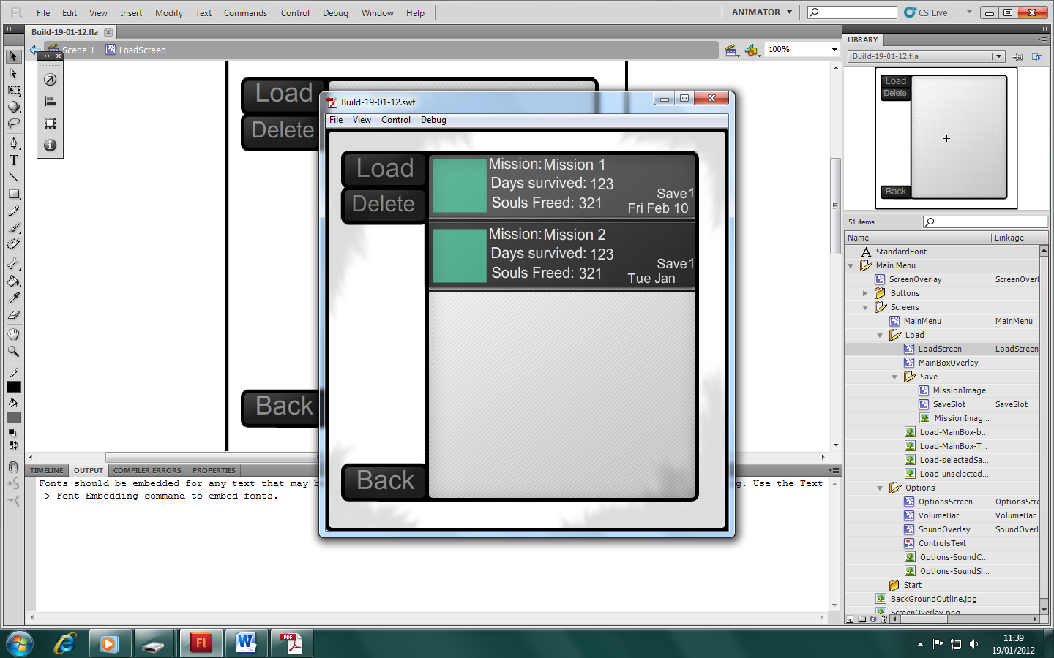
As you can see when “Mission 1” save slot is selected and the load and delete buttons are still set to their default backgrounds.

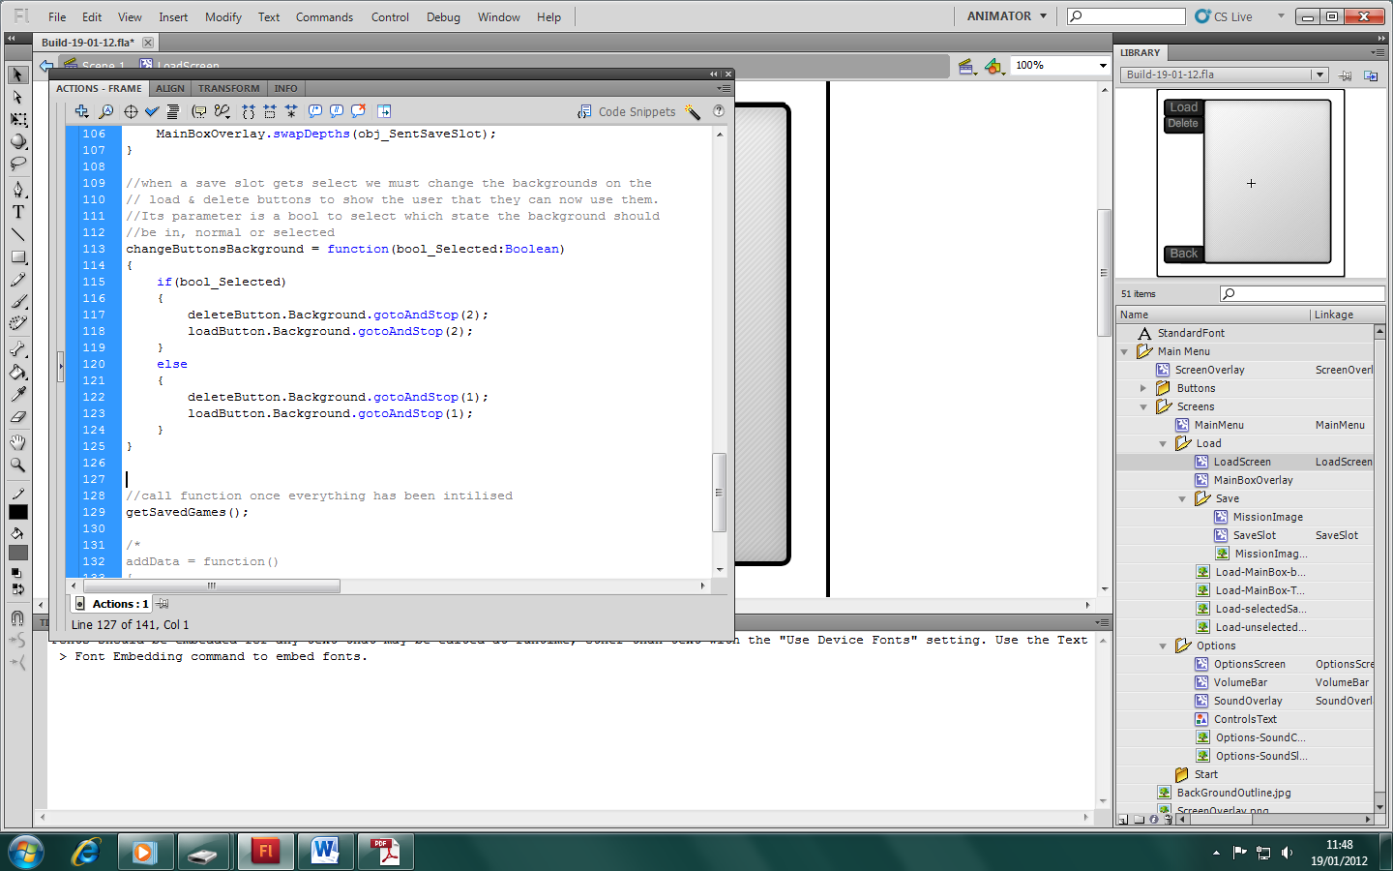
This first thing I have done is added a new function to the first frame of LoadScreen movieclip. This function takes a Boolean as a parameter to determine which sate the button background should be in. True mean that it should be on the selected background and false means it should be on default.

I have also added a line of code to the first frame of SaveSlot Moveclip to call the function when the button is press and when the button is unpressed.

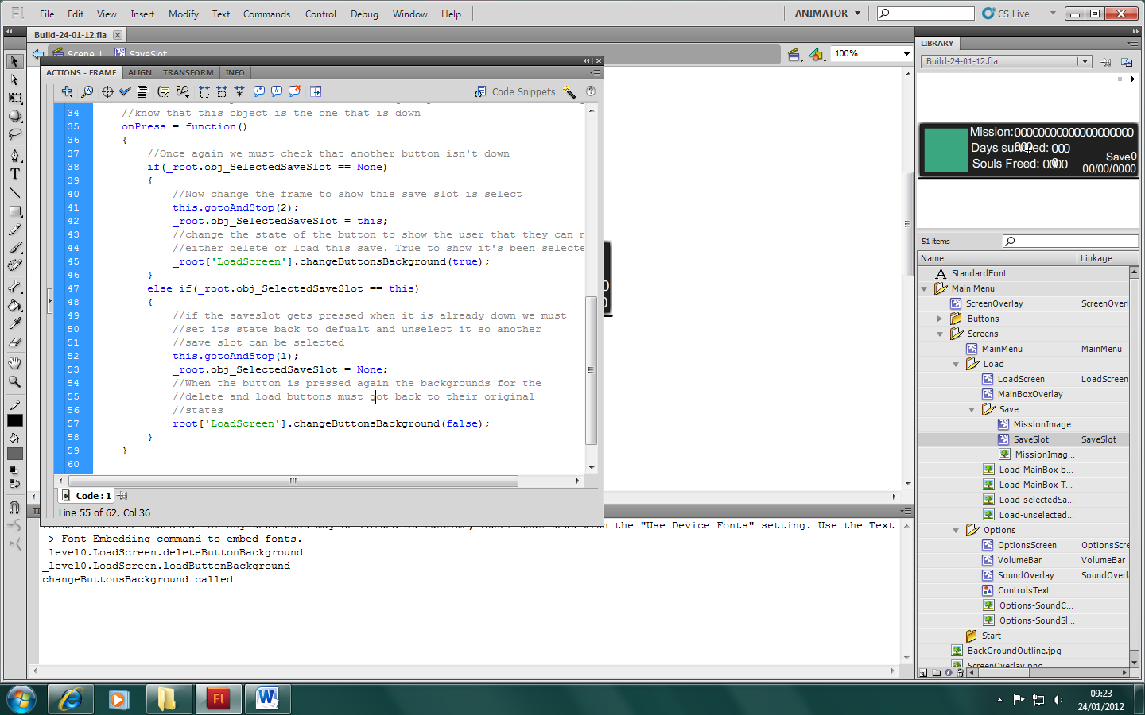

To test that the function has been called have successfully I have placed a trace call in changeButtonsBackground function, which will output "changeButtonsBackground called” when the function is called
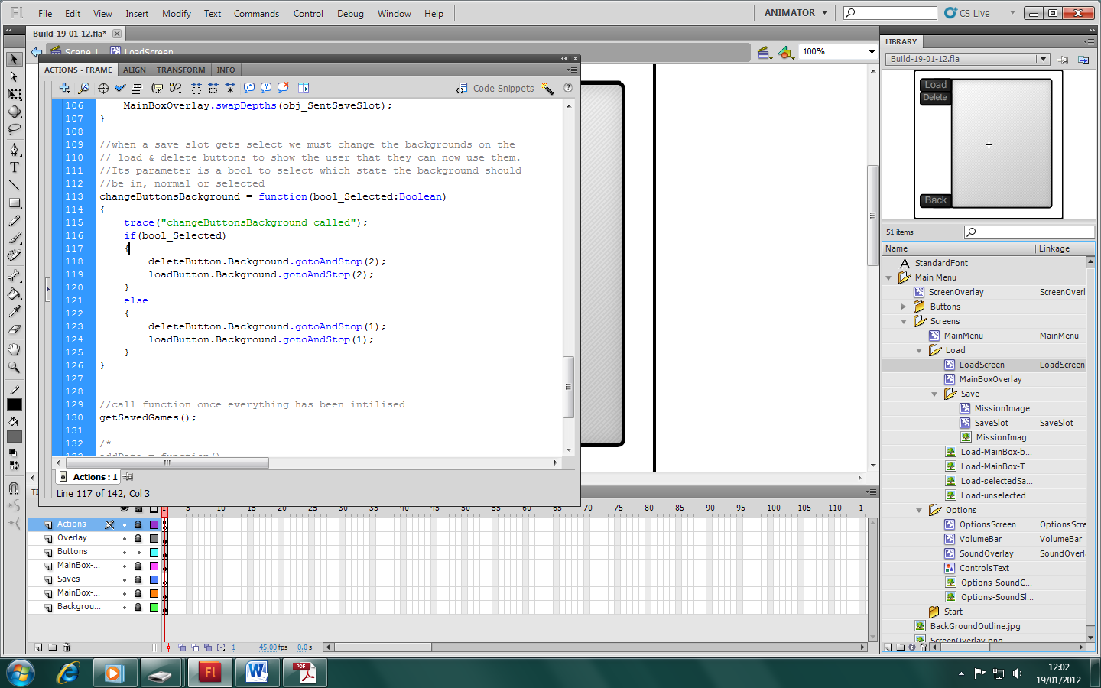

Now when I compile and run the code the function is called and "changeButtonsBackground called” is outputted but the background of the button does not change meaning the reference to both the buttons is not correct.
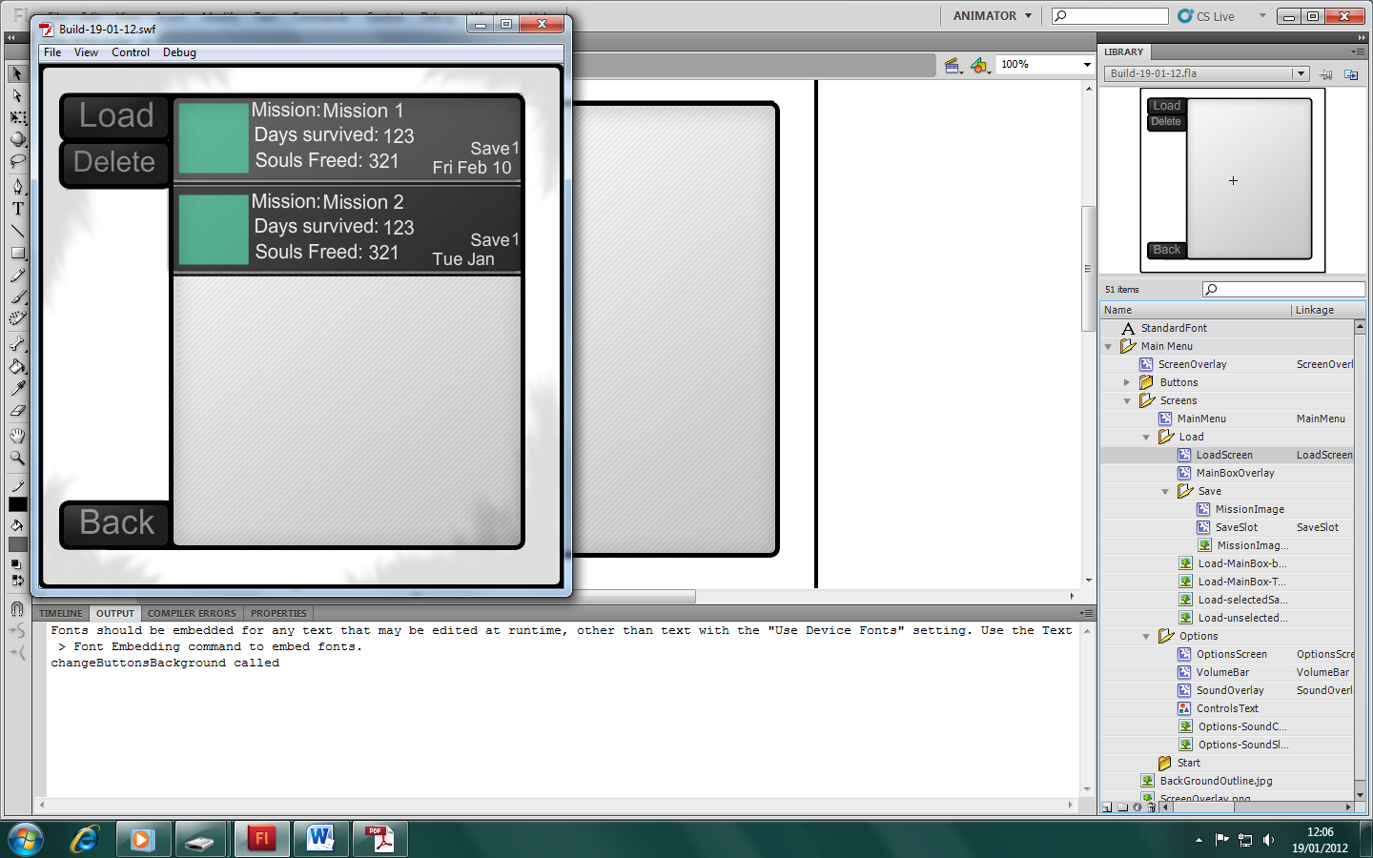

After playing around with the button itself I found that having the background outside of the button allows you to manipulate it. I could have changed the button to a movieclip but that would have involved writing onPress, onRollOver, onRollOut functions which a button already has built in. I only had to change four lines of code to get this working at that was the reference to the background itself.

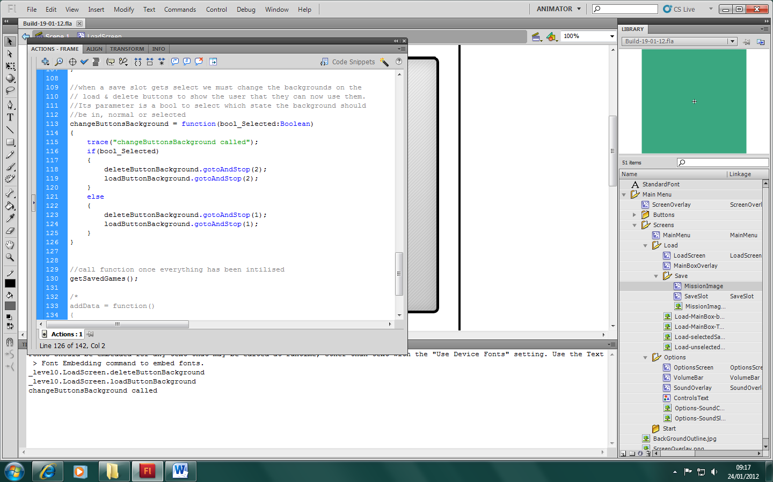

24/01/2012
Today I am going to work on the player mechanics. Unlike the menu this code is easier to right in class which you then assign to a moveclip. This is the base

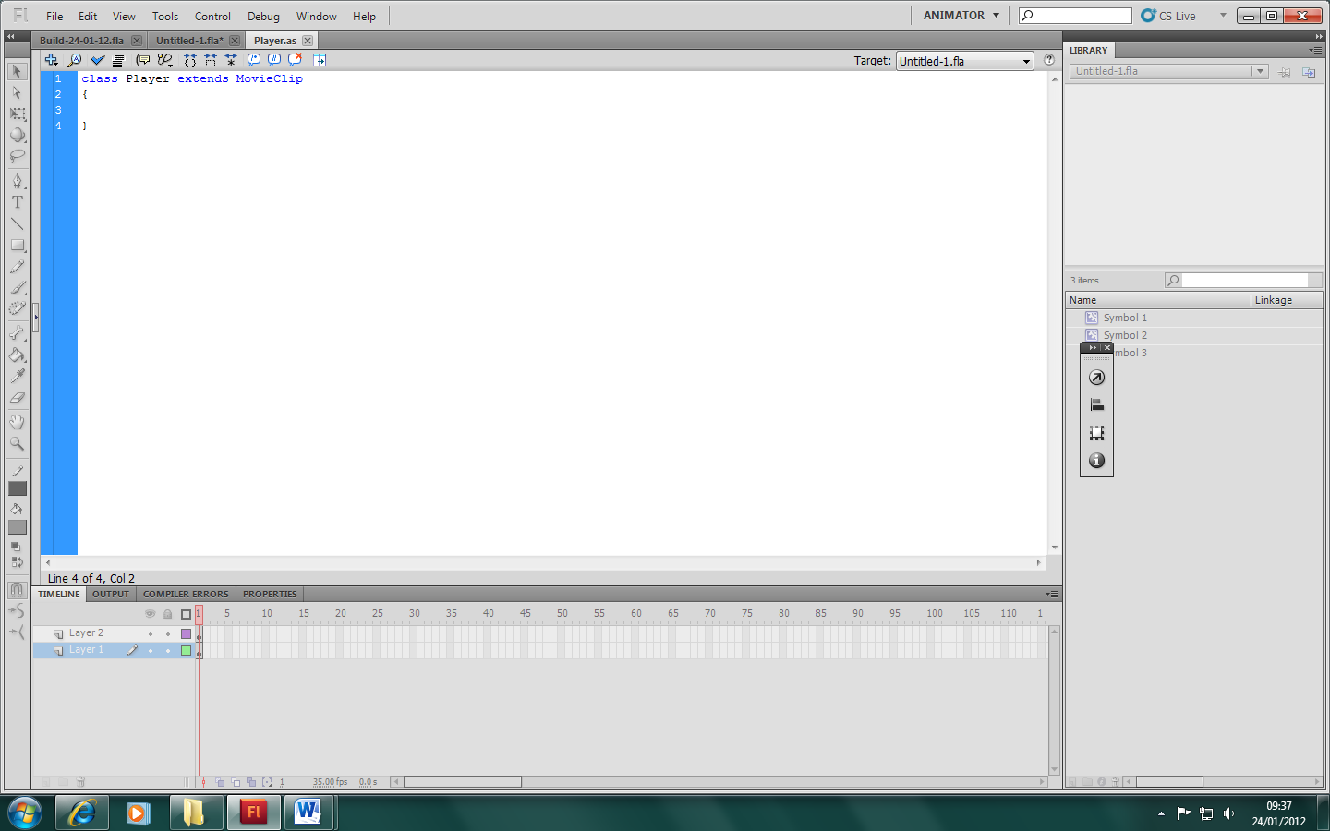

First I must initialise all my variables. Out of personal preference I have split my variables into groups.

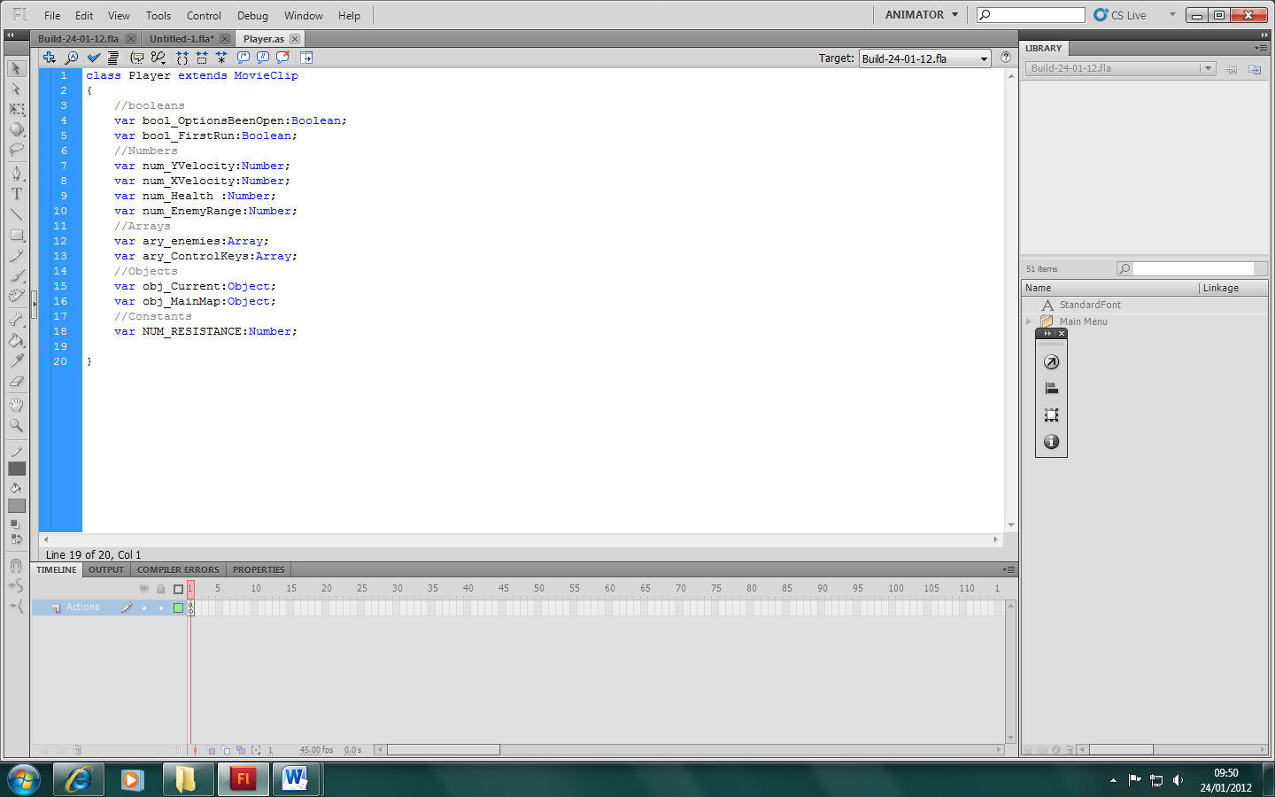
Next I have added in the main routine. The function first checks to see if the controls need to be loaded in and then calls function which check user input to see if the player should be moving, attacking or trying to open the inventory screen.

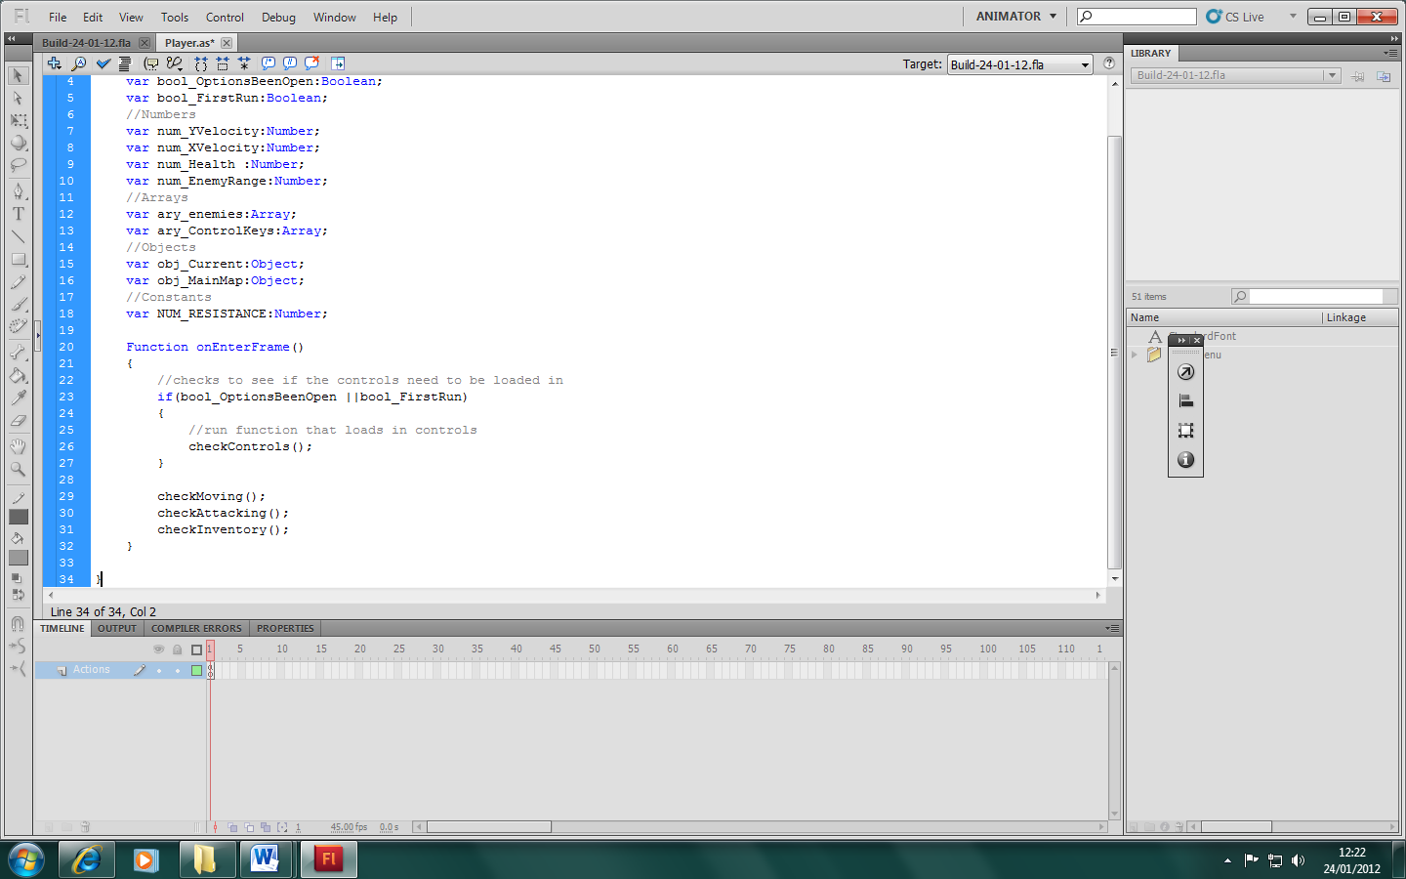

Now I am adding in the ‘checkMoving’ Function. This function checks input against set controls to determine whether it should move the map up, down, left or right.

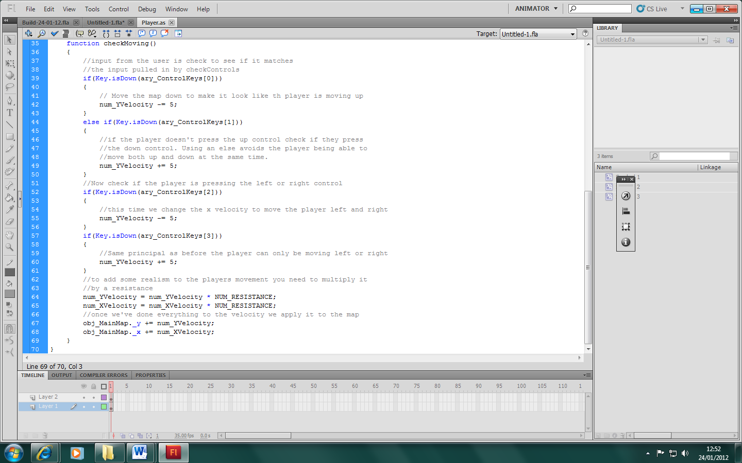
‘checkAttacking’ is the next function I added. This function checks if an enemy is inrange then does damage if they are.

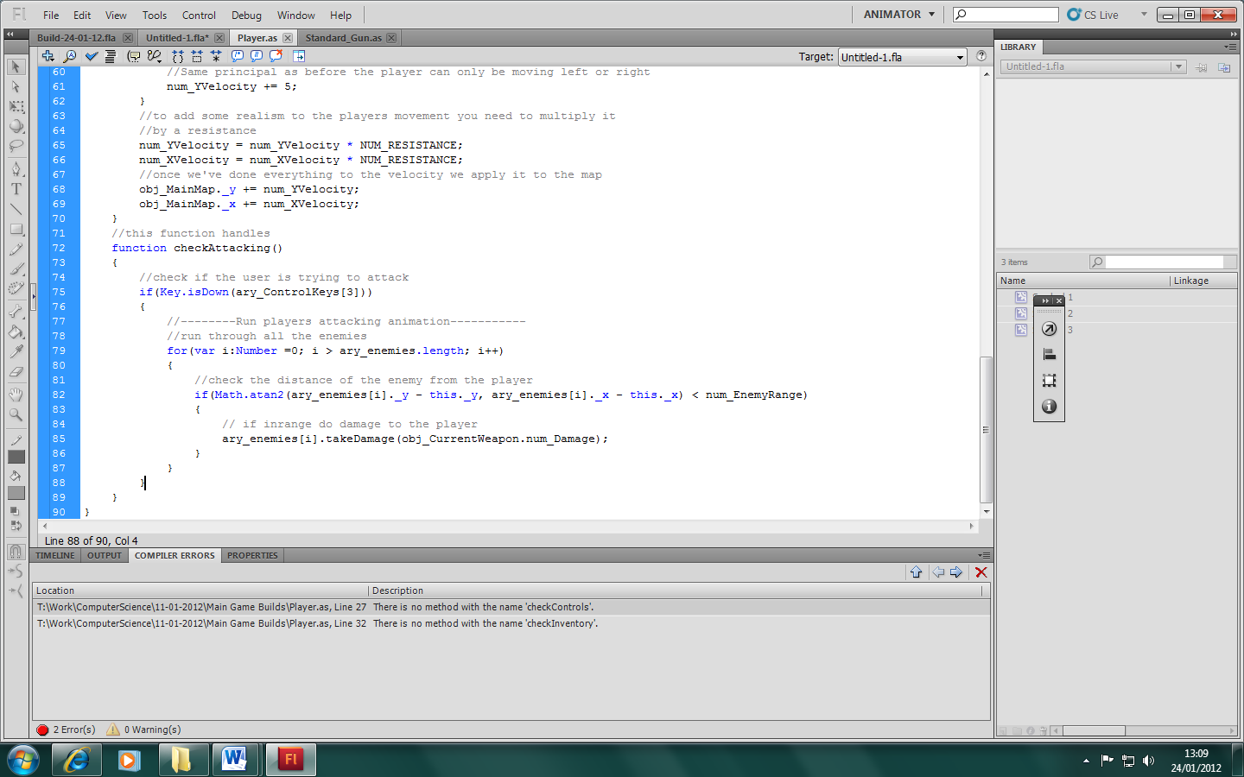

25/01/2012

‘checkInventory’ checks the input for the user to see if they are pressing the right key to open the inventory

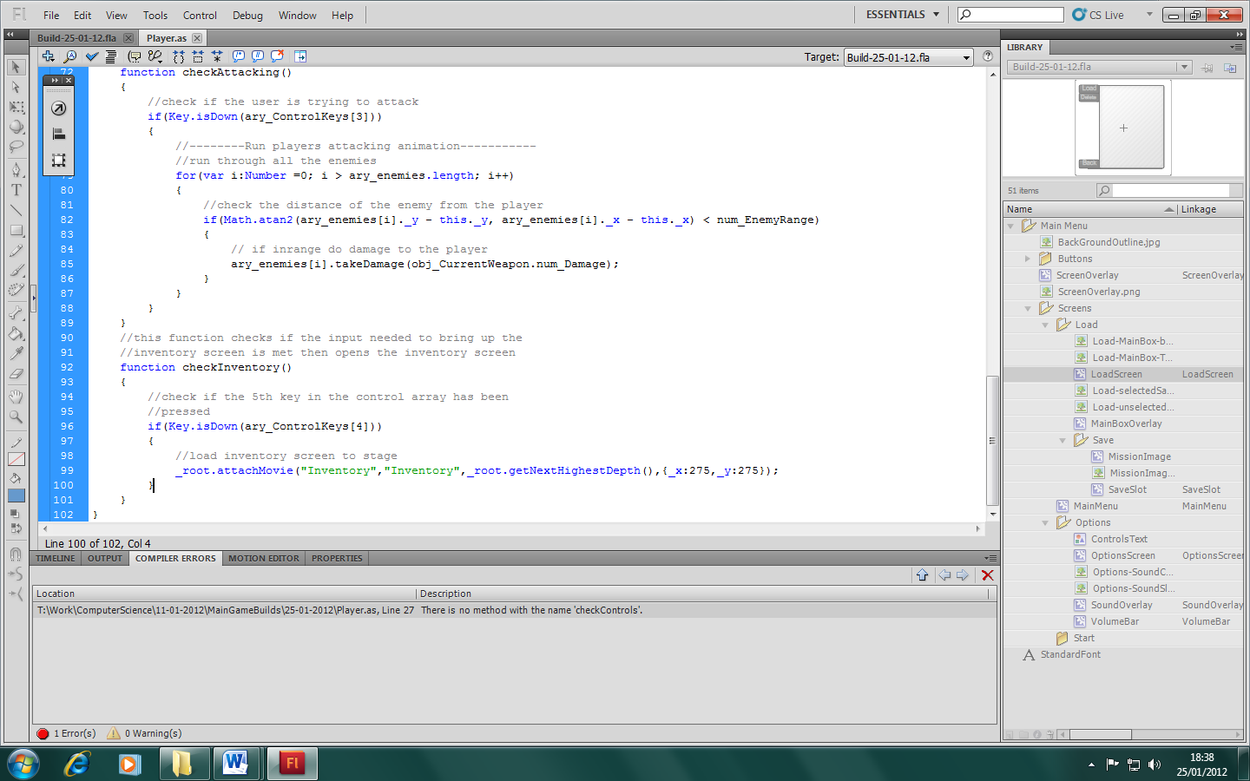

‘checkControls’ and ‘checkKeyArray’ go together to check through all the saved keys againest the ones already in the local memory. This also sets up the controls to be used by the other functions.

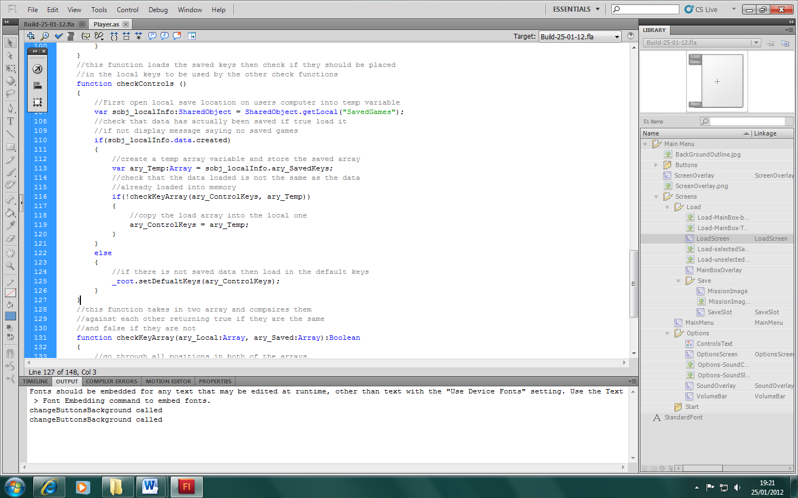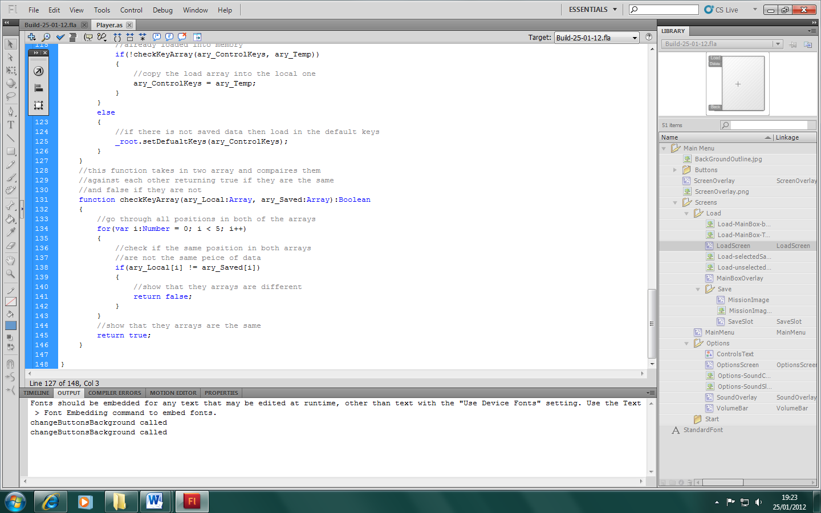

The last two functions I need to add to the player class are not actually used by the player class. ‘takeDamage’ and ‘playerDead’ are both called by other classes. I’ve done this so that variables linked to the class don’t get manipulated by other classes thus making them easier to maintain.
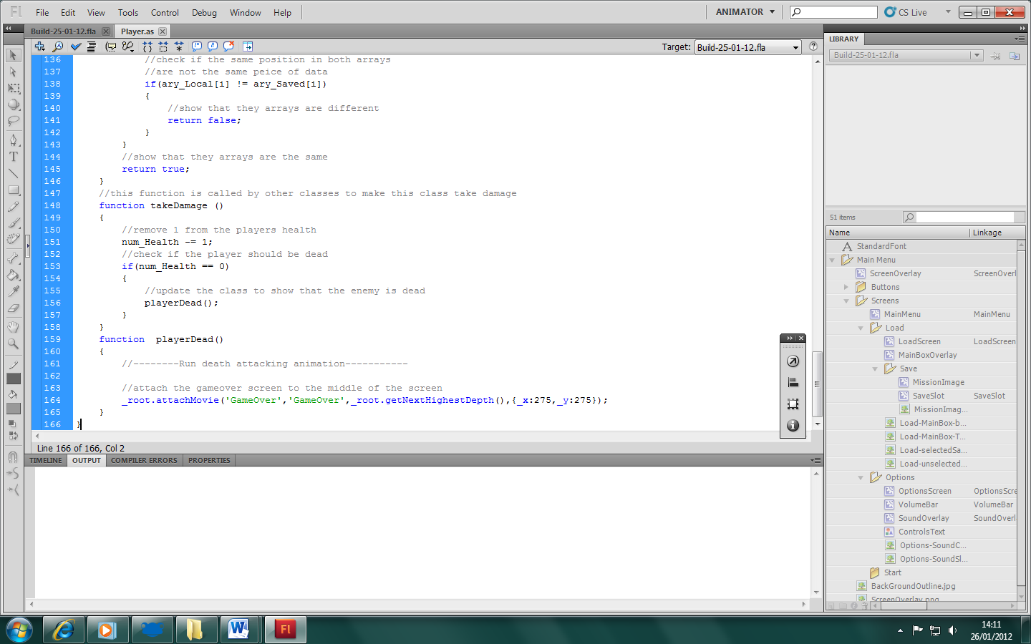

26-01-2012
Today I am testing they player class code I wrote yesterday. I have created a simple graphic to represent the player. I will then place it on screen to see if it works

After just quickly reading over the code I have realised that for setting up the default keys doesn’t need to call a root function. I have replaced it with a constant array which I have initialised in the ‘onLoad’ function.

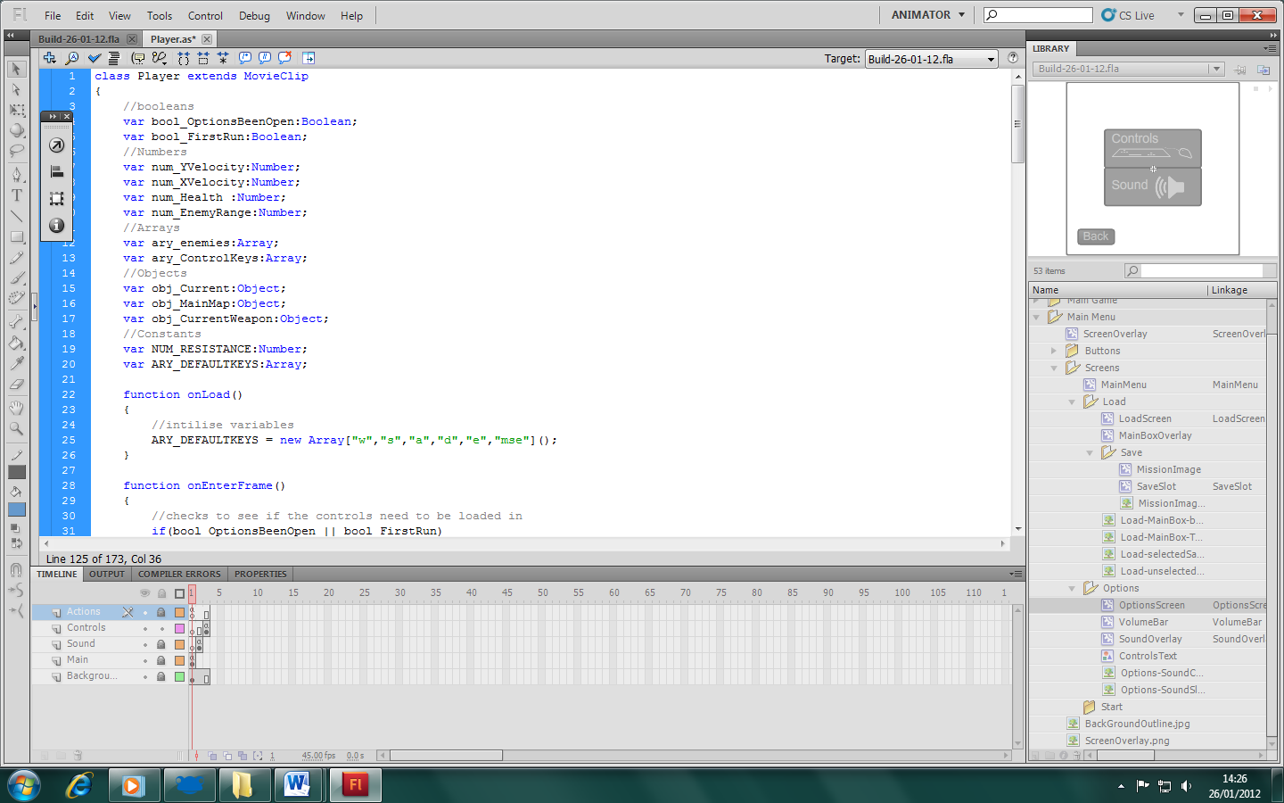

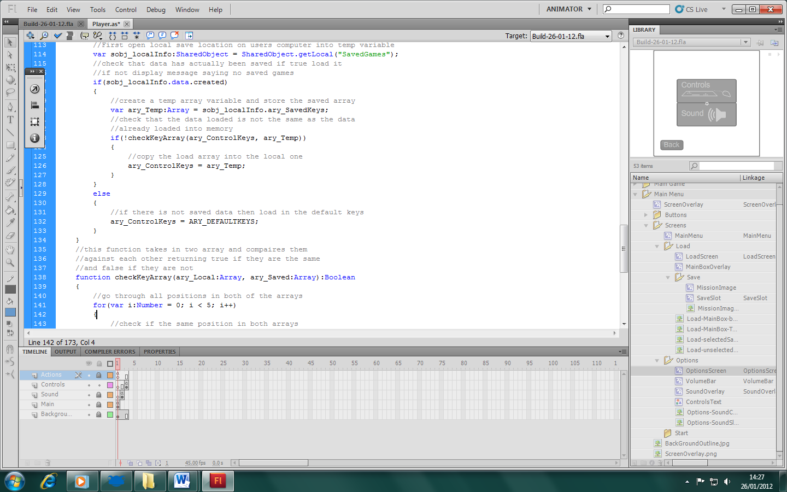

I have also realised that I have not placed a map movieclip which is the object that really gets moved. After creating a temp image to represent the map I must load and set it as the initial value for obj_MainMap. At the same time I have given the constant NUM_RESISTANCE a value as well.

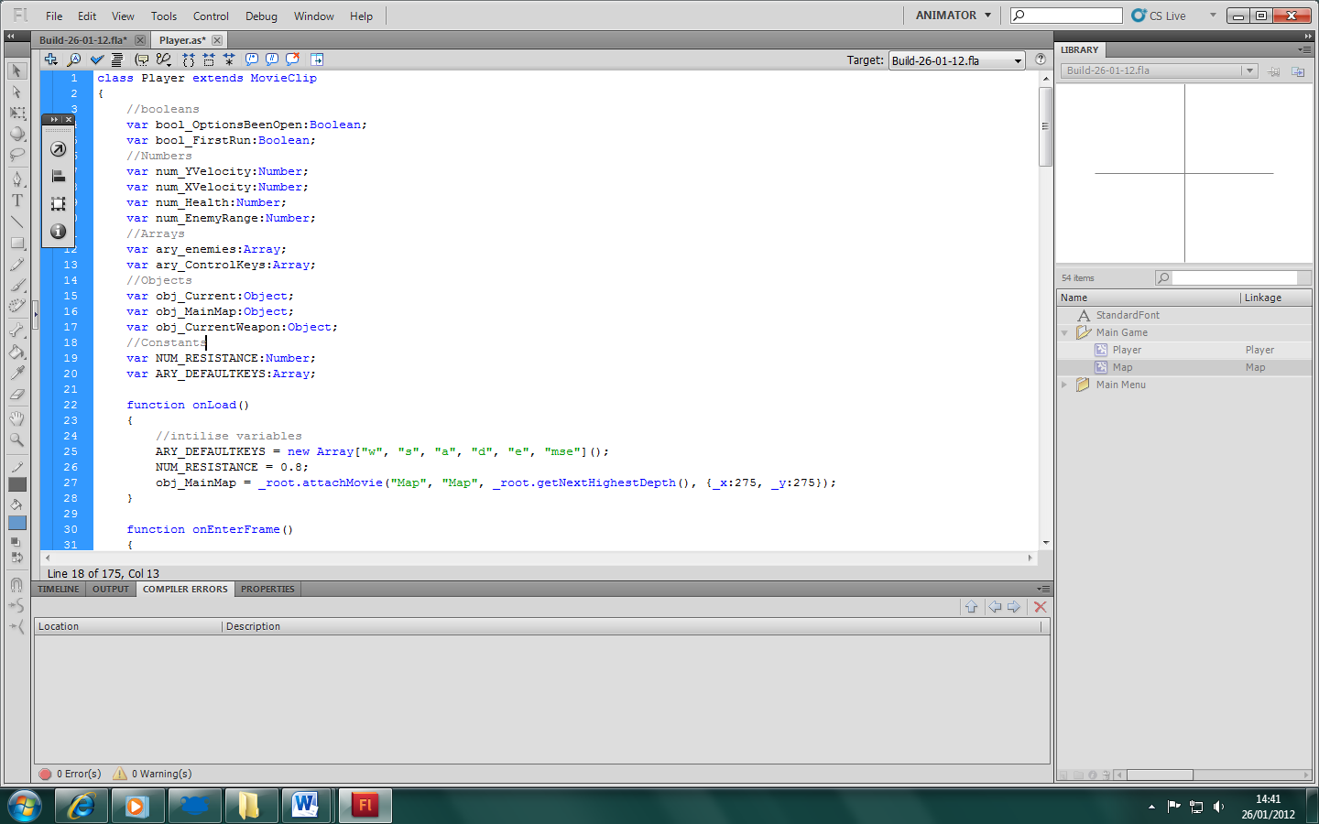

When I build the game I can see that the map has been attached but pressing the default keys doesn’t do anything. I think the problem is that I am not change the letter to their ascii values so the game does not know what key it’s looking out for.
(The map is the cross on the screen)

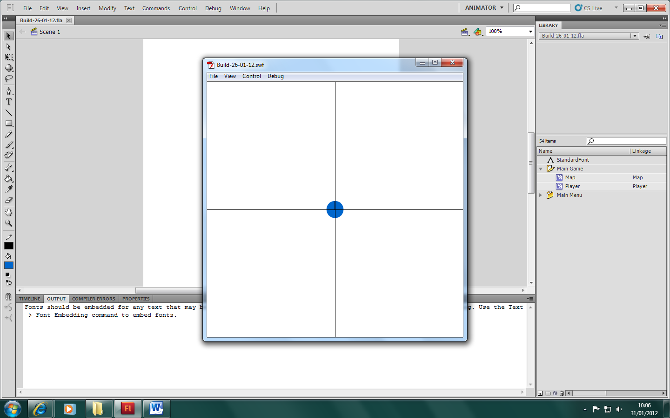

31/01/2012
Not sure what I was thinking last time but after running through with the debugger I found that a few key variables had not been initialised so I’ve initialised them
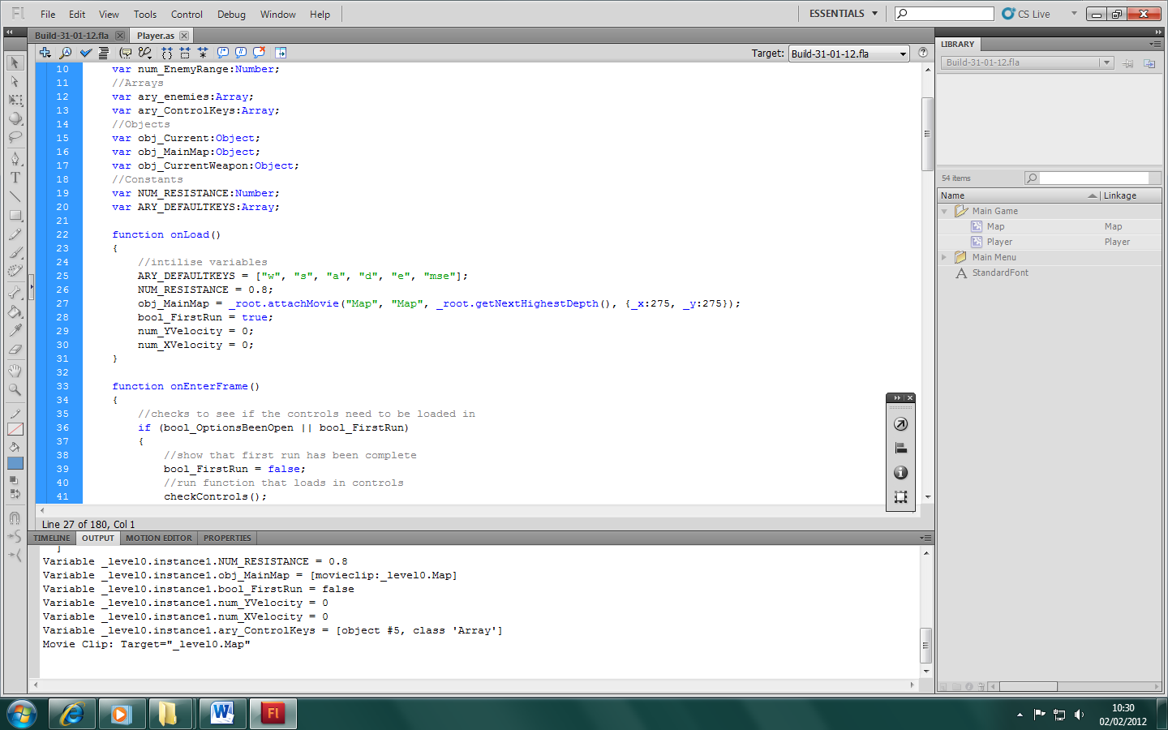

After rereading what I wrote before I found that I was trying to pass a string value through Key.isDown() instead of a number. I have also found, after changing this the letters must be capitals. I will now make a function that converts all numbers pulled in into capitals before placing them into the array.

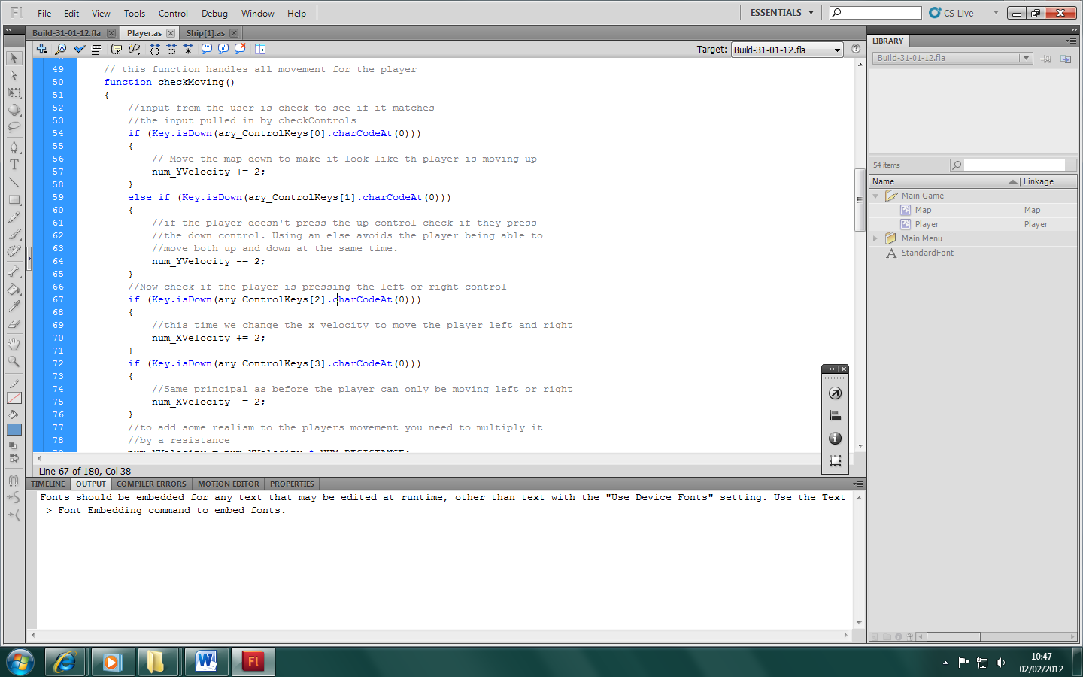

The background now moves then the default keys are pressed.

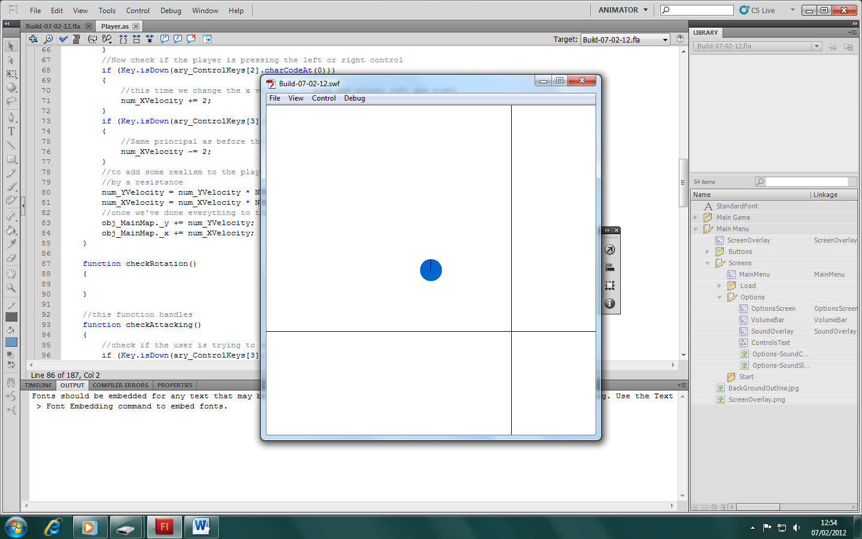

12/02/2012
Today I’m working on adding rotation to the player so it’s always facing the mouse. I have written a piece of code is the past for a tower defence game which would rotate the tower to face an enemy. I have taken this and made it work with the player.

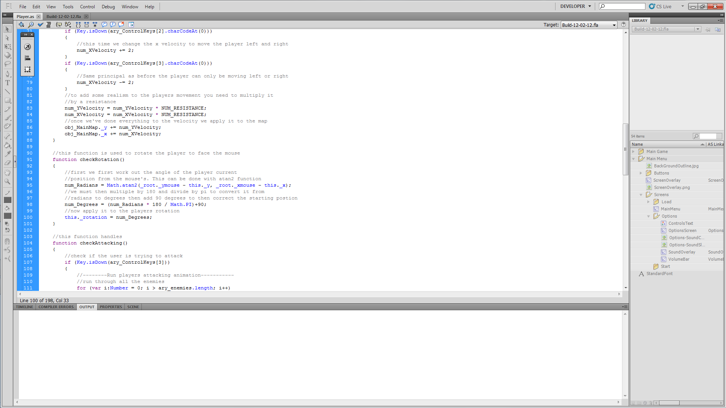

Check rotation function is called from within the on enterframe function.

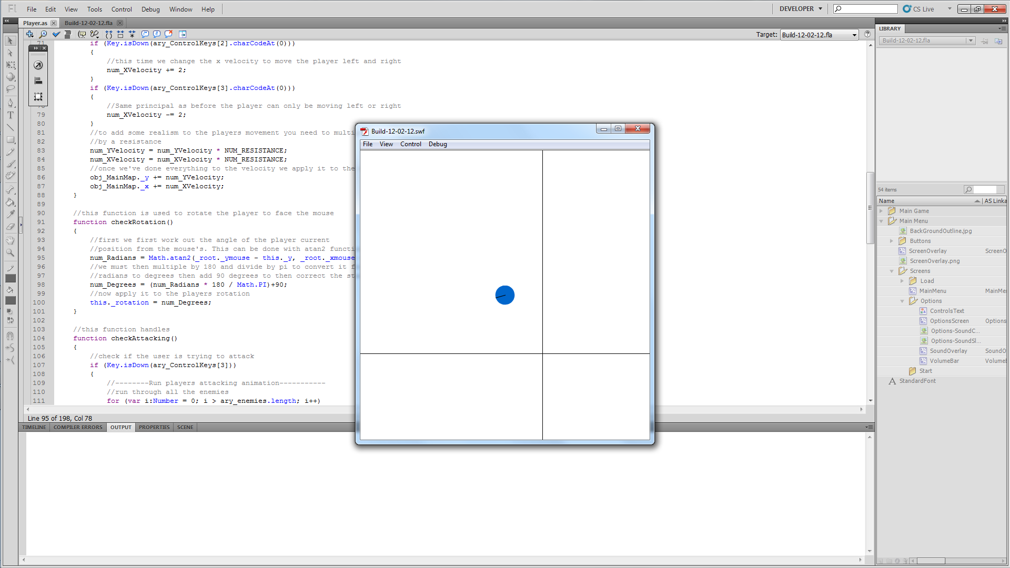

Annoyingly you can’t see the mouse but it does rotate properly. I only have one problem with this; the player is always facing the mouse which isn’t that that smooth really it should rotate around to the mouse and not face it all the time. This can be easily achieved by adding a fraction of the distance the player has to rotate to face the mouse.

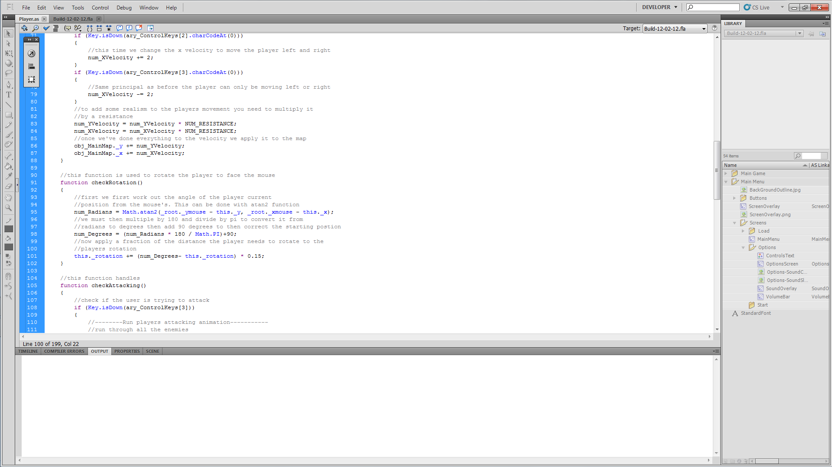

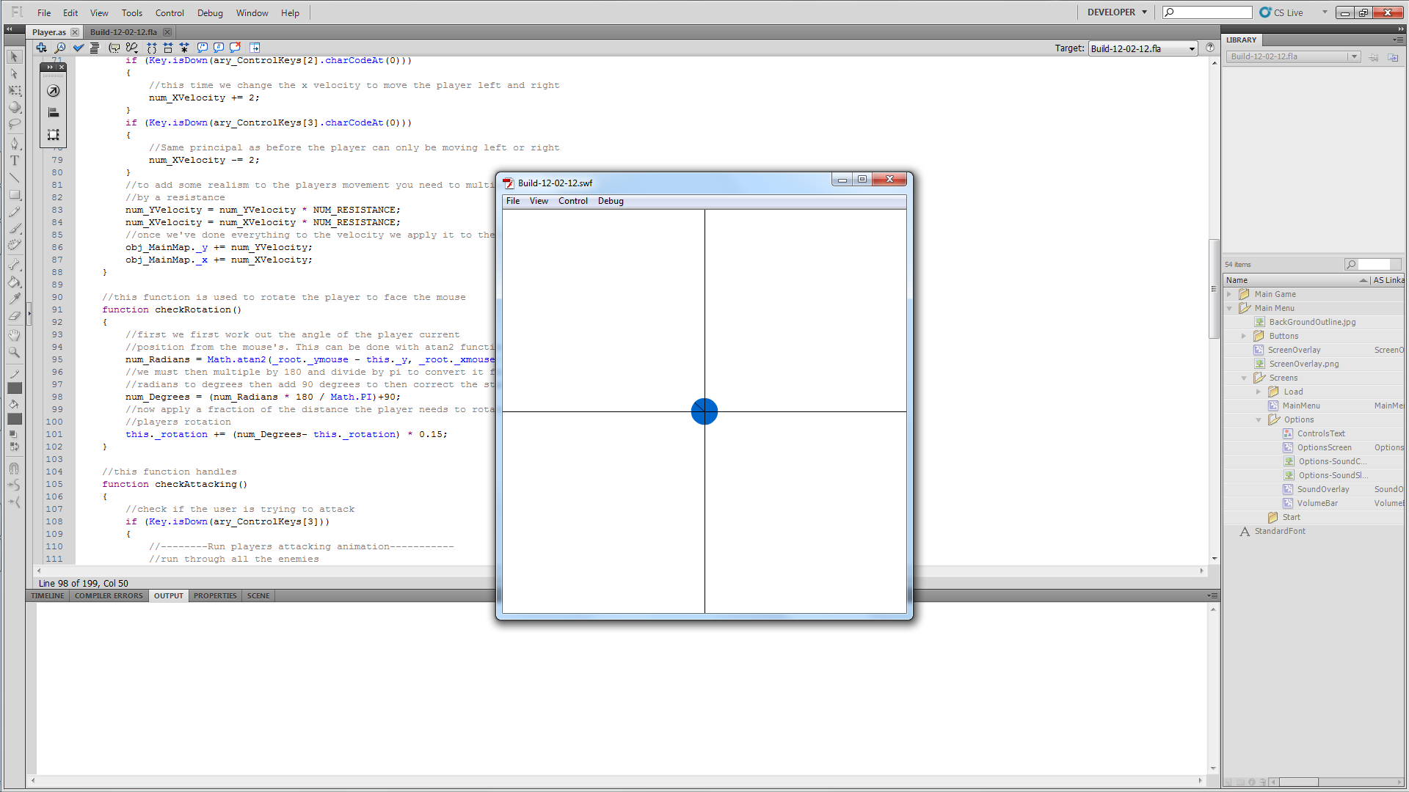

This works fine apart from when you place the mouse in bottom left corner of the screen. For some reason it goes crazy and does a full rotation and then just keeps going round.

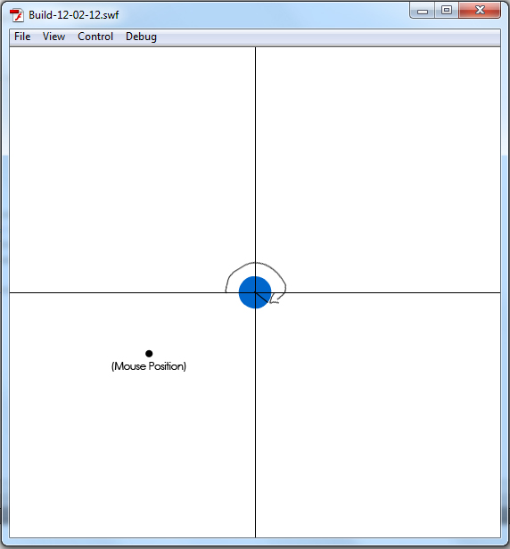

I think it’s something to do with the jump from 360 to 0 or 0 to 360.

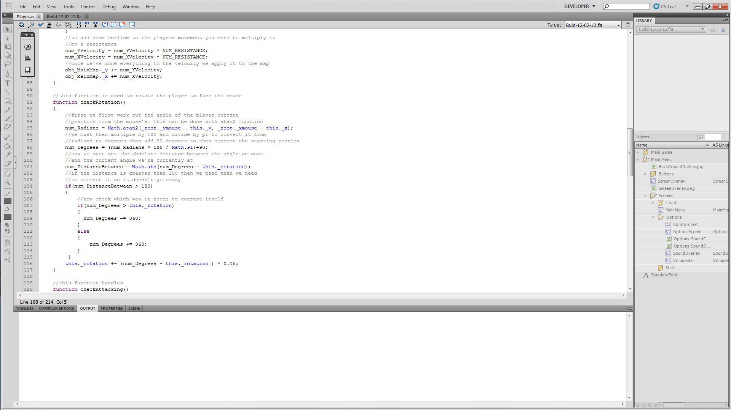
After few hour of plying with it, trying to get it to work I have come up with a solution! I found I needed to check the distance that the player needs to travel to face the mouse; I made it an absolute value so I only had to do one check, then if the distance is greater than 180 it checks which way it needs to correct.

For now I don’t think I need to do anything else to the player so I’m moving onto items. Once I have the items sorted out I can come back, create an inventory system and get the weapon mechanic working.

First I’m going to create an Items Class.

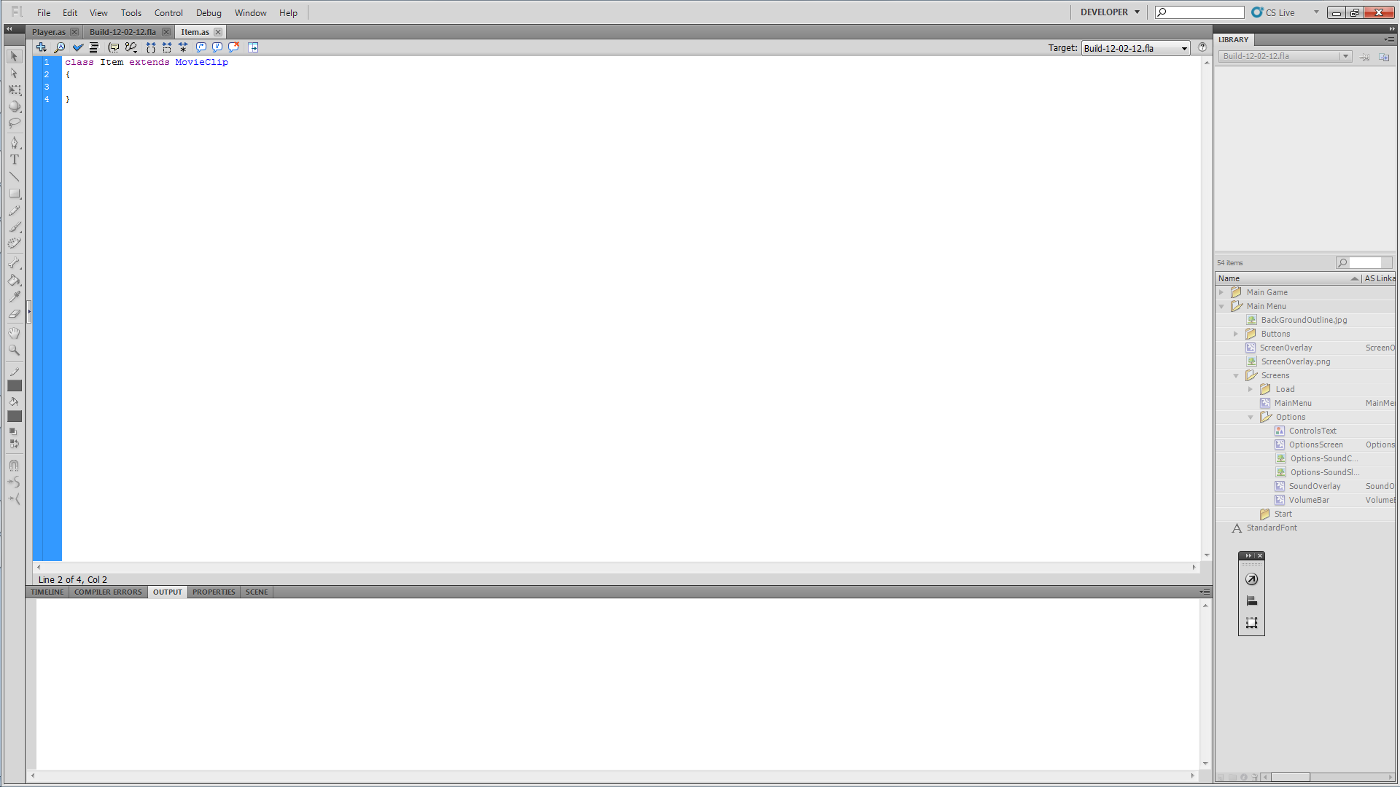

This class will hold all data about an item when it’s created which other classes will refer to. It will also have function to manipulate private variables to avoid complications later on.

First off I am declaring variable that will be used by all items.

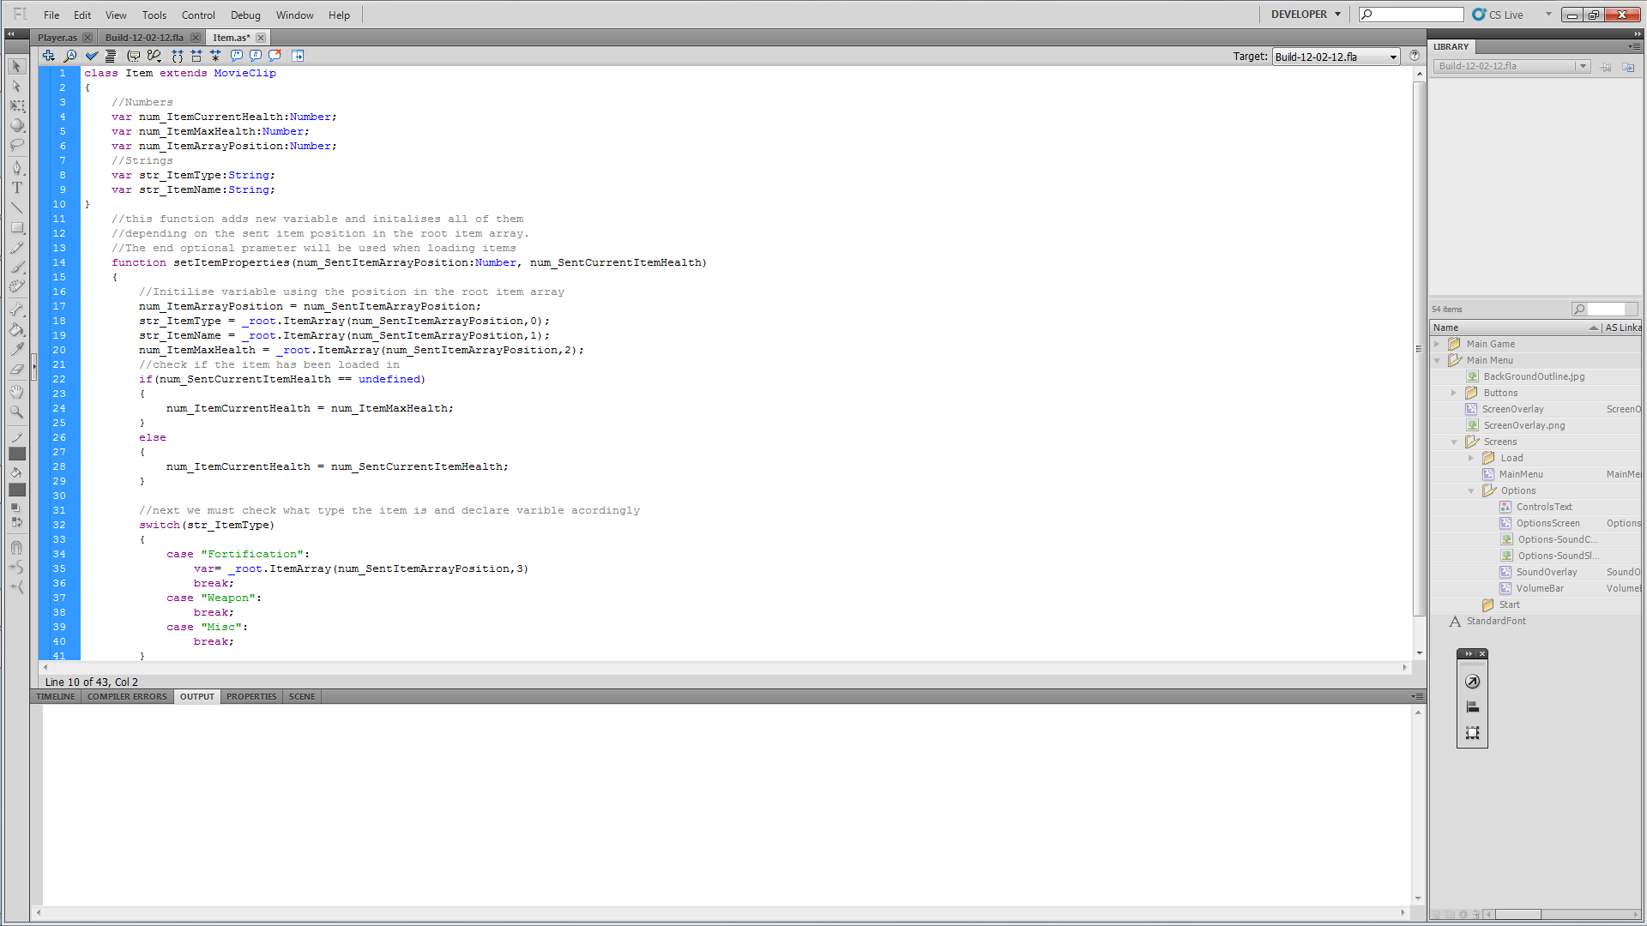

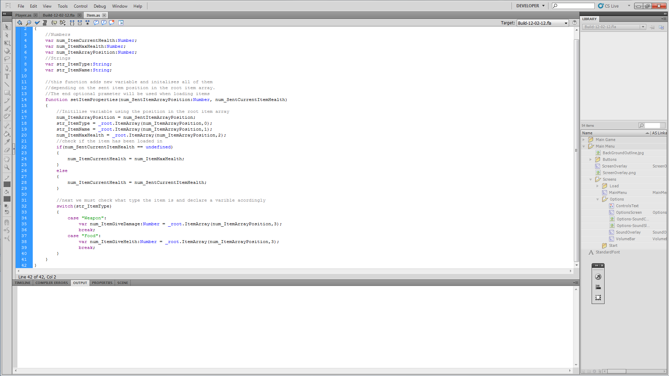
Next, when the item is created it will be initialised by calling a function sending across the info about the item. This function will be called setItemProperties.
Now the item and player need to know if they are touching each other so the user can pick up the item. This will be done by the item check if the player is touching it in the onEnterFrame function. If the player does collide with the item then a function call is sent to the player class to say ‘interact key can be pressed pick up this item’. As a message will show up on screen to show the user they can pick up this item.

Just looking back through my code I have realised I have hooked up the interact key to open the inventory. I need to change this now. I am renaming it Interact and it shall be called when the player and the item are touching. A parameter will be sent through so the function can call the correct function when the key is pressed.

(Item.as)
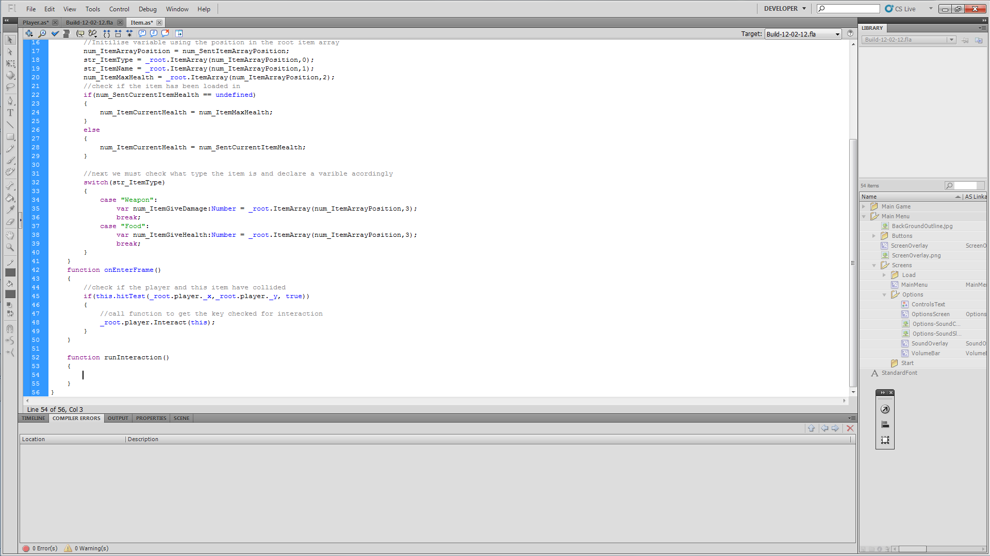

(Player.as)
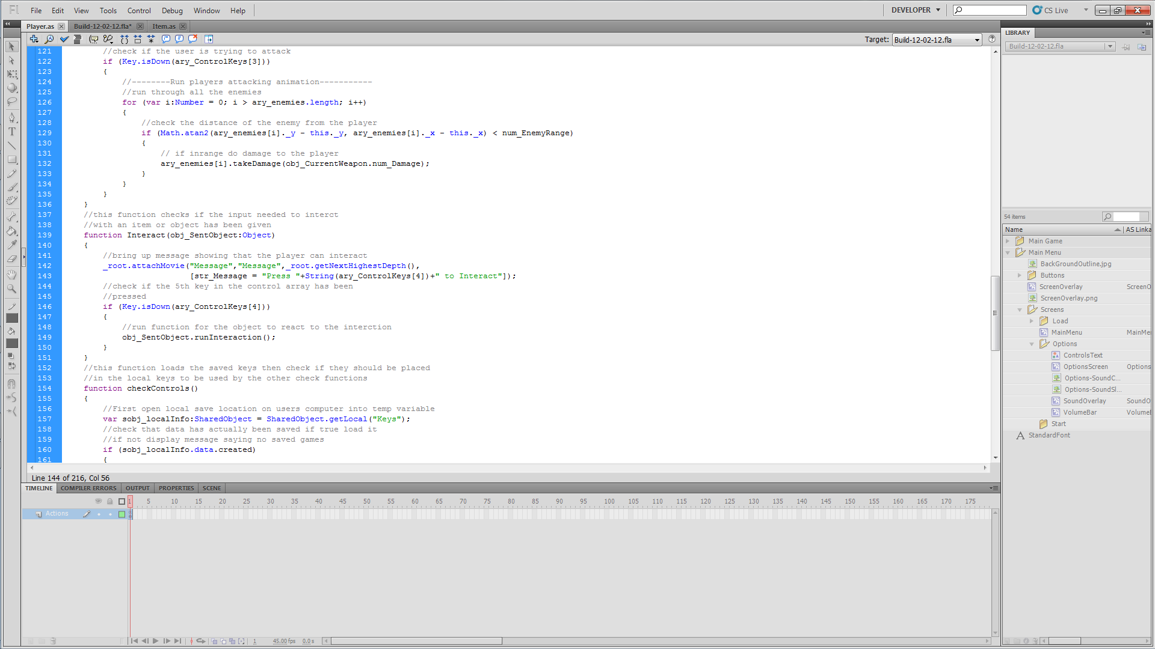

(Item.as)
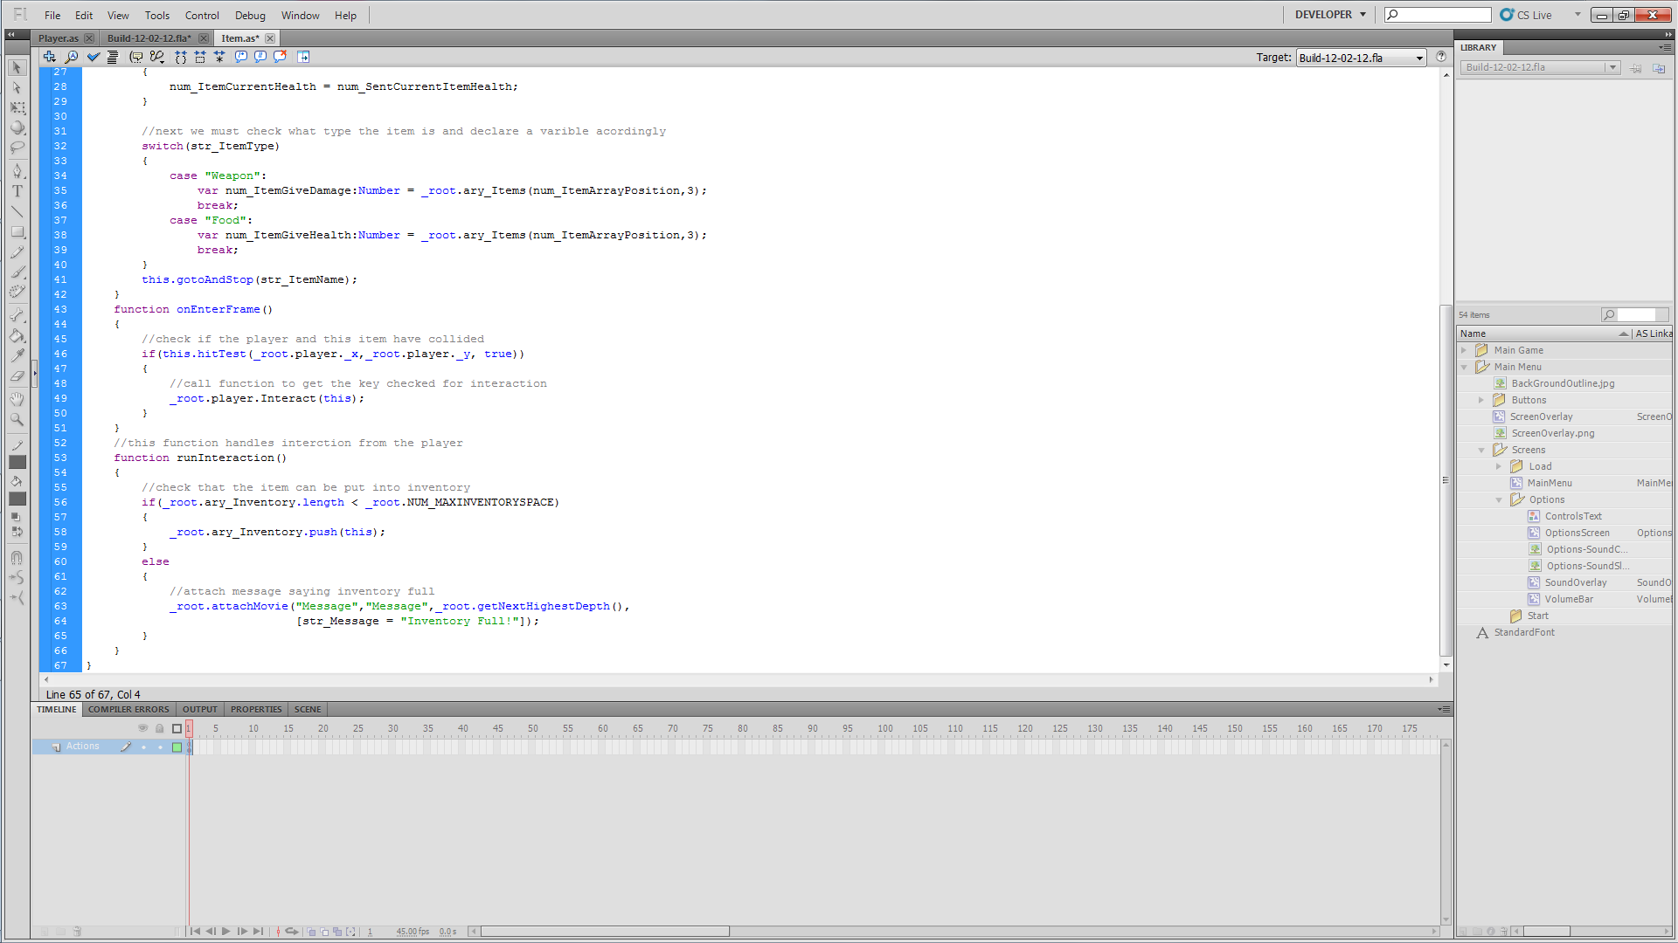

Now to test. I’ll just set up a dummy item and an array with dummy properties.

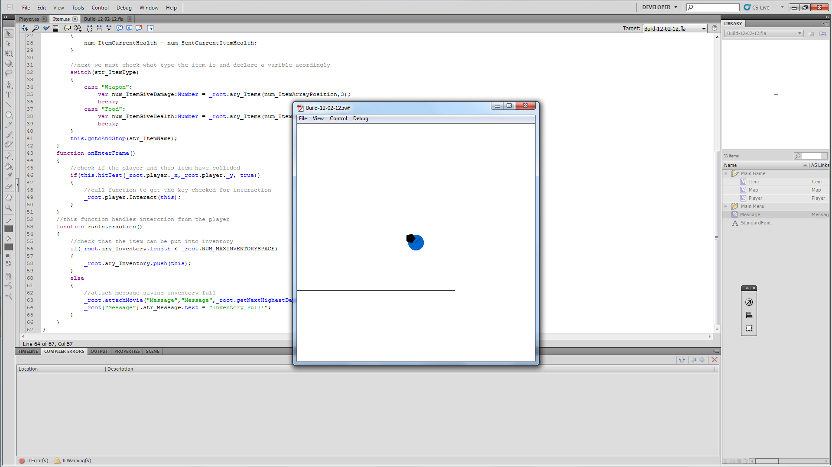

Everything built fine but I can’t seem to pick up the item so I’m going to put in some traces to see if the hit test is working.

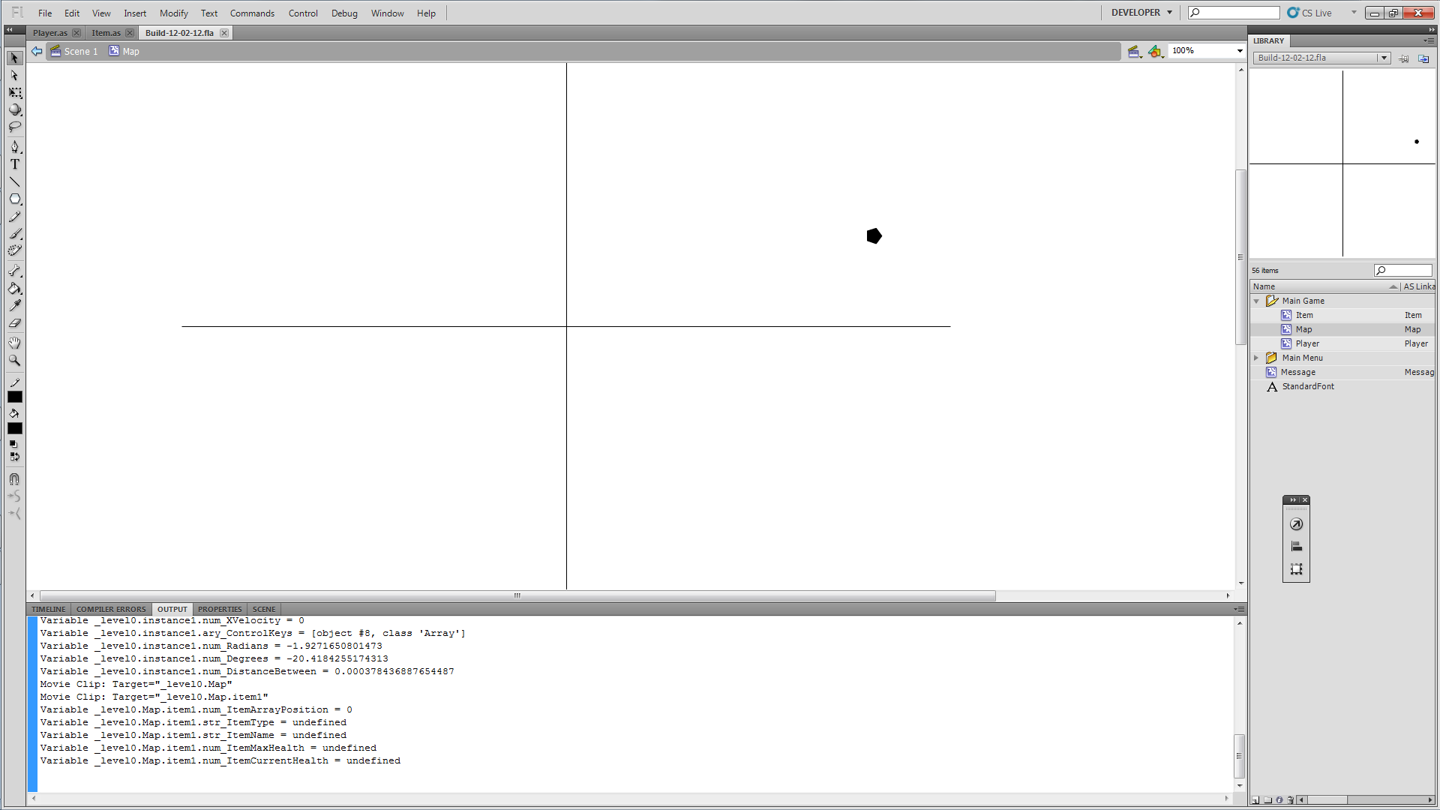

I can see know that it’s all being called and stuff but no properties have been put into the item. Right the problem is my syntax. I’ve been using () when I should have been using [] for an array. So the properties being loaded is fine but still the two object colliding is not happening.

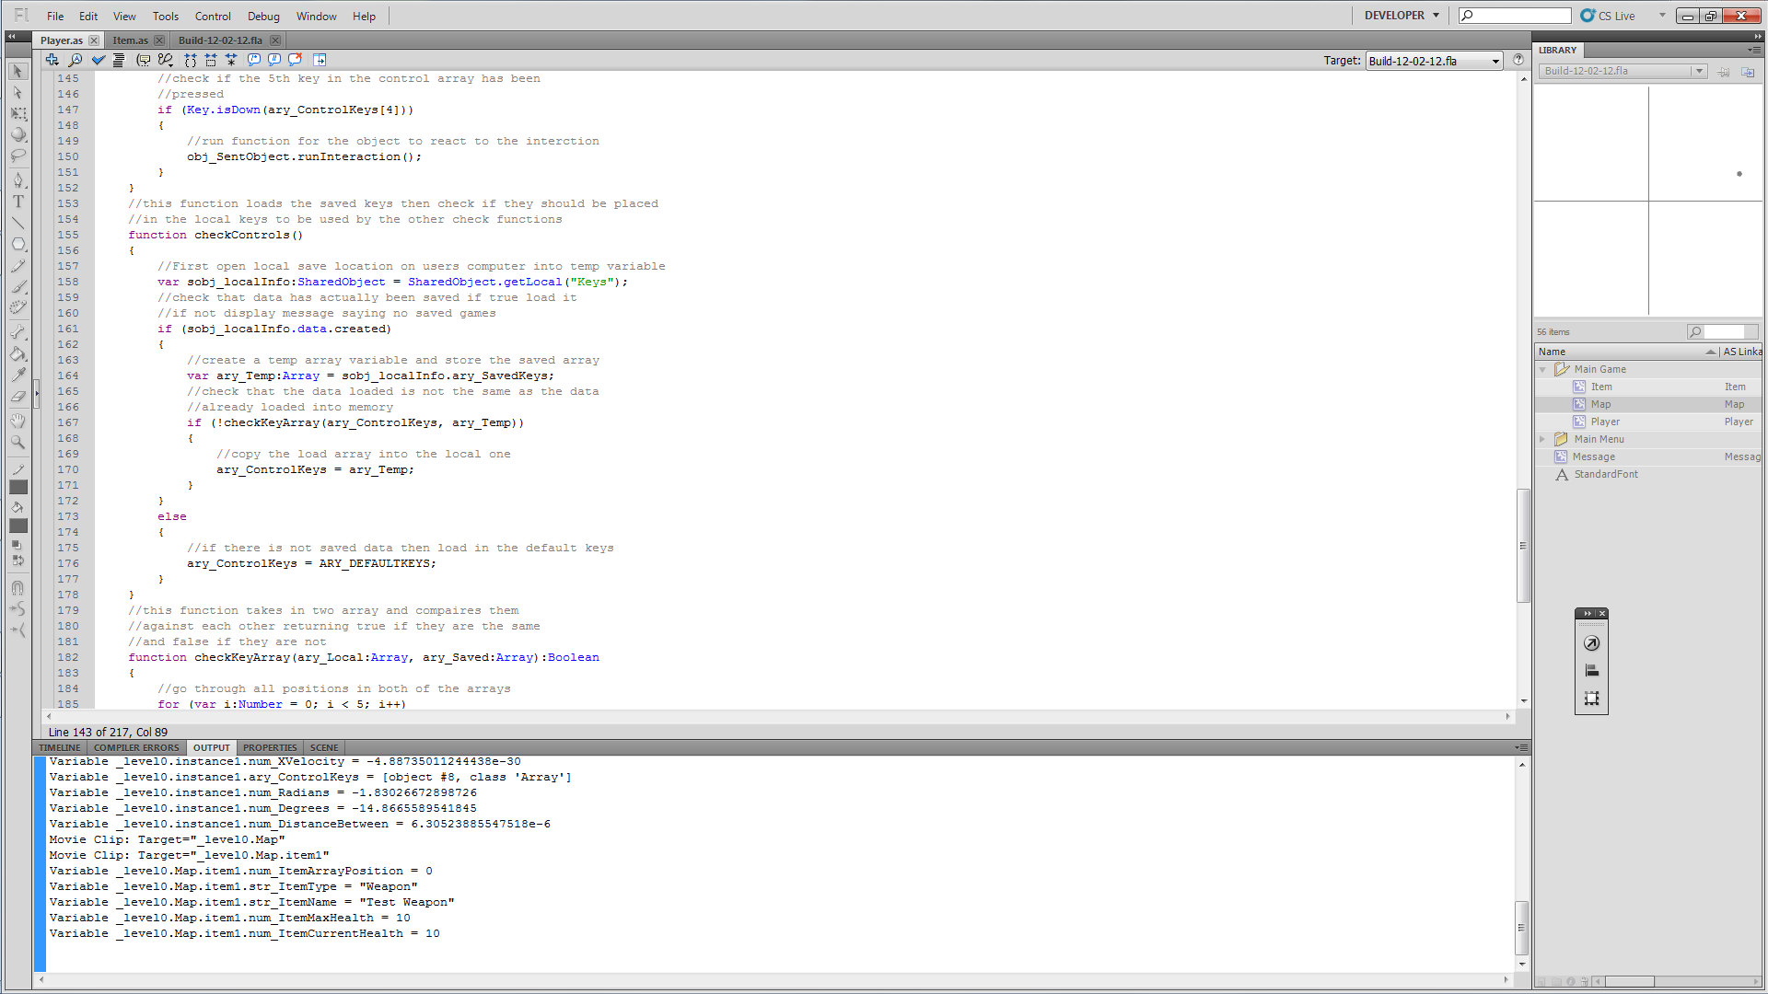

After tracing the positions of both the player and the item I found that the player has no position. I believe I have not named the movieclip on screen.

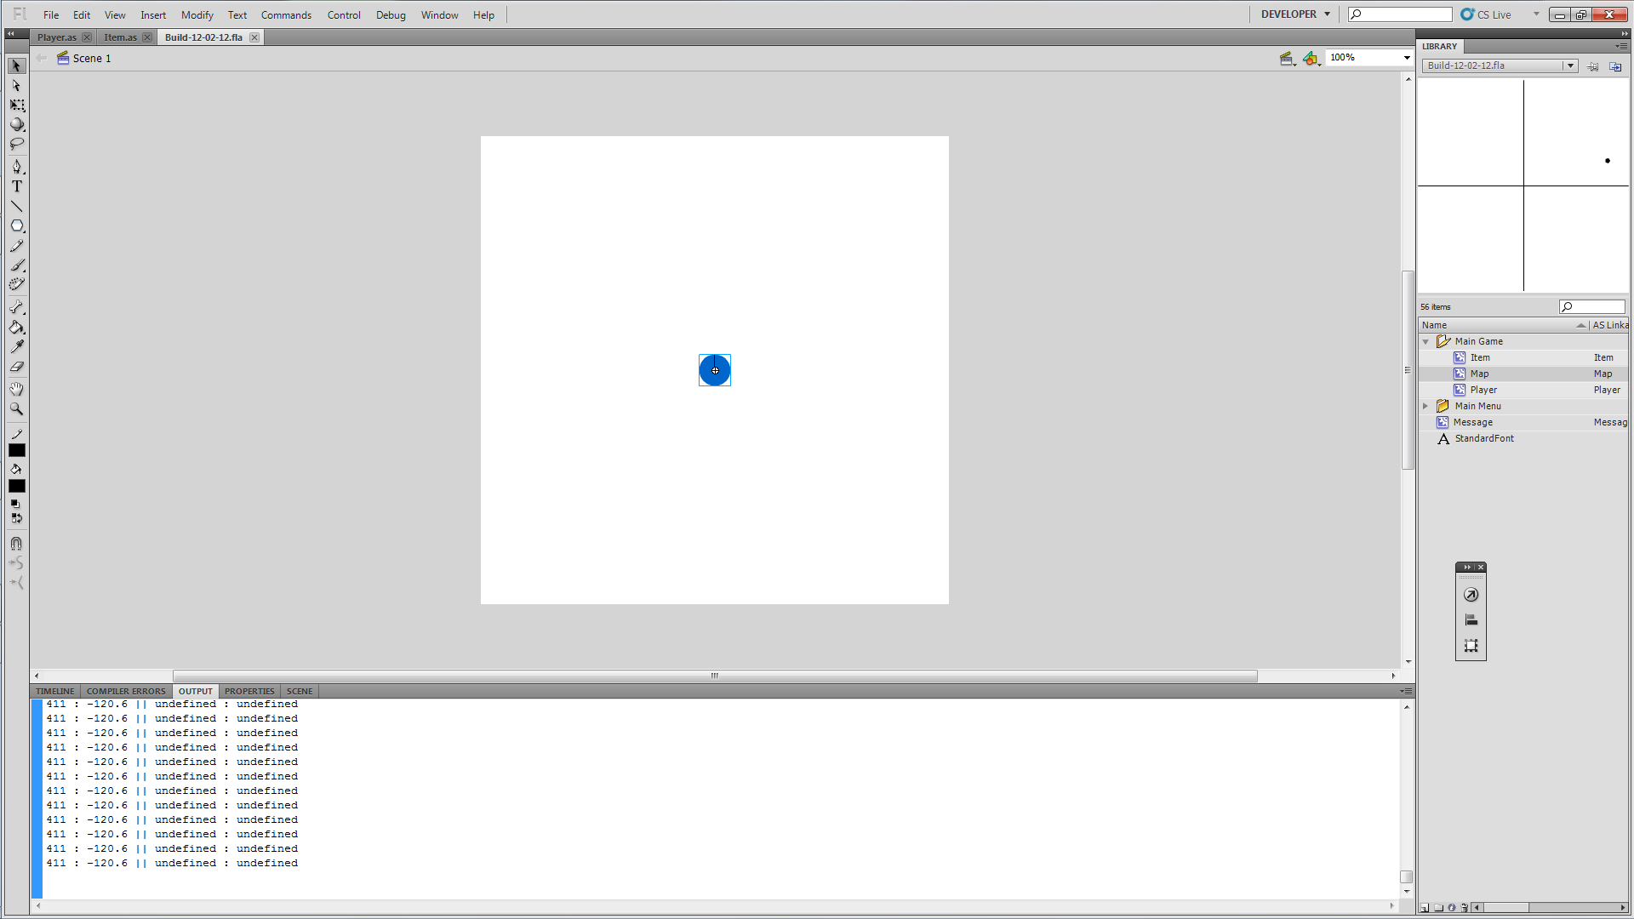

Now I’ve named it the hitTest works fine.

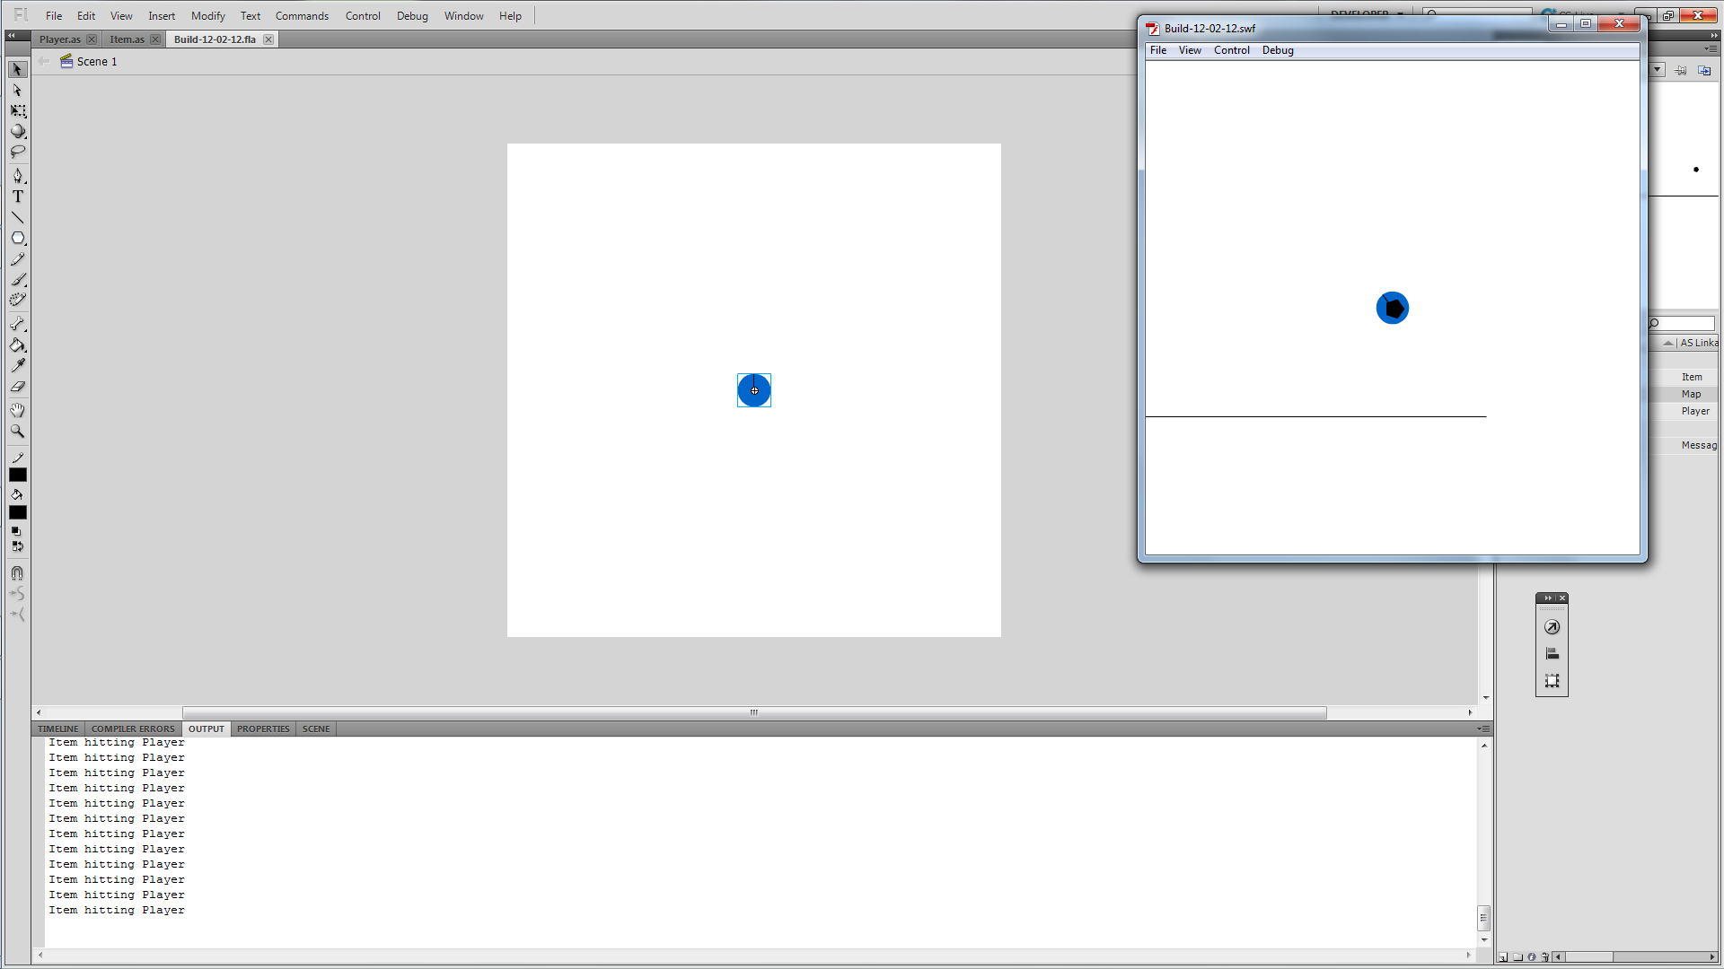

No message though but that’s because I didn’t give it a position on screen. I’ve placed in two more traces to see if the key has been pressed on the item and if the item reacts when the key has been pressed.

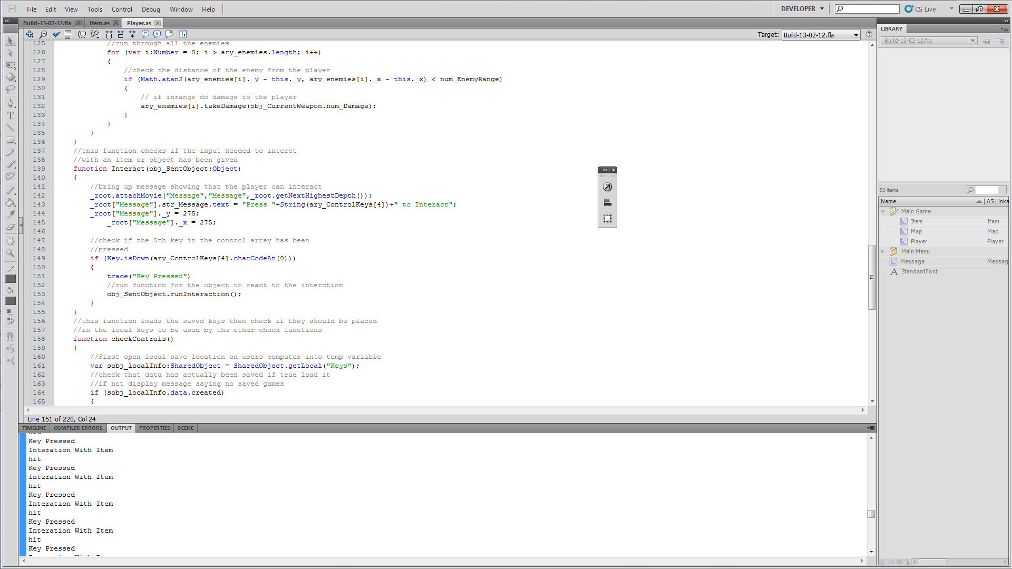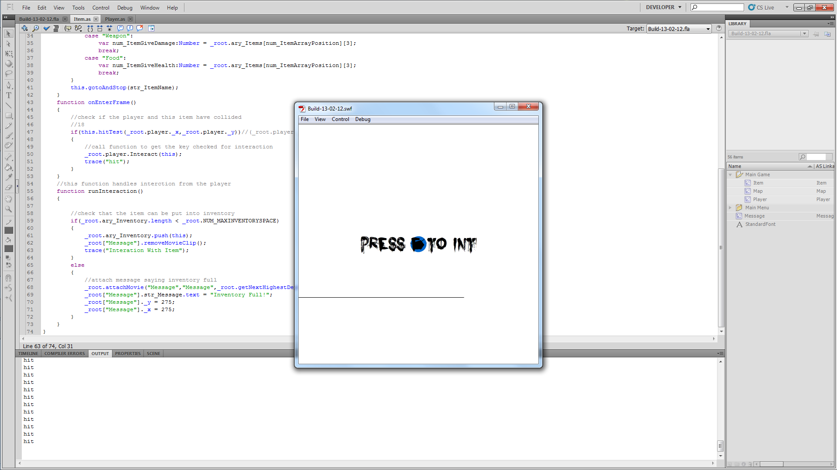

When I press they key once we get multiple presses. This can be sorted by hiding or remove the item. Removing doesn’t seem to work, there is a logical reason but I can’t remember, so I’ll just hide it.

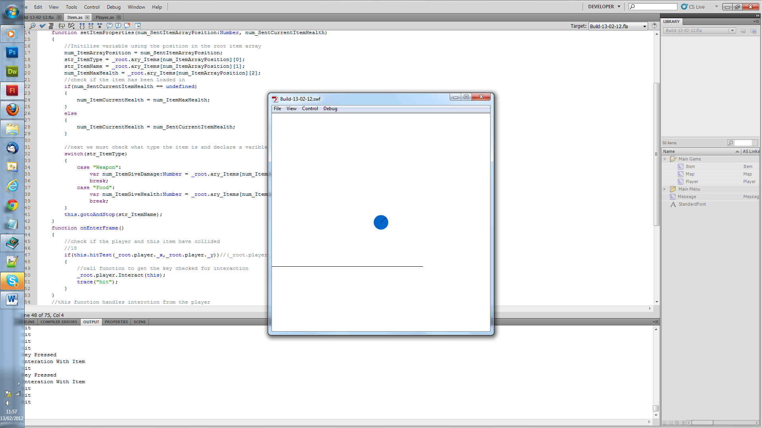

This works fine but once the item is invisible it still gets hit by the player. There just needs to be a check to see if the item visible before allowing the user to interact with it. Another thing I want to change is the hit testing. Currently the centre of both the item and the player have to be touching for the game to class it as a hit test I am going to rewrite this so only the edge to the centre of the player has to be touching the centre of the item.

14/02/2012
To get what I said above working it took a bit more work that I though. For some reason when moving the map movieclip it doesn’t update the position of any movieclips within it. This meant I had to pull out and place the item onto the main stage. Then to get it move when the map was moving I added in a function which would move every item that had been spawned and placed. The call was placed where originally only the map got updated.

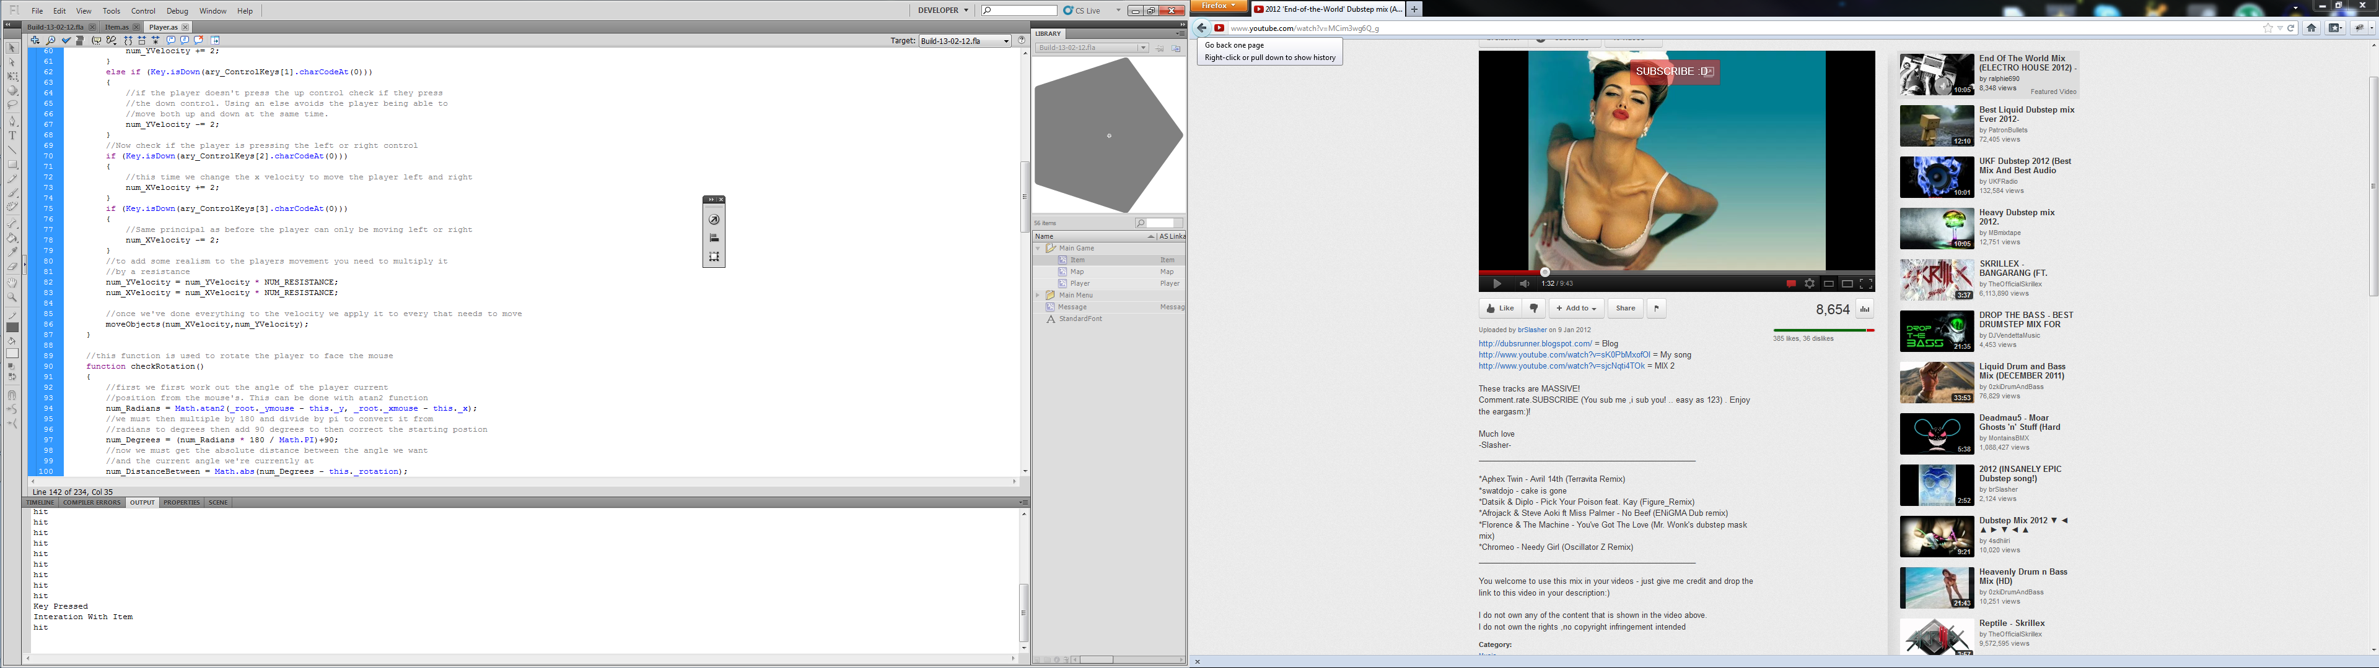

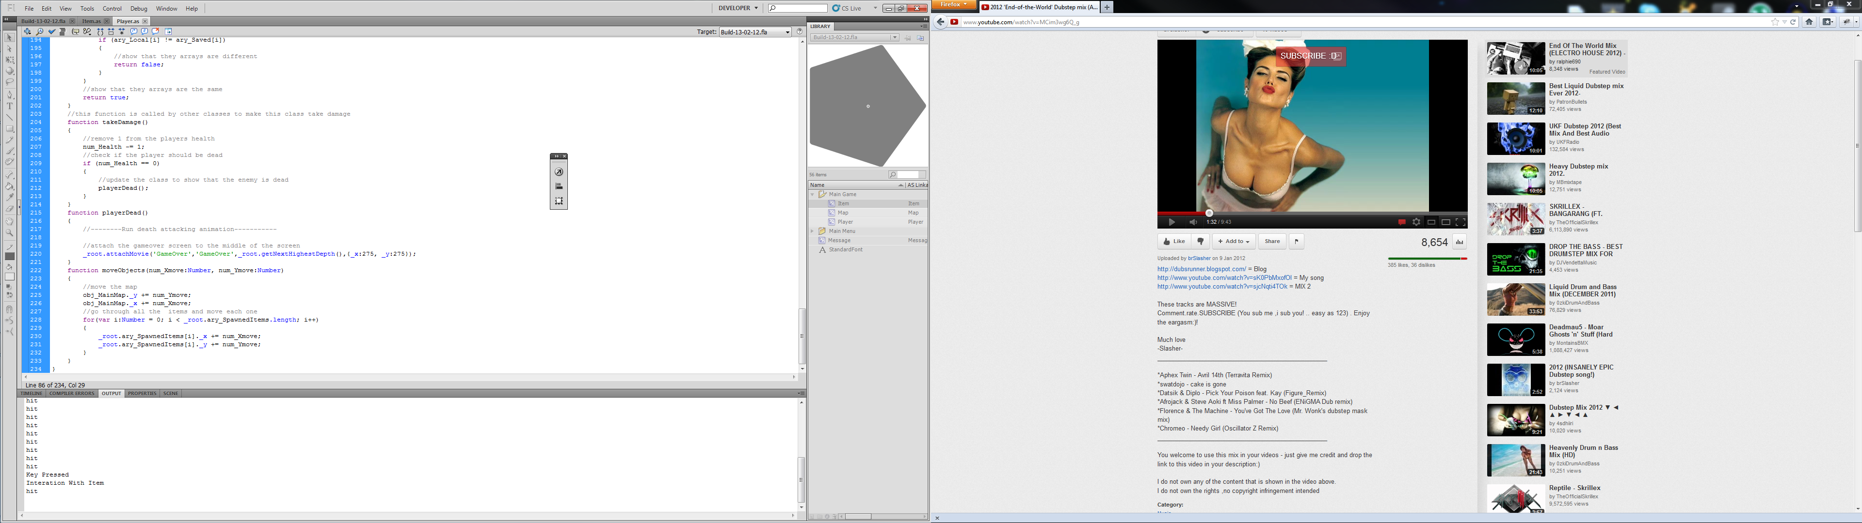

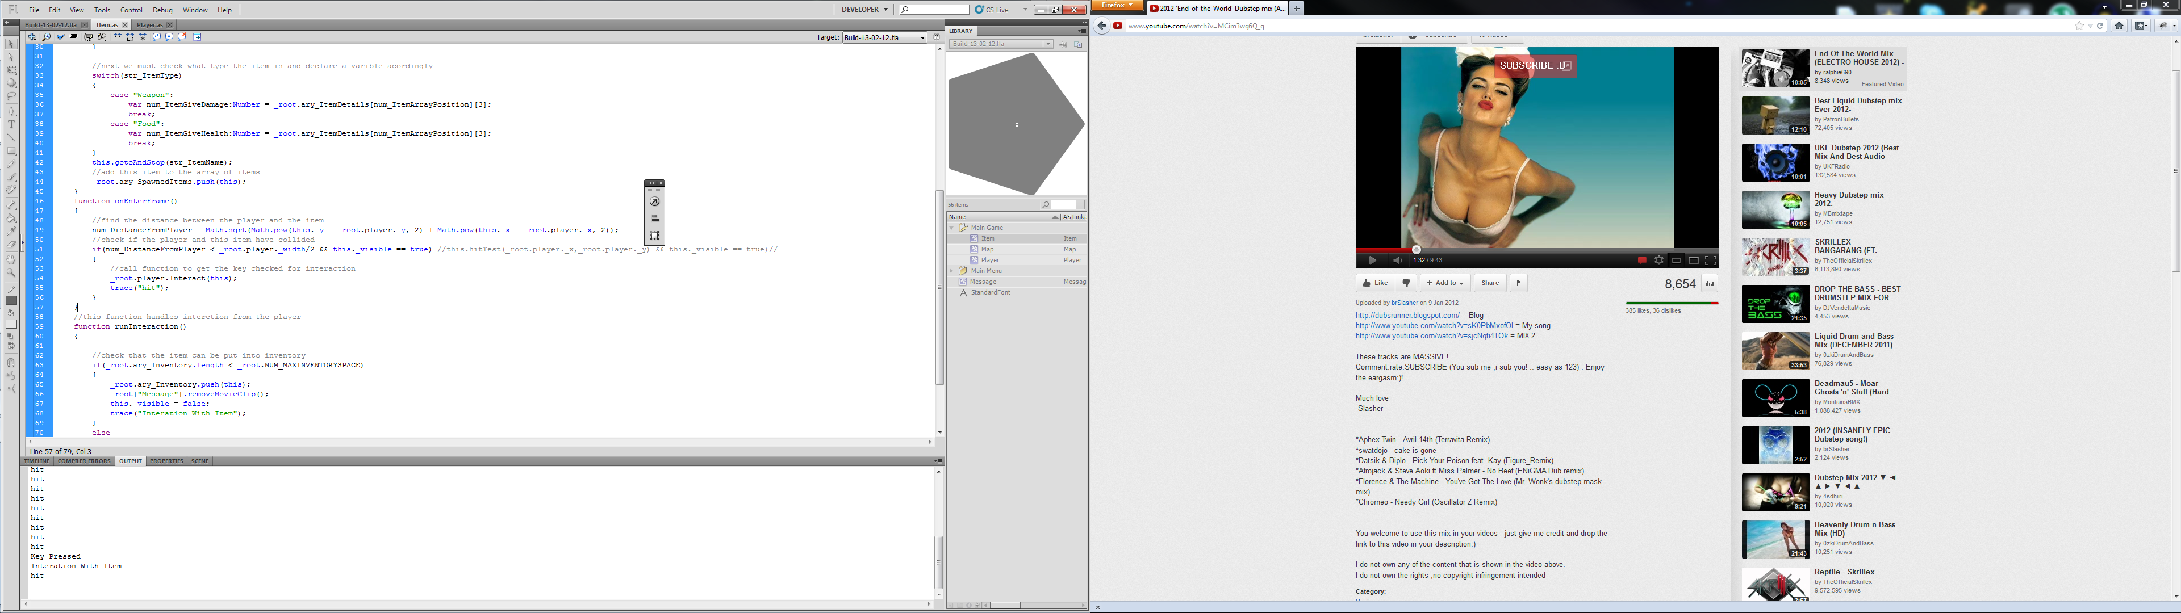
The code below is the hit detection for the player and item. This works by check the distance between the player and the item to see if they are within half the players width from each other. It also checks that the item is visible as well so we don’t try and pick up items we already have.

Next I’m working on the player’s inventory.

15/02/2012
First I need away for the inventory to come on screen as I currently haven’t put ain the HUD. This should just be a key press in the player.as onEnterFrame function.

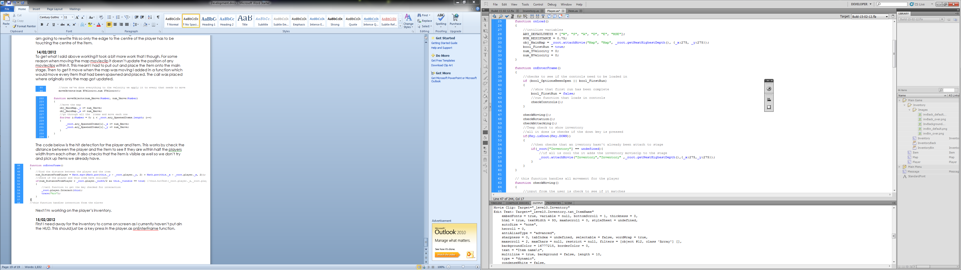
This works fine.
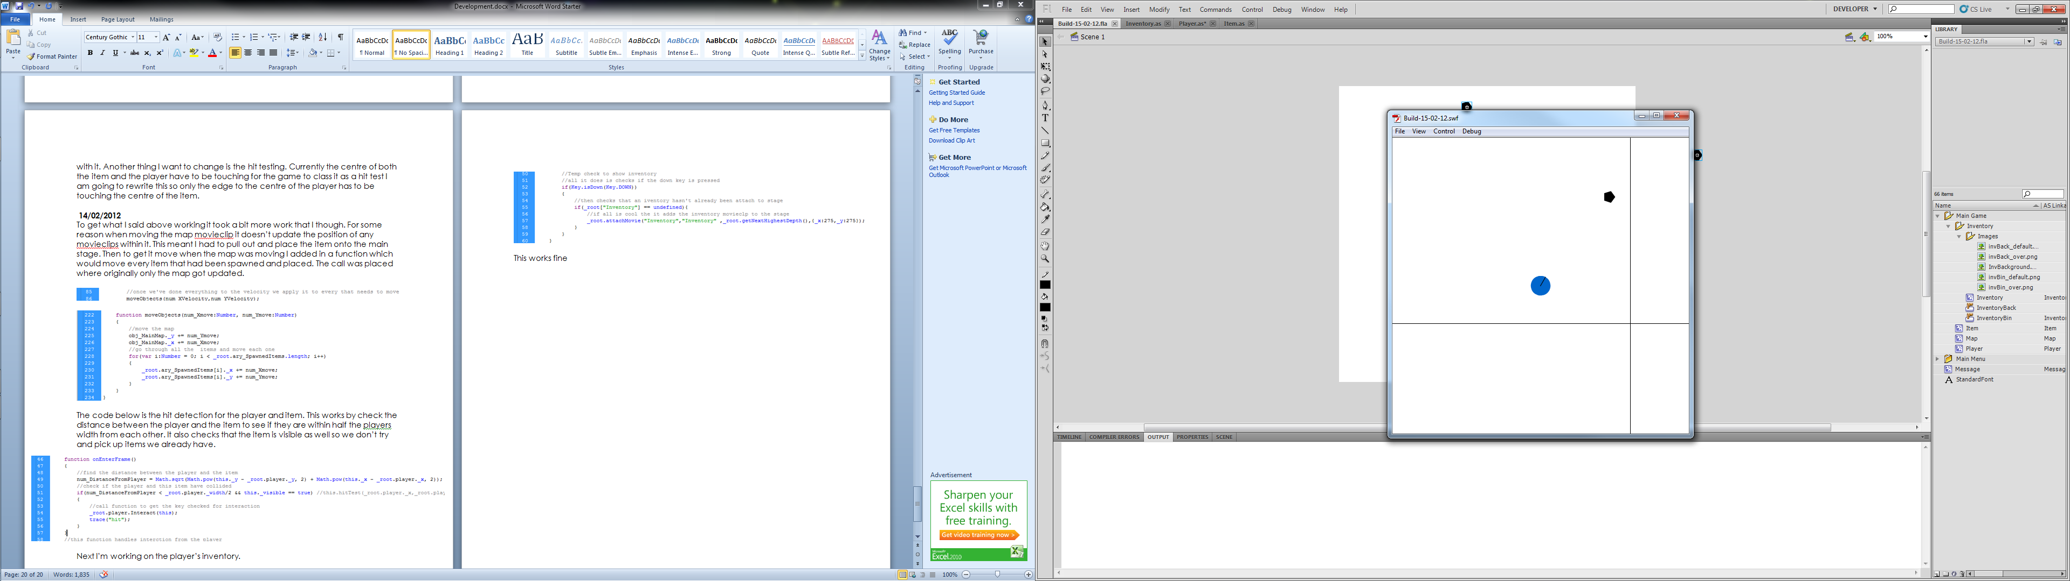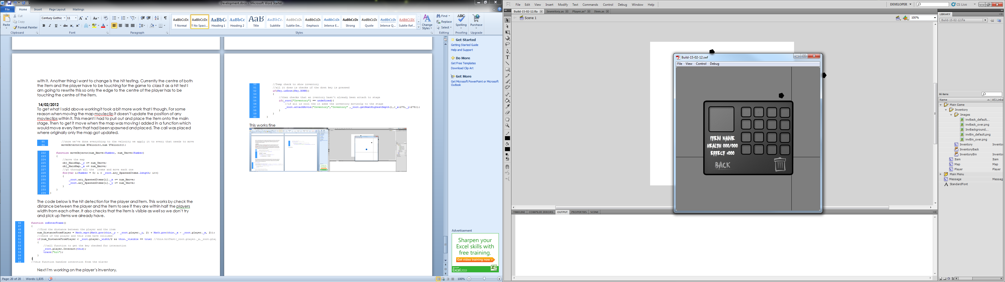

Now I need to create an Action Script class for the inventory movieclip.
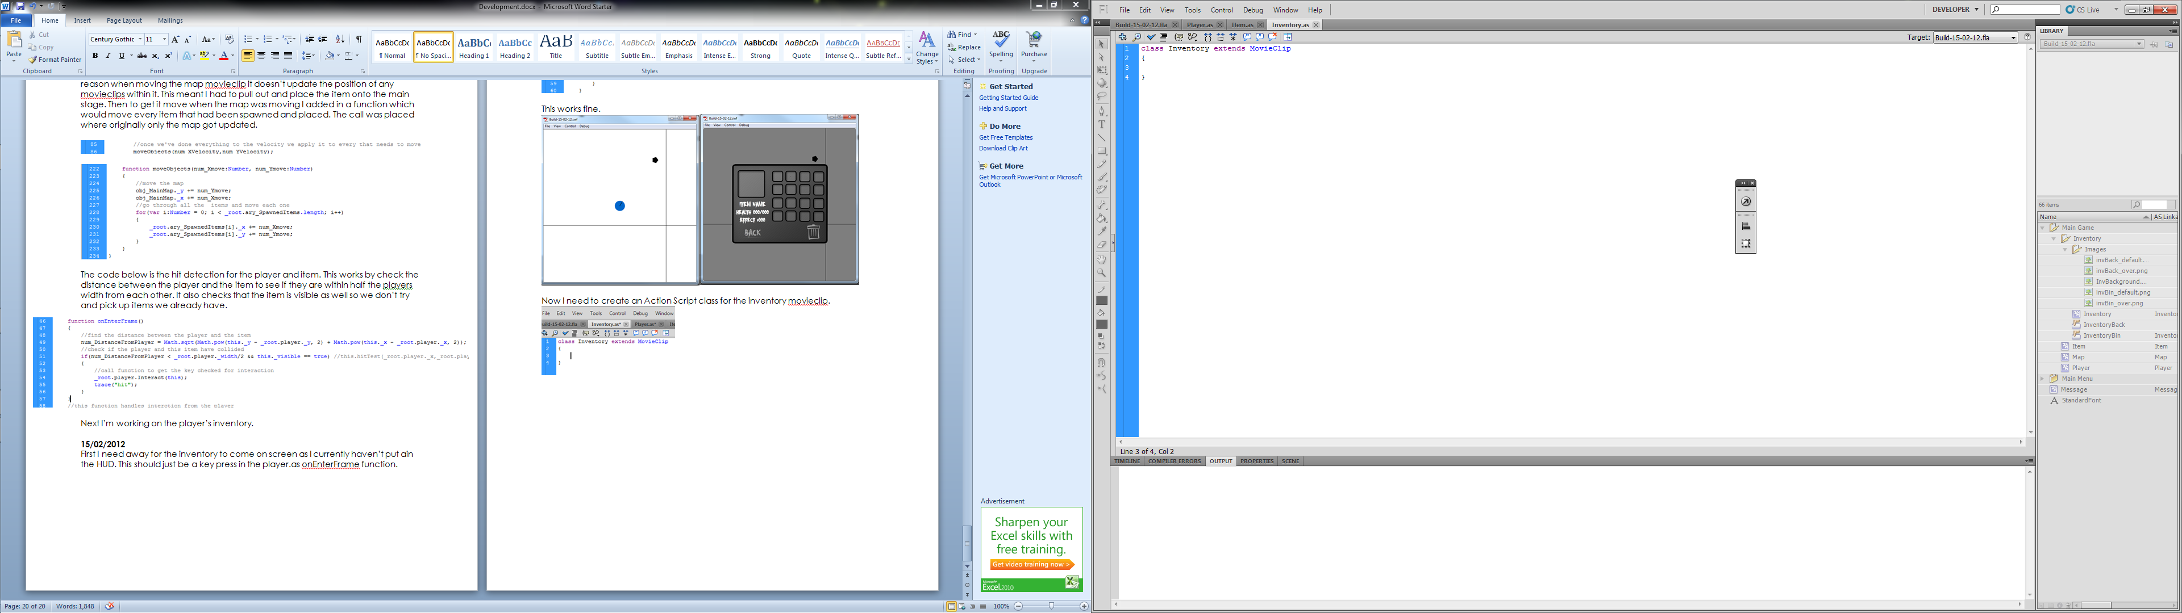
I can now start to build up code. To start we need to get the items in our ary_Inventory array into the spaces on screen. This can be done with a loop going through the array, creating an item for each position then positioning the item on screen.

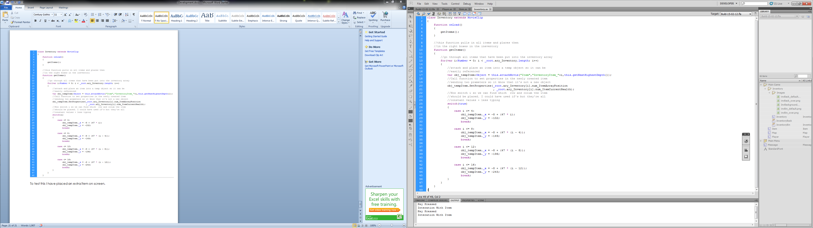

To test this I have placed extra items on screen.
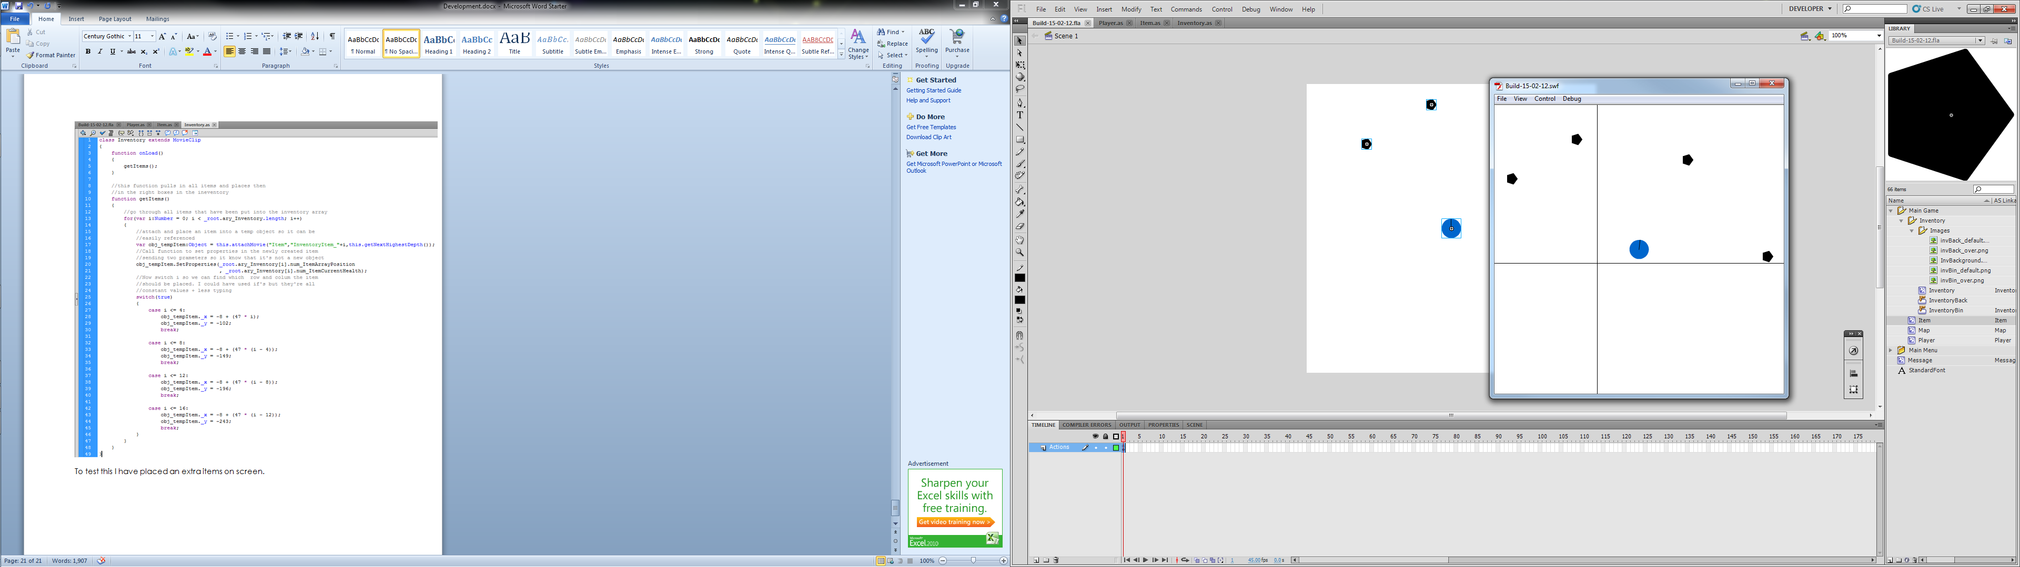

Then pick them up and pressed the down arrow.

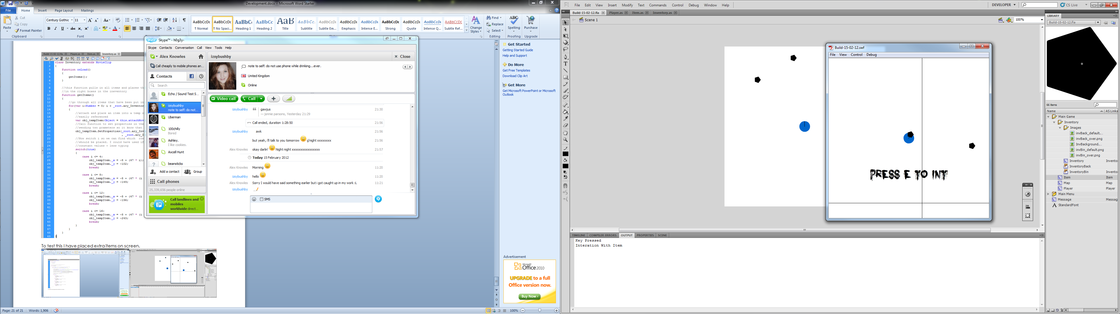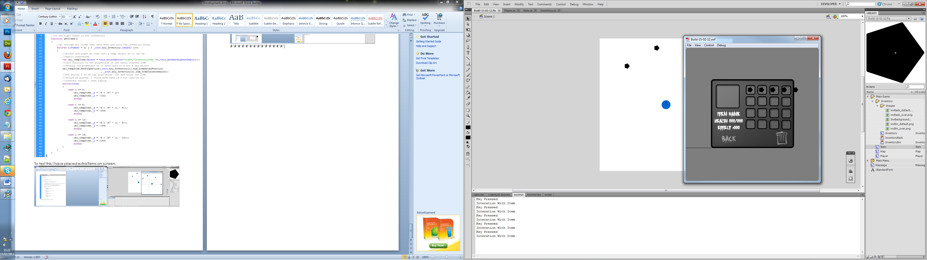

And oh look it doesn’t work. It looks as if it hasn’t placed the 5th item on the next row and I know why because the I starts at 0 and I made the switch check for 4 which has a difference of 5 not 4. I’ll change this then try again.
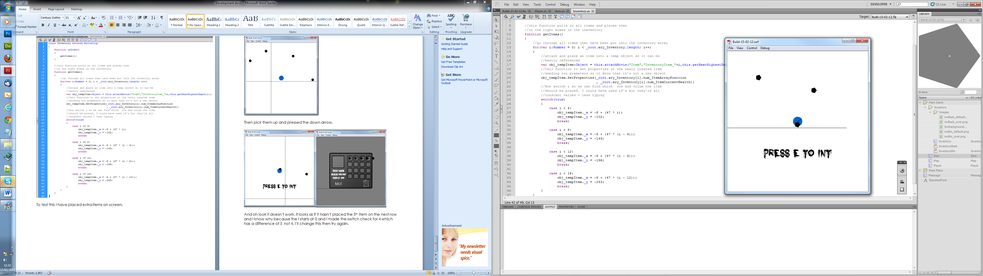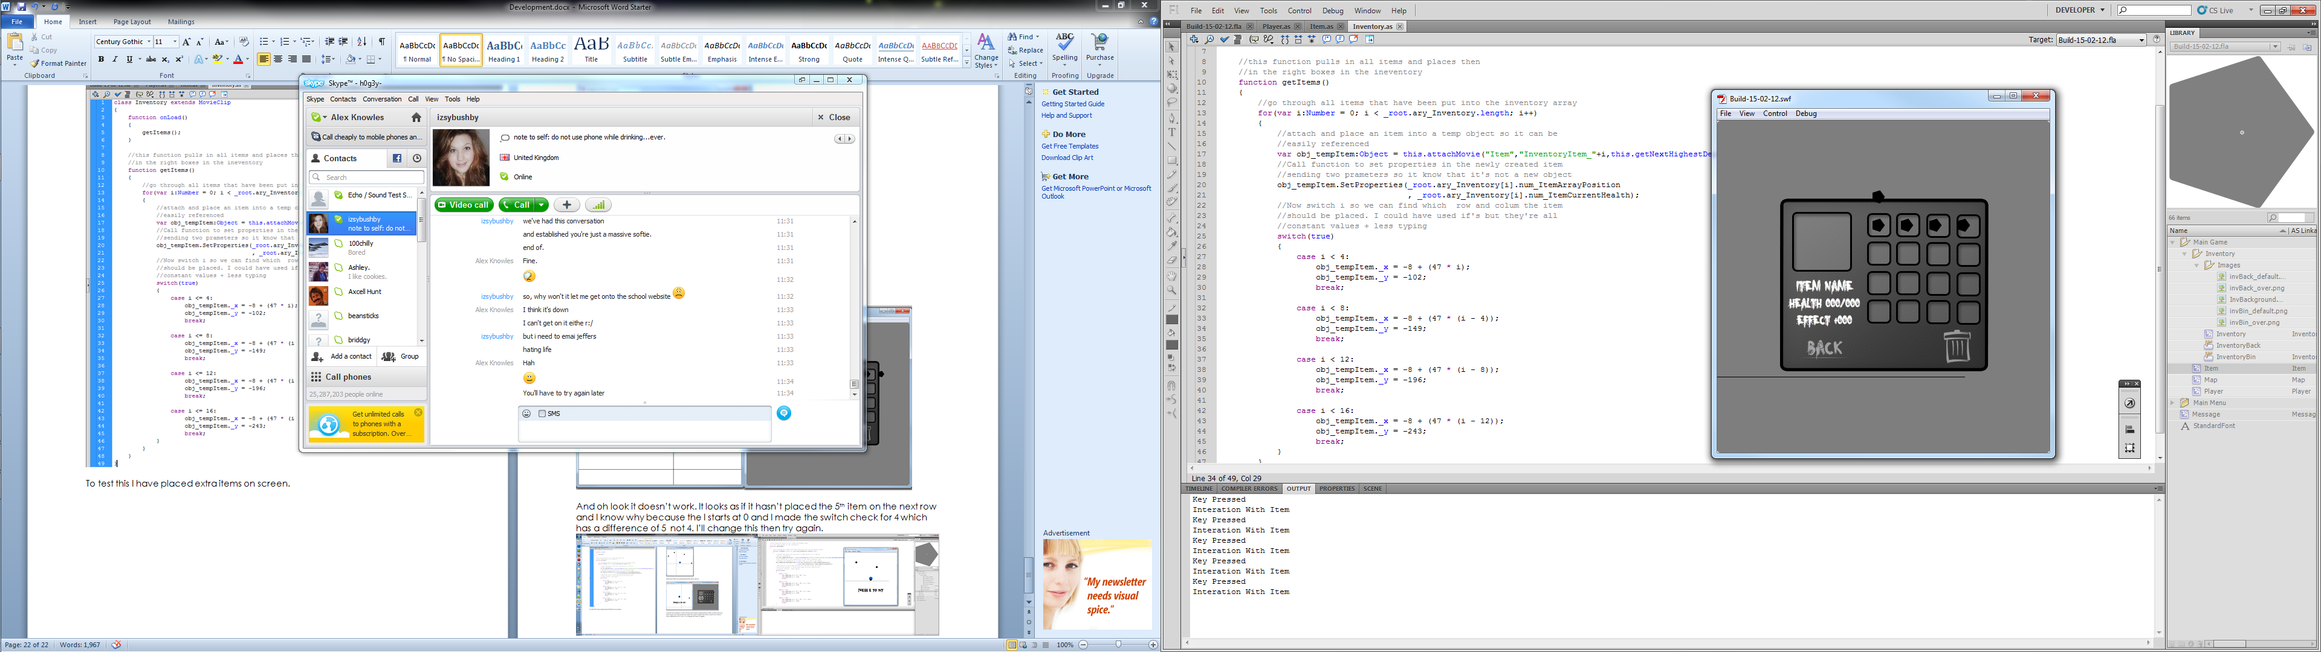

Okay still not working but this is because I inputted the y values wrong. After all the messing around this is what my switch statement looks like:

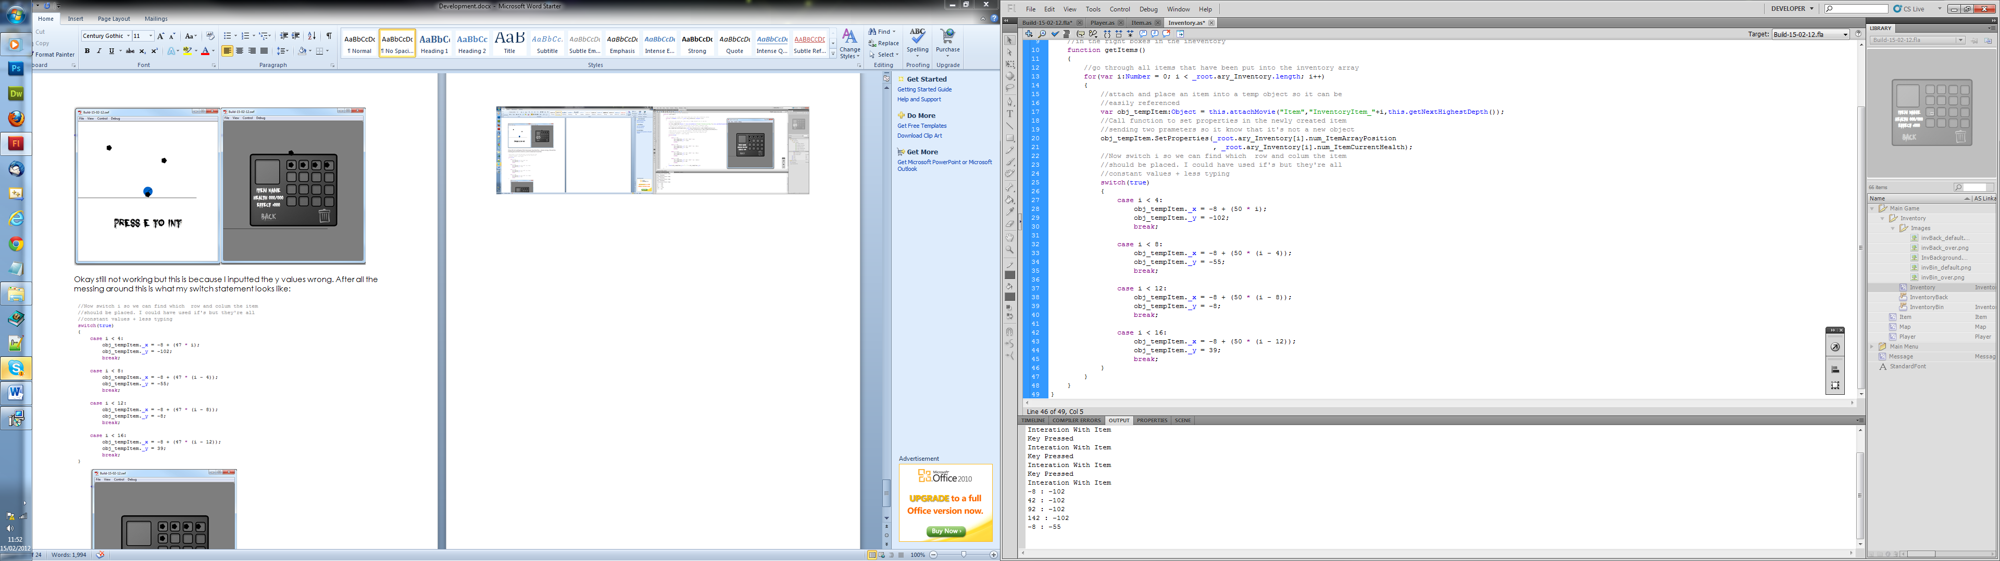
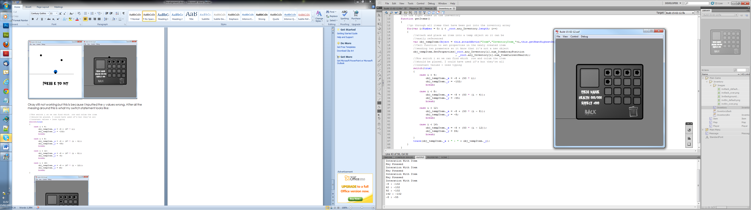

After thinking about memory usage and remember looking at the variables when debugging, I have realised that the invisible items are still running their checking routines which can be very memory consuming when you have lots of items loaded to stage at once. This should be easily combatted by having an if statement to check whether or not the item is visible in the onEnterFrame function. I can remove the check from here :
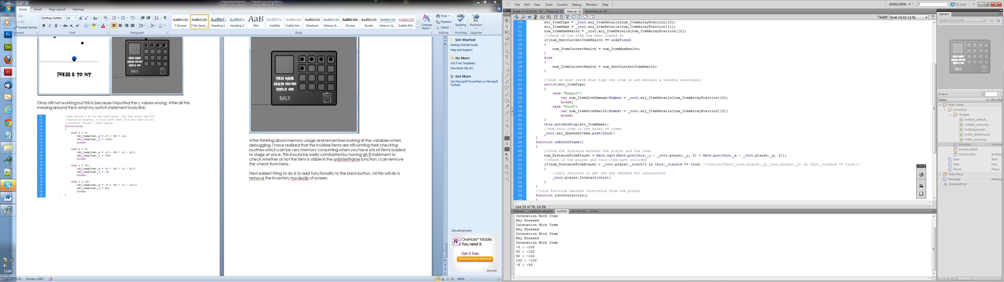
And put it at the beginning of the function so that it also doesn’t run this line as well:
(Couldn’t fit the line number)

Finial code:
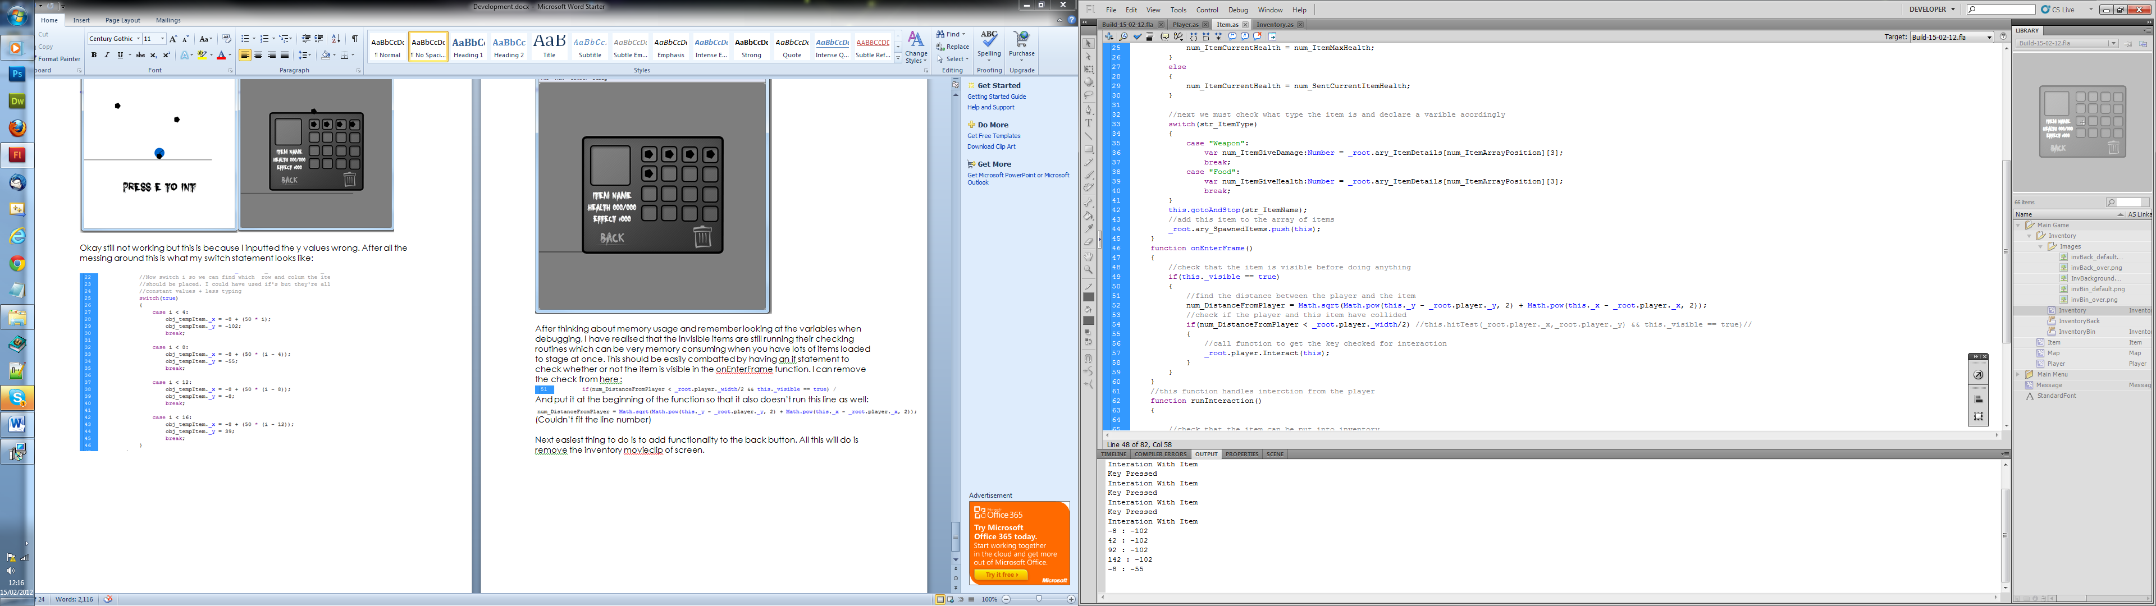

Next easiest thing to do is to add functionality to the back button. All this will do is remove the inventory movieclip of screen. At the same time I’ll set up the pausing when the inventory screen is opened.

For the back button this can be done in code in the inventory moveclip. The code should only be 4 or 5 lines.

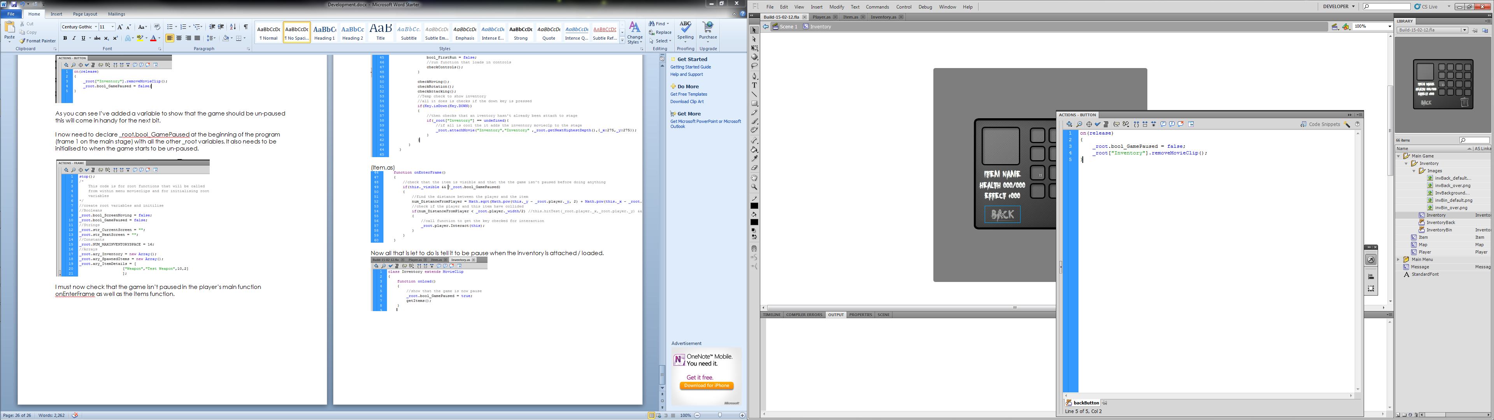

As you can see I’ve added a variable to show that the game should be un-paused this will come in handy for the next bit.

I now need to declare _root.bool_GamePaused at the beginning of the program (frame 1 on the main stage) with all the other _root variables. It also needs to be initialised to when the game starts to be un-paused.

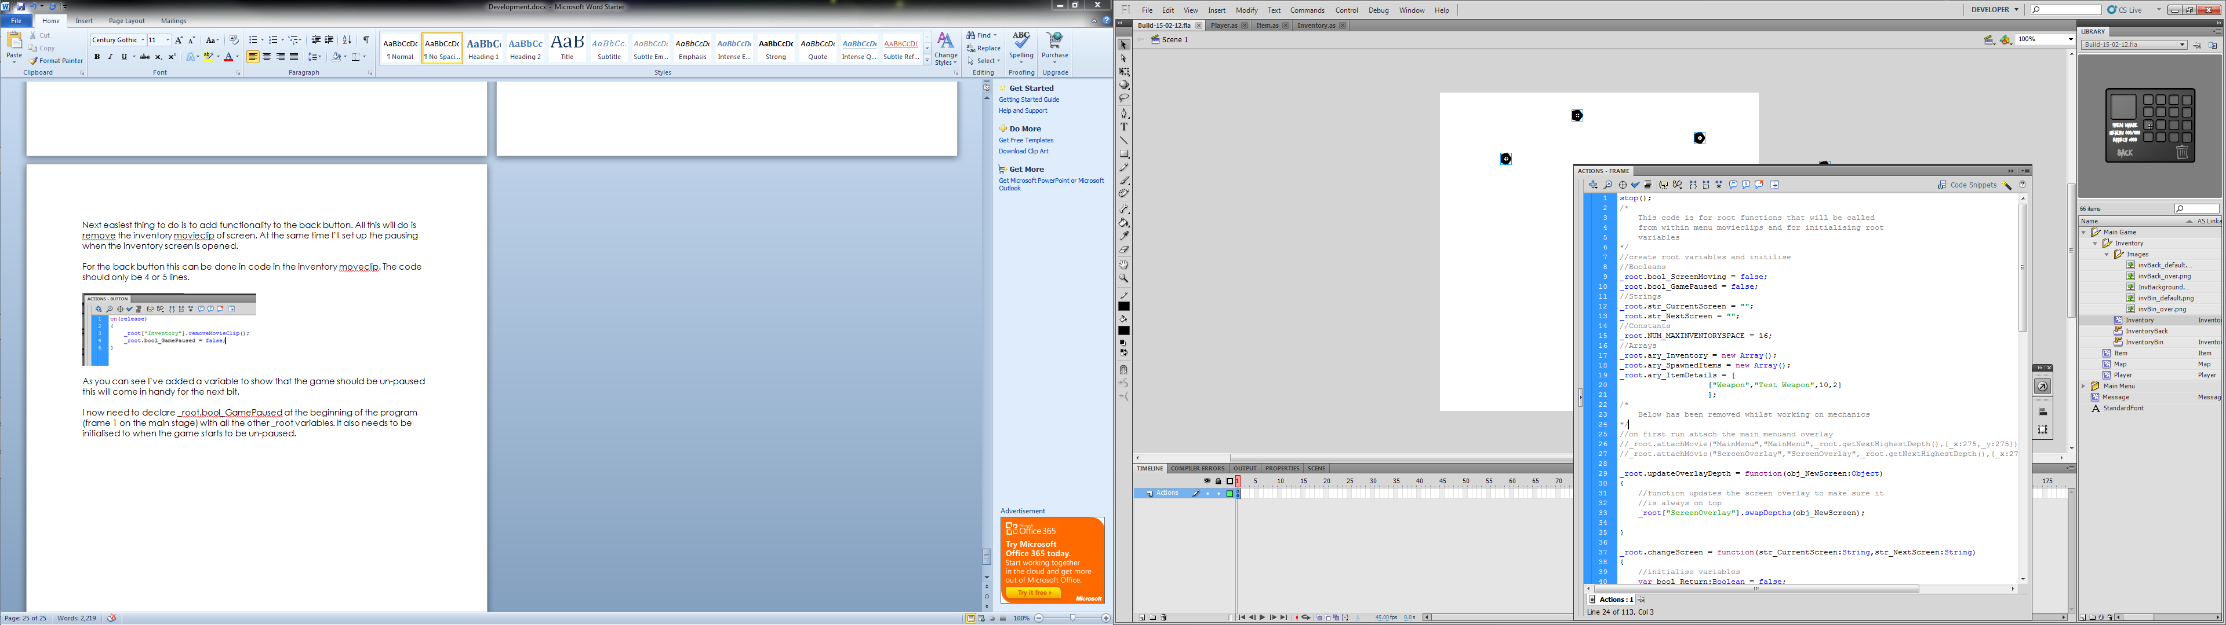

I must now check that the game isn’t paused in the player’s main function onEnterFrame as well as the items function.

(Player.as)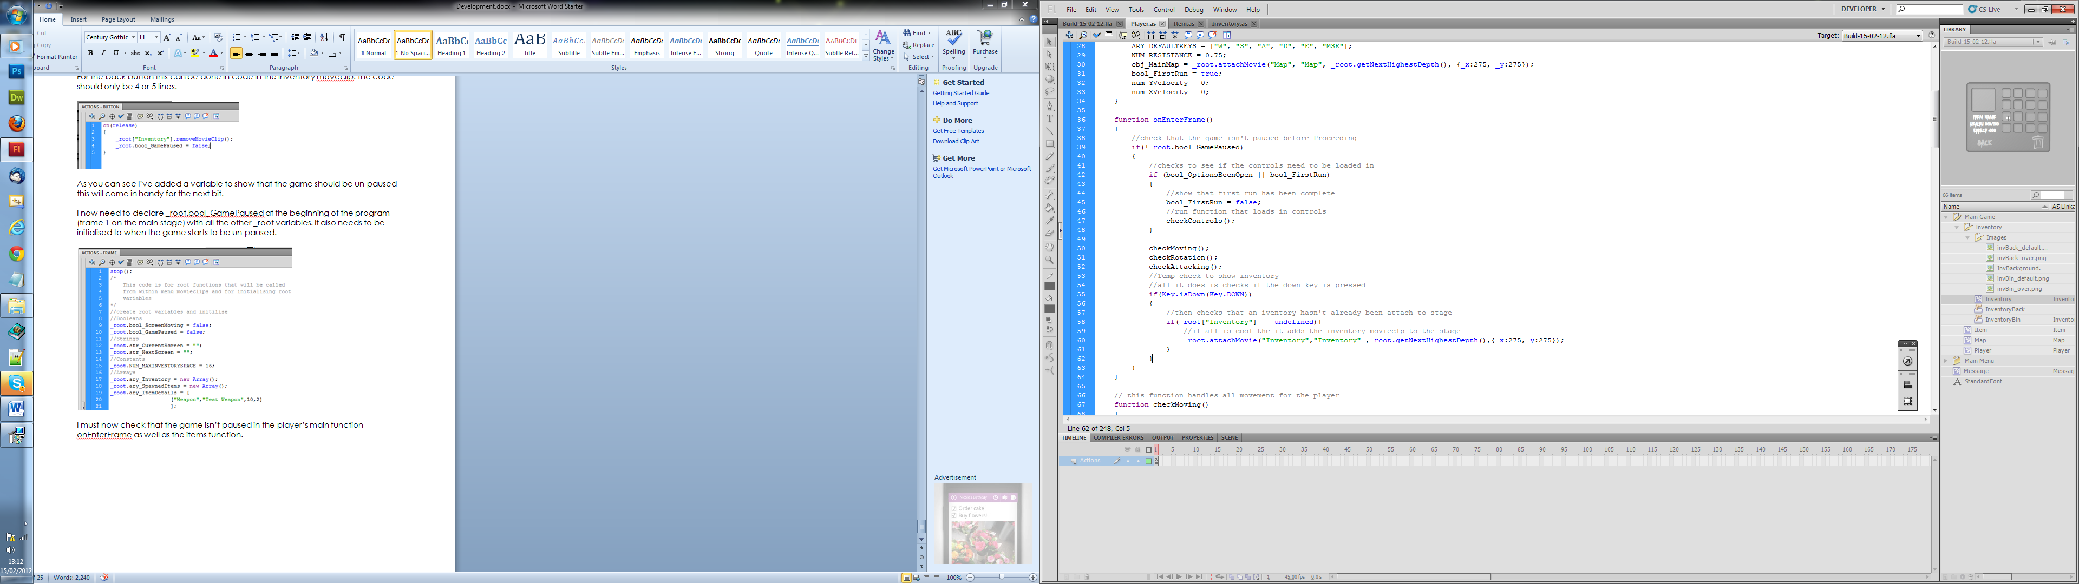

(Item.as)
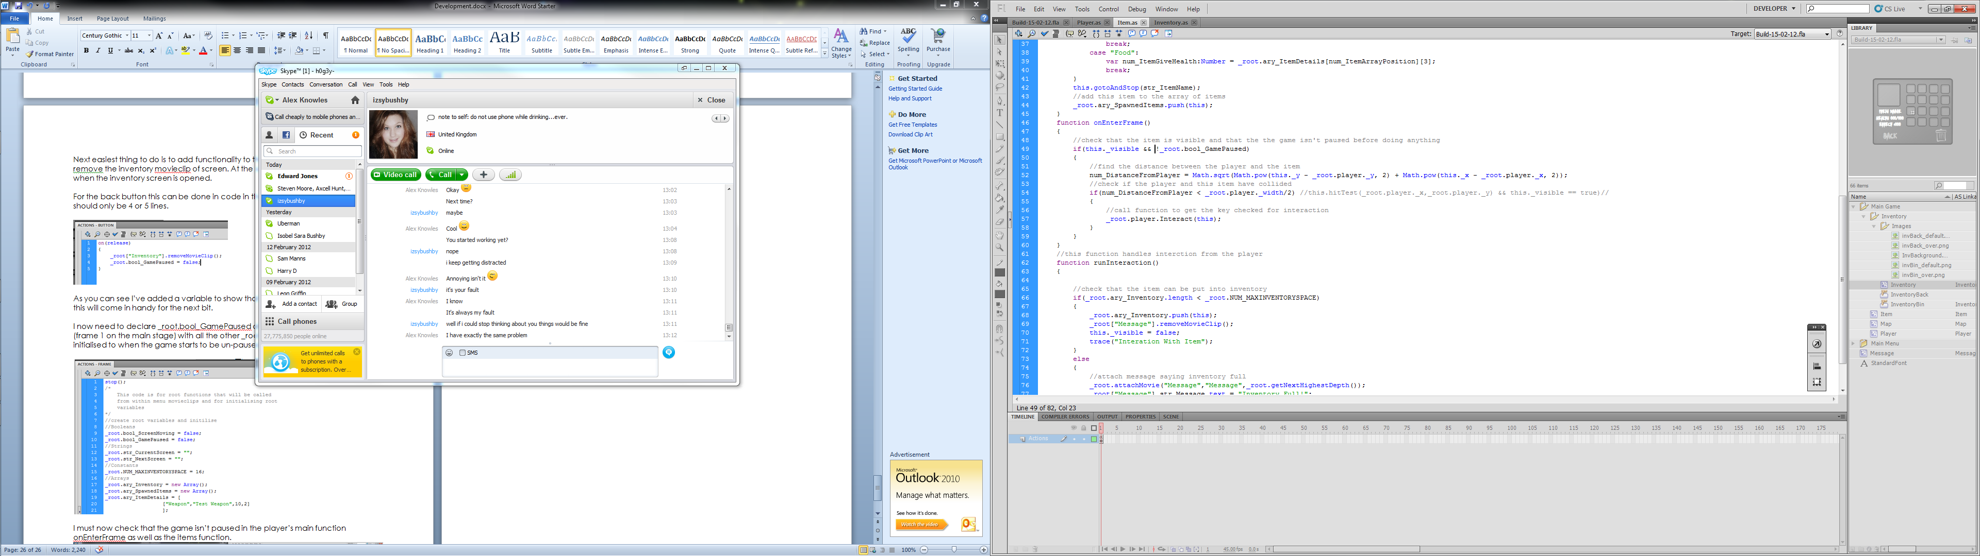

Now all that is let to do is tell it to be pause when the inventory is attached / loaded.

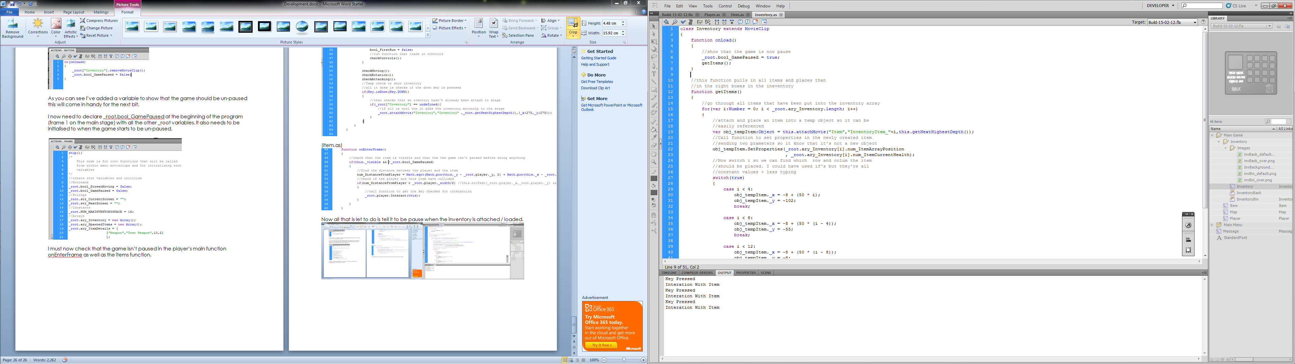

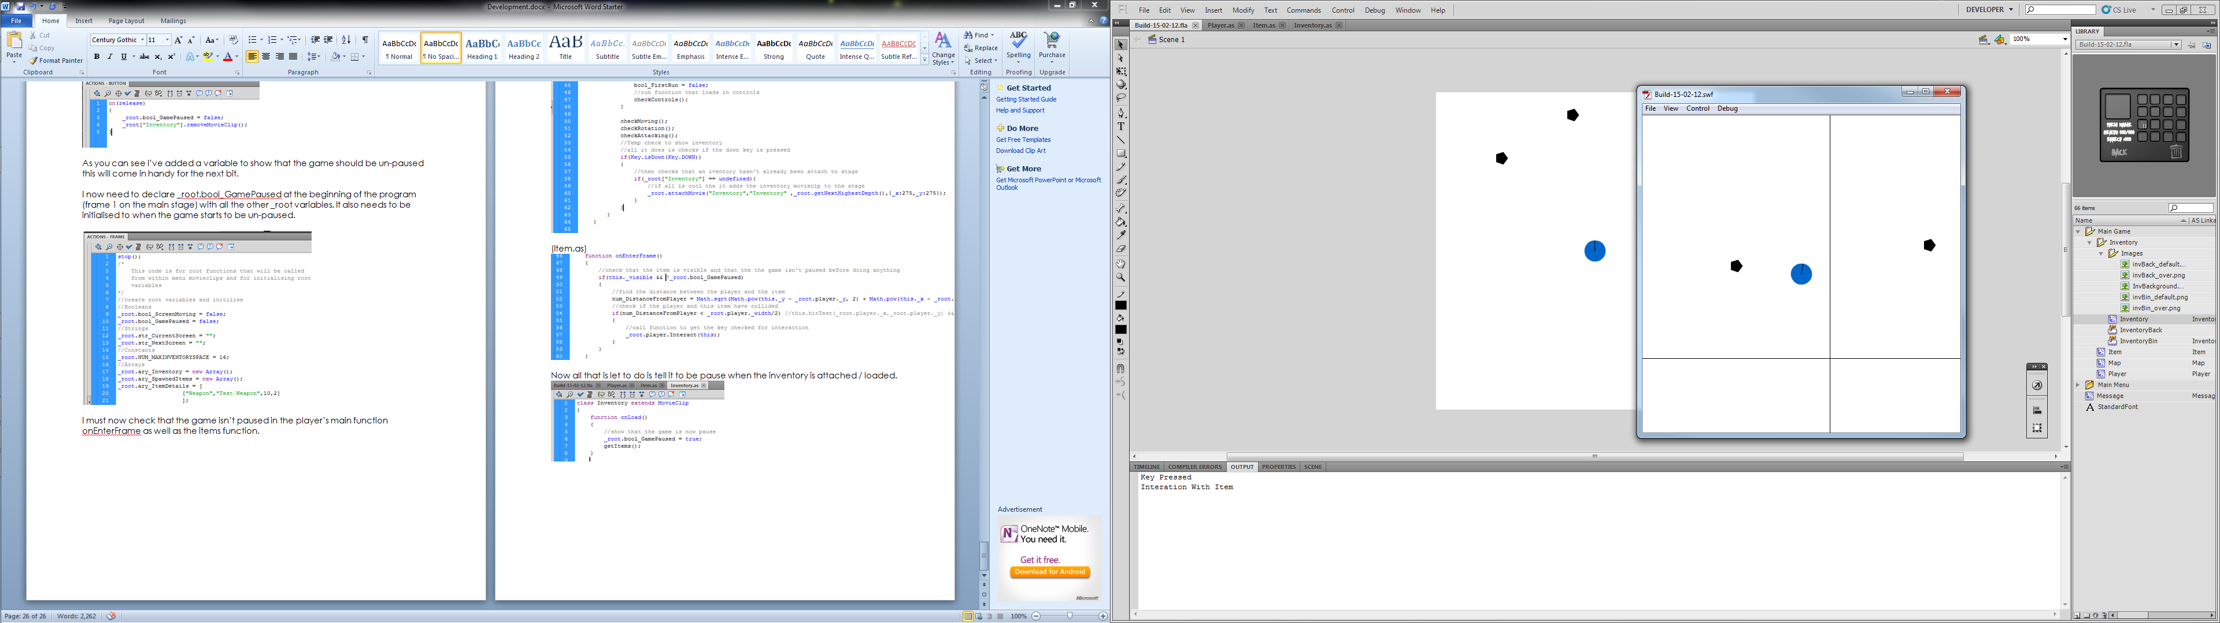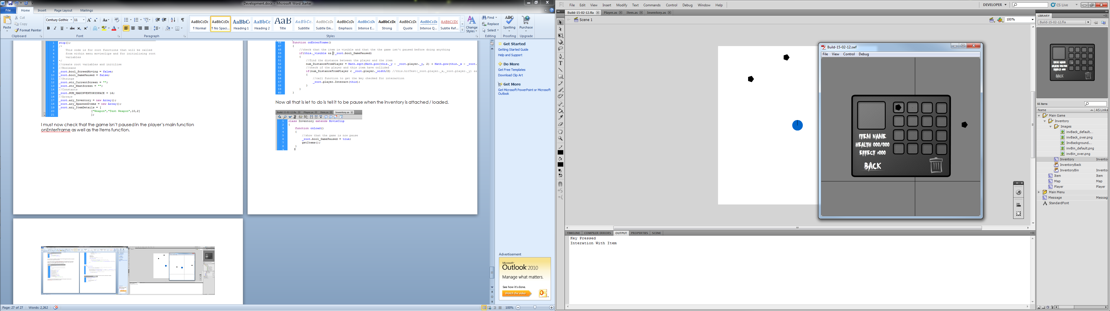
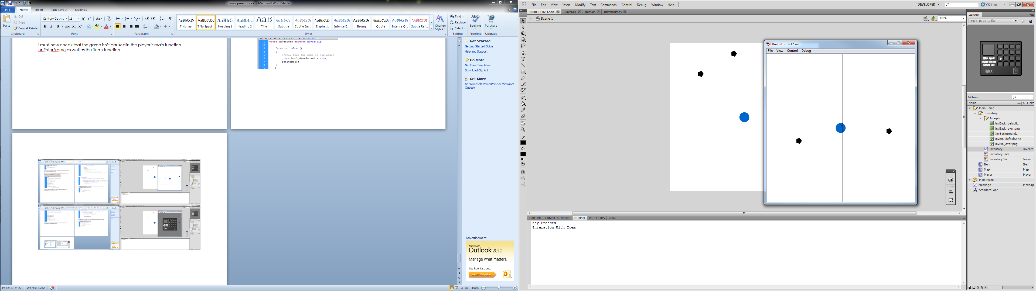

Good, that’s all working now I’m going to move on the more complete part of being able to drag and drop items from one slot to another. First I’ll start with the dragging mechanism. Simply this will be a onPress function which makes the item follow the mouse.

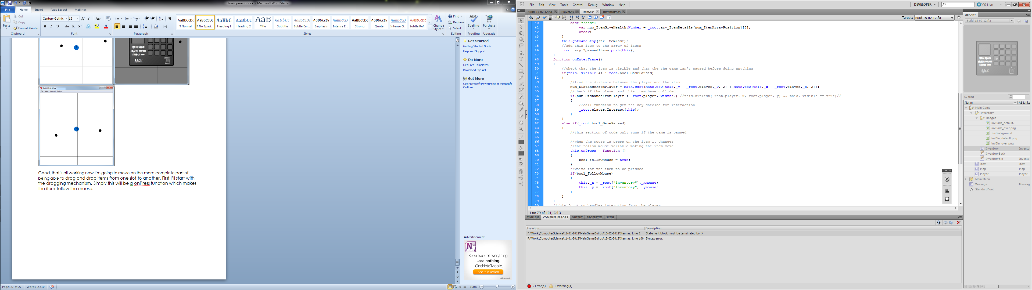
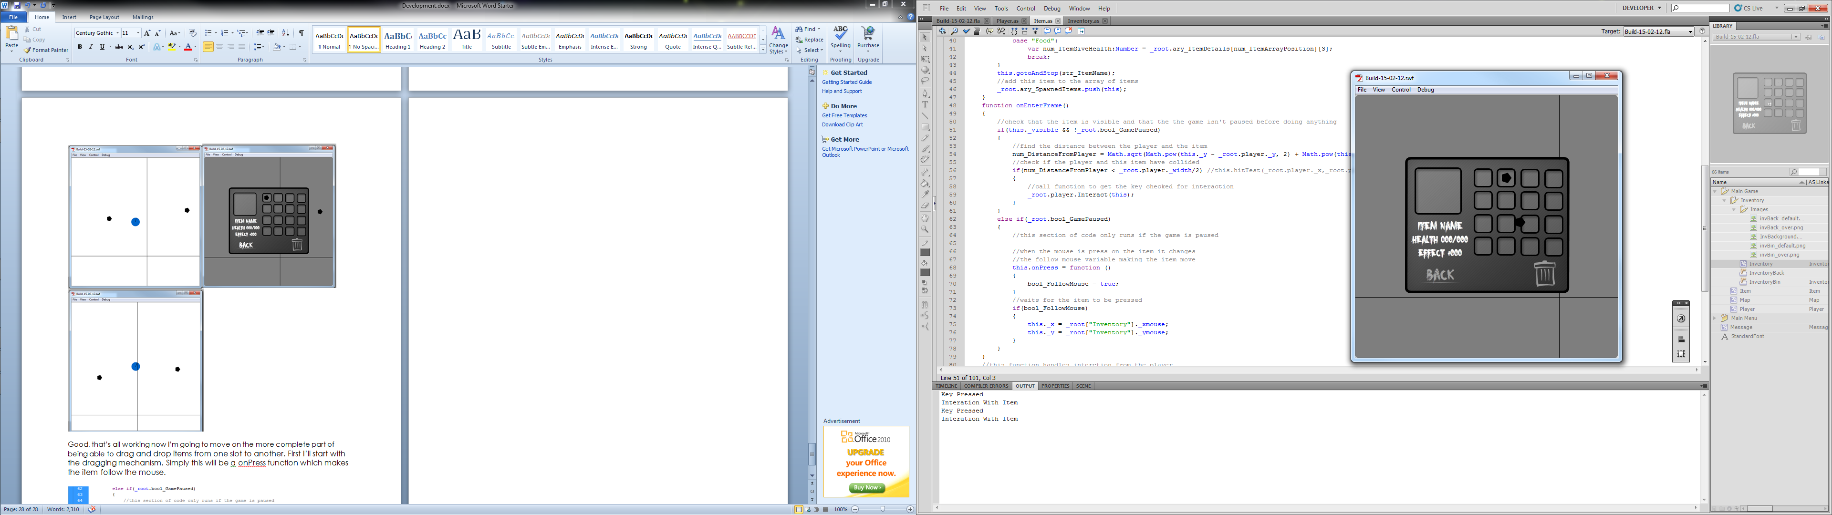

Annoyingly you can’t see the mouse but it does work. Next we need to make it so you can release the item once you release the mouse. This is just one line in onRelease function changing bool_FollowMouse to false.

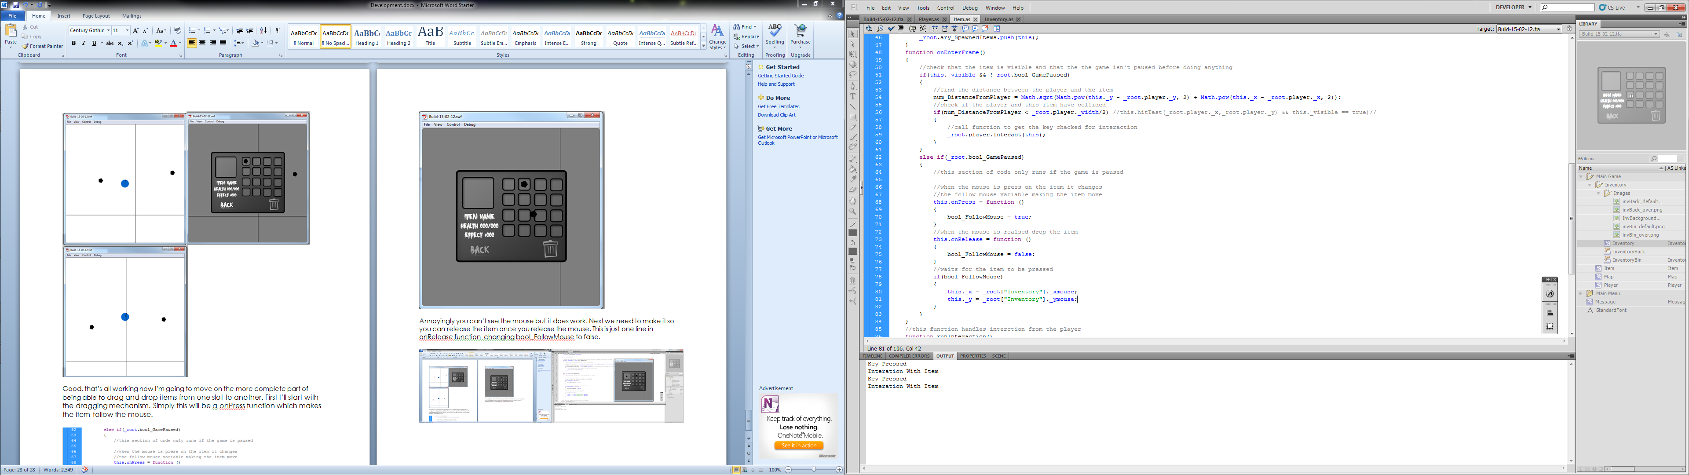

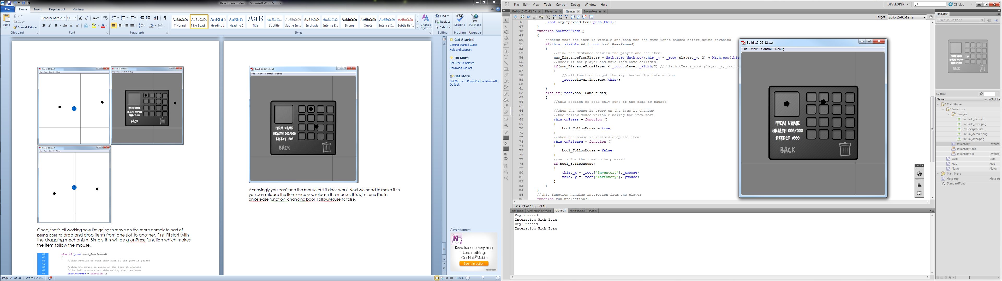

17/02/2012
Clearly we don’t want the user to be able to place the items anywhere on the screen so we need to check whether the item is over an inventory slot and if it not put it back to where it came from. First I’m going to need a constant array of the positions of each inventory slot. Seeing as they’re all the same size I just need the top corner. Each box is 34 x 34 pixels.

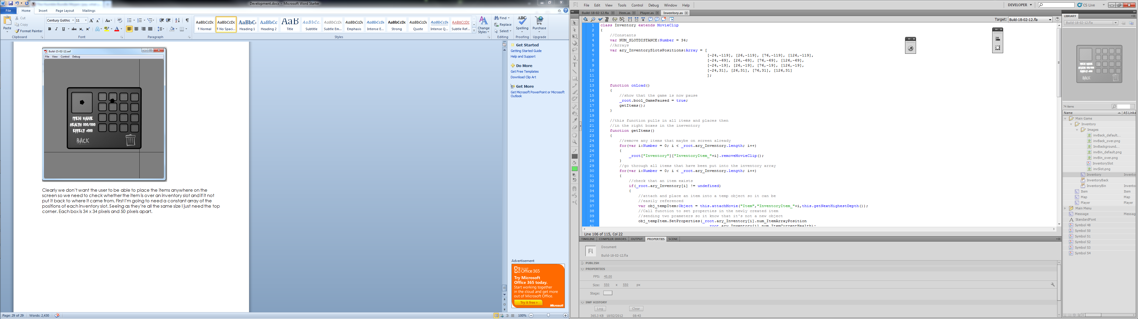

Again, I can’t fit all the code on screen so I had to cut off the line numbers.

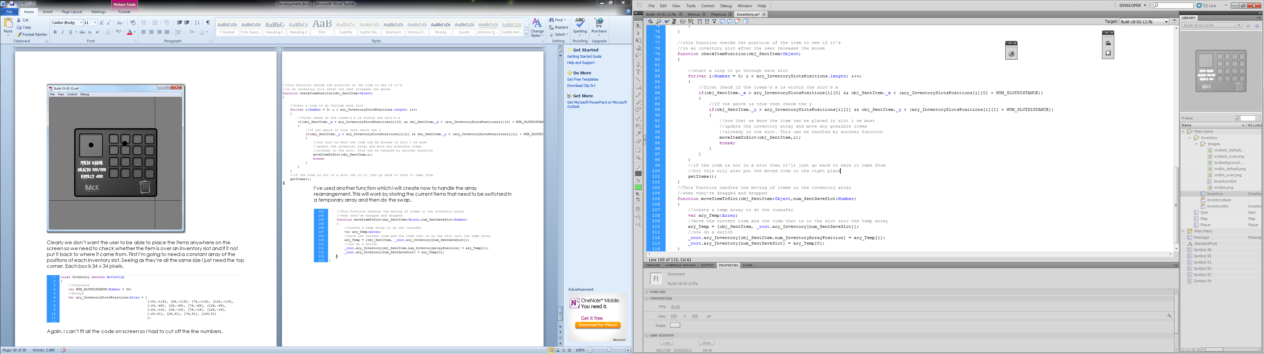

I’ve used another function which I will create now to handle the array rearrangement. This will work by storing the current items that need to be switched in a temporary array and then do the swap.

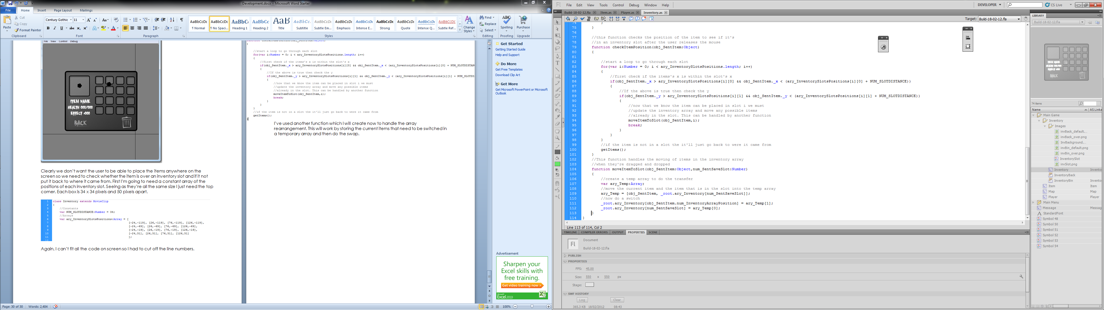

Now I just need a line to call this function when the item is released.

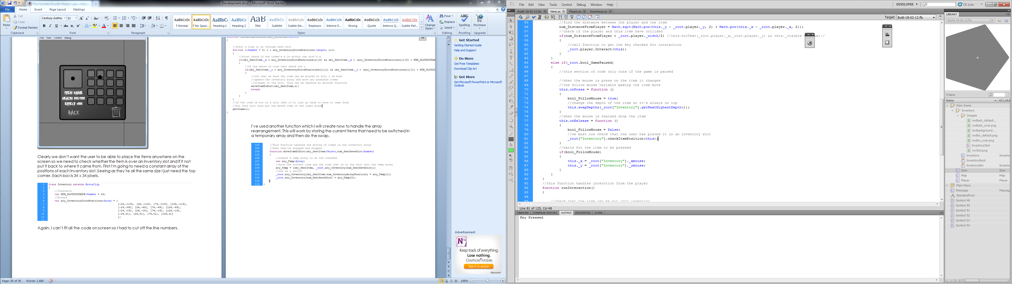

Snaps to place:
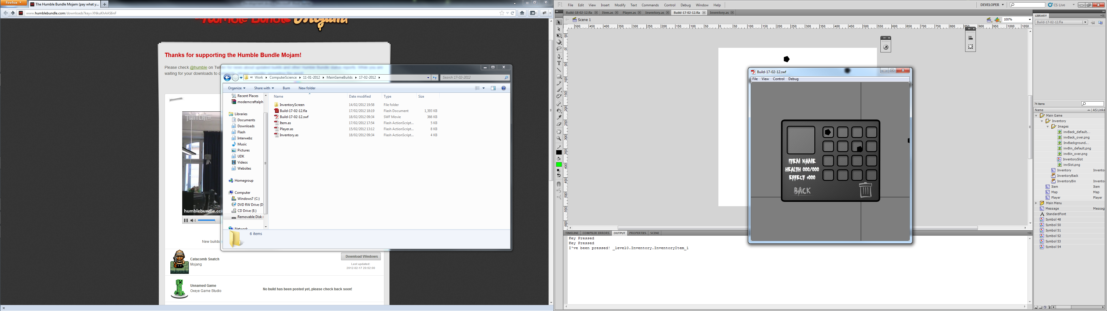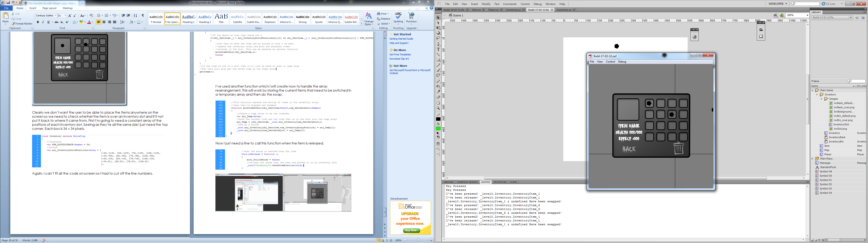

And returns to previous place when not over a slot:
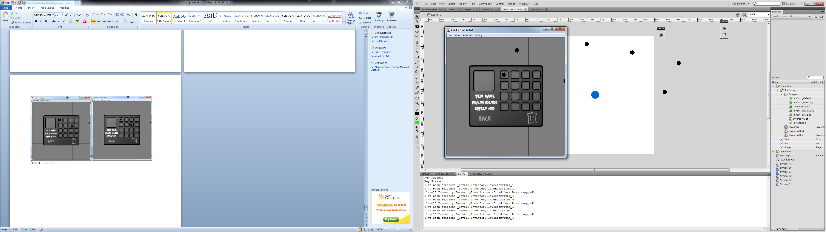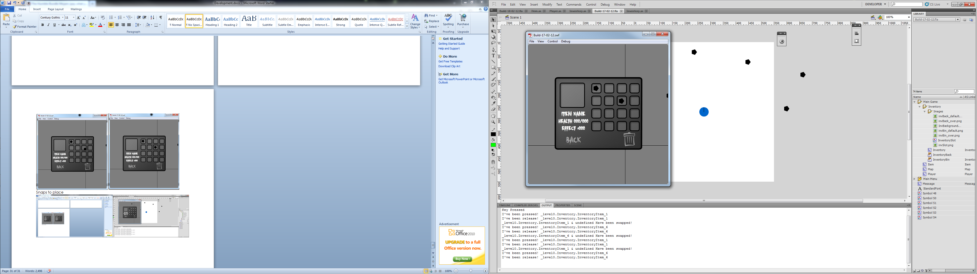

18/02/2012
Next thing to do is to get the selected item box up and working; showing off all the stats. I’m going to have an extra item on the end of the Inventory array which will be the selected item.
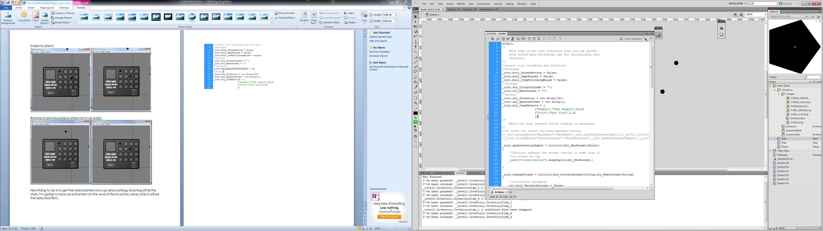

When the items are getting placed in inventory, the game need to know where to put the selected item.

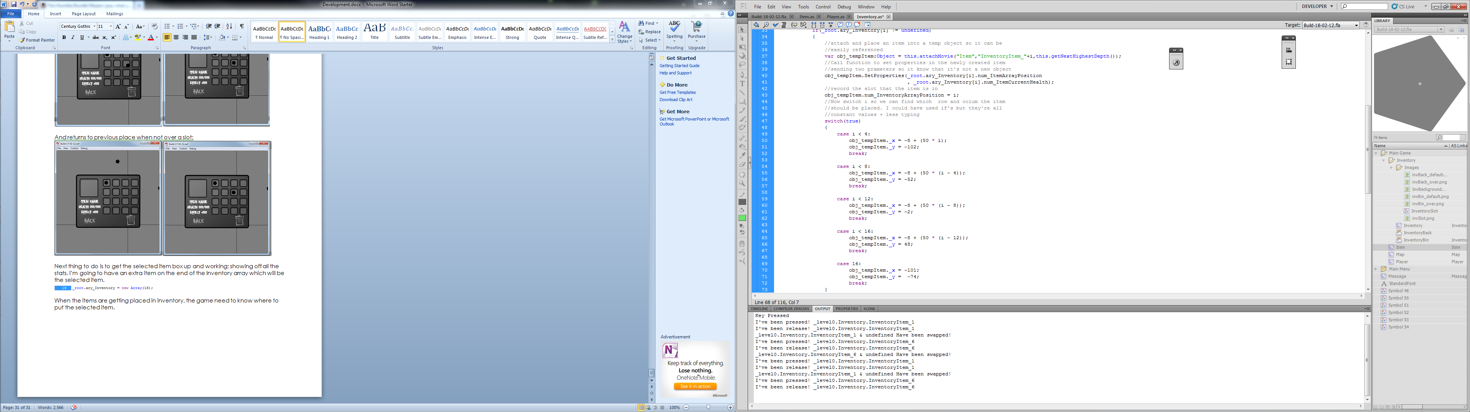

Now to add a check if an item is dragged into the selected item slot.

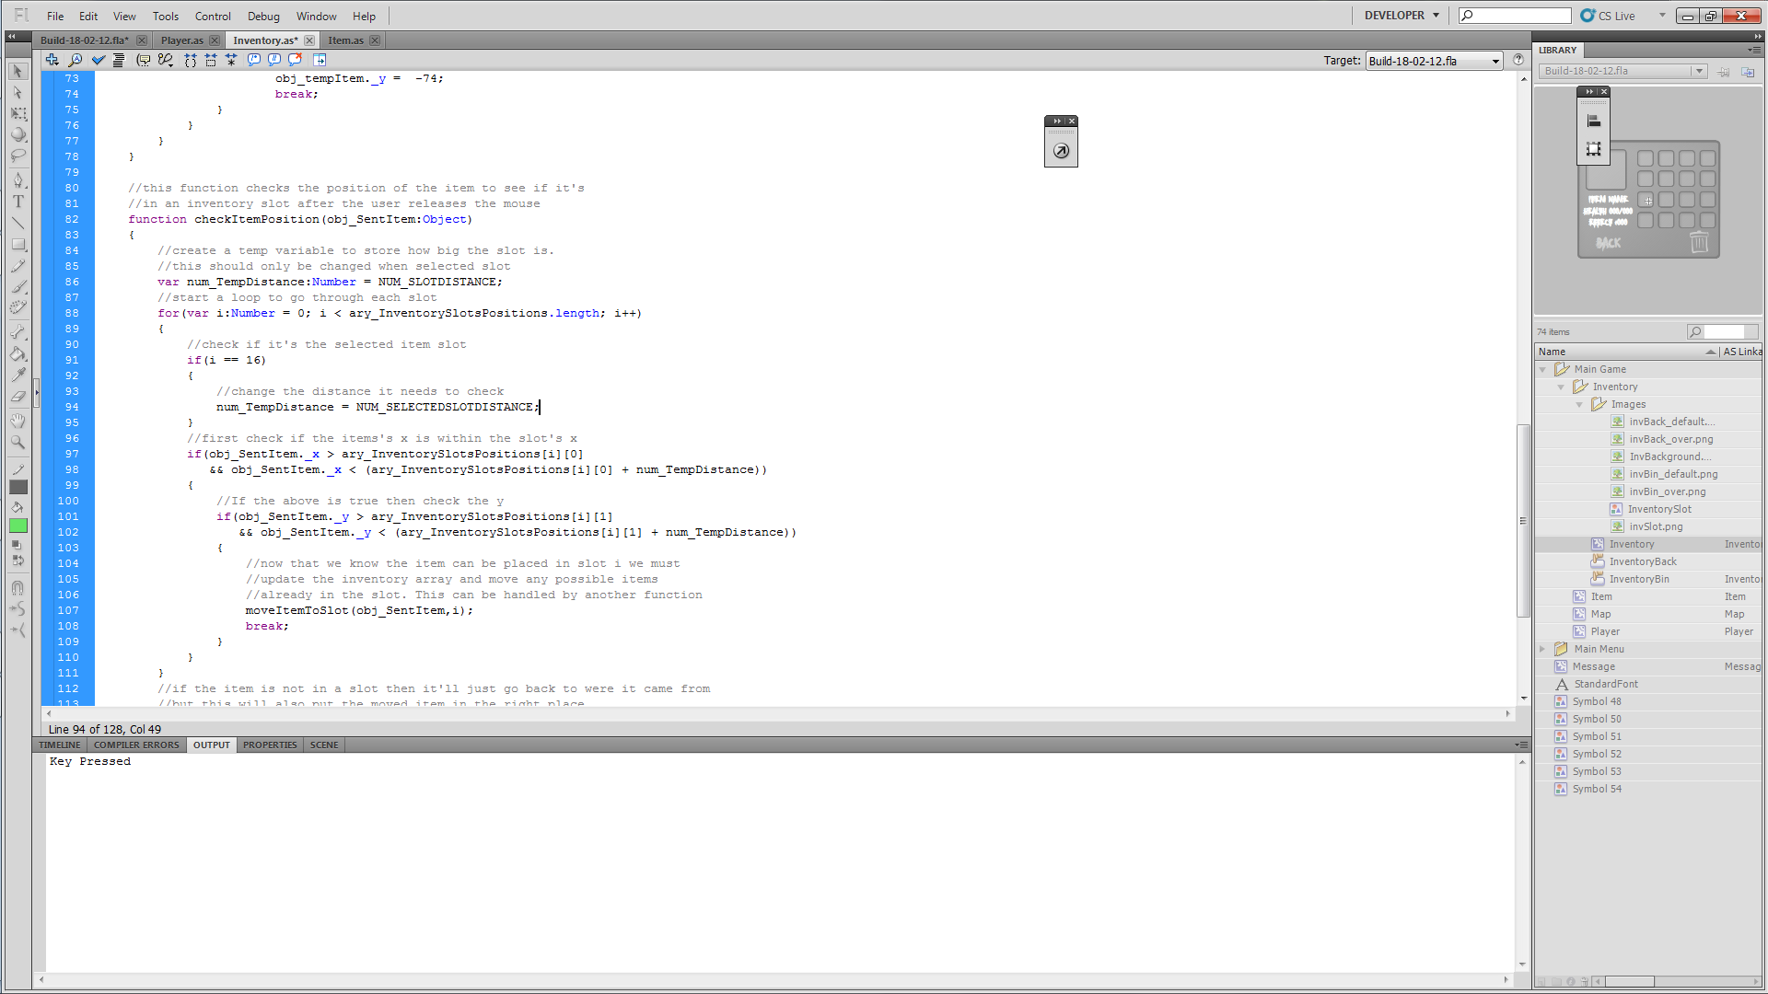 (I’ve put the if statements on two lines so you can actually read it this time)

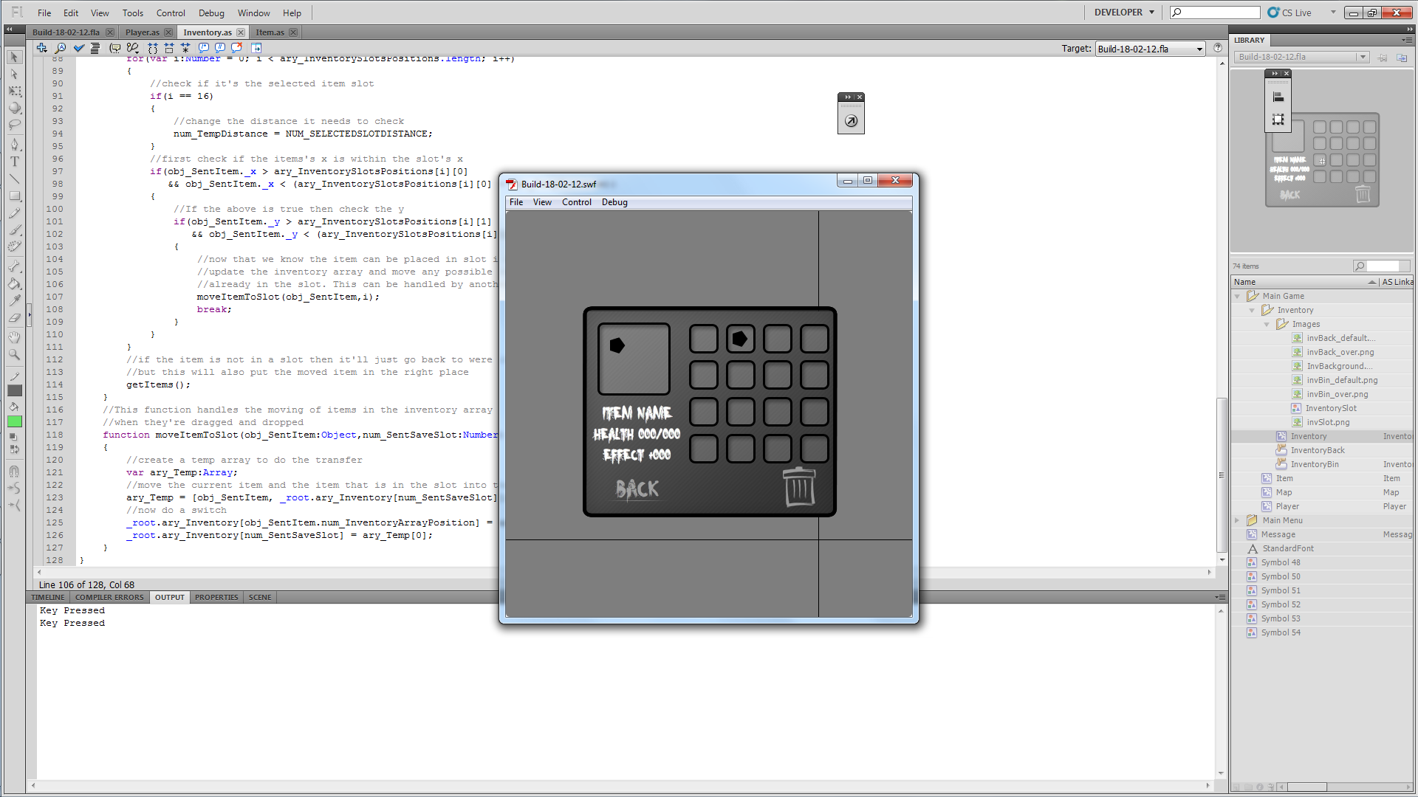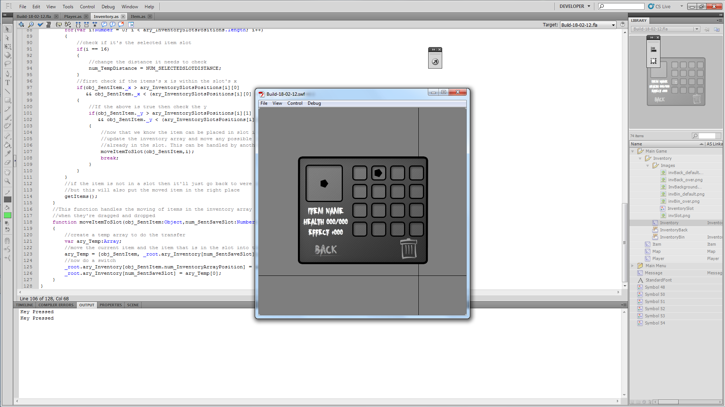

We need the text to change to info about the current item. This will just be a function called every time the items are put back into the slots.

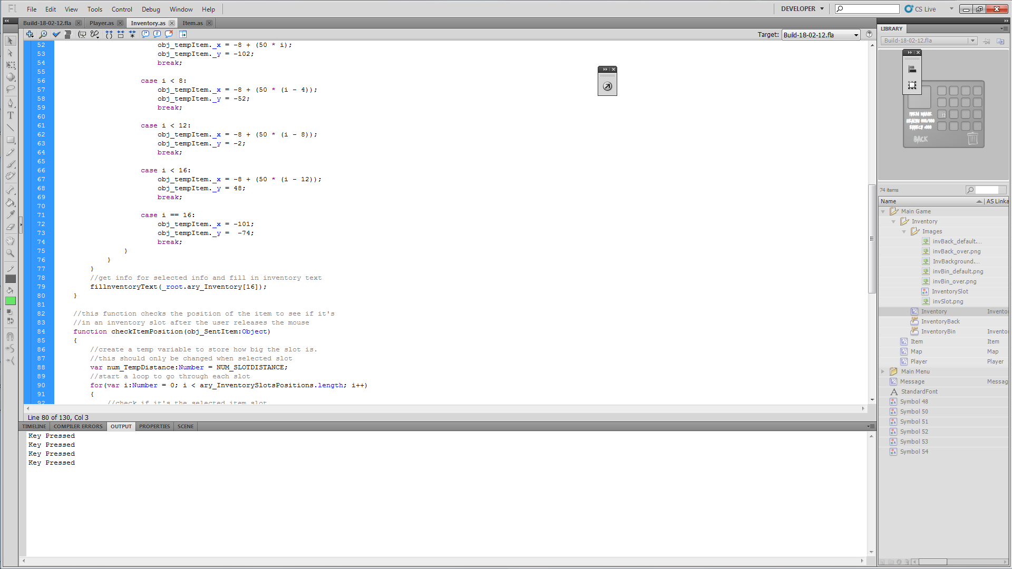

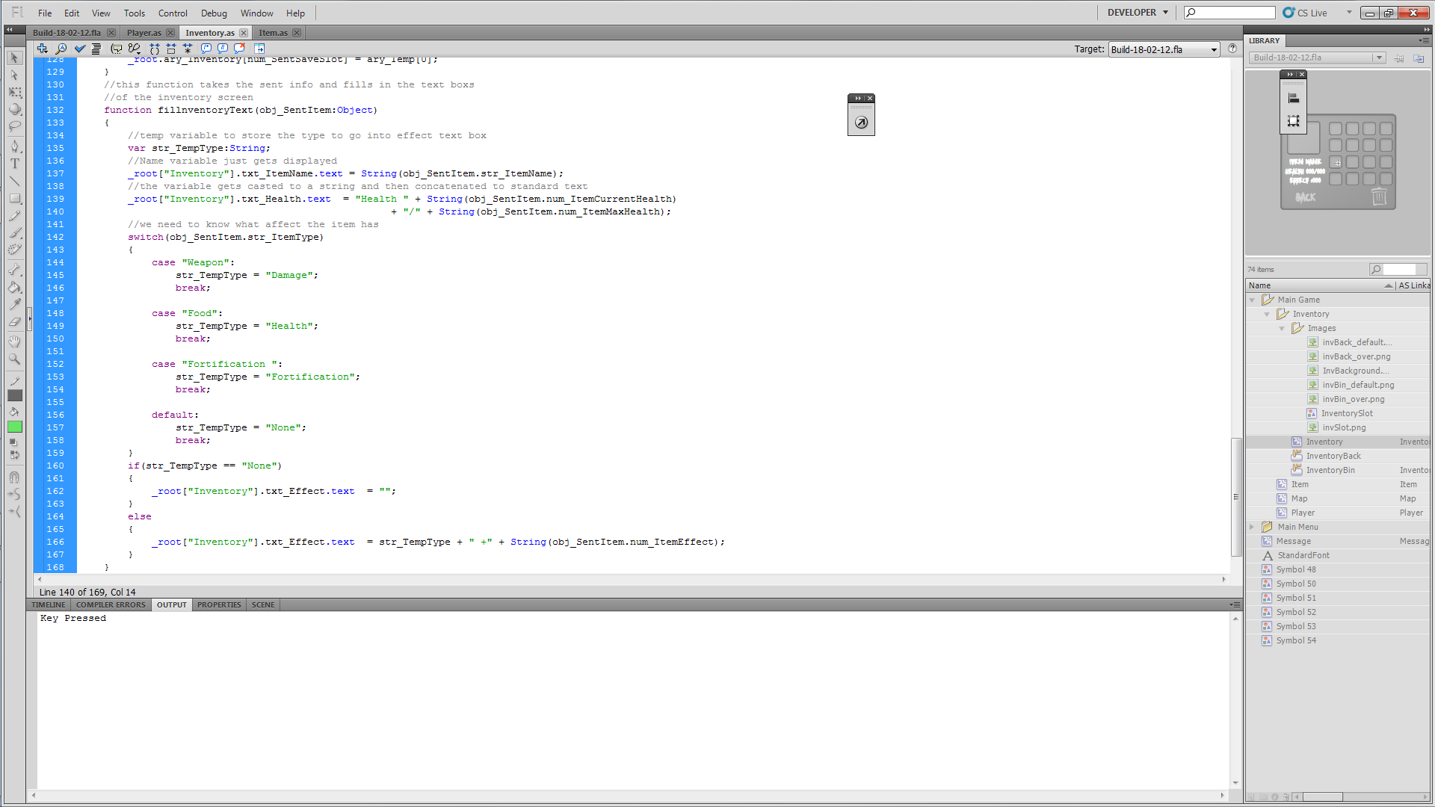

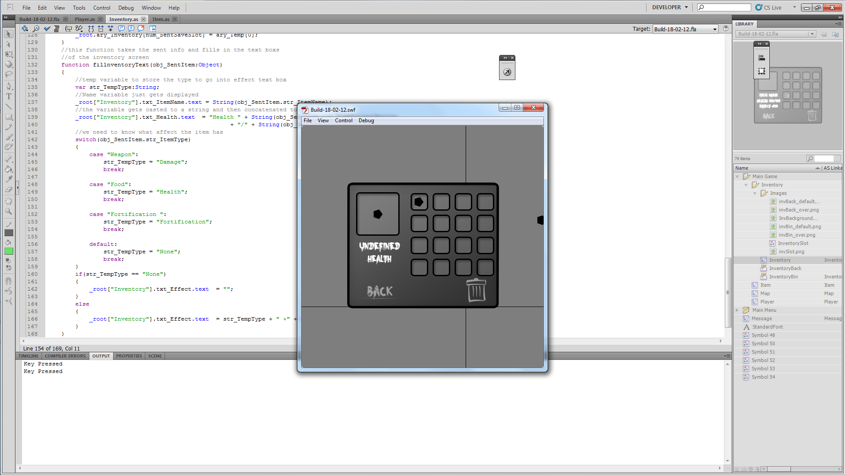

Sadly it doesn’t work. After investigating the code using traces, because the debug doesn’t want to allow key presses, I found that the items are not being give information. I believe this is because they are initialised before the array holding the info so no info is given to them. This calls for something I was planning to add later but I best do it now to make everything work. What I’m on about it spawning items in instead of placing them on the map. This will be a simple function that goes through an array of positions placing and initialising the items.

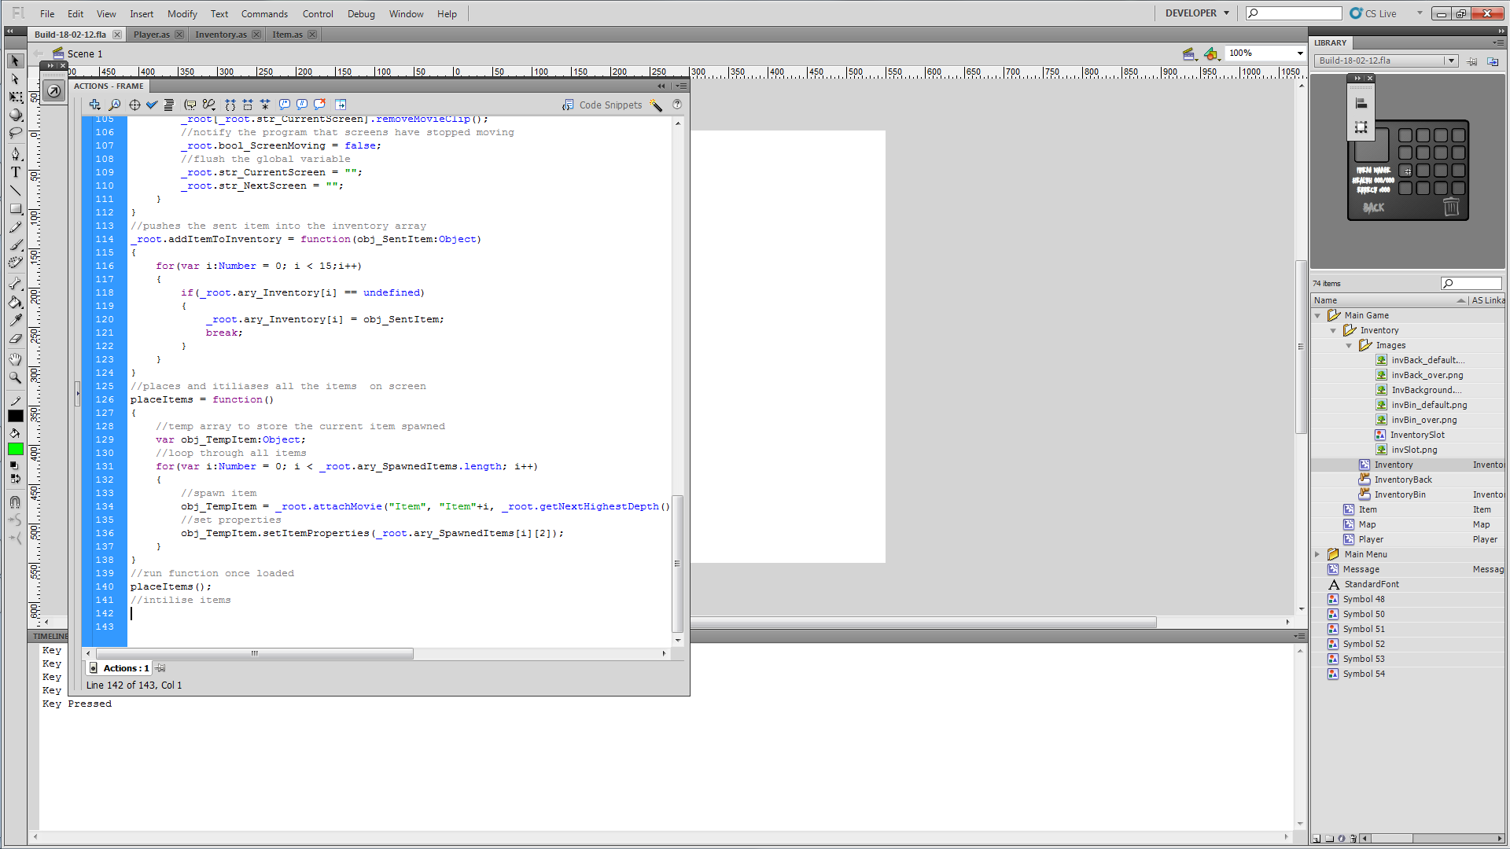

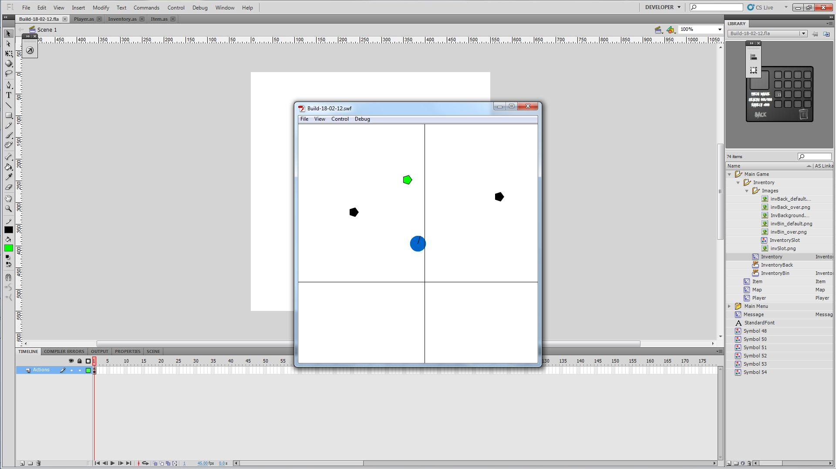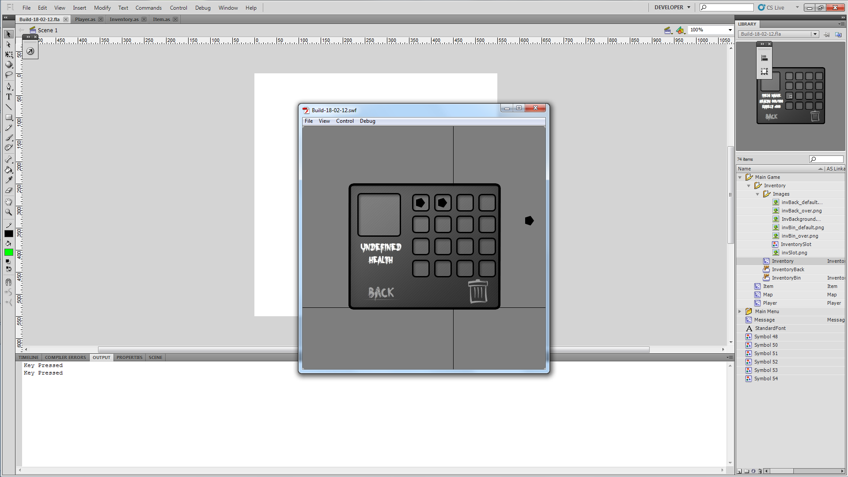

The code worked fine for loading the items onto the screen but not when they’re loaded into the inventory. After tracing for a few minutes I found that the setItemProperties wasn’t being called when the item where put into the inventory slots, which was a syntax error because I tried to call setProperties which didn’t exist.
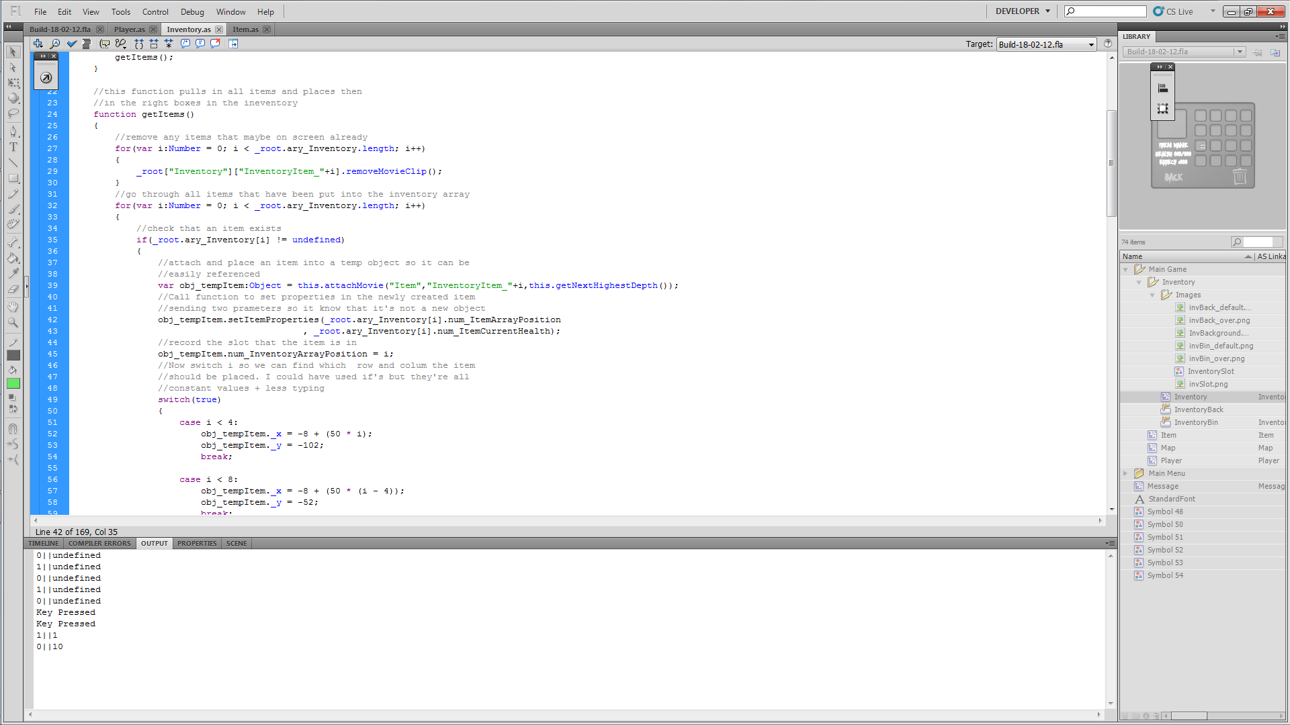

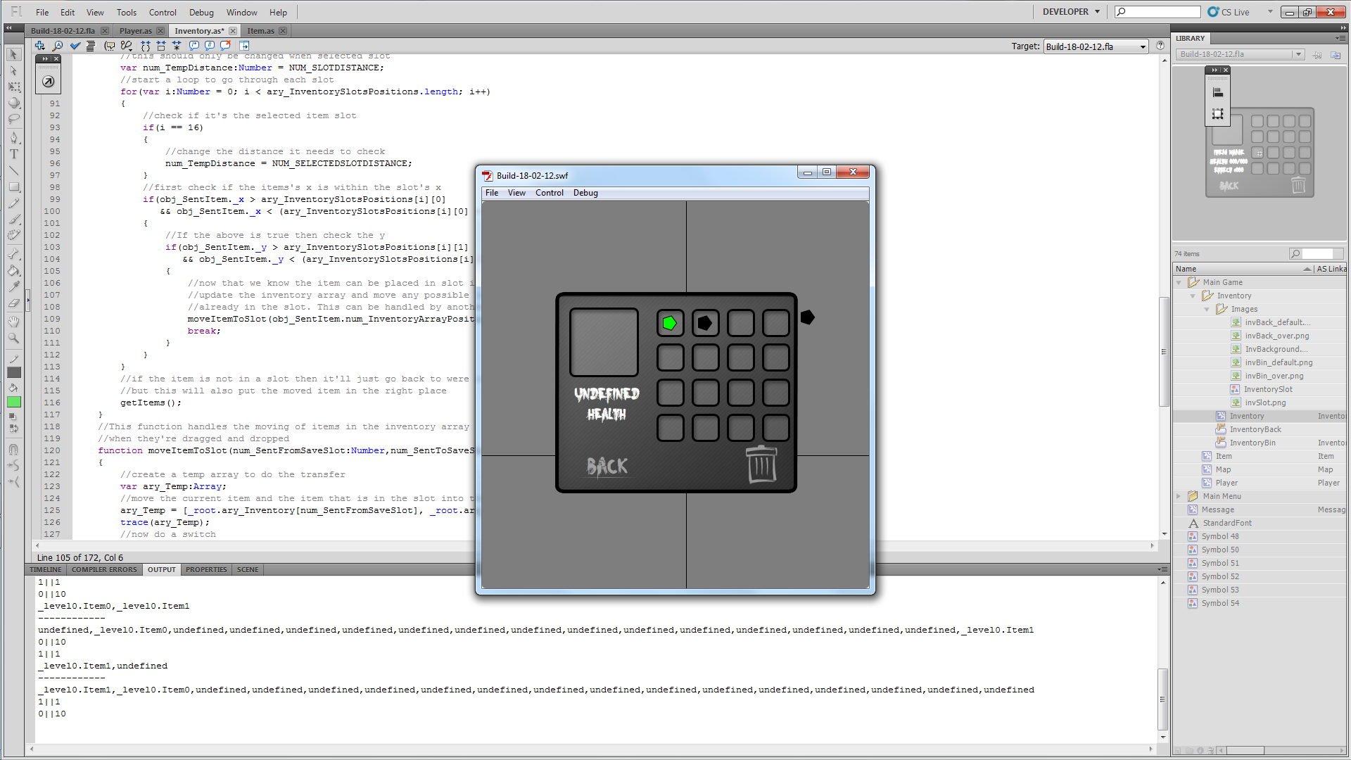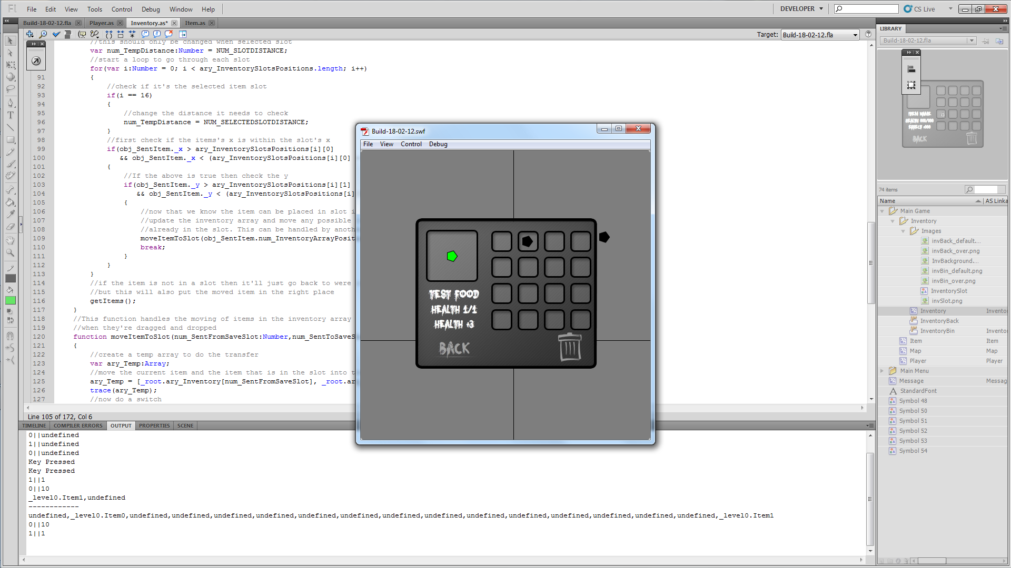

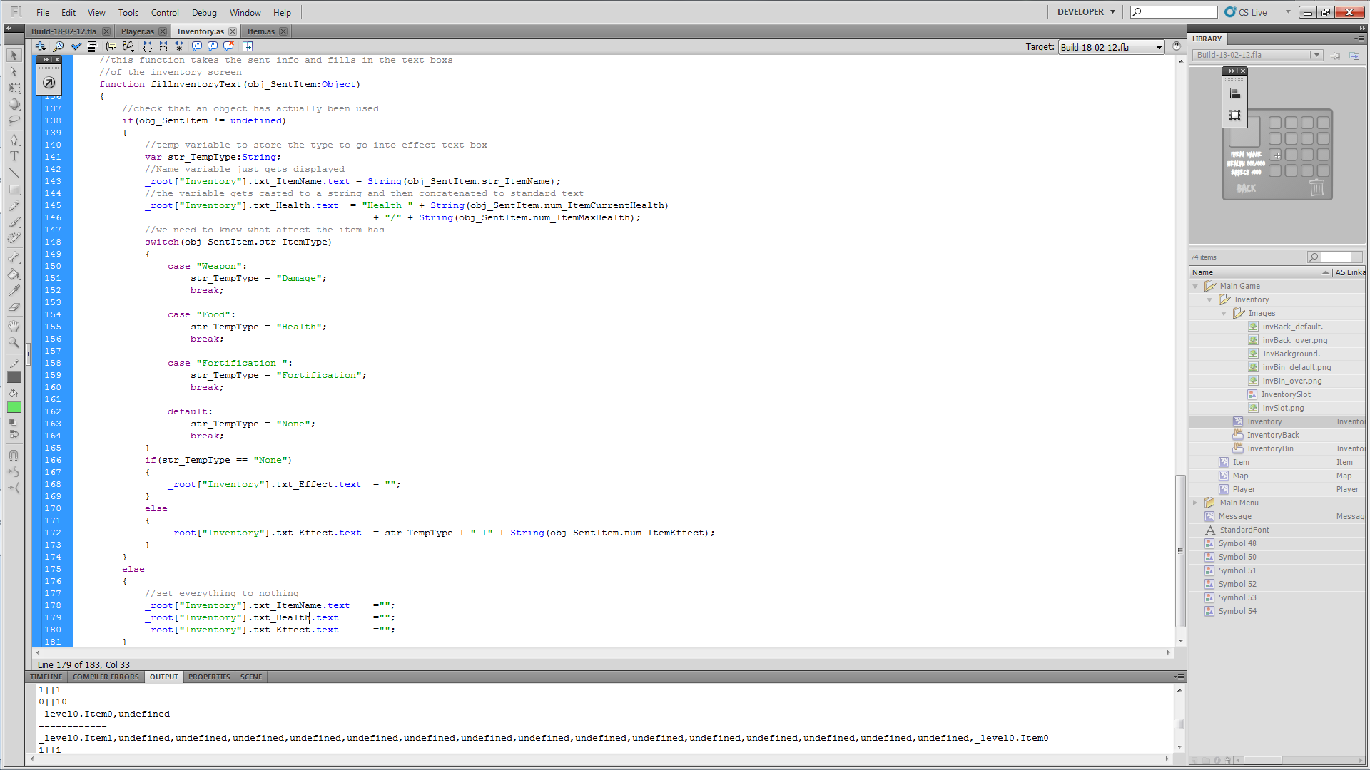
Now I just need to add default text when no item has been selected. Just a simple if statement checking if an object has actually been sent should sort it.
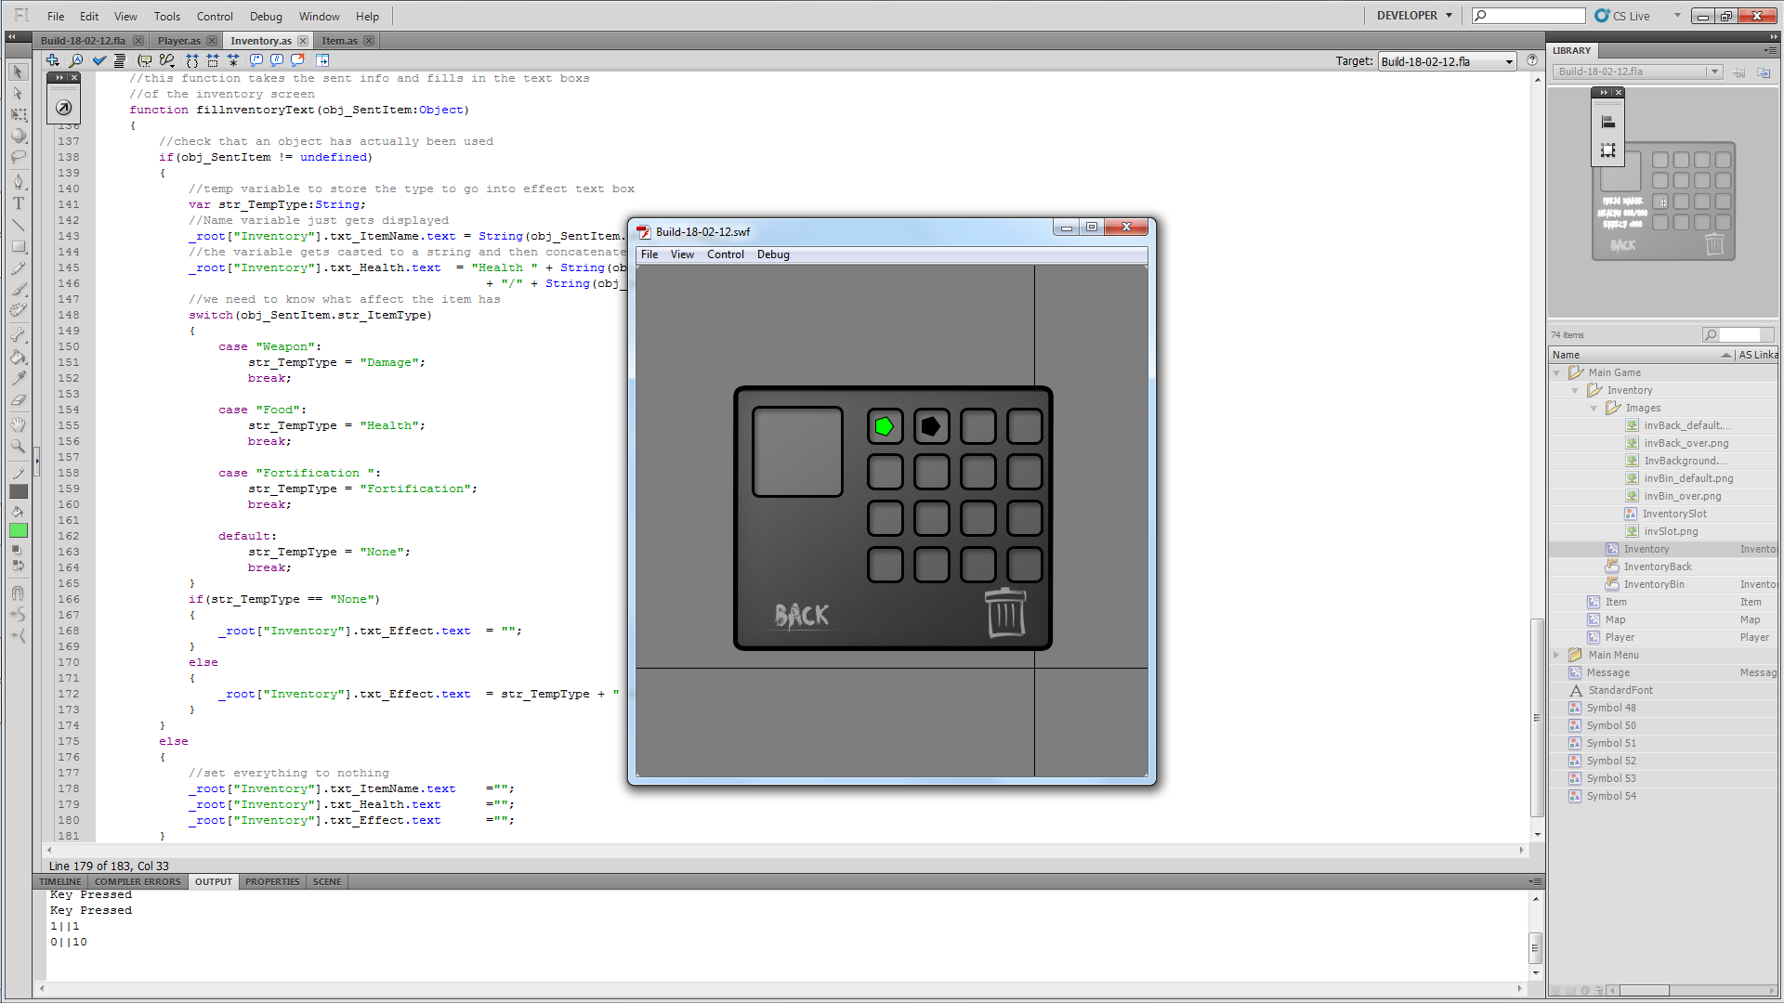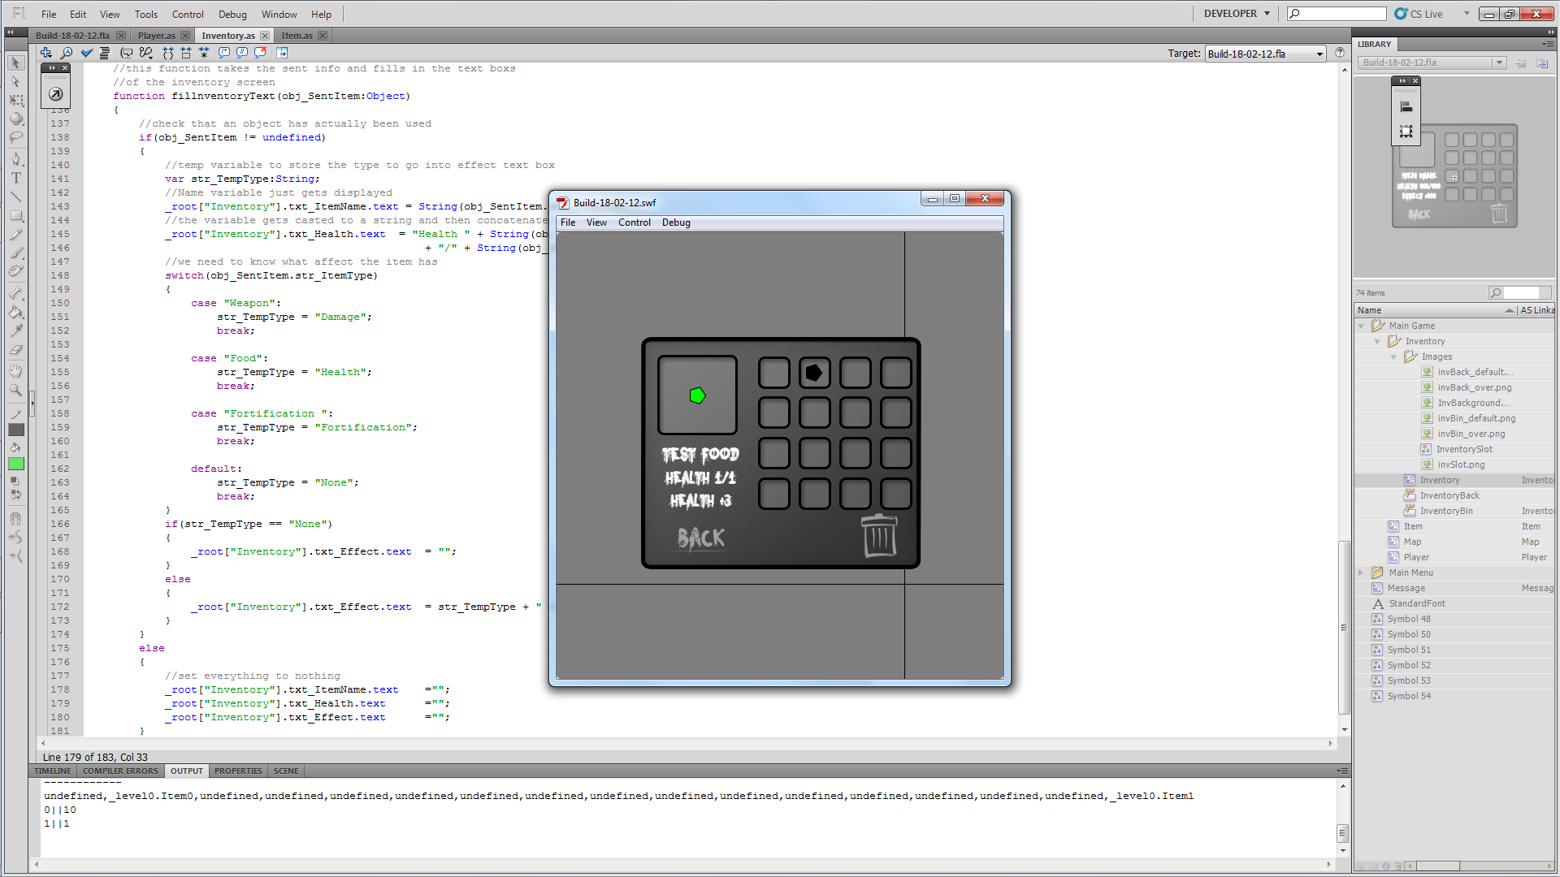

Done. Now, because I’m picky, I want it so when the user rolls over an item it shows the stats of the item. This should just be a simple onRollOver and onRollOut Function in item.as.

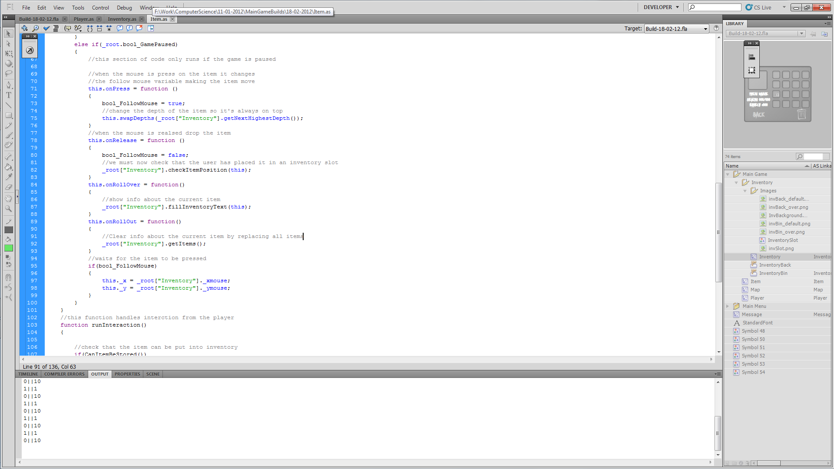

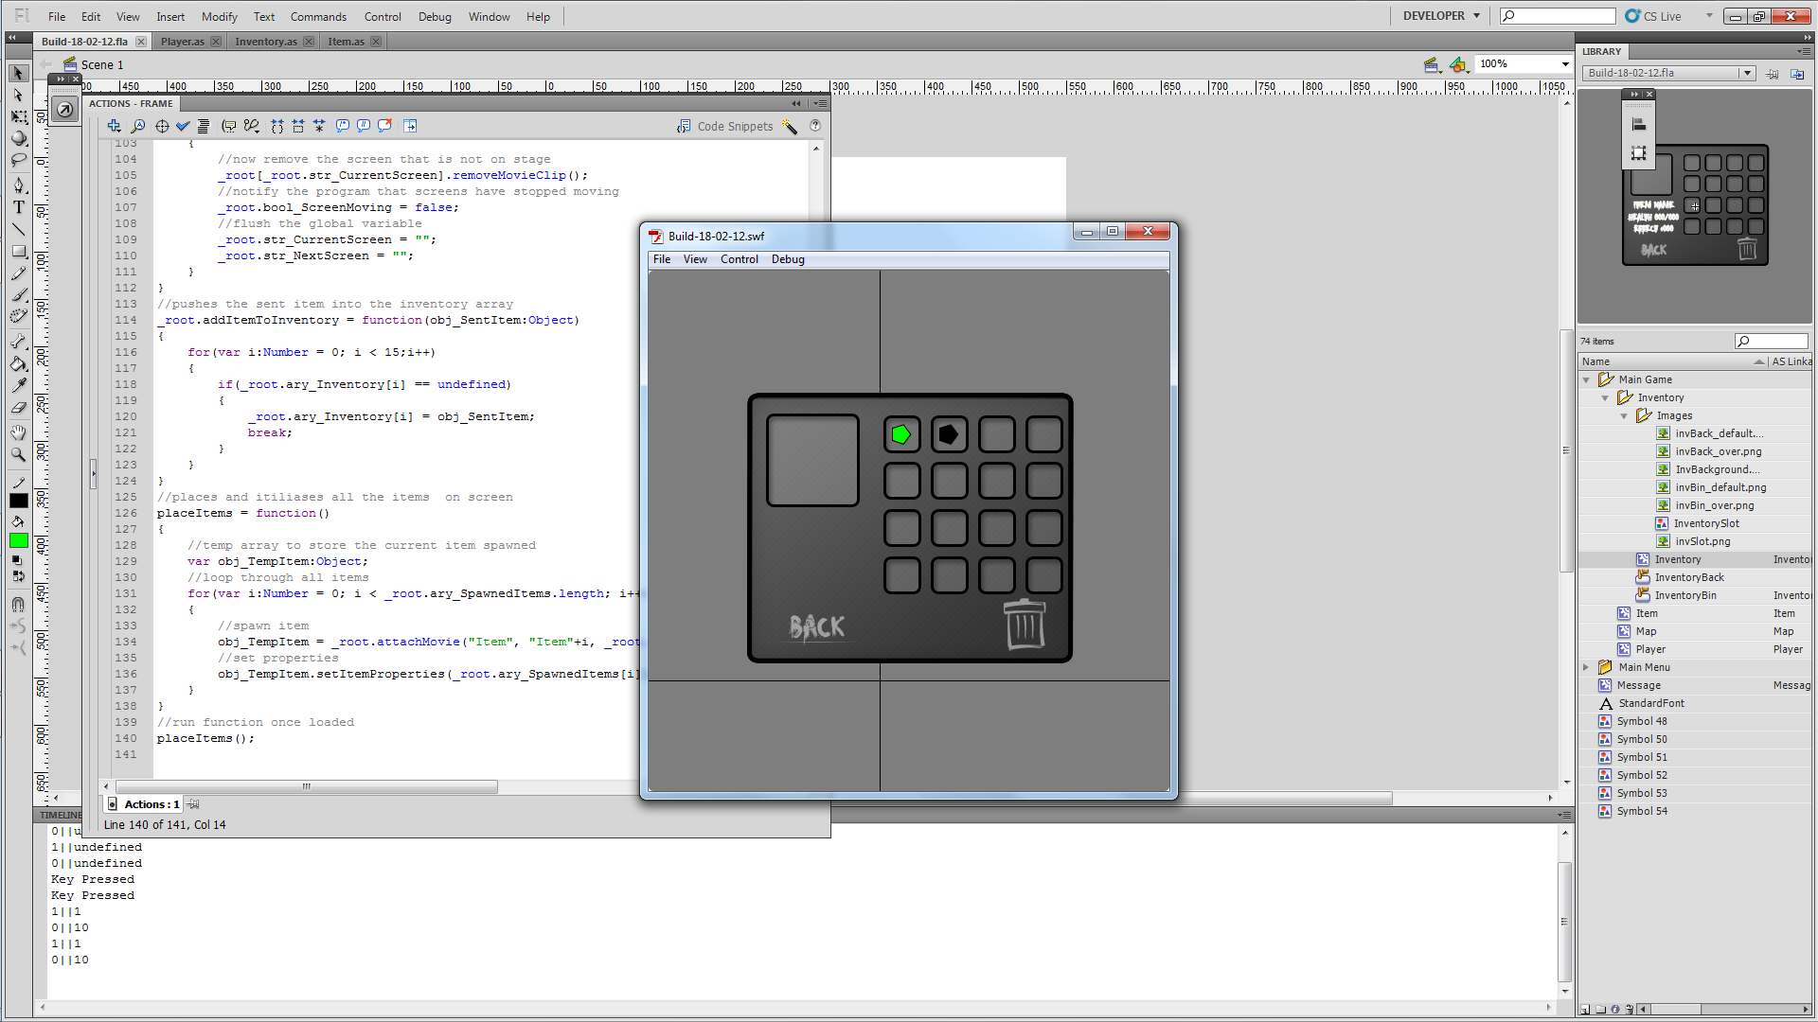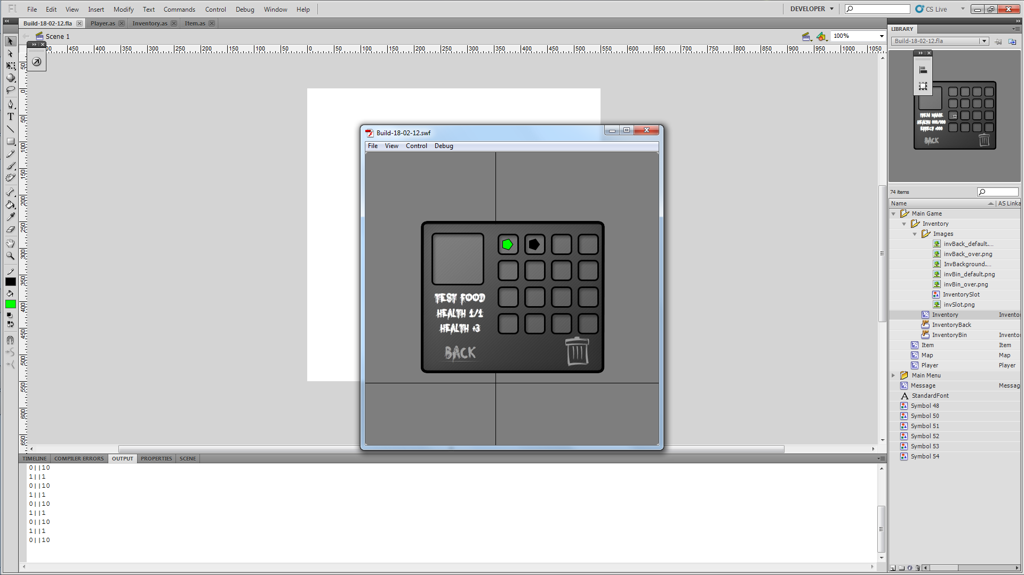

Now we’ve got one more thing to sort and that is the bin button. This will need a check to see if an item has been dragged over it. Then a function will run dropping the item on the ground in front of the player and adding it to the list of items on the ground.

(Inventory.as)
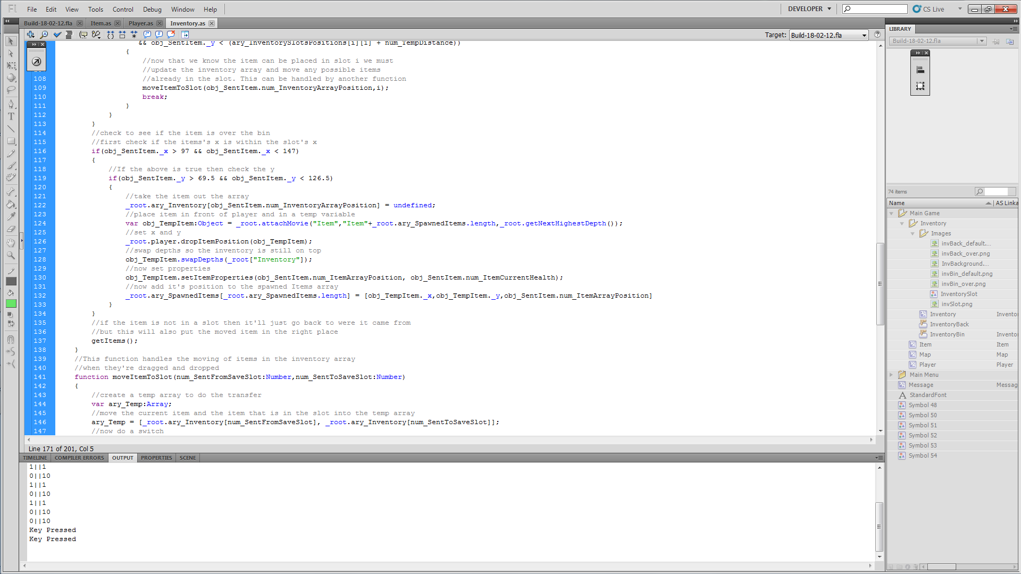
(Player.as)
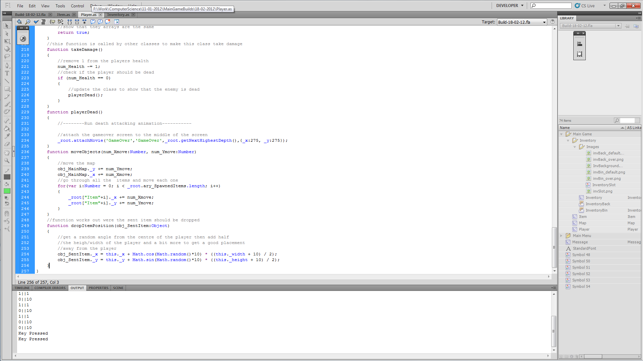

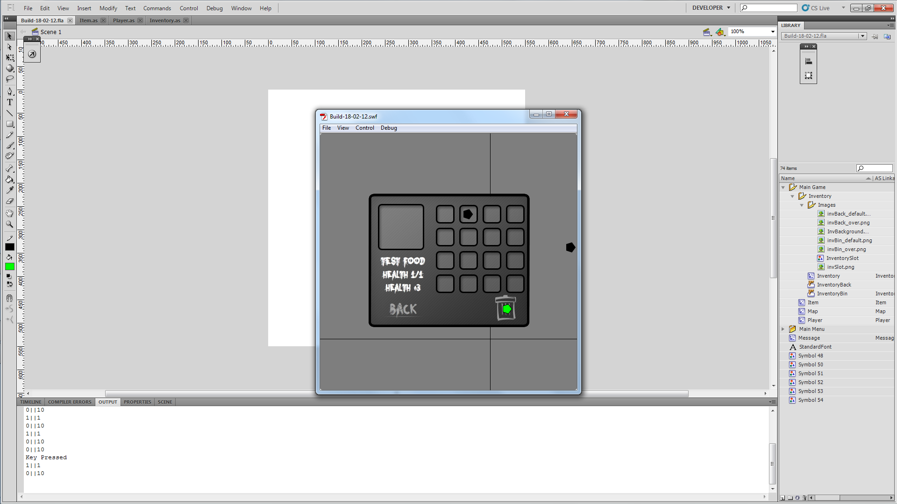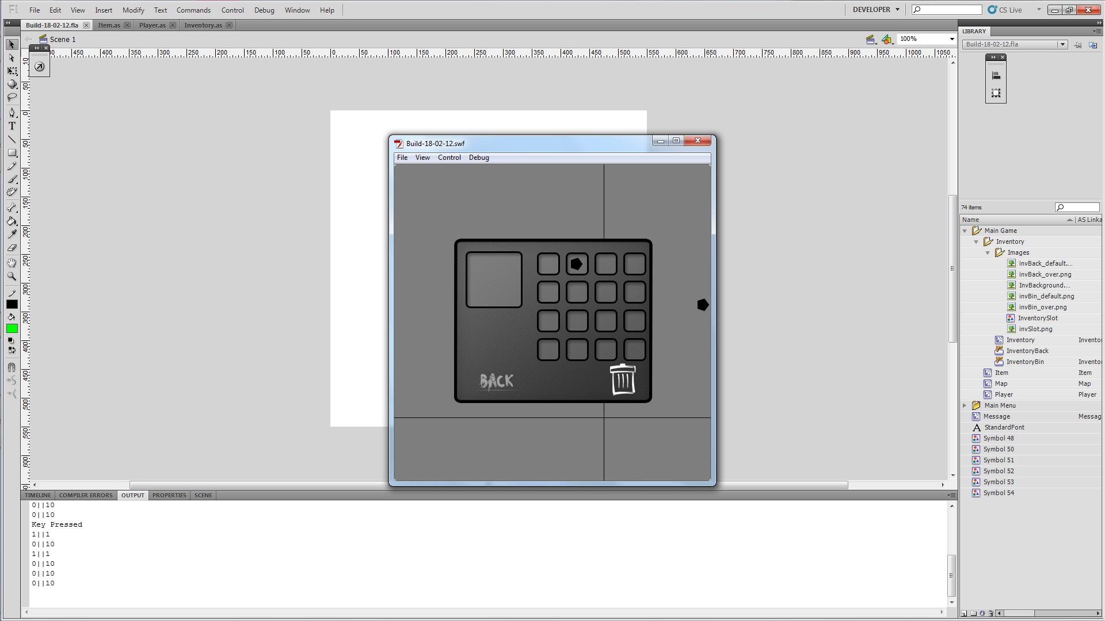
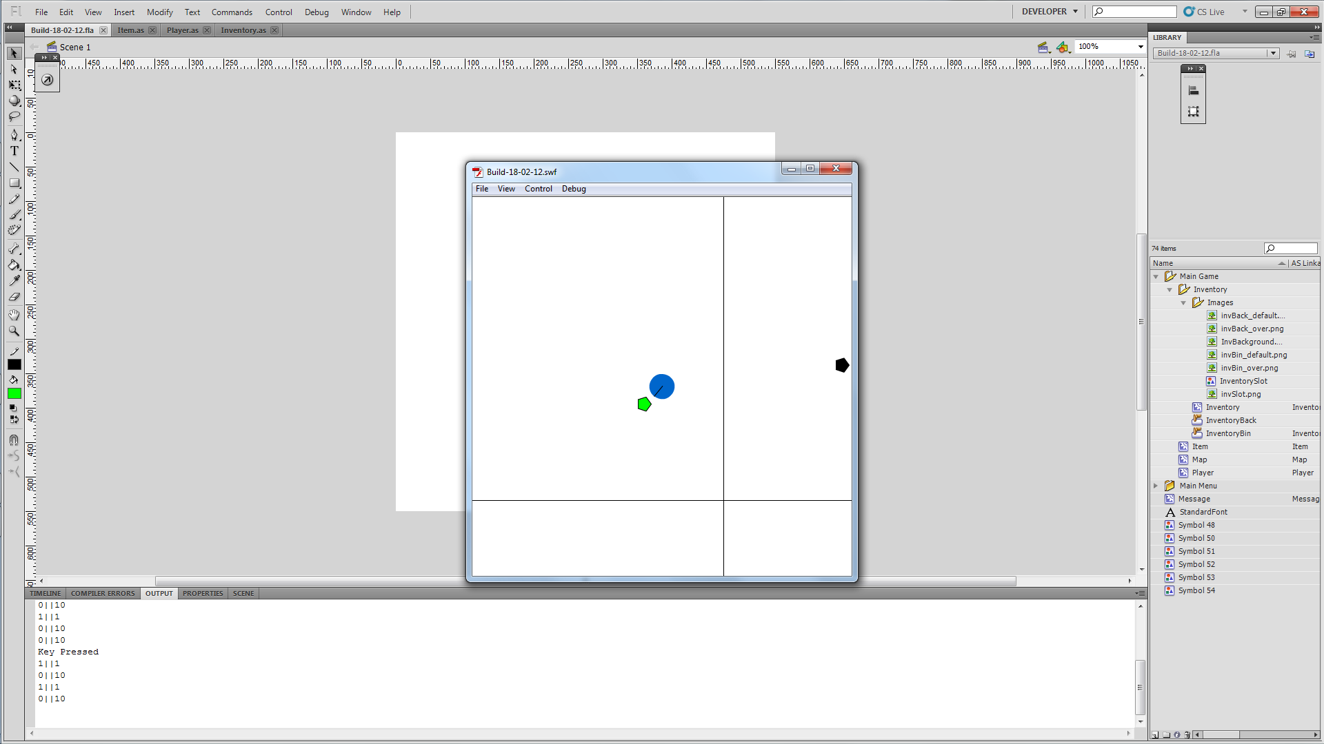

One problem when the item is over the bin it doesn’t highlight. This just needs a check if the item is hitting the bin the change the graphic of the bin to show it.

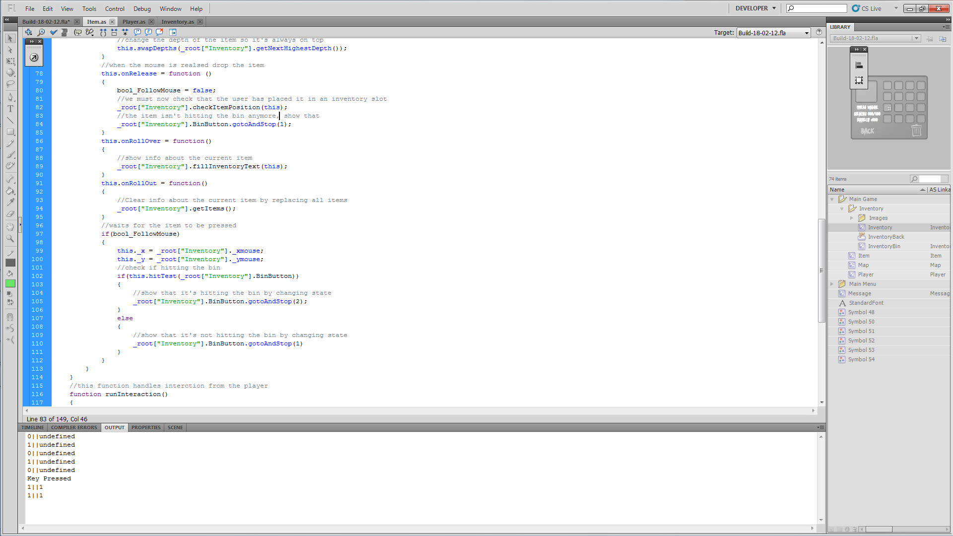

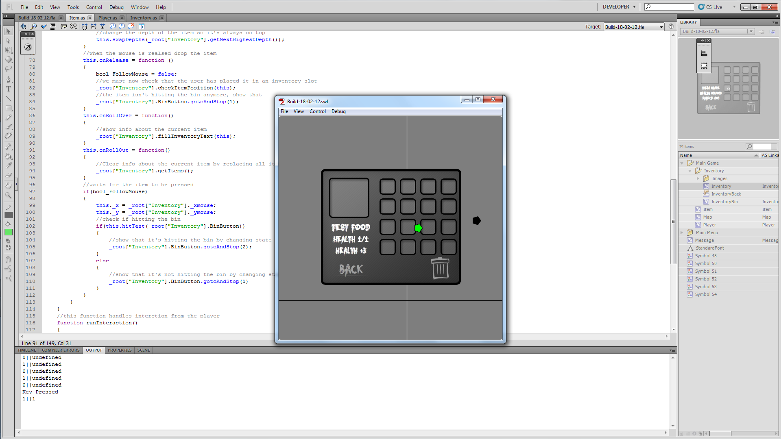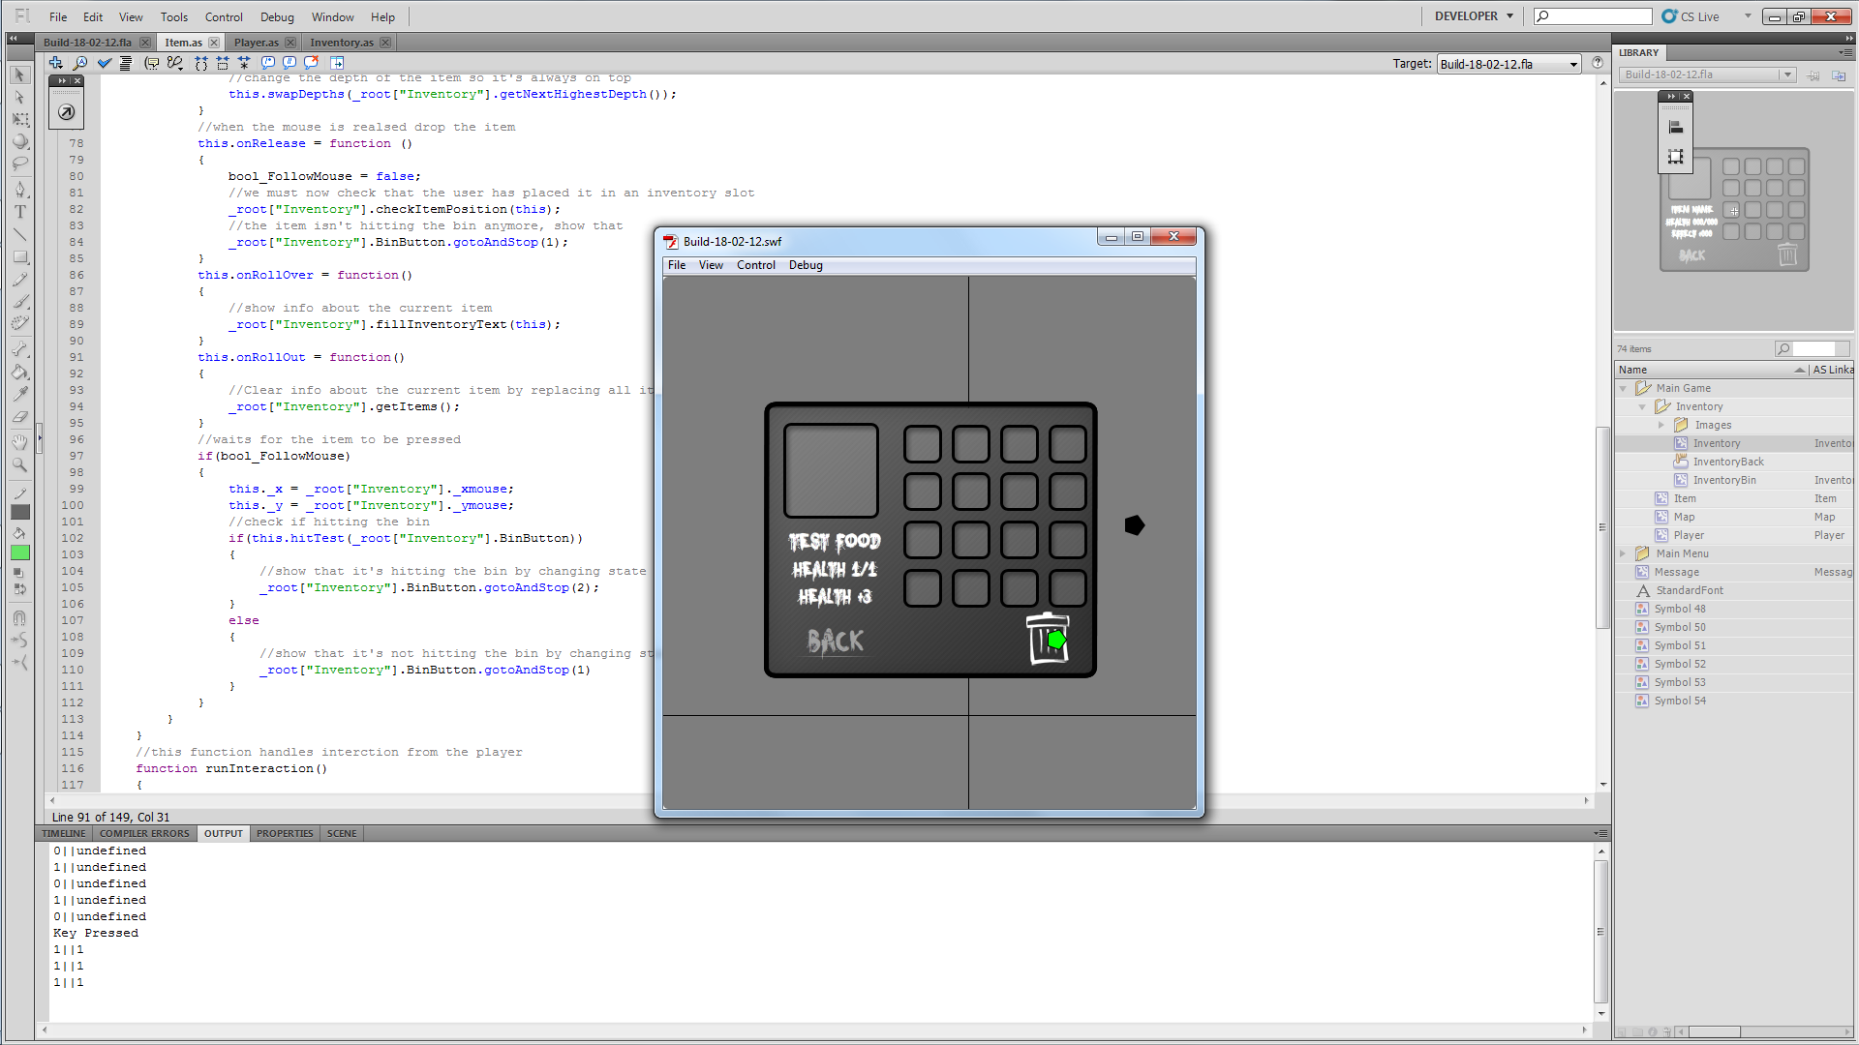
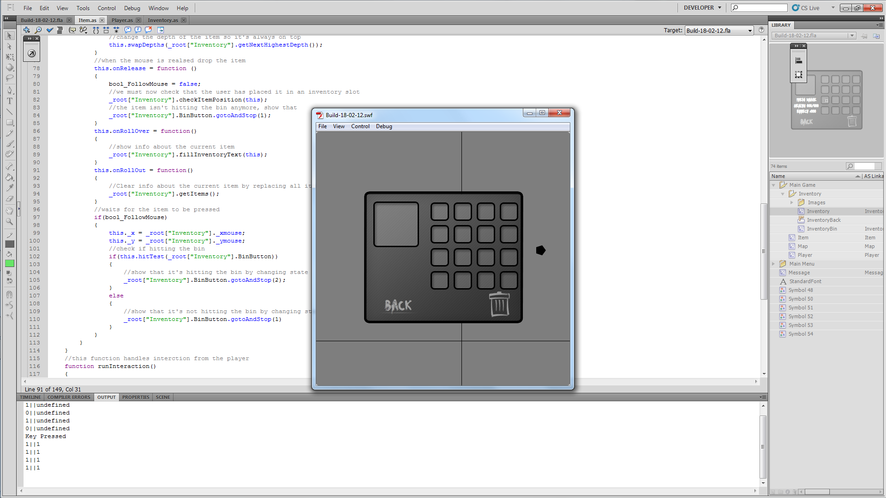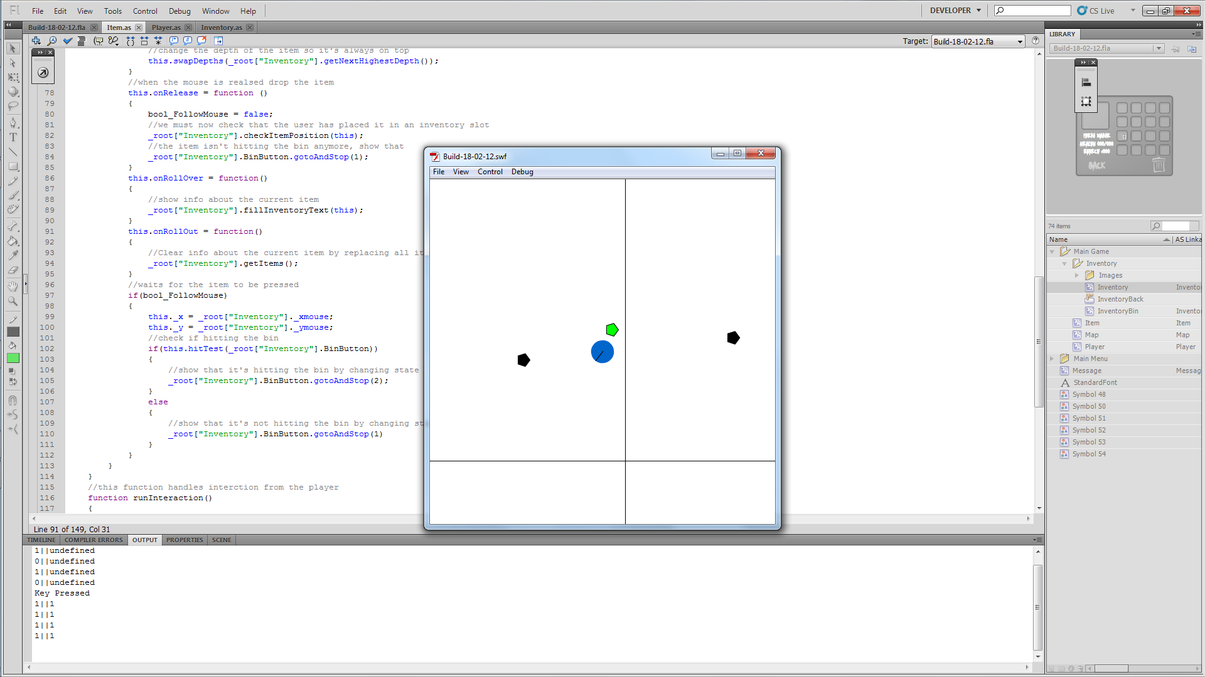

And I believe that my inventory is done. Next up, enemies! We shall start with creating a new class for the enemy.

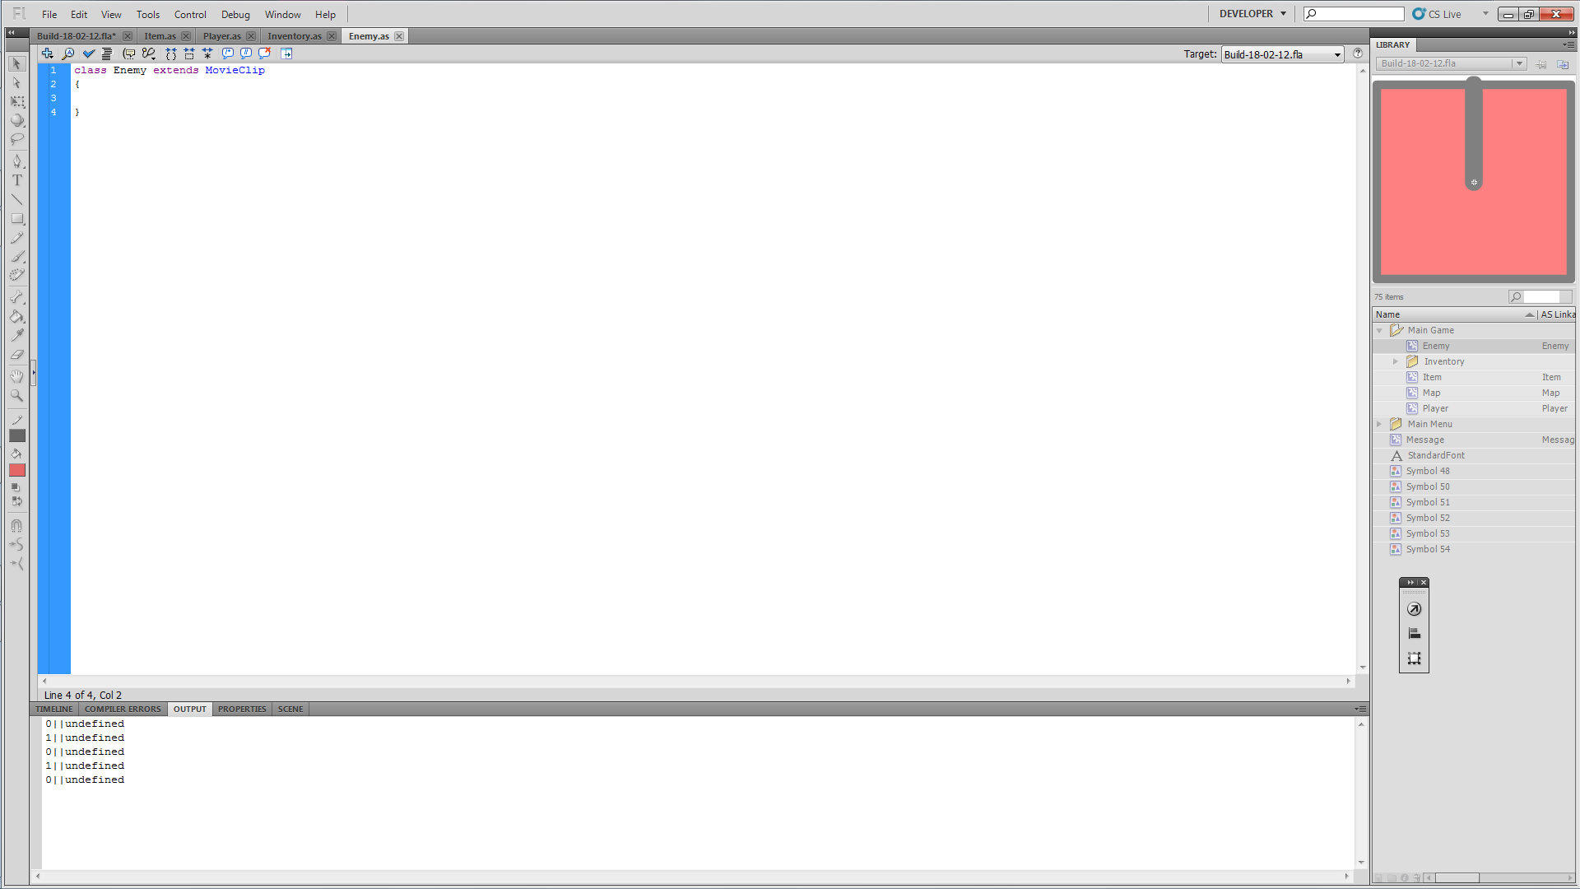

Then we need some basic variables for movement, rotation and health.
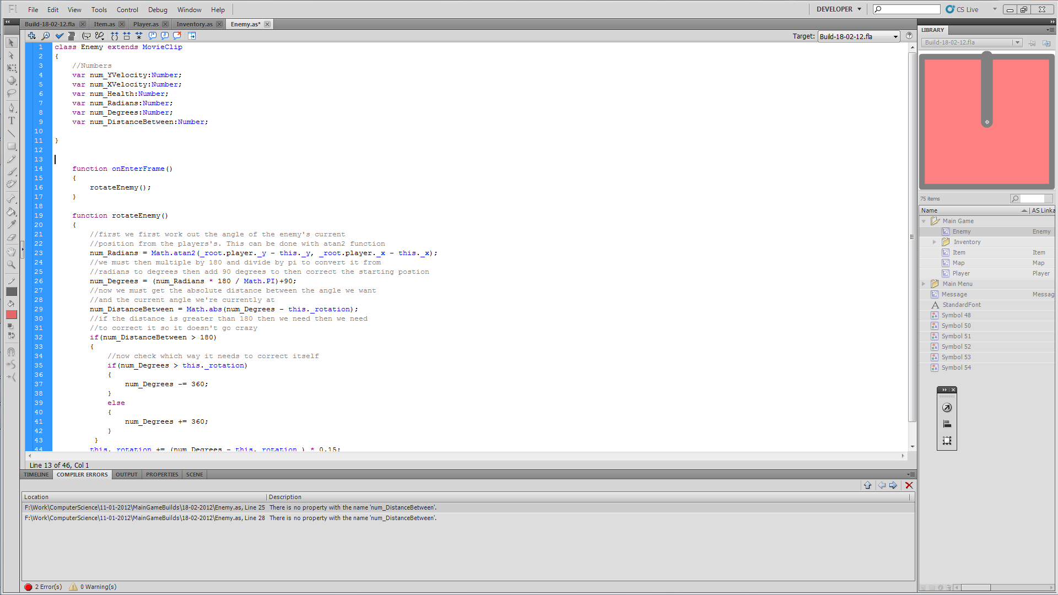

And now we add some simple rotation to face the player. This is just the same code used for the player.

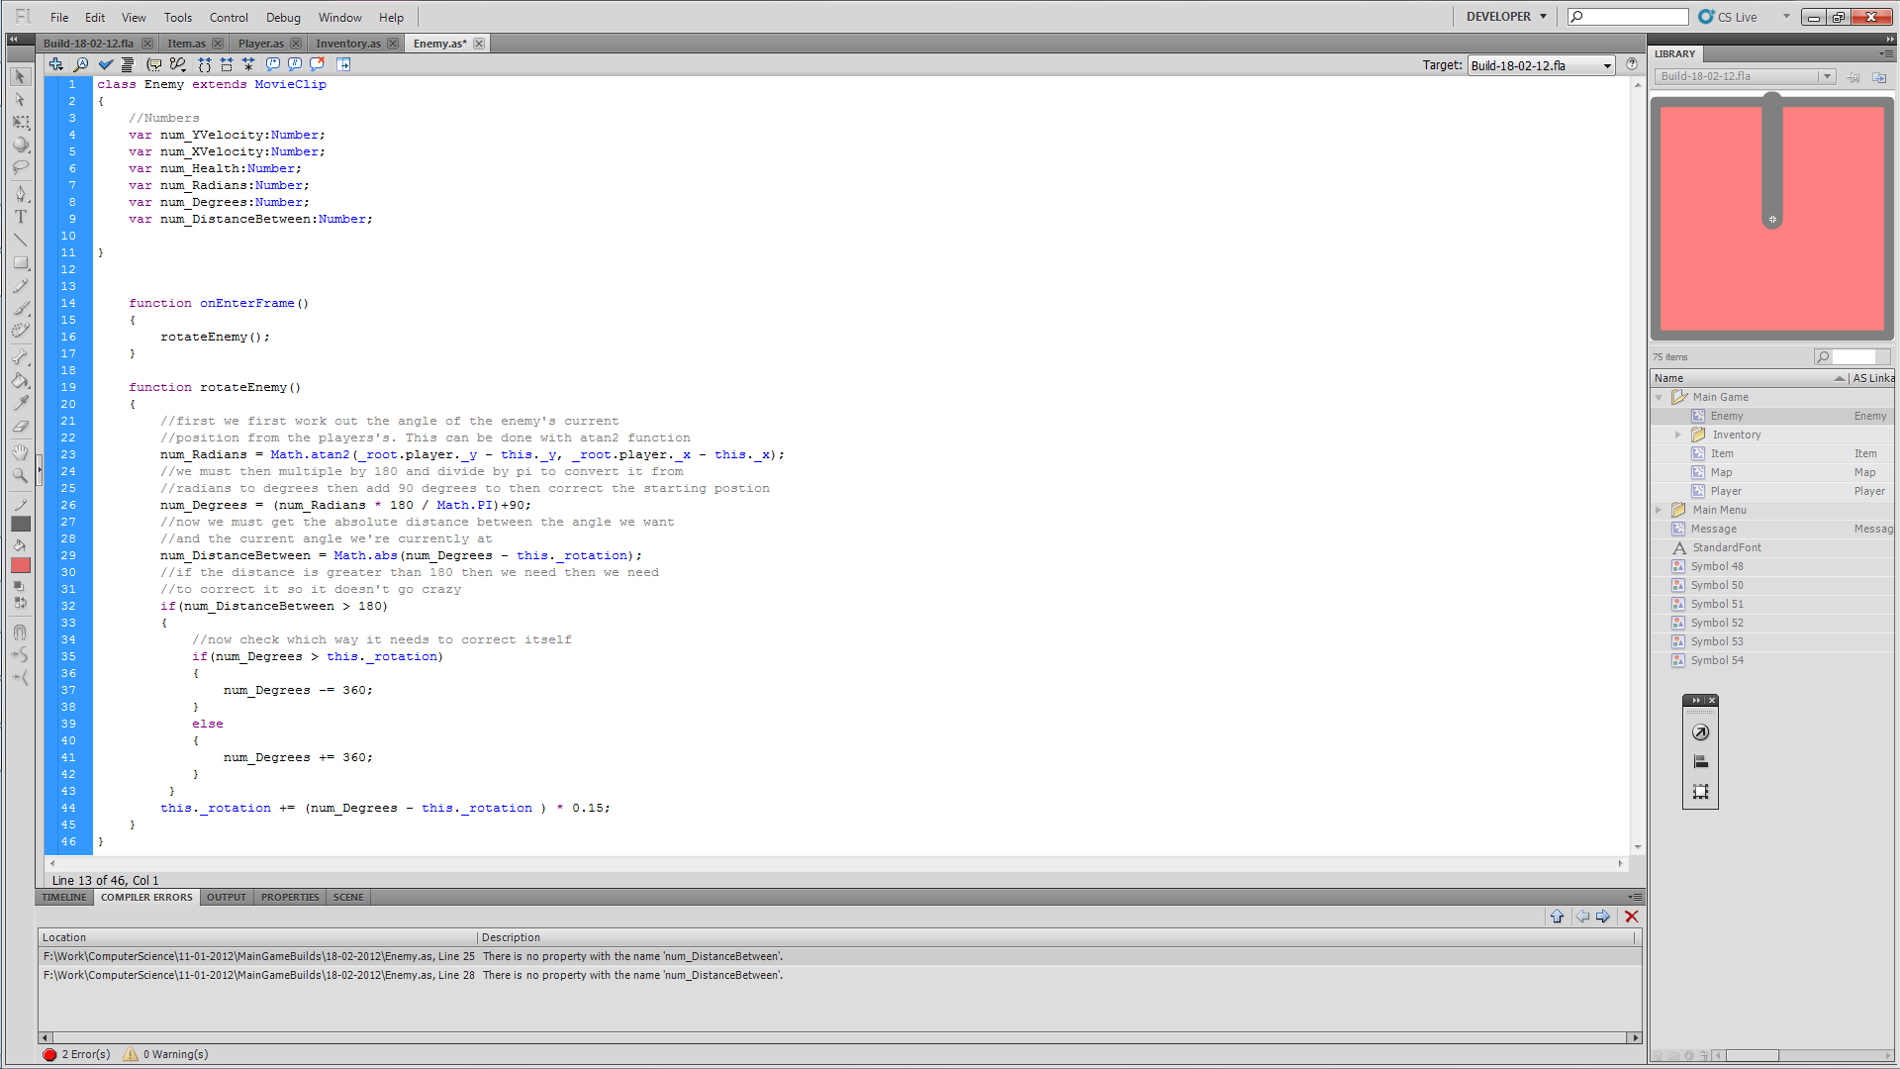

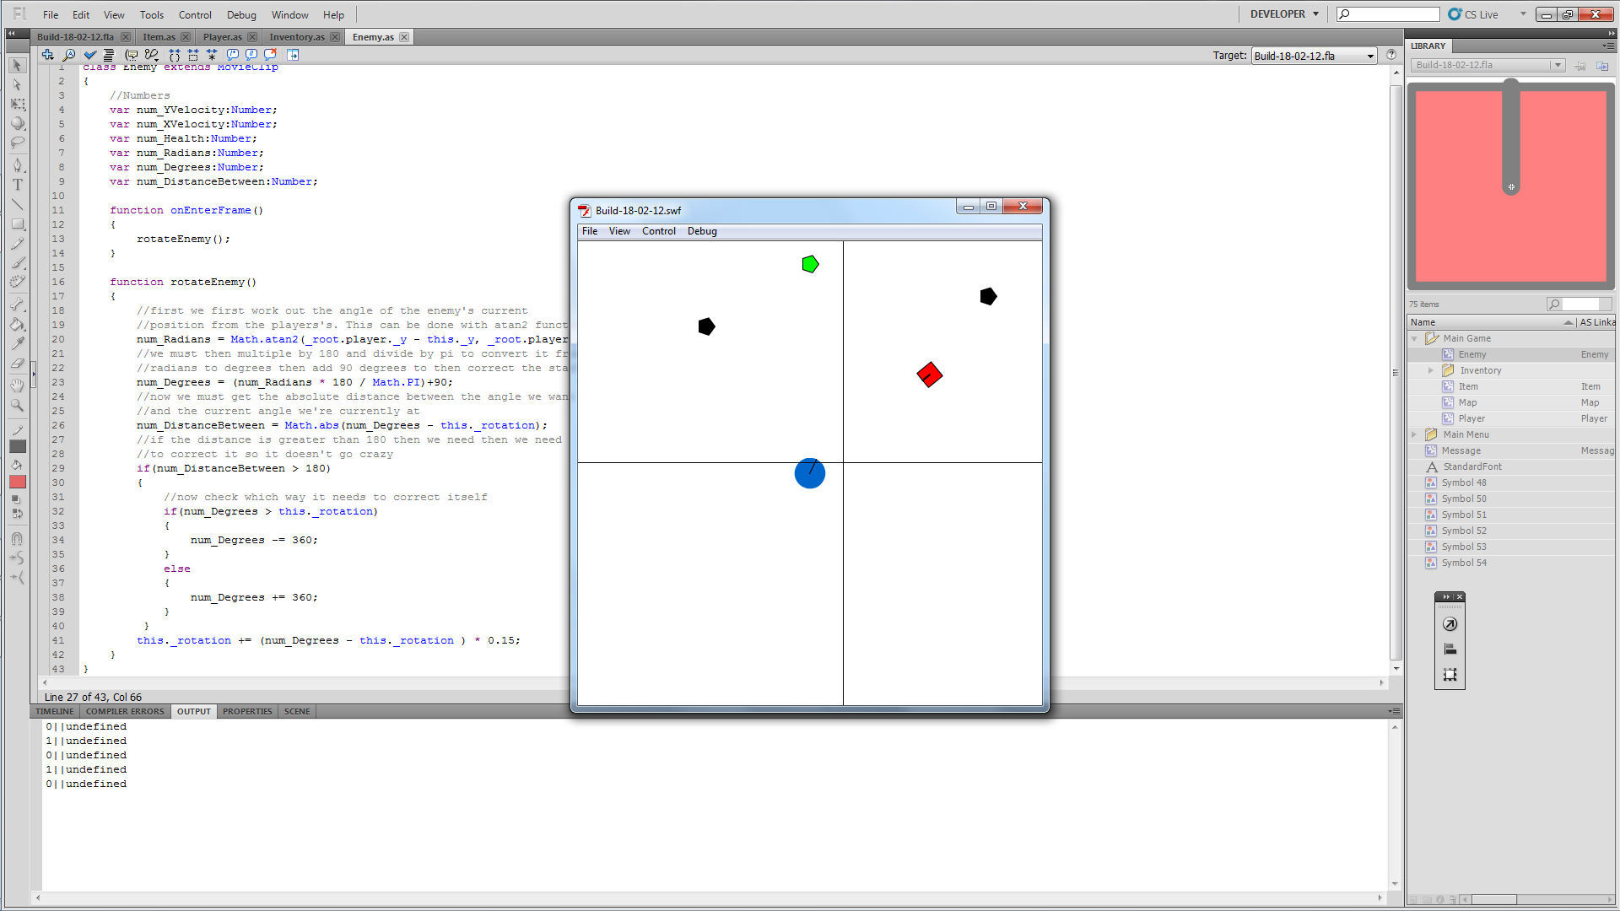

It works but it’s kind of creepy that that when you move the player the enemy moves with you. I just need to make it move in the player’s class.

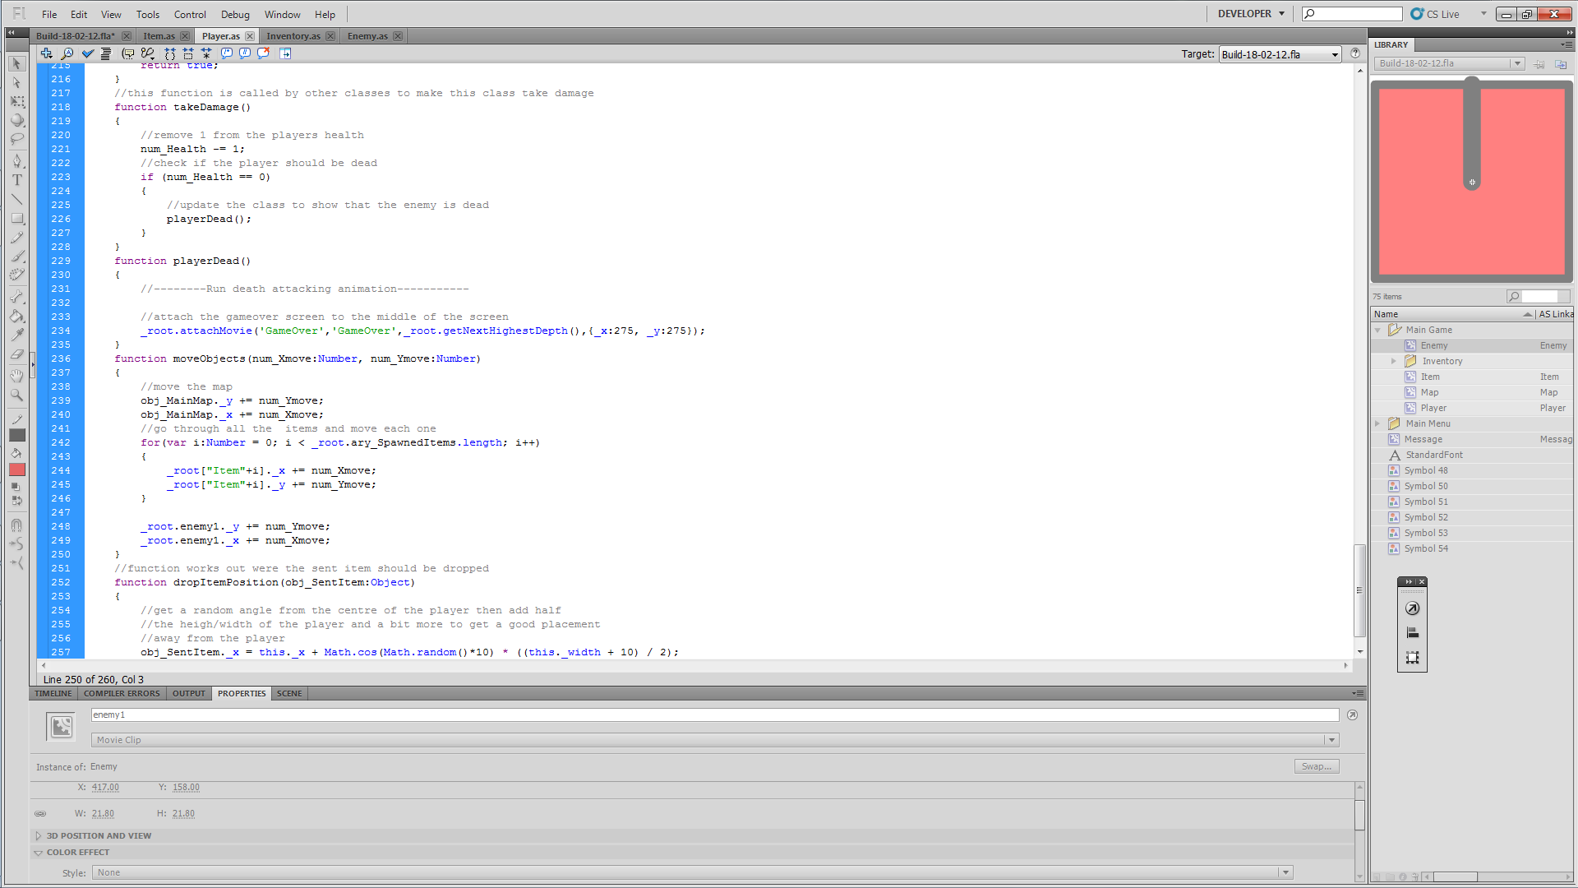

This is a temp fix until I put enemy spawning in.
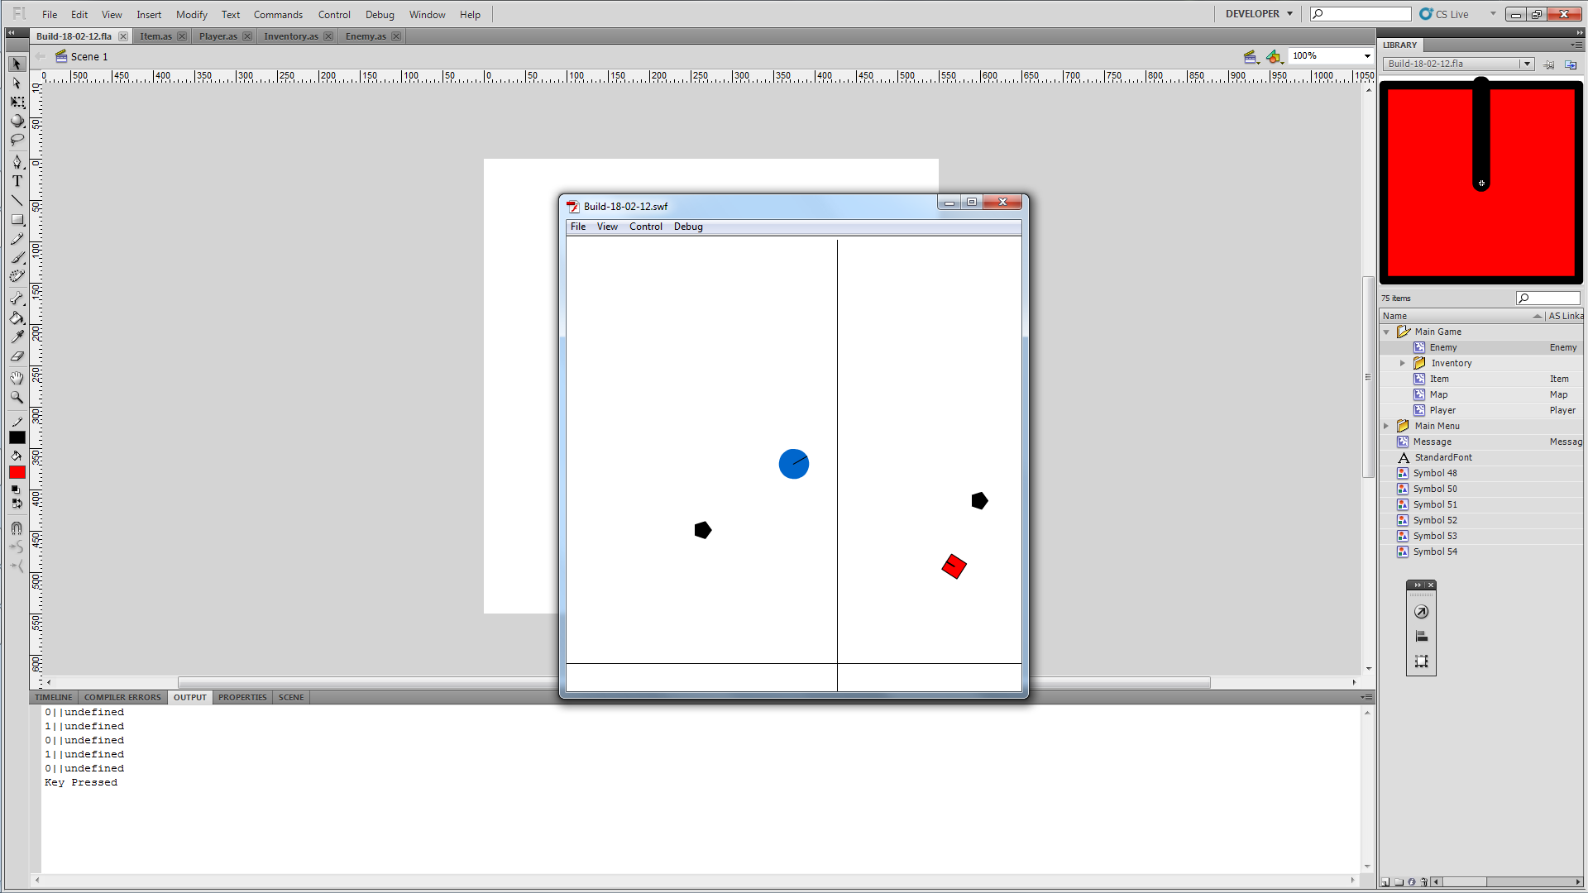

As I’m thinking about it I should add the pause if statement into the onEnterFrame function.

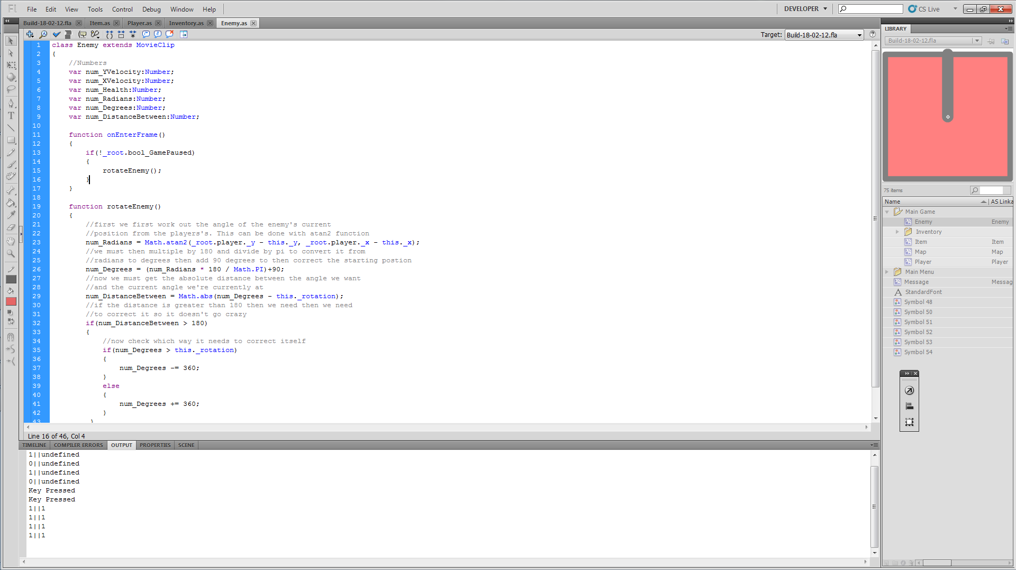

Movement next; this should be simple and pretty much like dropping the item except we want the enemy to only go forward and at a constant speed.

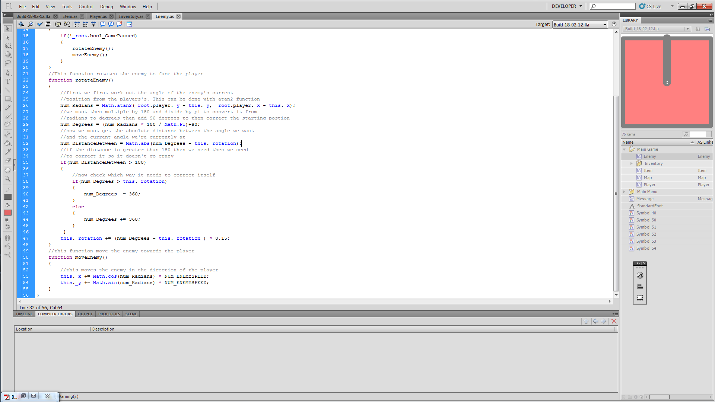

We also need to call it in the onEnterFrame function.

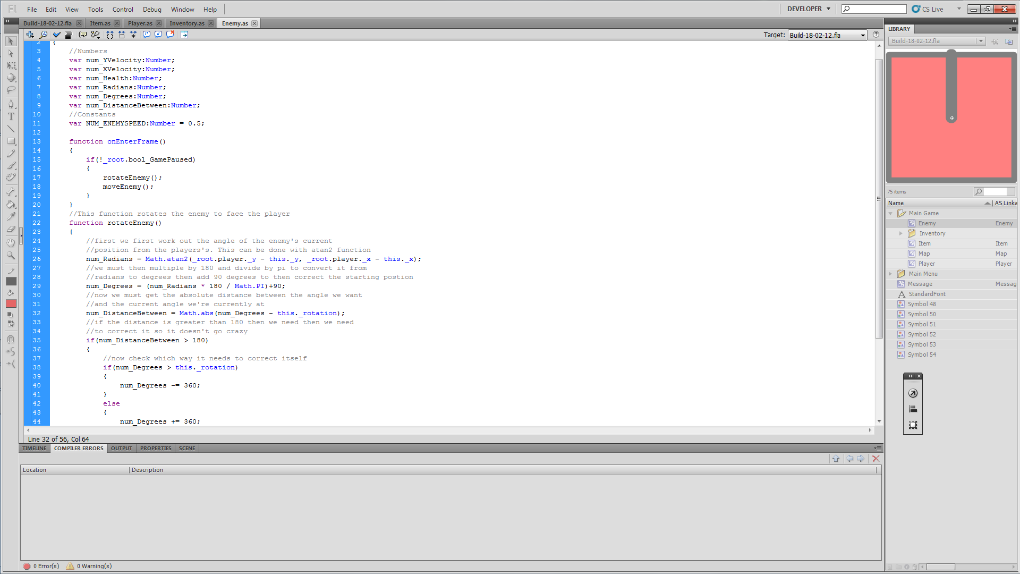

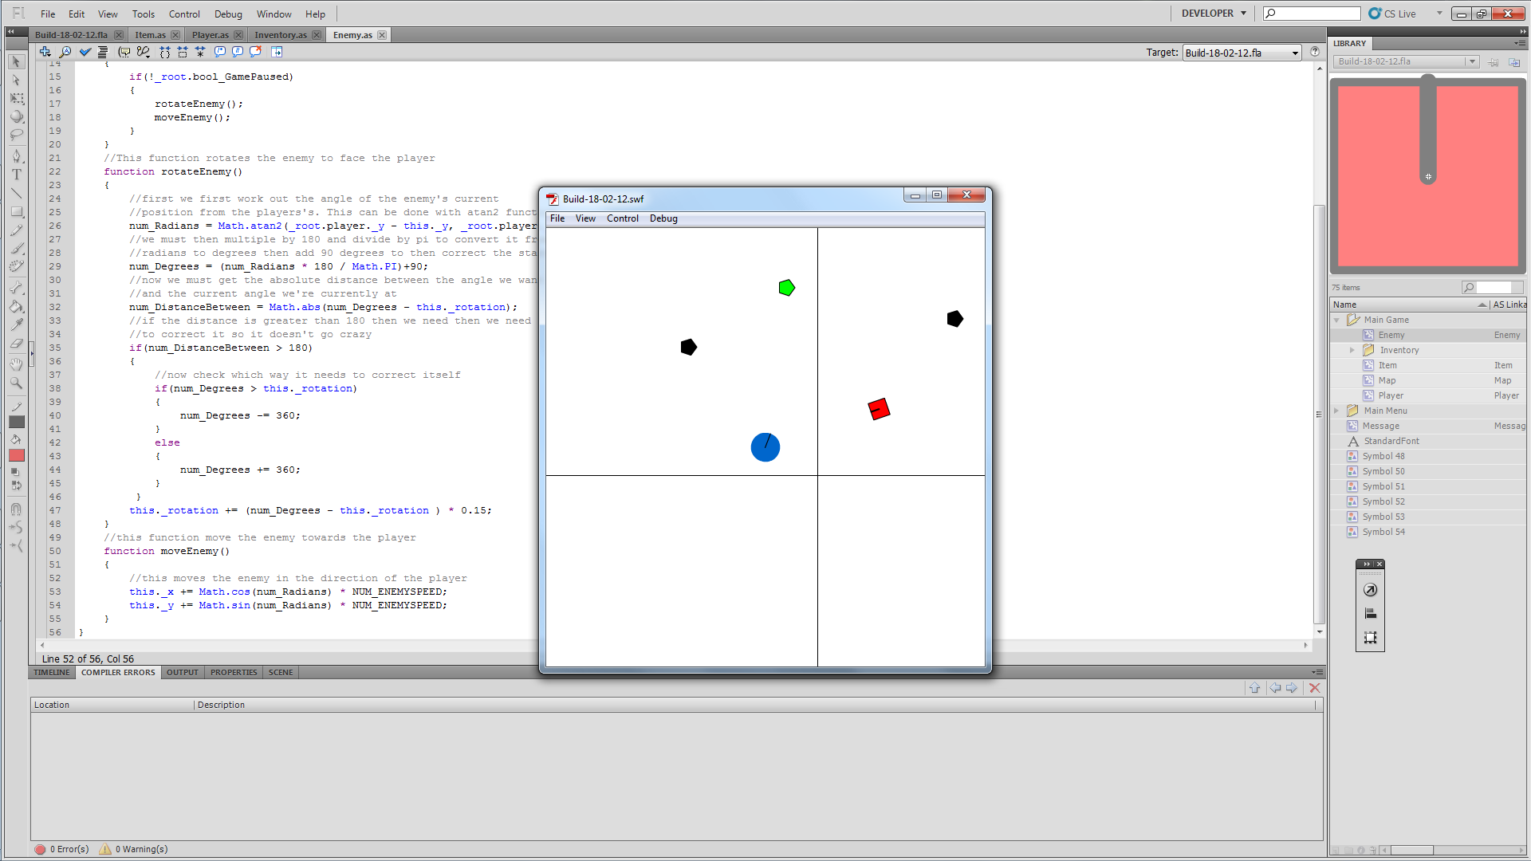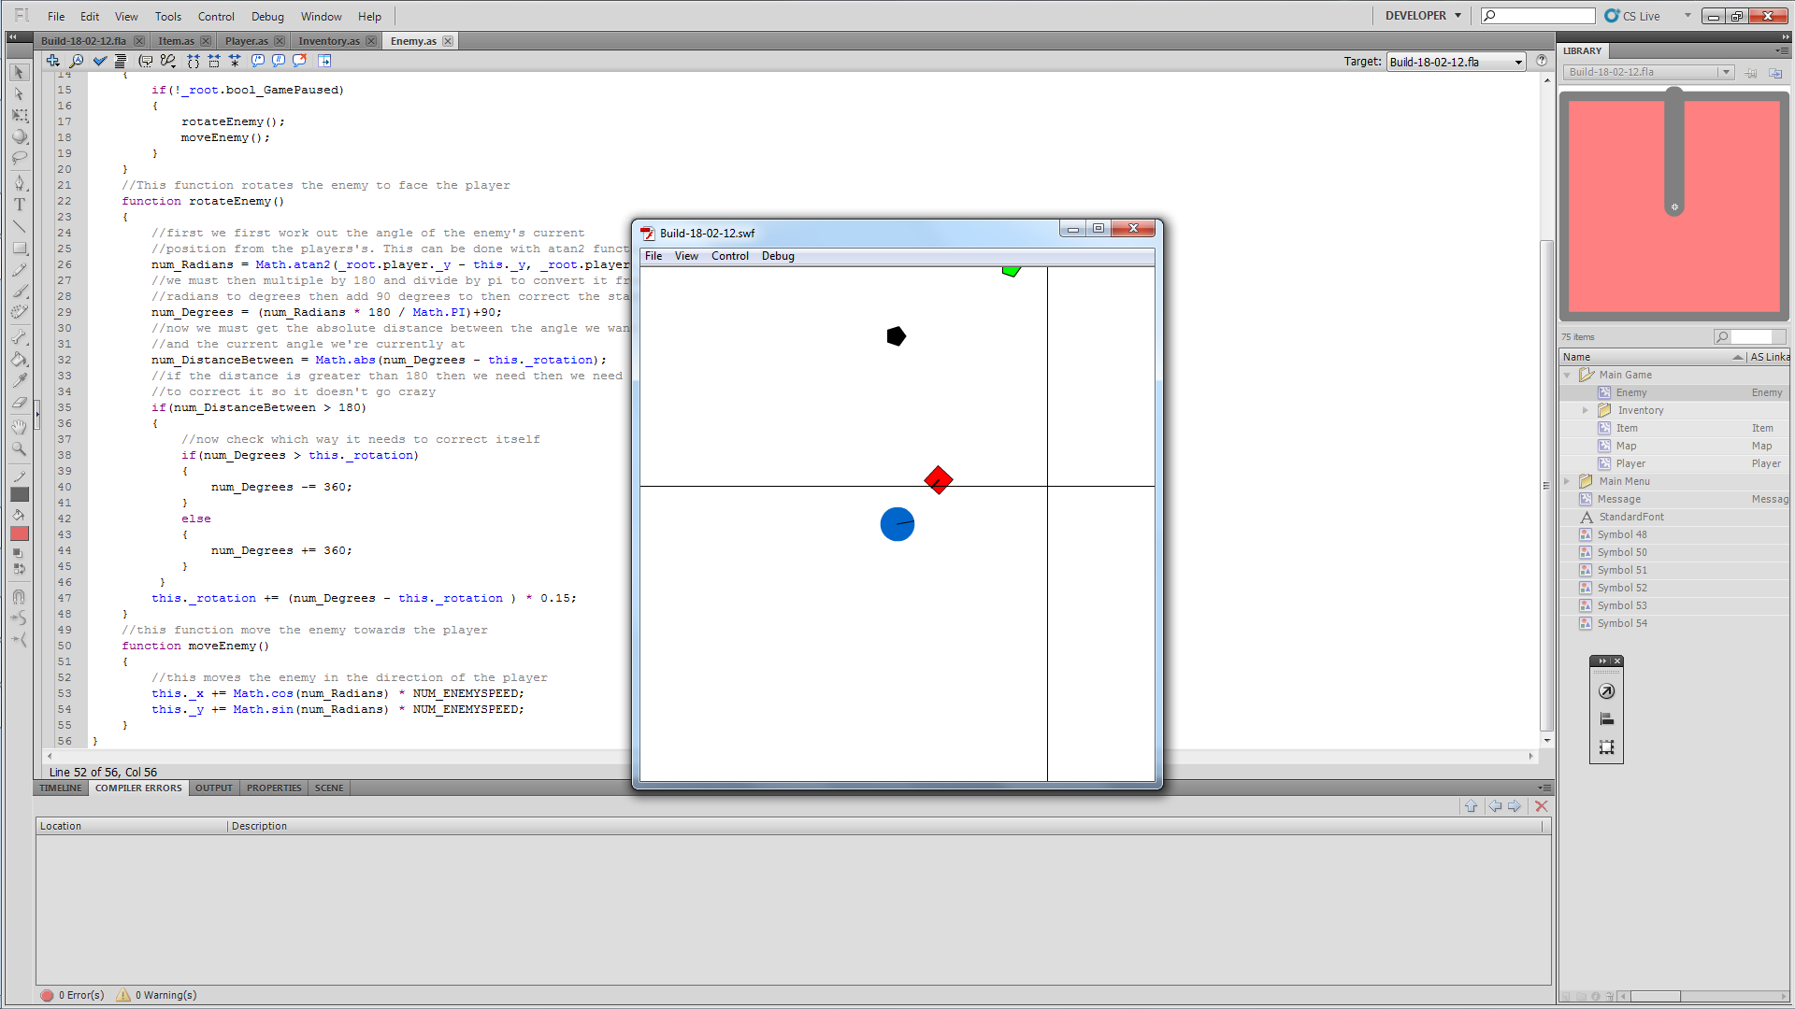

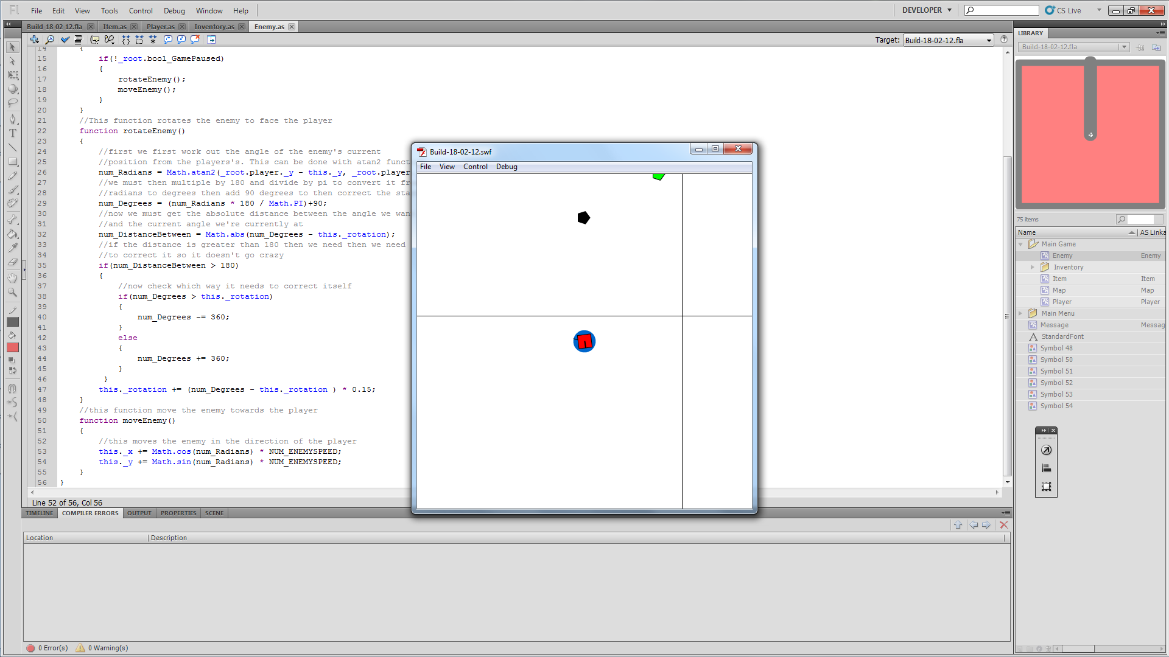
Works fine but the enemy does go inside the player and messes up. I’ll need to put a range on the enemy and tell it to stop moving and do damage. I may be able to pull off a hitTest instead of a range check.

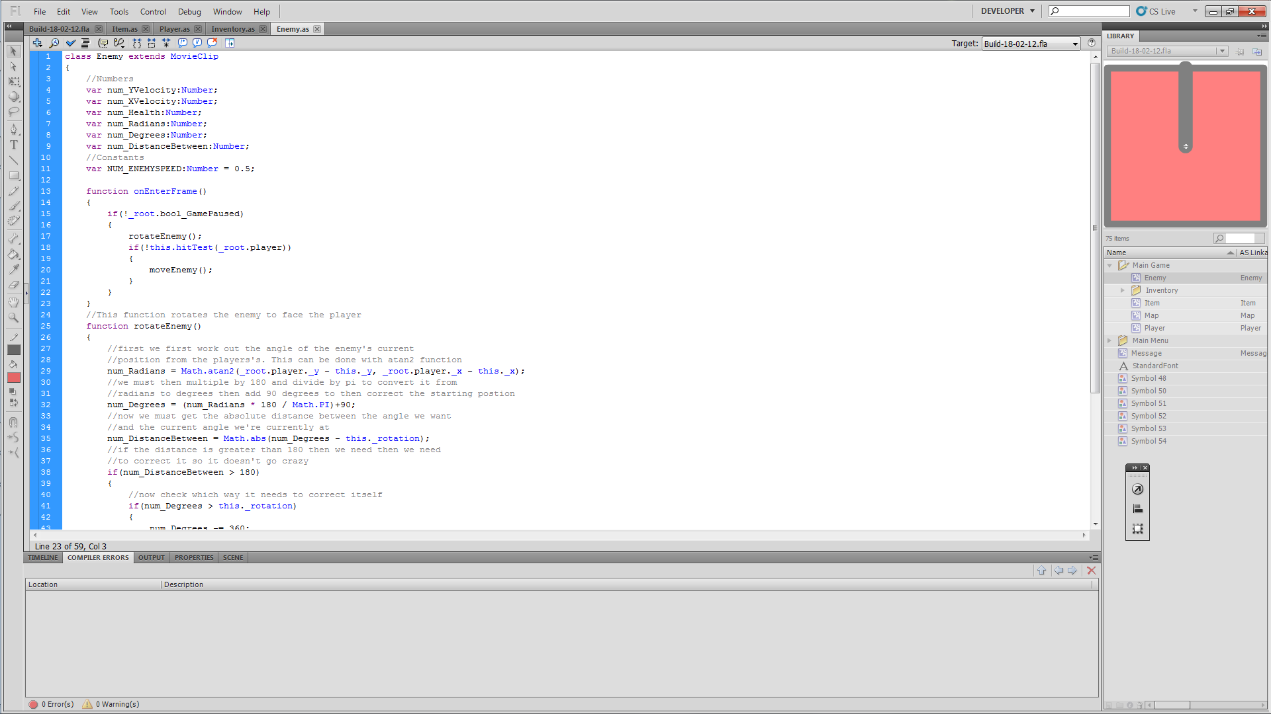

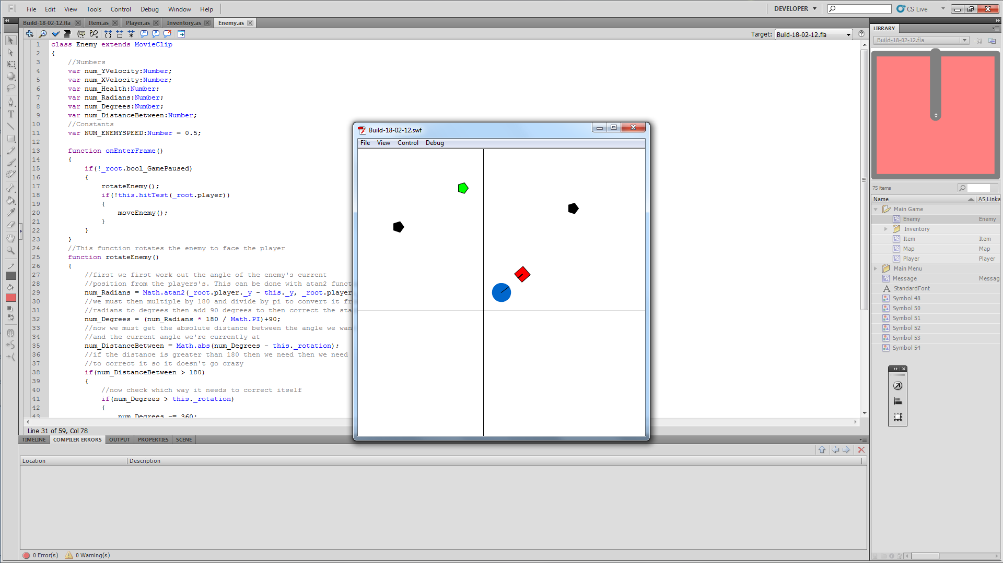

The hitTest does work but it stops the enemy too far away for my liking so I’m going to try out the range.
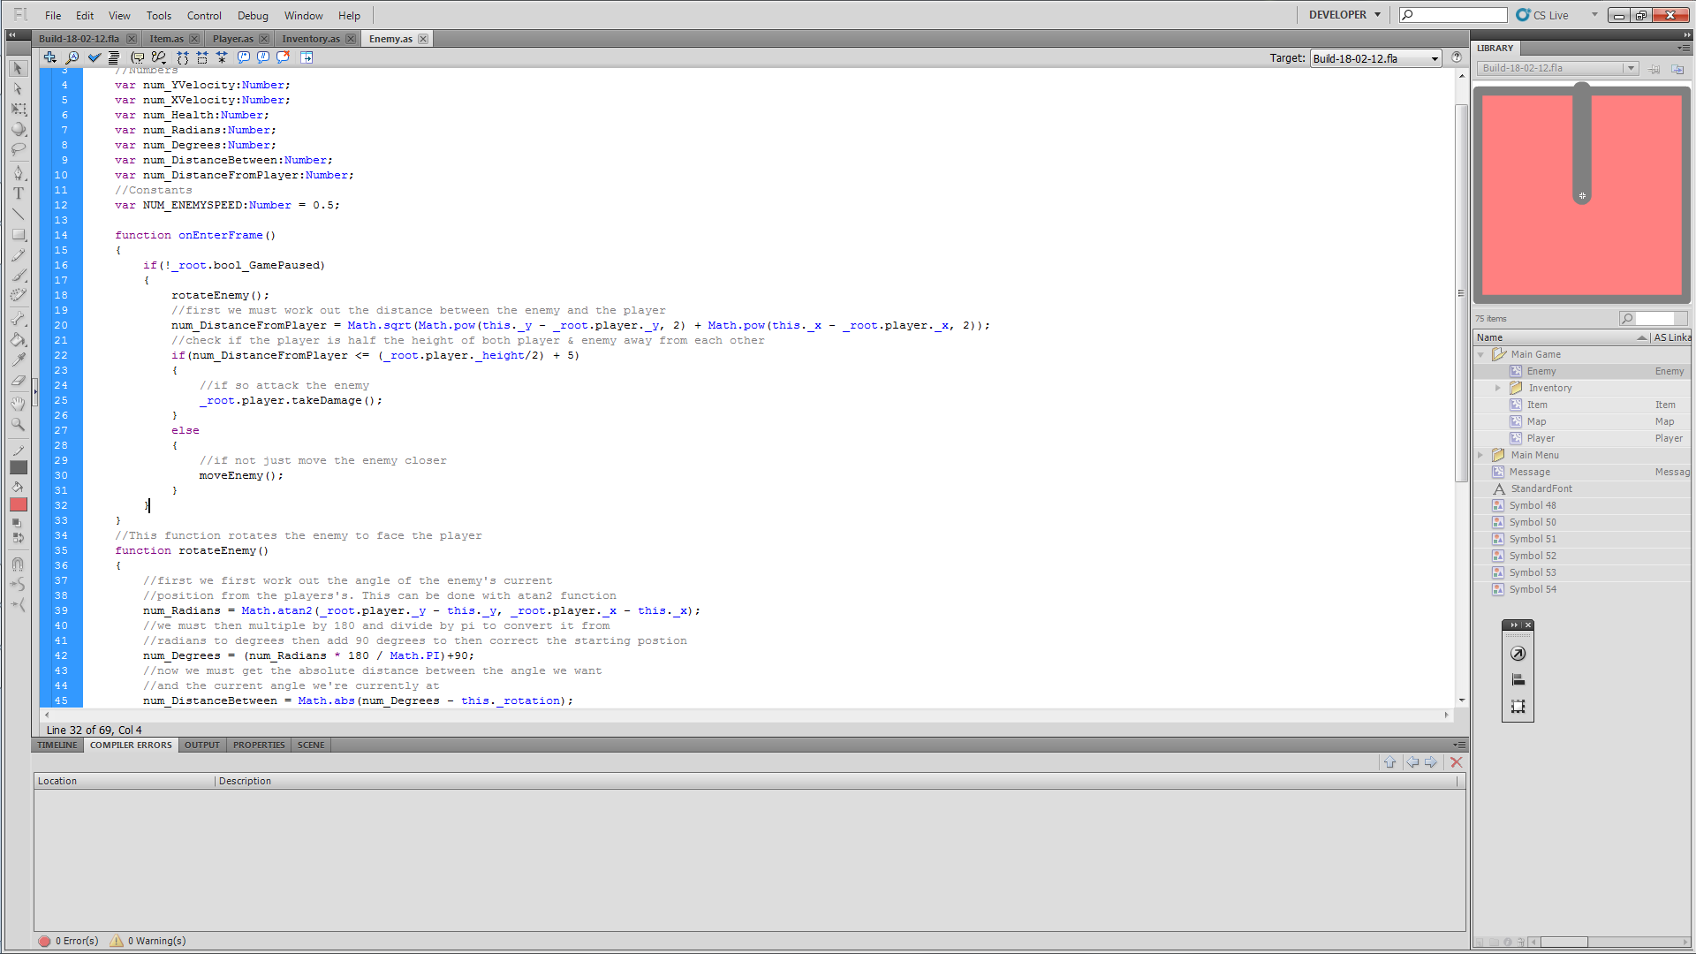
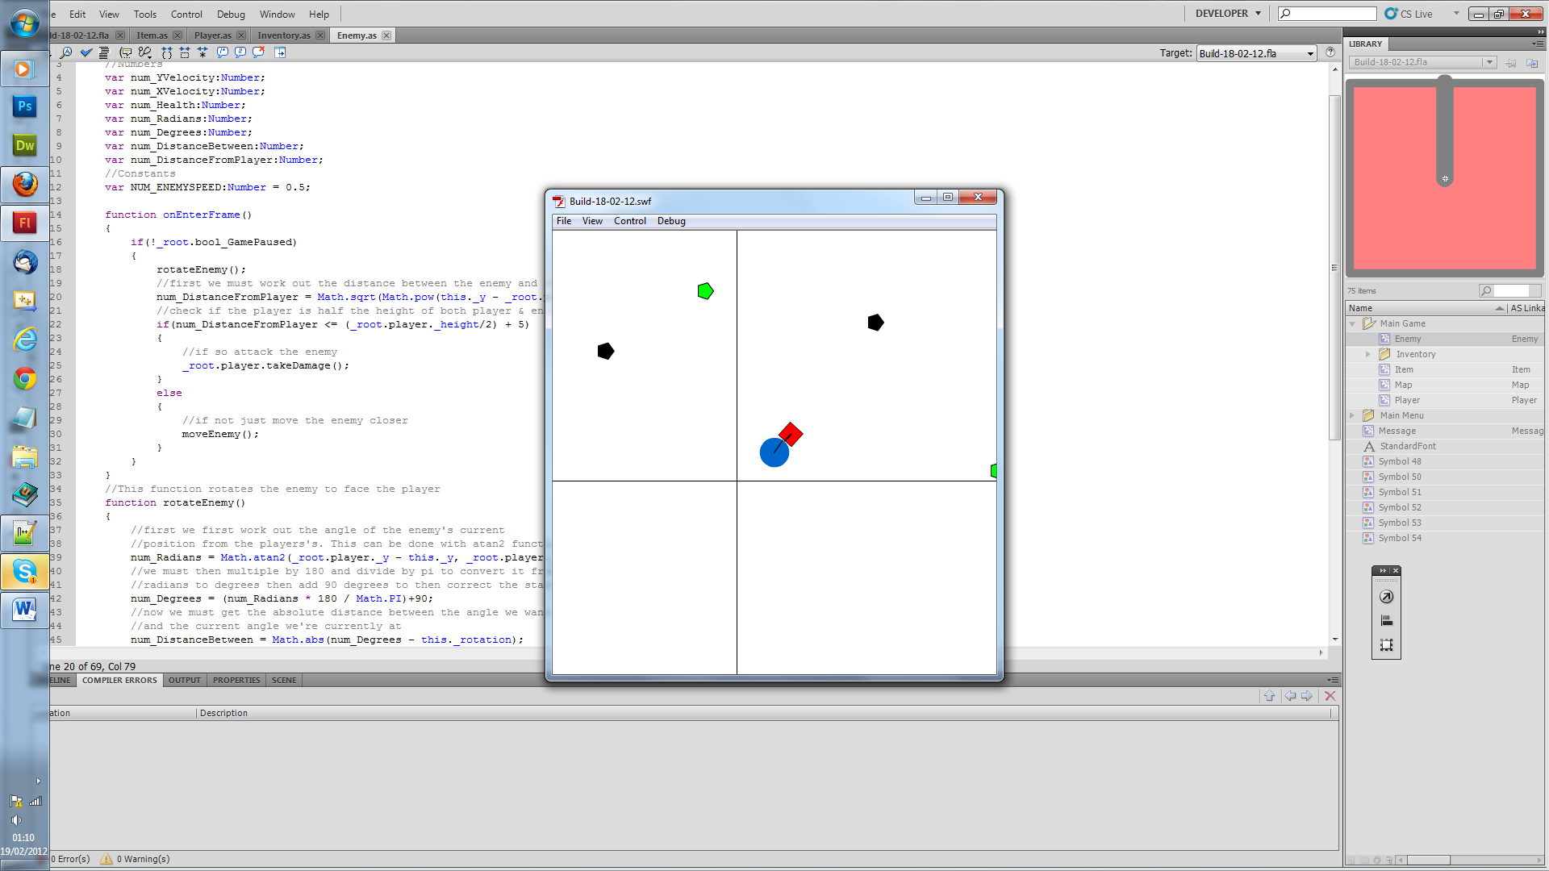

The code worked like a charm! I can also edit how close I want it with that constant. Now when the player moves forward the enemy stays there and goes inside the player, this needs to be sorted. I’m thinking that I need to stop moving the enemy in the player class when they’re touching.

19/02/2012
After getting some much needed sleep, I realised how to solve the problem above. We need work out the direction the player is moving and the direction the player is being attacked from and compare to see if the player can move that direction.

20/02/2012
After spend a day trying to work out how I could the above to work I have given up. I’ve decided to work on just checking if the enemy is touching the player then building up for there.

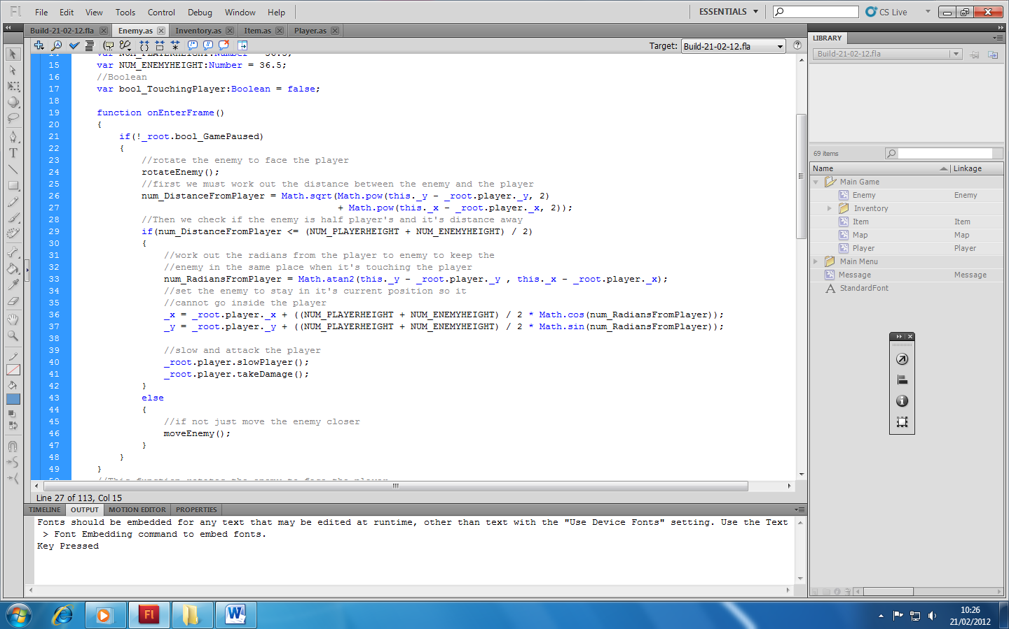
In the onEnterFrame function an if statement checks if the distance between the player and this enemy is less than or equal to half the height of the player and this enemy (this makes the not go inside of each other) if this is true the enemy is not allowed to move and has to stay in its current position. It also calls two functions, one to slow the player and the other to cause damage. These functions currently don’t exist. If the statement is false the player must move.
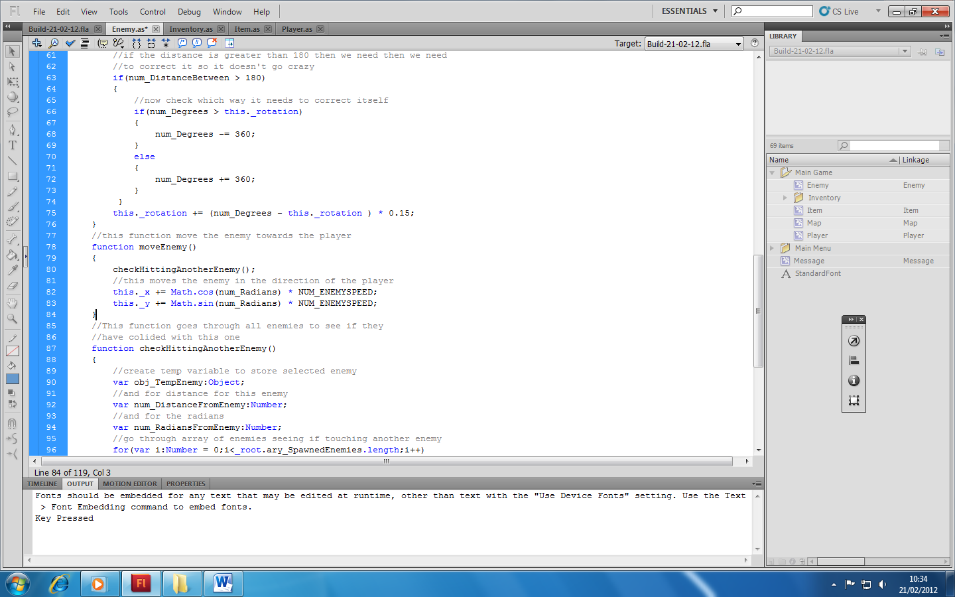

When moving the enemy checkHittingAnotherEnemy is called to correct the enemy is it’s touching another enemy.

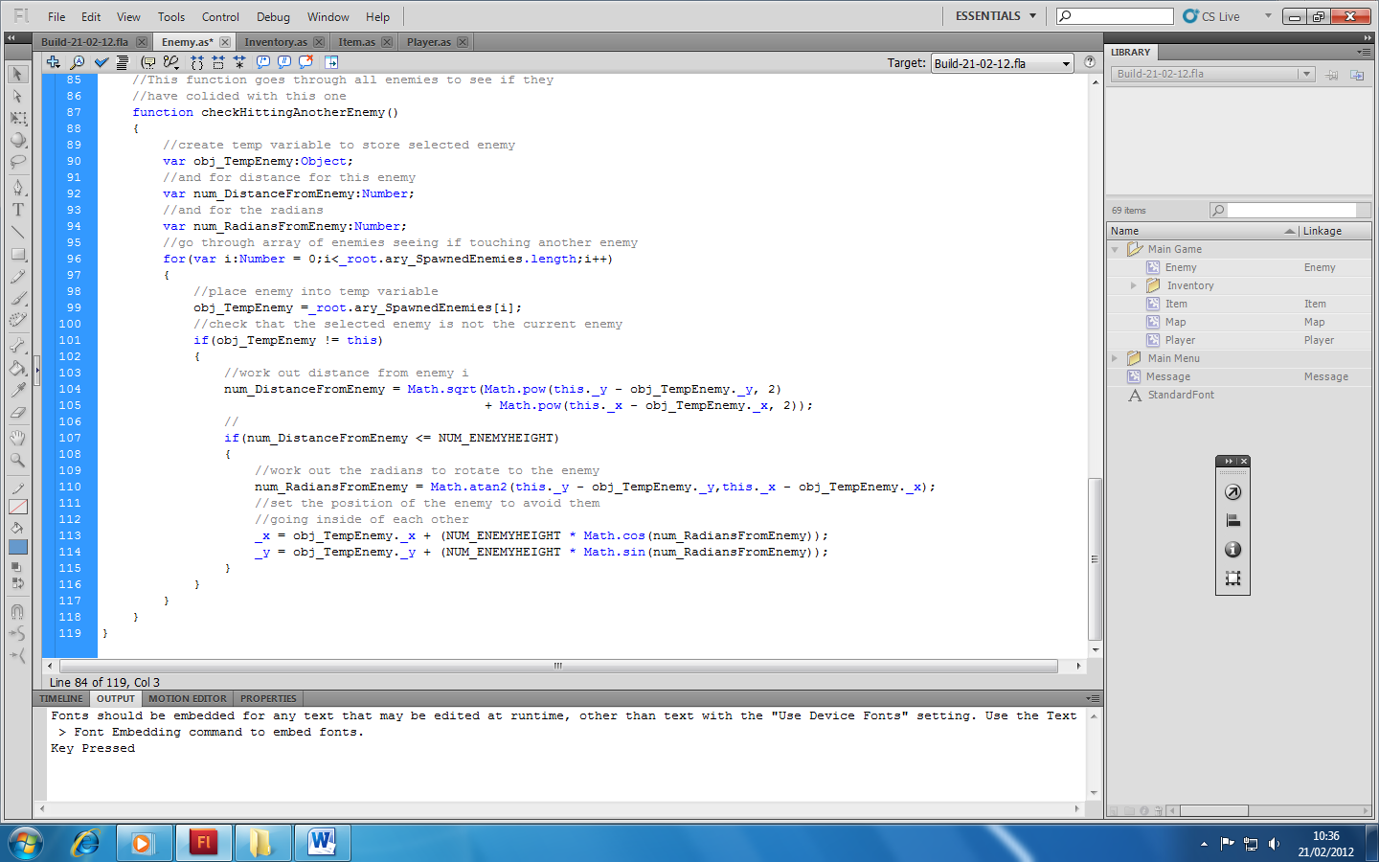
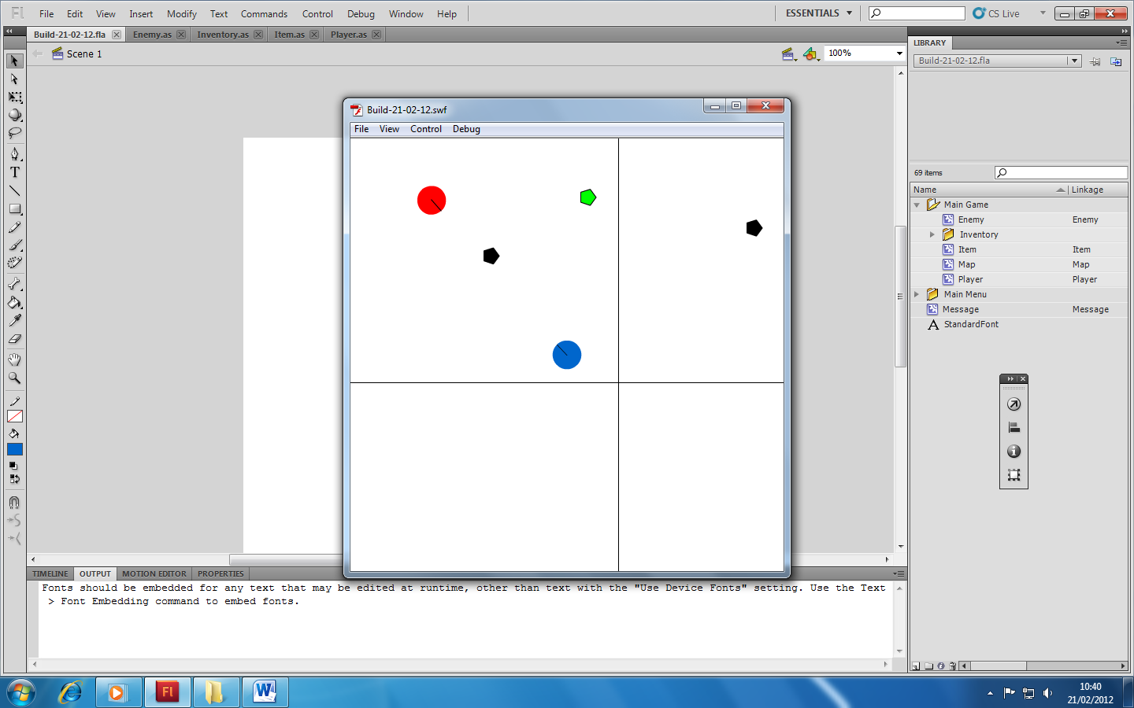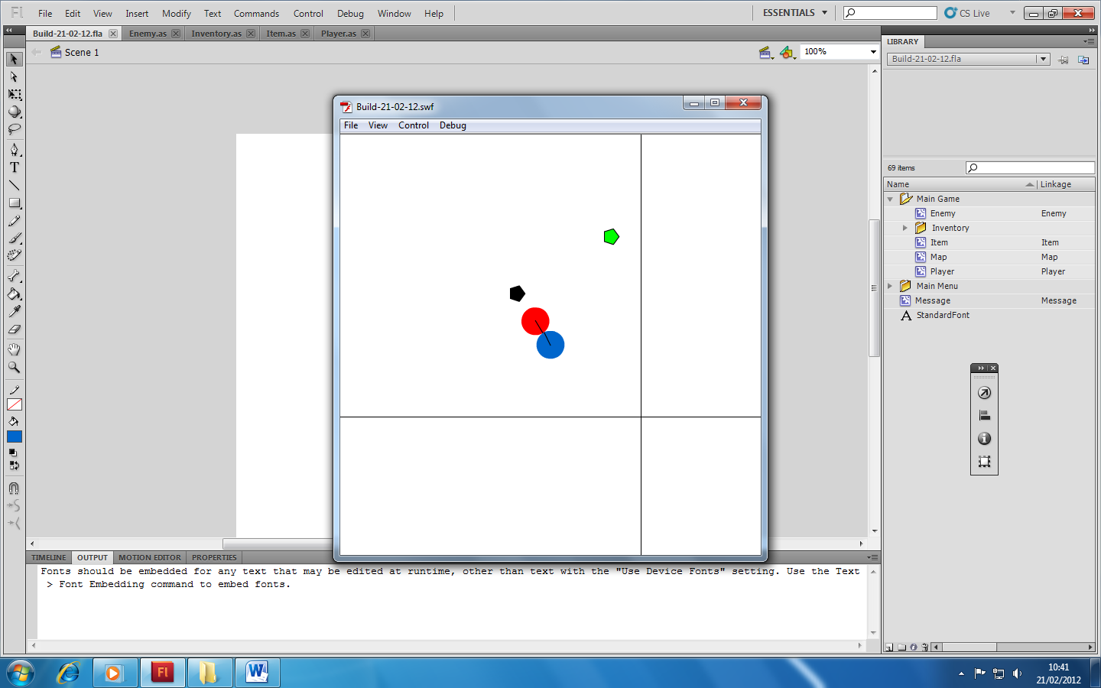

Currently you’re able to easily push the enemy out of the way. This will be sorted once I put in the slowerPlayer function in.

21/02/2012
Today I am going to be adding the slowPlayer and takeDamage functions to Player.as.

slowPlayer will work by changing the friction to the players movement. First we need to show that num_resistance is not a constant anymore.

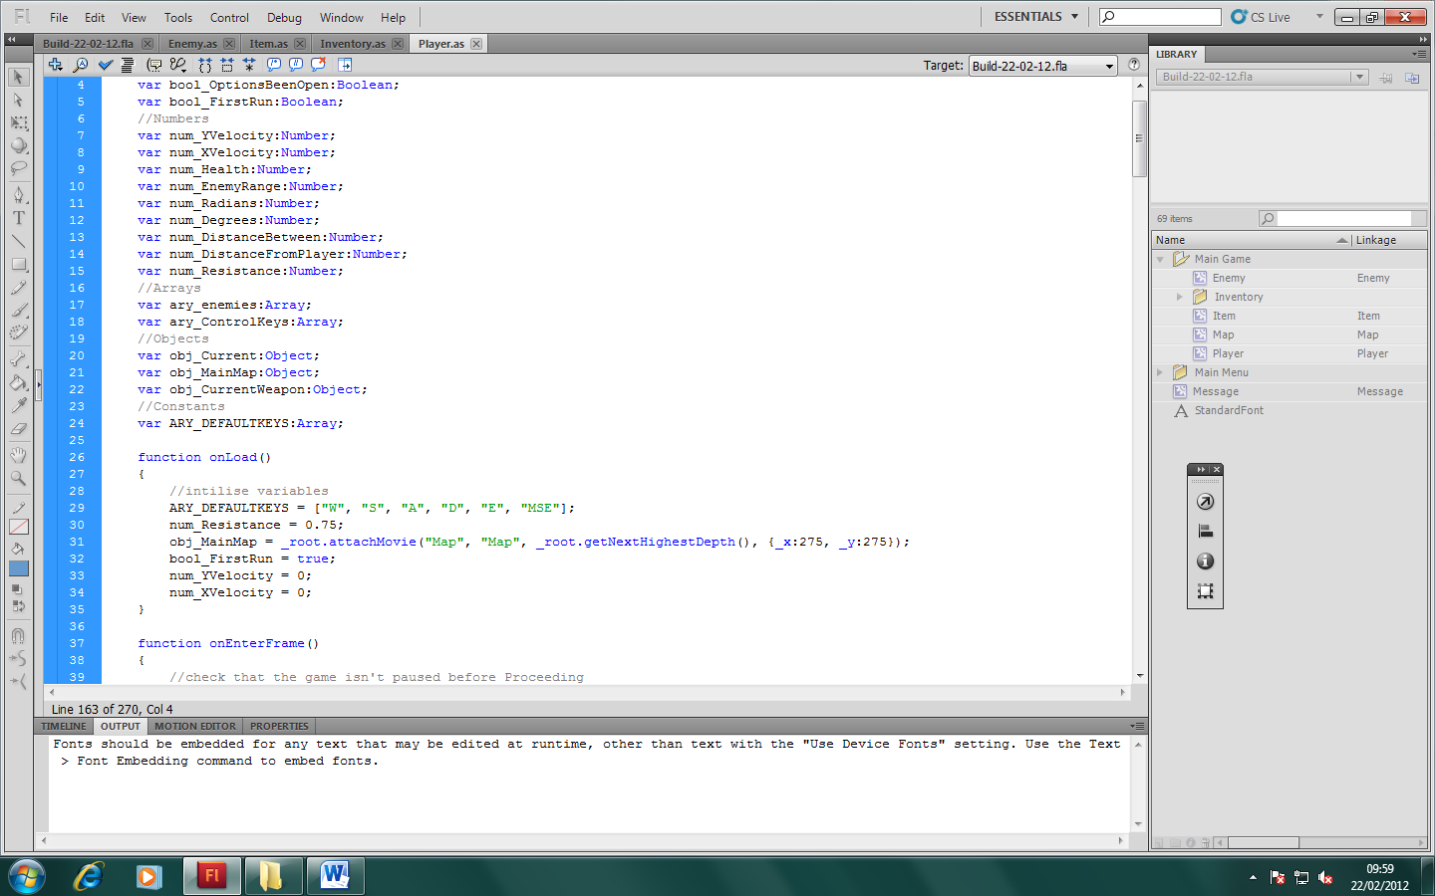

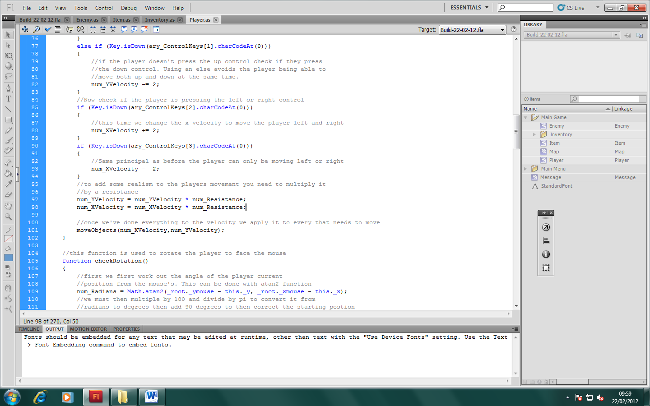
Now we apply a manipulation in the slow player function.

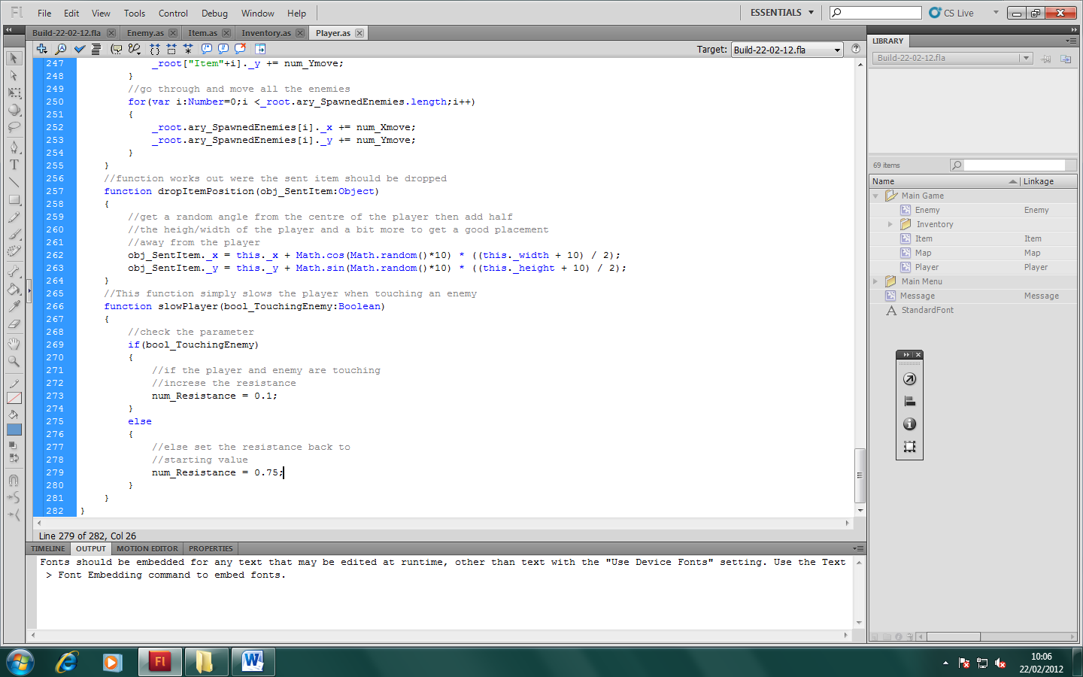

Now we call it from within the enemy class

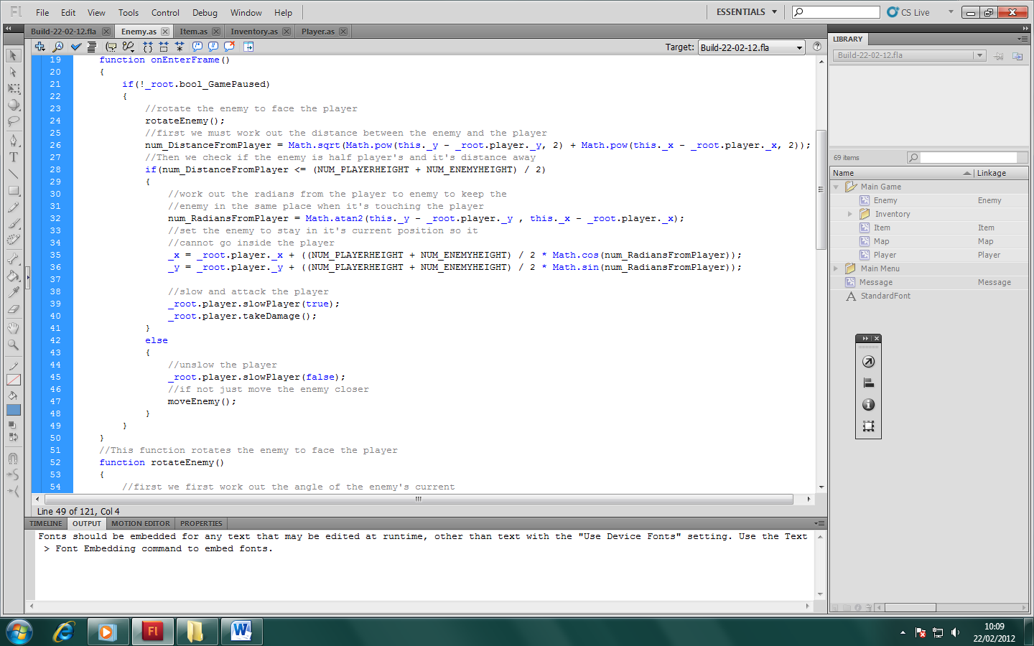

This works on a single enemy but annoyingly doesn’t work for a group. I believe this happens because the slowPlayer function is called by the other enemies to reset the resistance counteracting the effect. I need to rewrite the function.

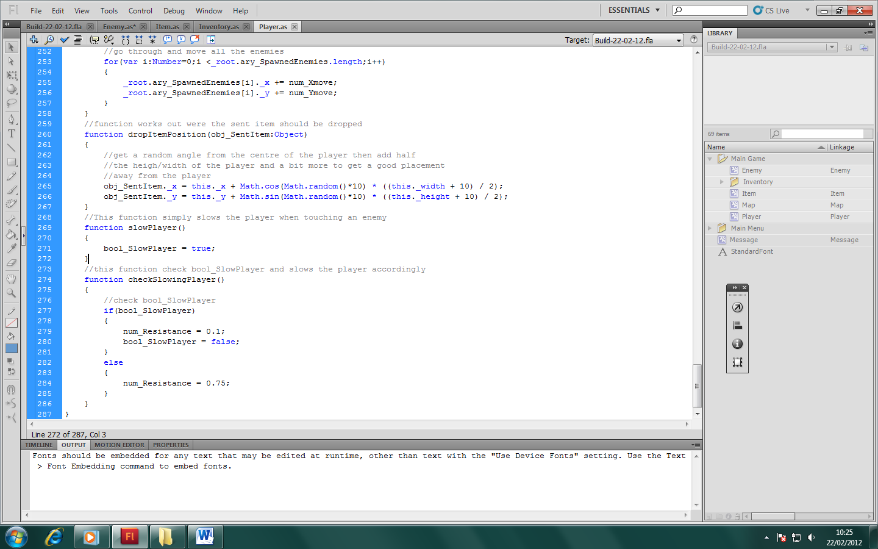

The function simply changes a variable which is checked every time before the player is moved.

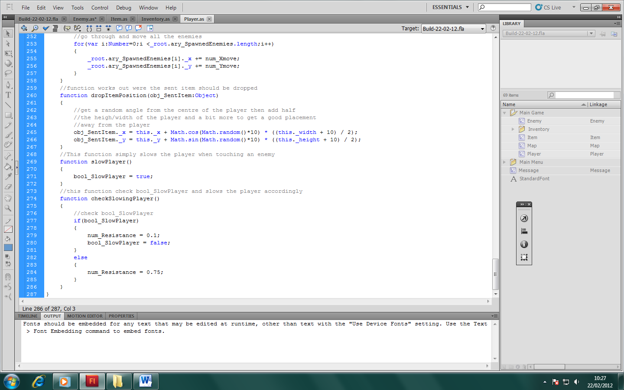

checkSlowingPlayer is pretty much the same as slowPlayer was before. This way it works better because it’s checked all the time the player moves so it can handle multiple enemies.
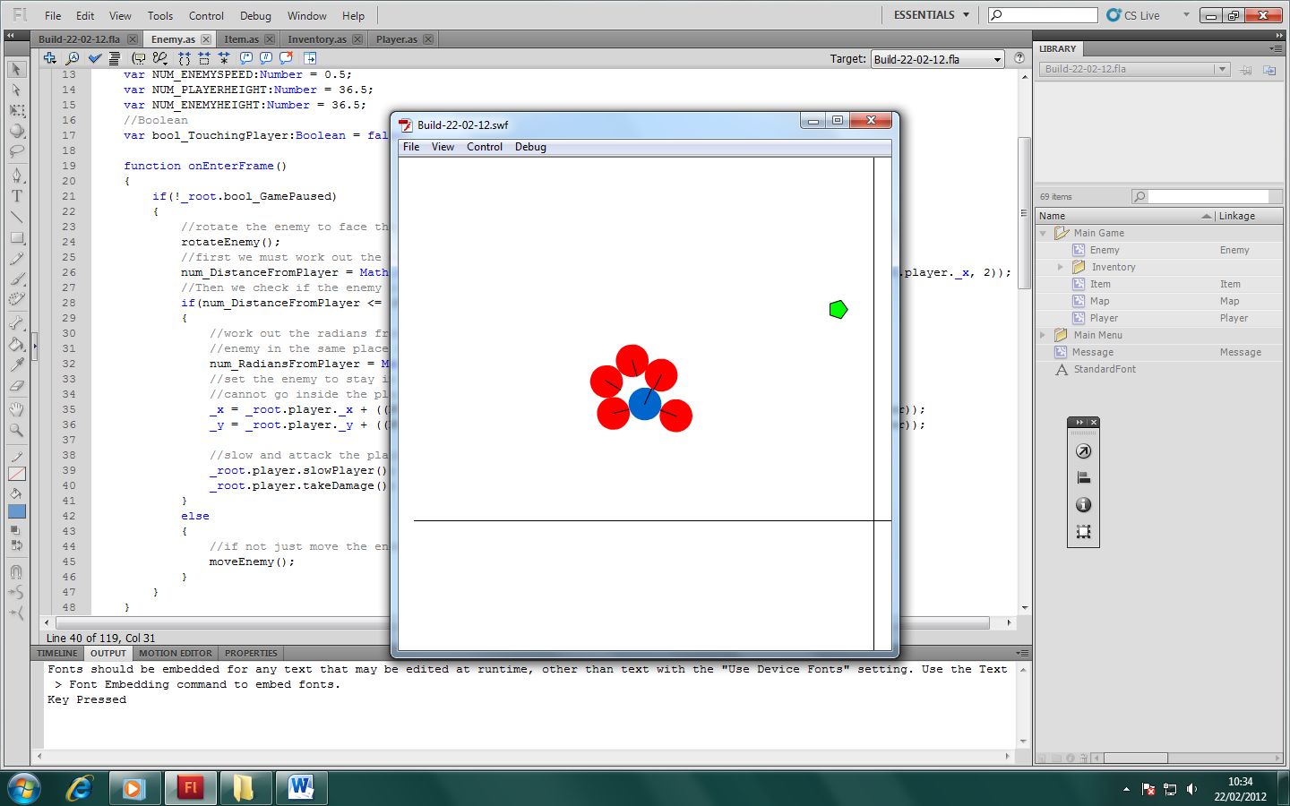
It gives of the effect that the enemies are grasping the player and they cannot get away easily.

Next thing to do is the enemy spawning. Enemies should not spawn on screen. But they can spawn around the screen. I have also found that I need to have a limit of about 20 enemies being on screen at once because of lag. I may be able to utilise this by having the enemies in a pause like state when off screen. First I’m going to set up spawning; this calls for a new class.

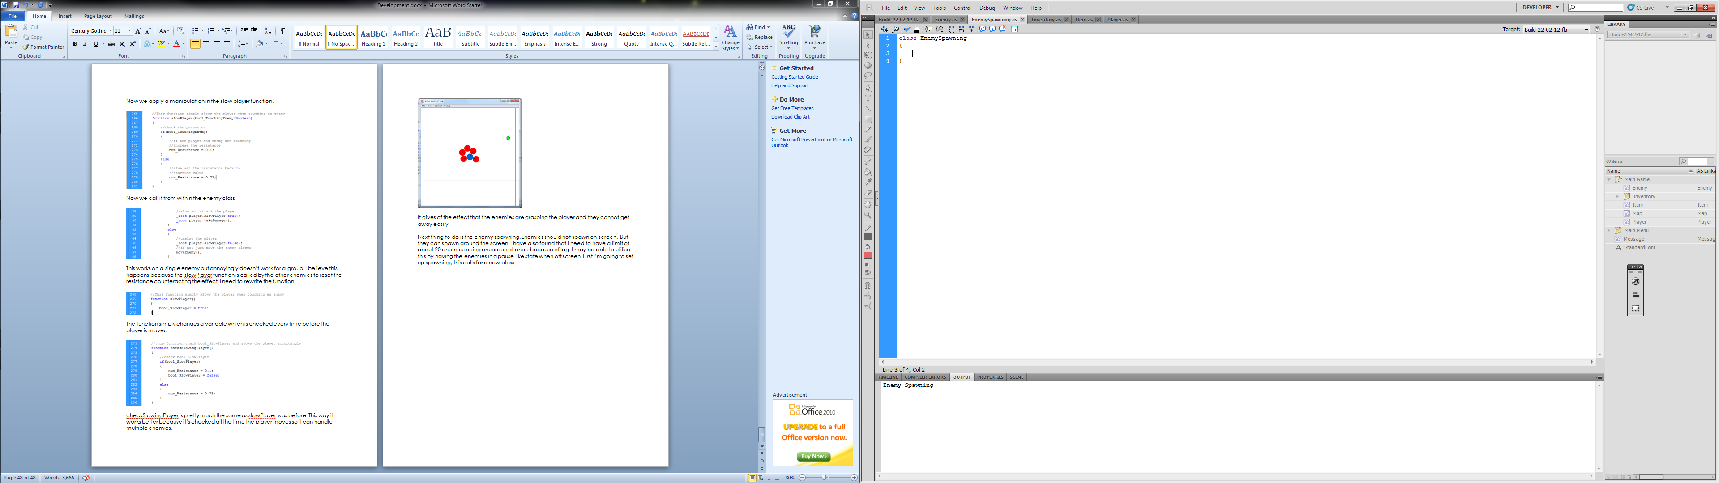

We then need to create an instance of EnemySpawning.as. This can be done when the game is first loaded.

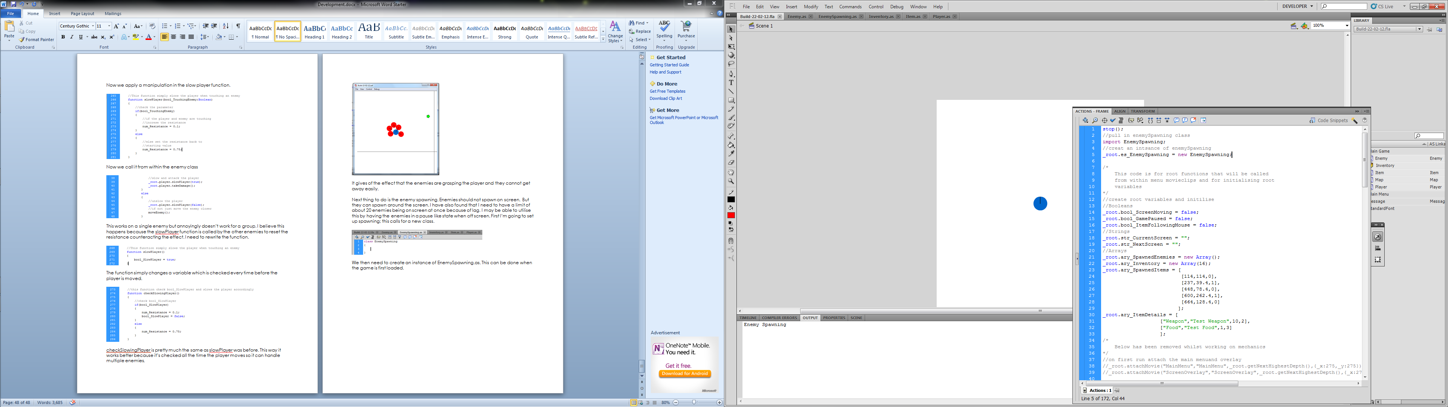

In this class we just need a function that starts the spawner and stops it as well as one the actually spawn the enemies.

We’ll start with the startSpawning function. This will just simply be an interval that’ll be call the spawnEnemy function.

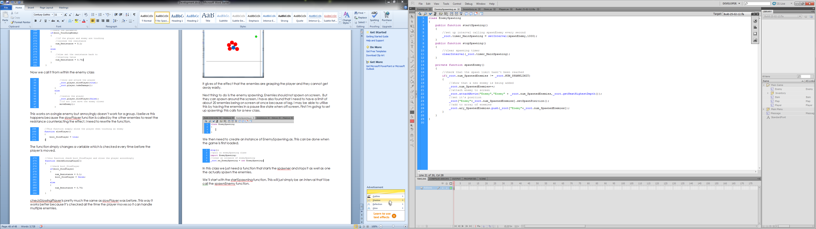
For the stopSpawning function we just need to remove the interval.

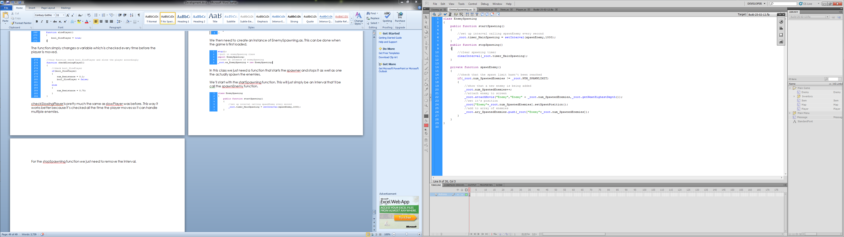

06/03/2012

Now for the spawnEnemy function. All this need to do is keep attaching enemy classes until the total amount of enemies needed have been attached then initialise them and put into an array.

I also made a function in the enemy class to position the enemy at a random position around the player

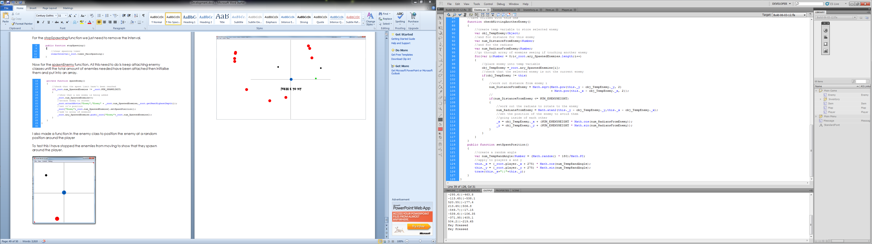

To test this I have stopped the enemies from moving to show that they spawn around the player.

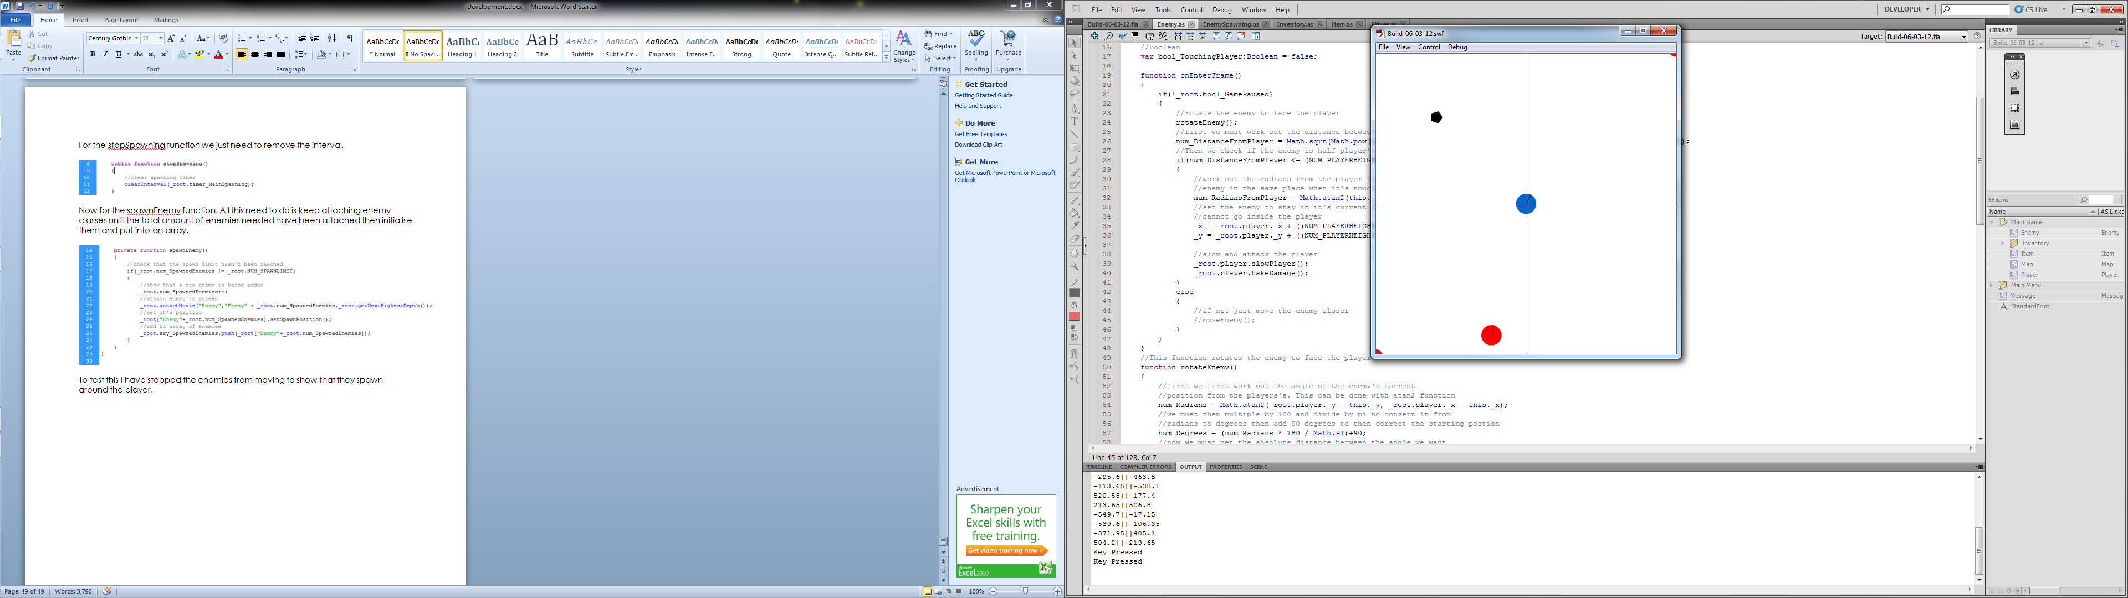
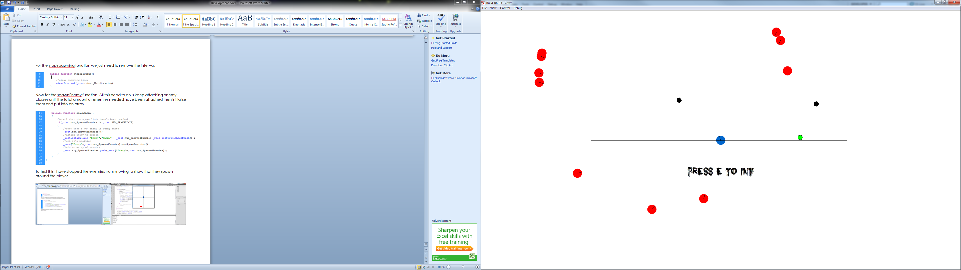

From what I can make out the enemies are still spawning around the origin. Really the should be spawning around the player. Look back at the maths behind the positioning I realised that all I’m doing is adjusting the size of the circle because cos and sin only return values between 0 and 1 I’m multiplying it by 550, which only gives it a radius of 550 so I need to add a value to the multiplication. This value is supposed to be the player’s position then the 275 should be the radius.

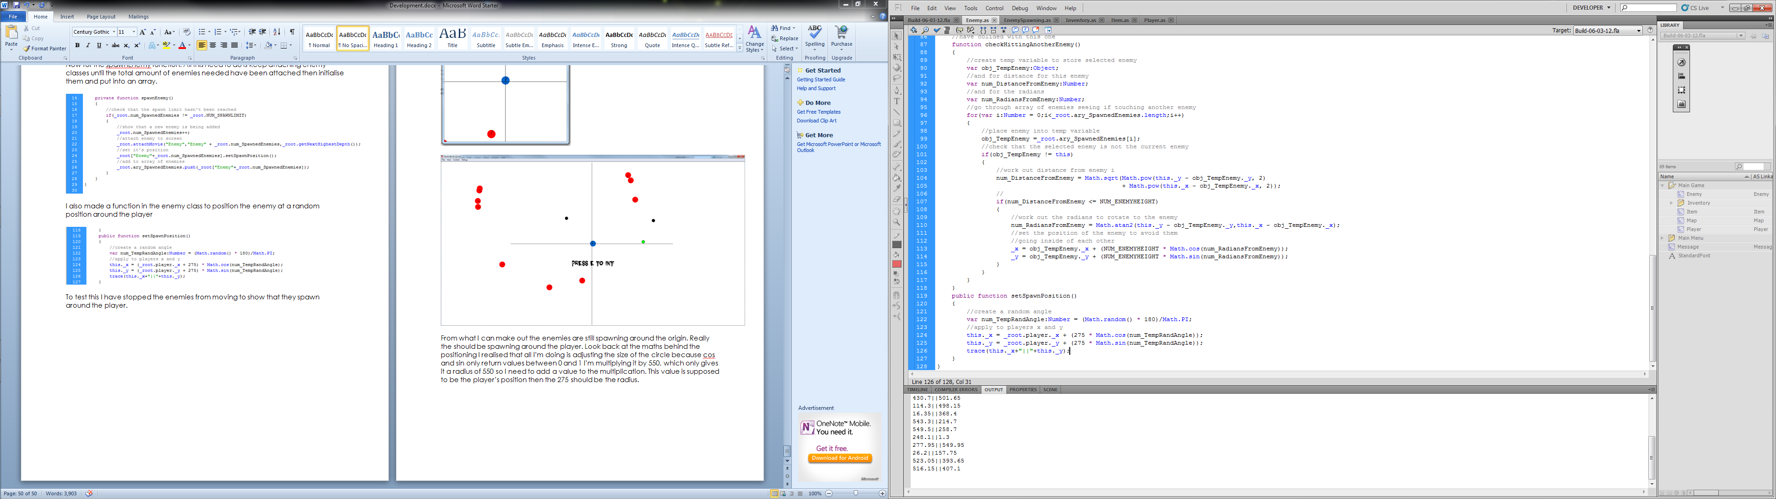
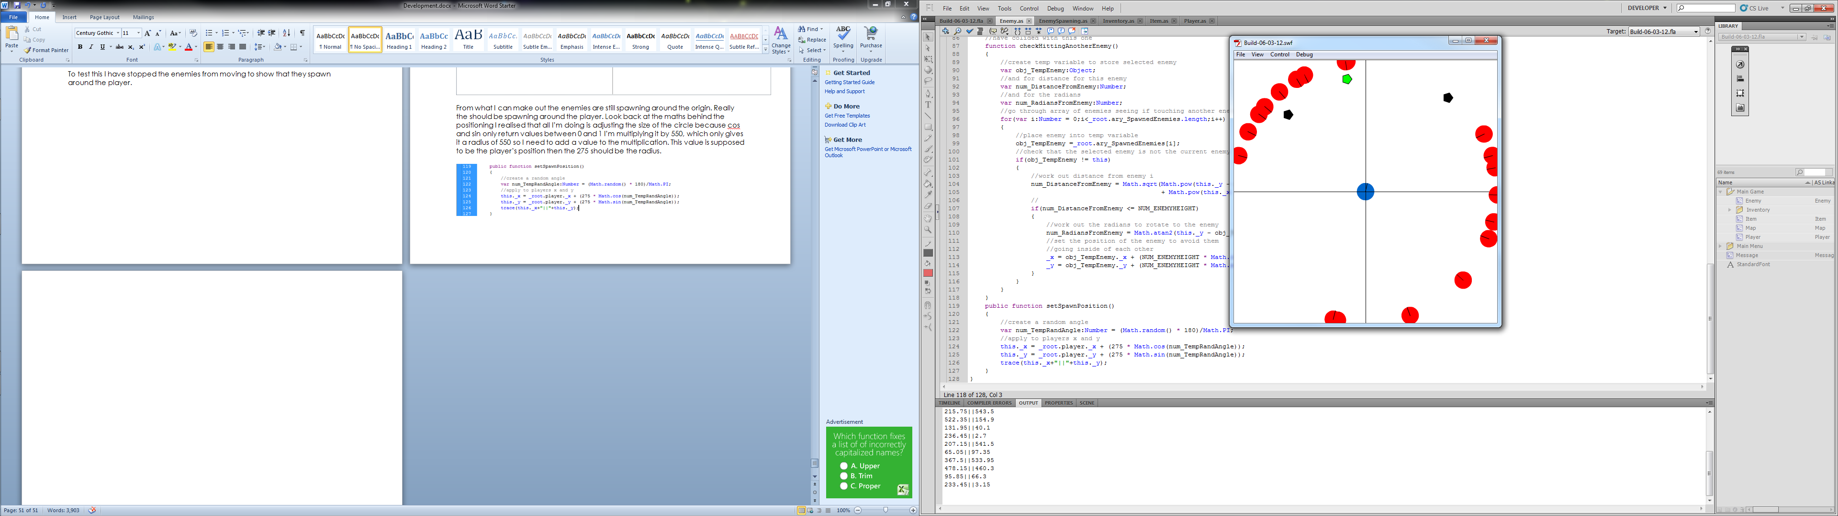

They’re spawning in the right place now but they’re still on screen and I need them to spawn off screen. This is just a simple change to how big the radius should be. To work out the correct radius I just need to do 275² + 275² which is 151,250 then square root it 389. Now to put that in instead of the 275

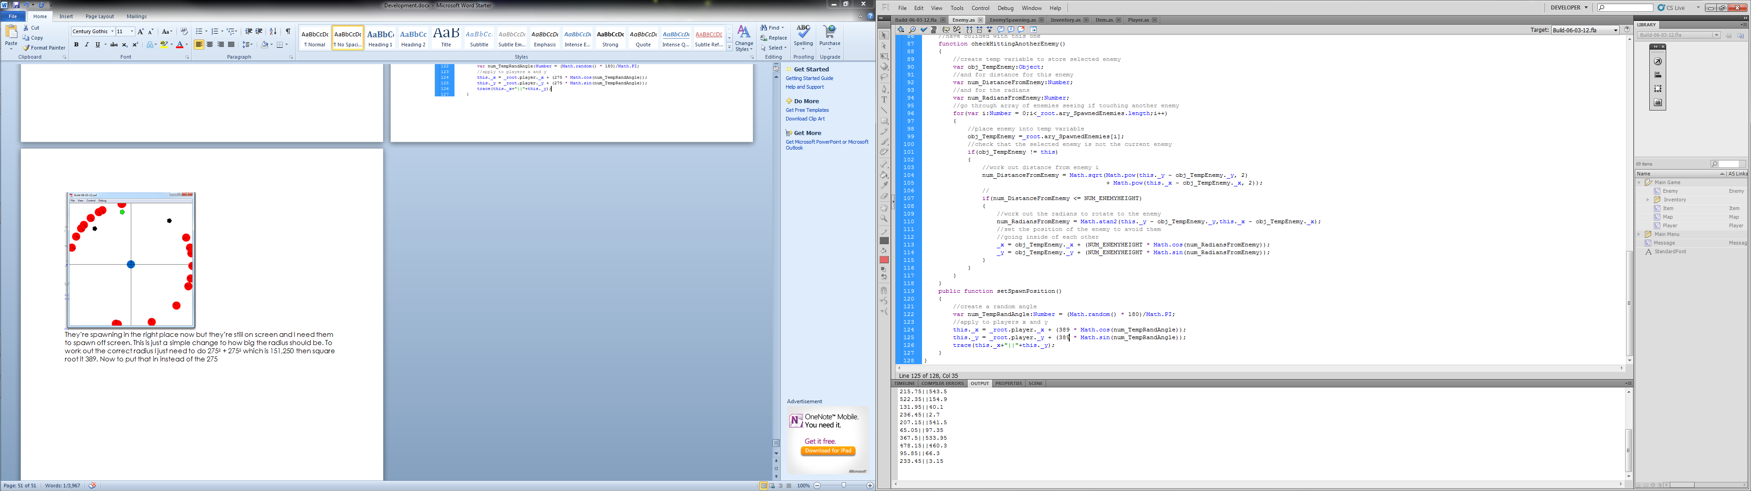

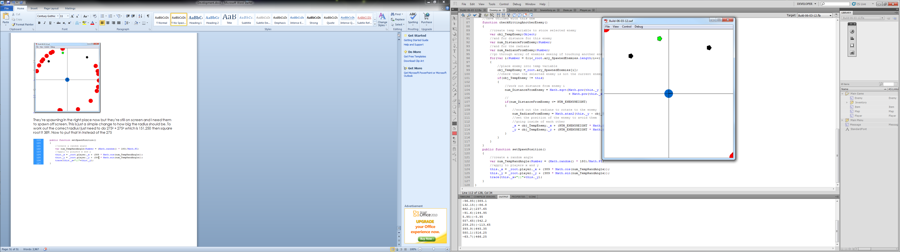

07/03/2012

I forgot to compensate for half the enemy width so they slightly show up on screen.

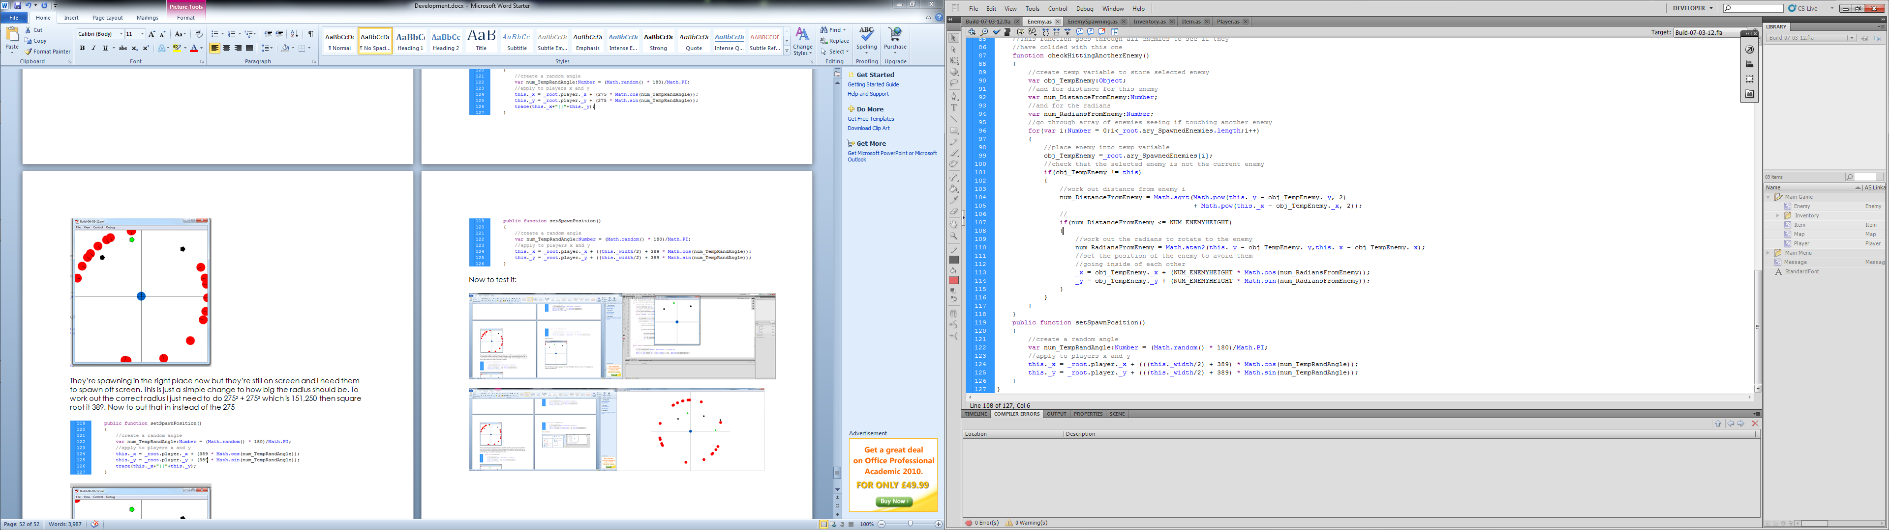
Now to test it:

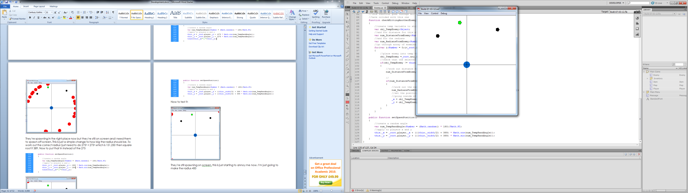

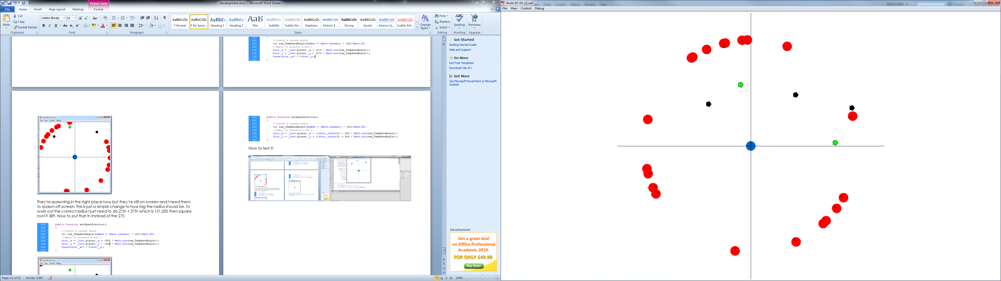

Works like a charm. Next thing to set up is the enemies giving damage to the player and the player’s health. I’ve already put a call for the player to take damage in the enemy class but no such function exists so I’ll start with creating it.
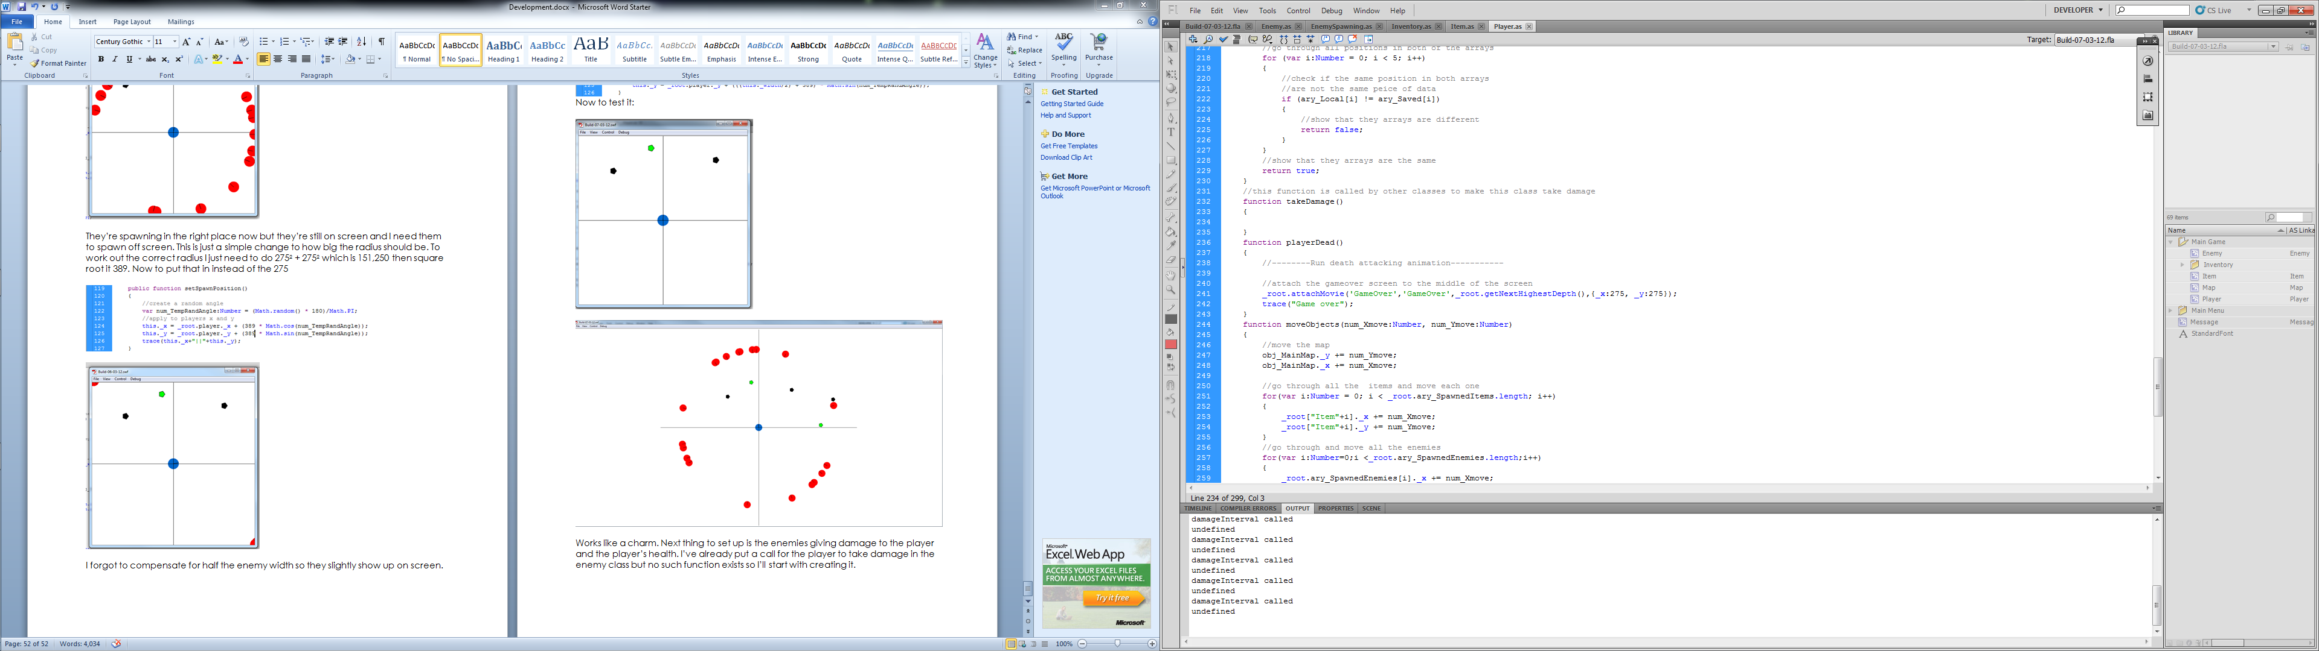

Now we must take into consideration that in the enemy class takeDamage is called when the player is in range, this means the function will get called every 1/45 of a second (45 fps) meaning that the player will lose health very quickly and die in less than a second. We must take into account a use of an interval when writing the takeDamage function. All this interval will do is call a function to change a Boolean value to true allowing the enemy to damage the player and remove the interval so it doesn’t repeat all the time.

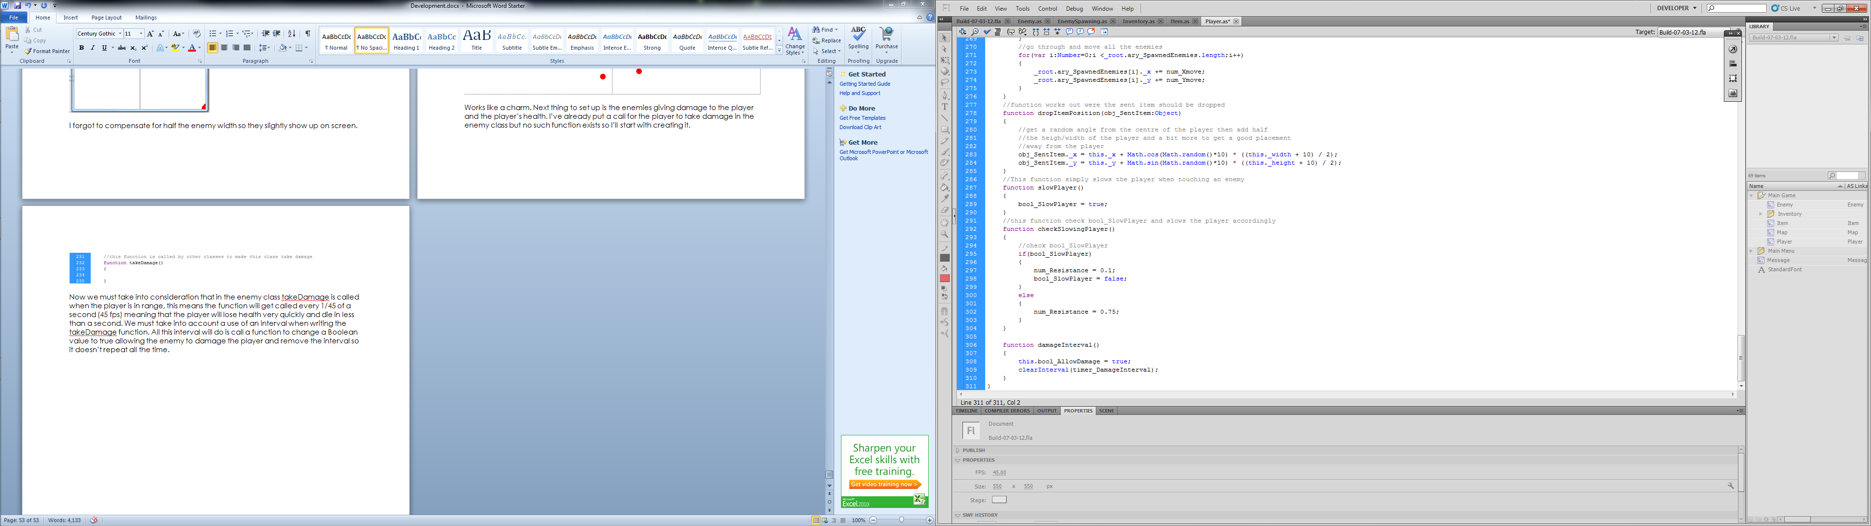

In take damage the first thing we’ll do is check that the player can take damage then remove health, stop it from taking damage and set up an interval. After this we must check that the player isn’t already dead.

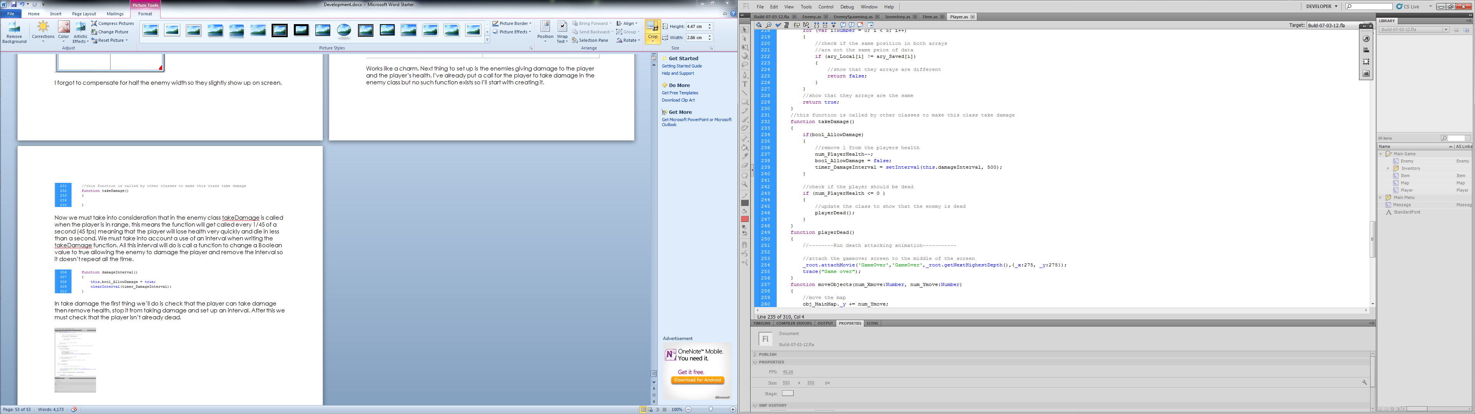

To test this I’m going to have a trace that constantly outputs the player’s health.

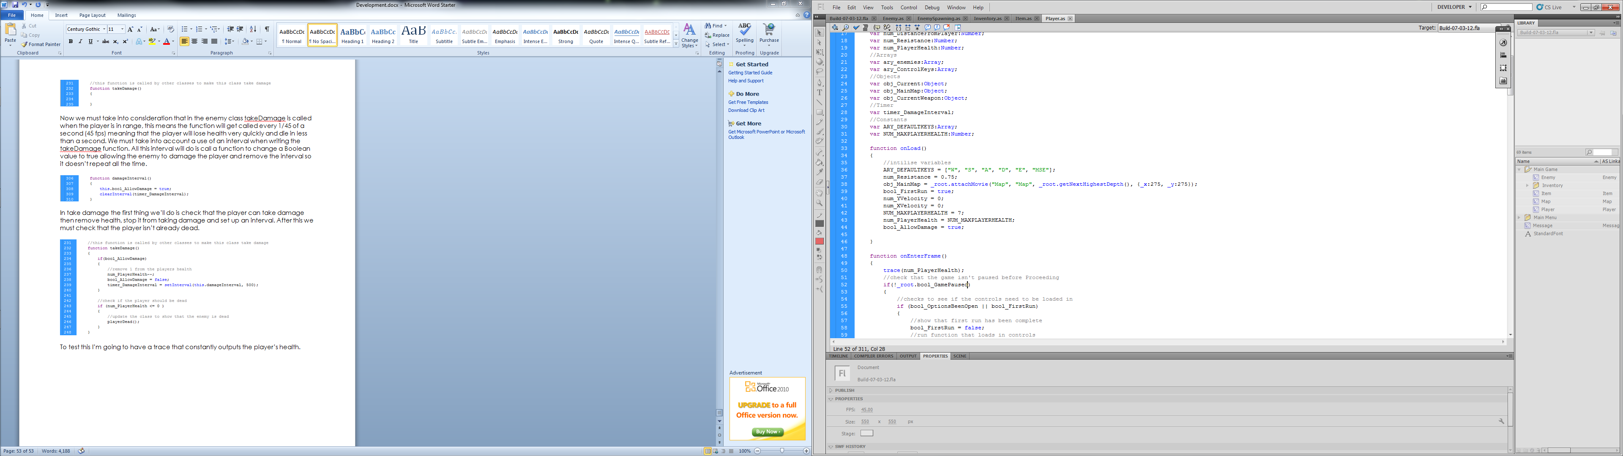

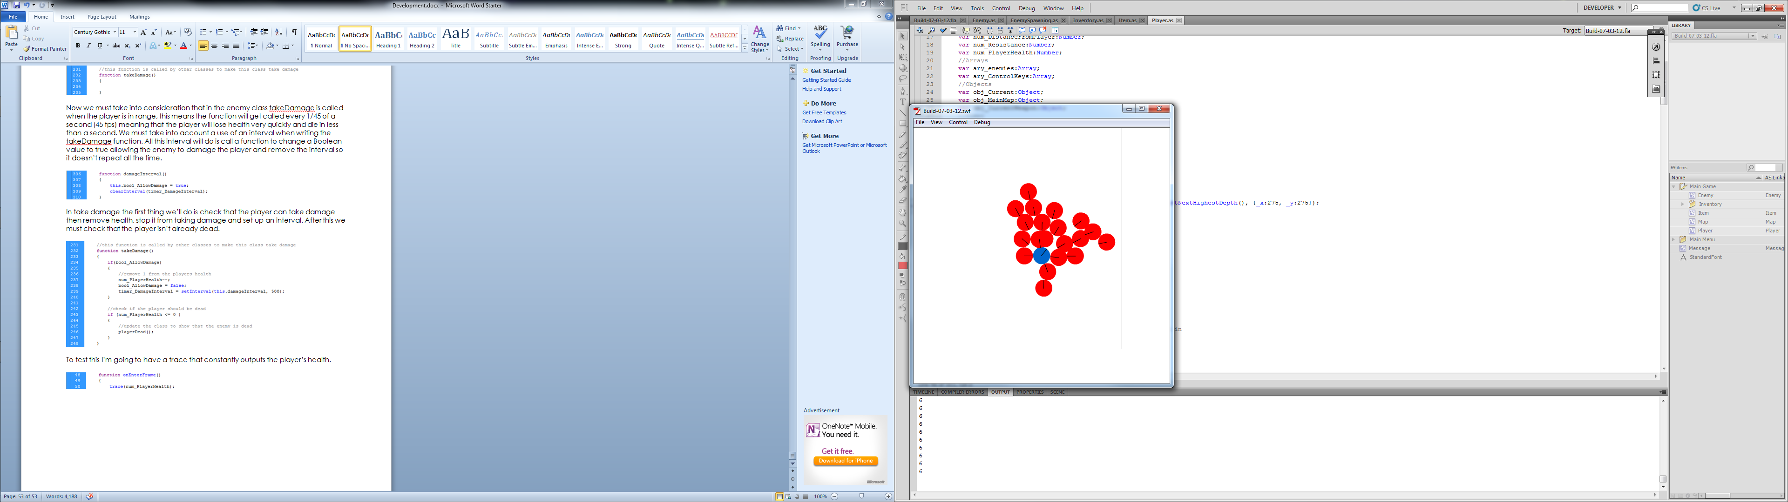

The player seems to take the initial damage but then doesn’t take anymore.

08/03/2012

After reading up on the setInterval function, I found that it can't see the properties of its own class. Great. With this research I also found a solution of sending itself as a parameter then setting itself as itself. I got all this info from http://www.actionscript.org/resources/articles/592/1/Working-with-setInterval-in-classes/Page1.html

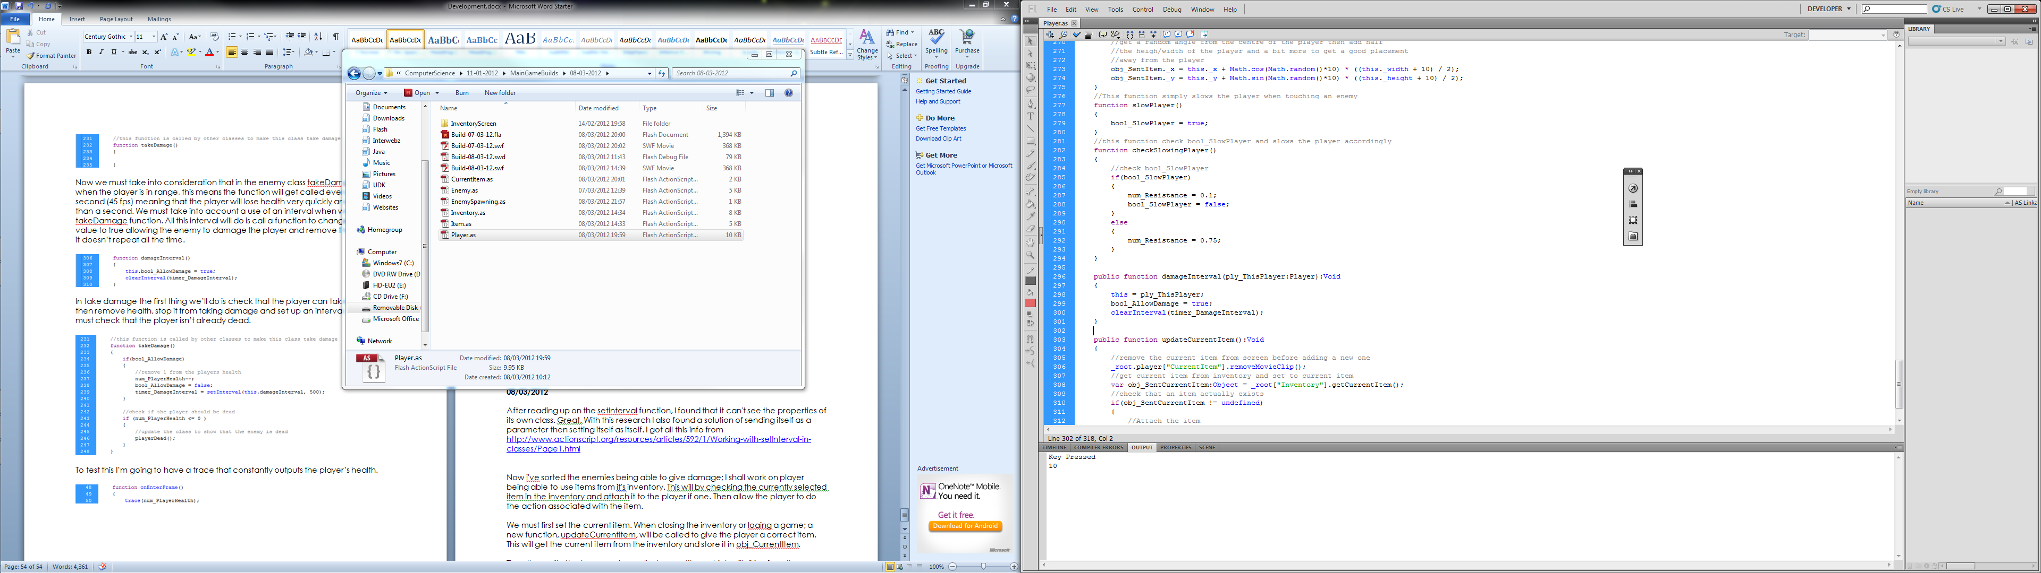

Now I've sorted the enemies being able to give damage; I shall work on player being able to use items from its inventory. This will work by checking the currently selected item in the inventory and attach it to the player if one. Then allow the player to do the action associated with the item.

We must first set the current item.

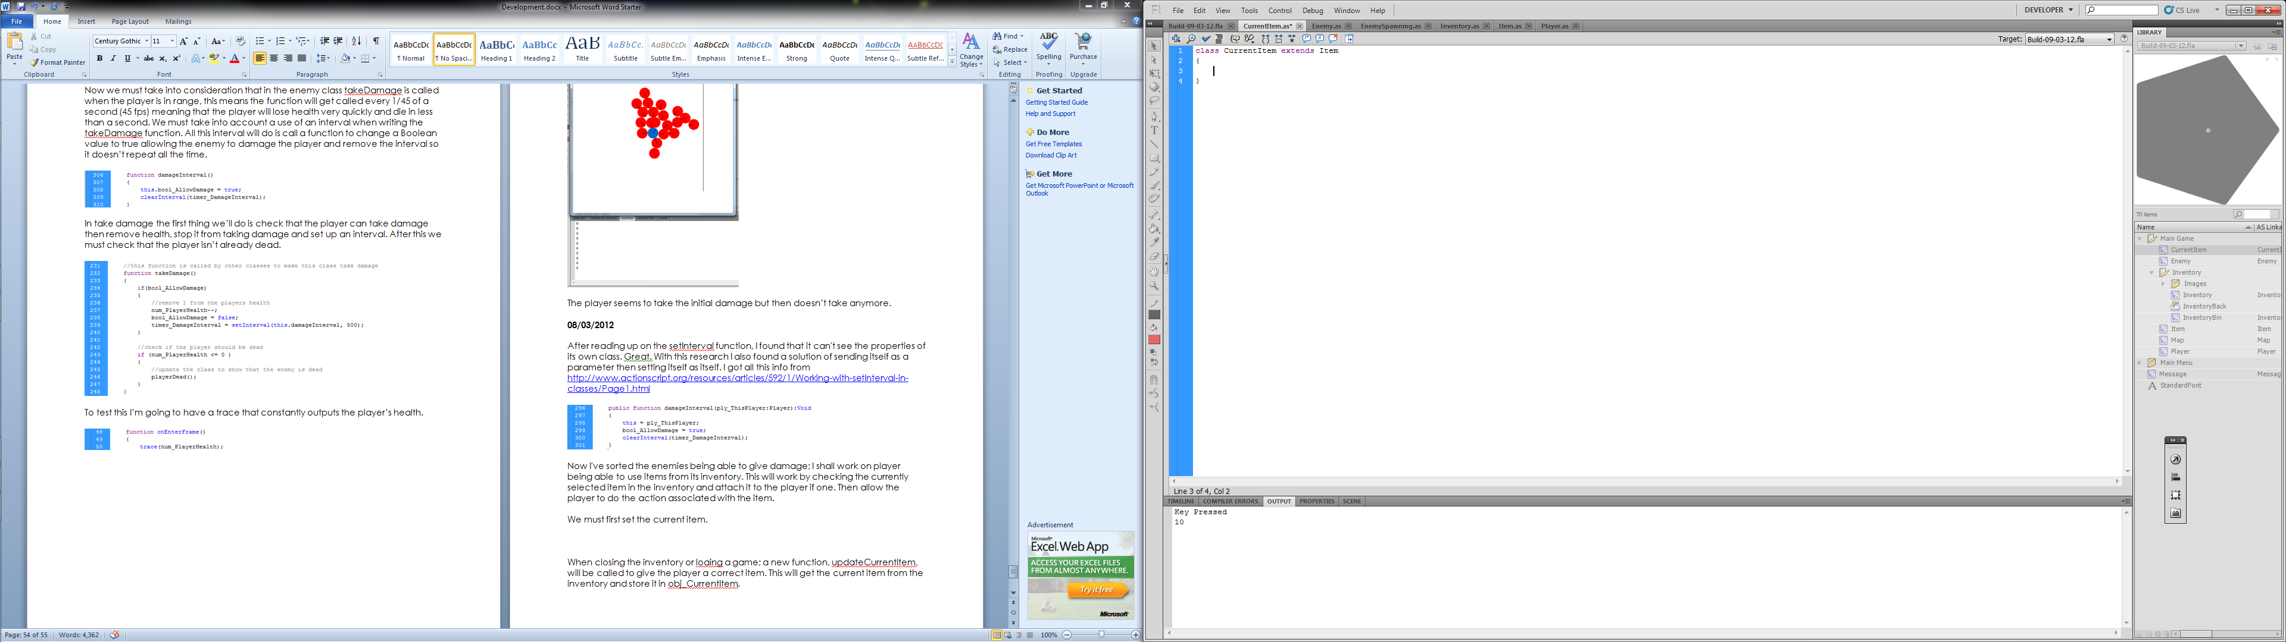

When closing the inventory or loaing a game; a new function, updateCurrentItem, will be called to give the player a correct item. This will get the current item from the inventory and store it.

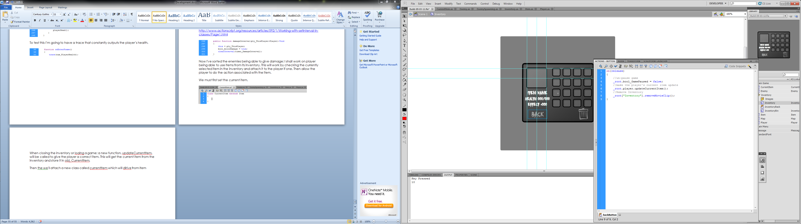

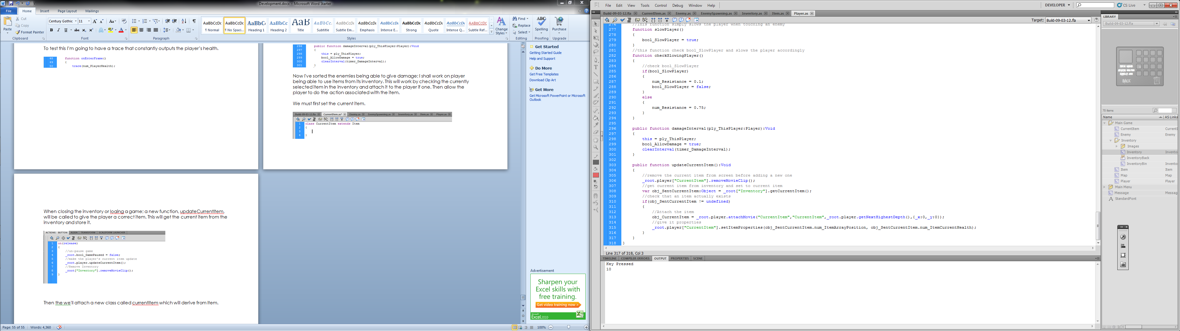
Next we need to build up the CurrentItem class to handle the different item type’s usages and start up properties. For the properties we can use inherited function setItemProperties. Because most functionally of this function is relevant we can super it as well as position the newly created it on the player.

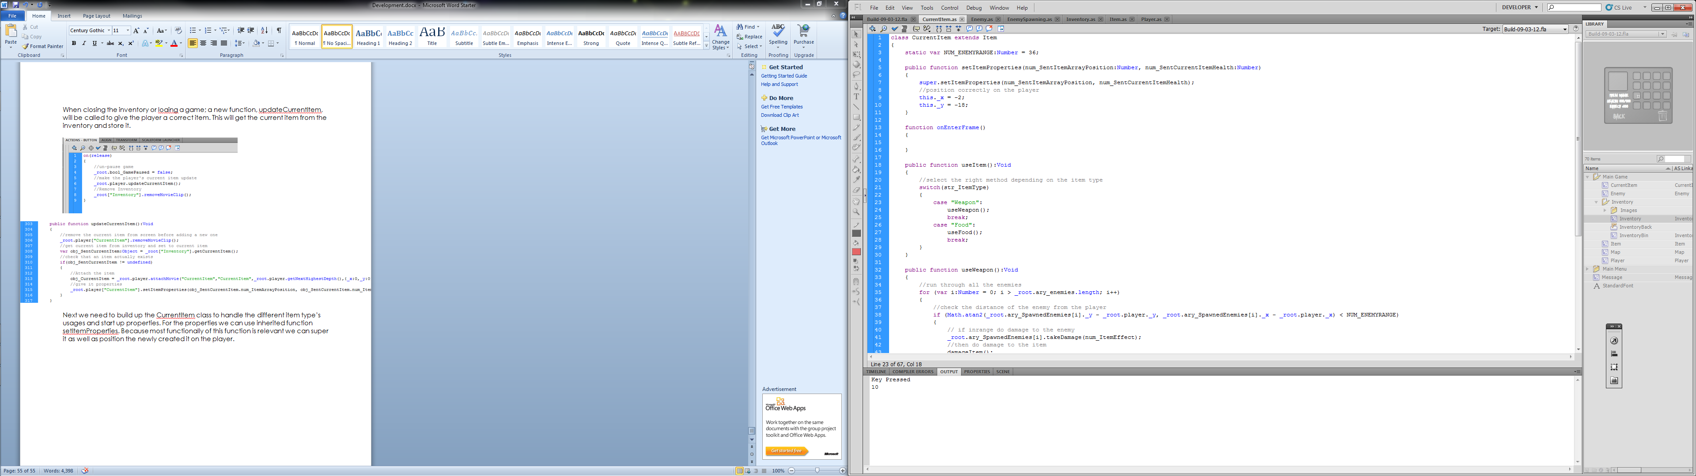

We need to over write the onEnterFrame function so we don’t get load of random item stuff happening.

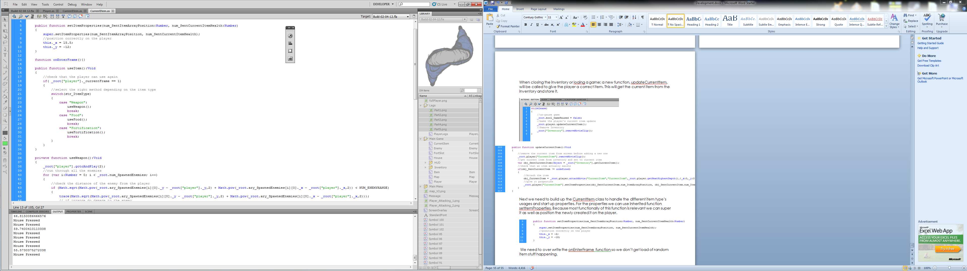

Now, we want to use this current item so we’ll have a function to handle this.
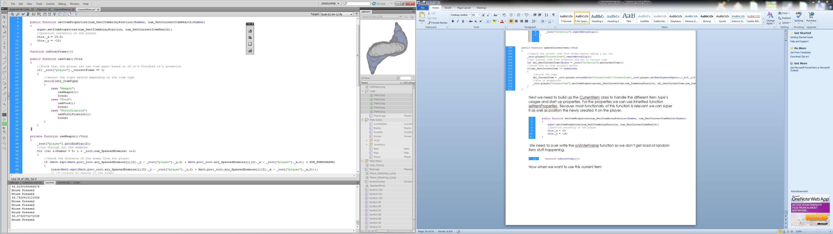

We need to create the functions useWeapon, useFood and useFortification. For useWeapon we need to run the attacking animation; go through all enemies checking if they’re in range and if they are do damage to them and do damage to the item aswell.
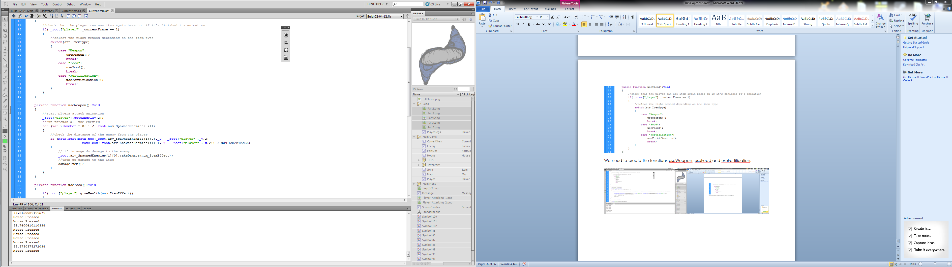

For useFood we need to know if we can add the health to the players health so I’ve created simple function in the player to do this and return false if I can’t so the item isn’t used when the player can’t gain health.

[Player.as]
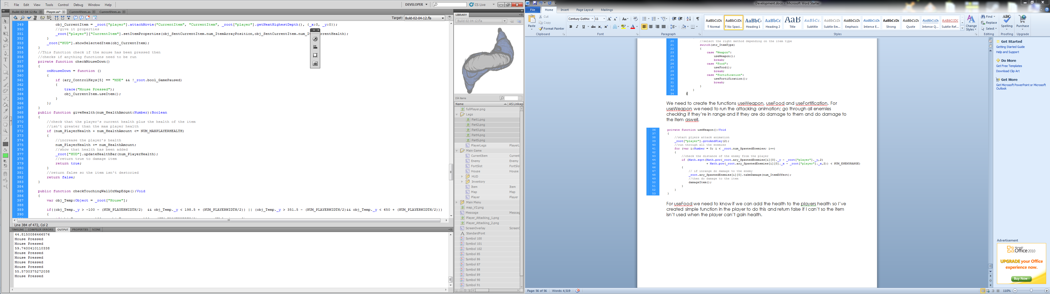

[CurrentItem.as]
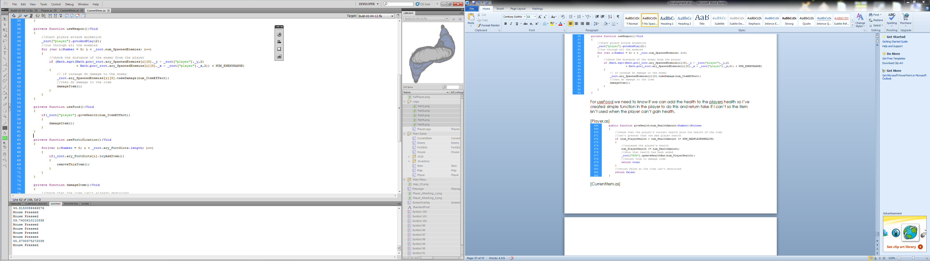

Now, for the fortifications we need to go through all the slots, these will be created later but will be stored in an array. We can then see if we’re able to add the item just like the useFood function.

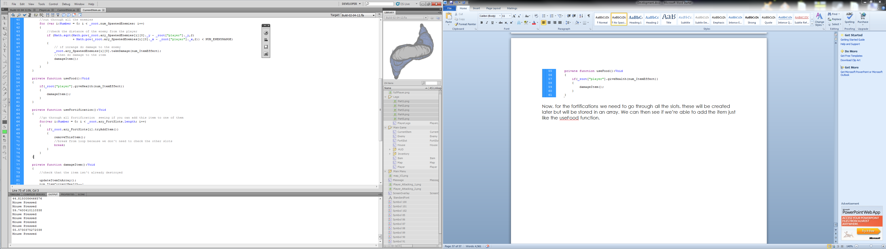

We’ve called the two functions damageItem and removeThisItem so we best create them.

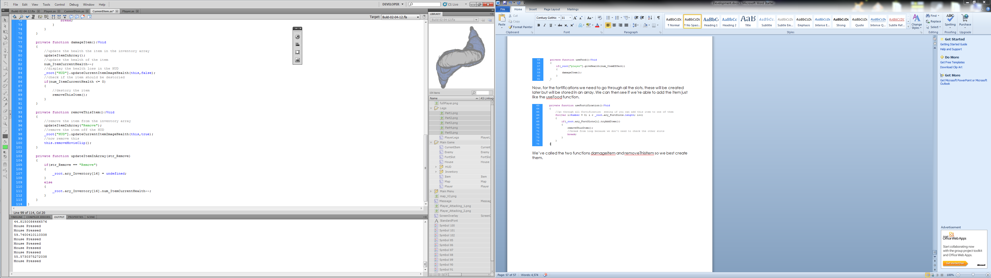

02/04/2012
Probably wasn’t the smartest idea to put off documenting development since the 8th but hey, a lot has changed and I’ll go through explaining and showing each section of code working.

Menu –

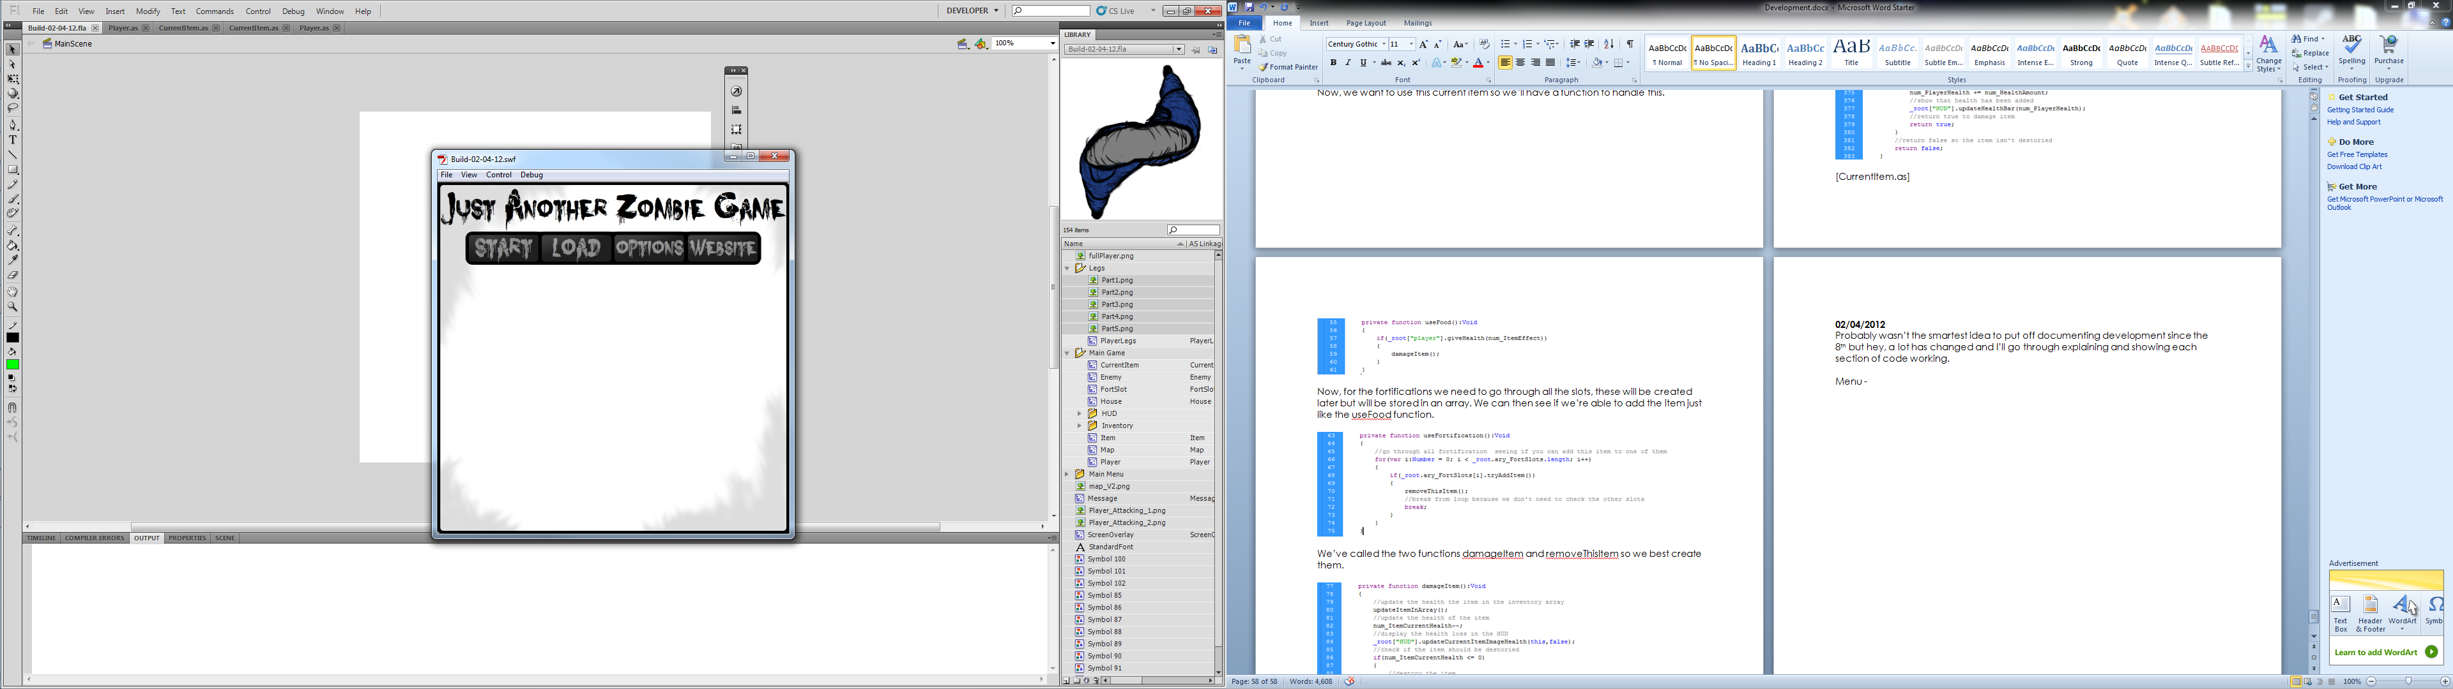

When the start button is pressed it pulls the screen down and attaches the next screen, off screen to the right. They the move in time and replace each other. This is handled by a function that takes the current and the next screen as parameters.

[First frame of main.fla]
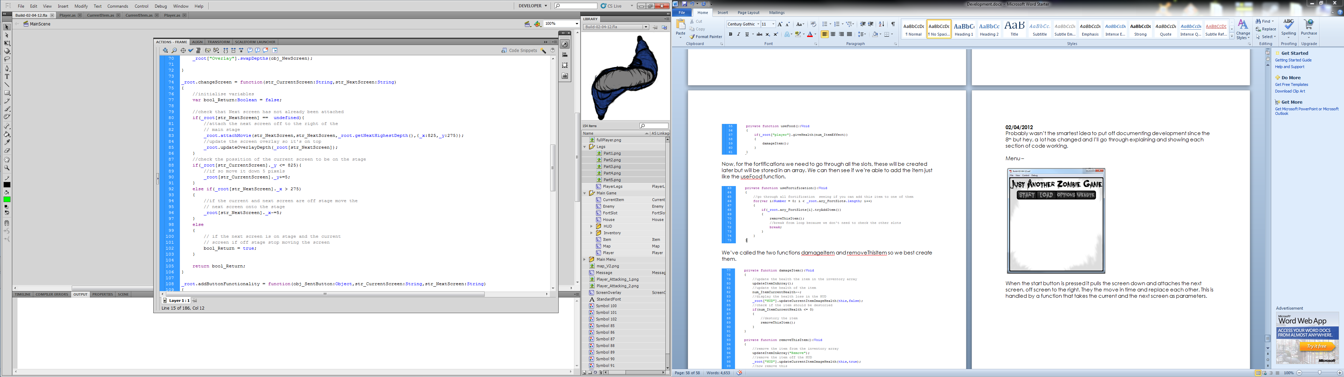
This function is called every time we want the screen to change.

This is the code in the main movieclip which sets up all the buttons by just simply calling a root function.

[First frame in MainMenu movieclip]
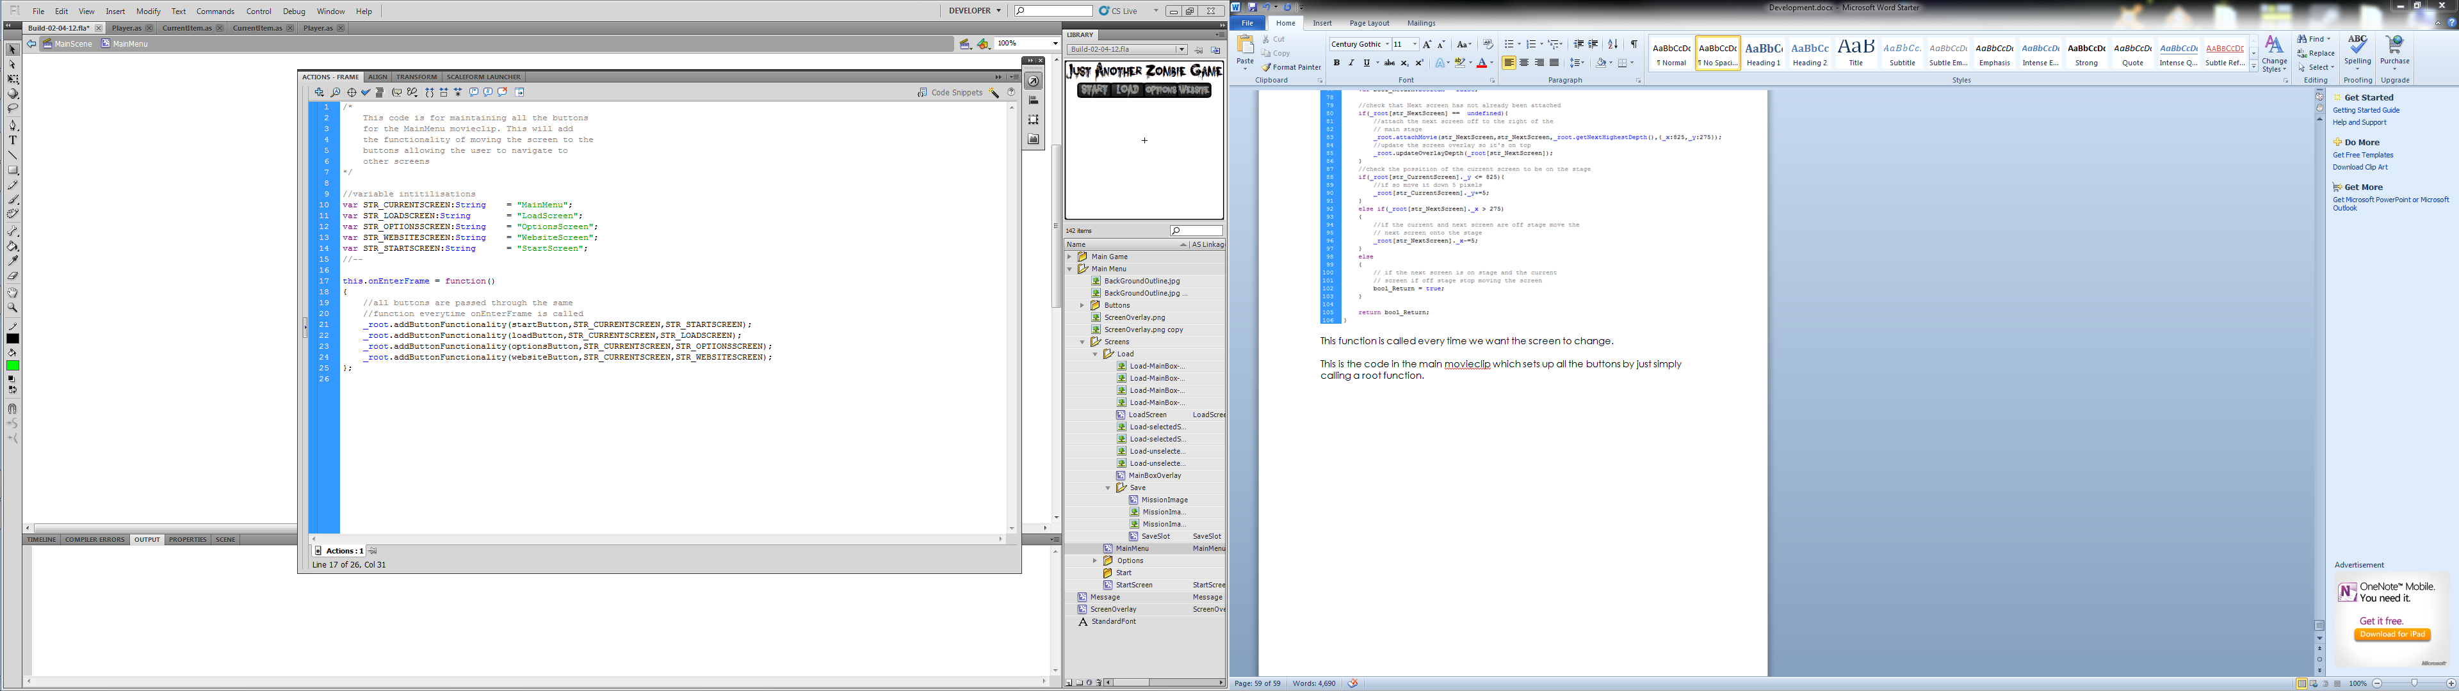

[First frame of main.fla]

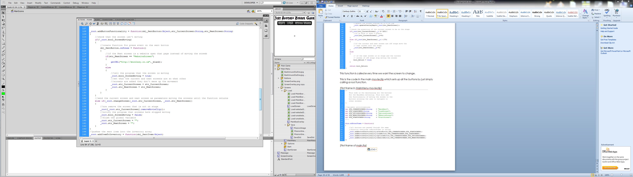
Now that we’ve covered the buttons we can move onto the game starting. The screen Start is attached, which simply places the player in the middle of the screen.

We start the player class by importing the ControlScreen and the EnemySpawning classes, this is so we can use methods contained within them.

Class Structure:
- Main.fla
  - Frame 1
- Game
  - CurrentItem.as
  - Enemy.as
  - EnemySpawning.as
  - FortSlot.as
  - Inventory.as
  - Item.as
  - Player.as
- HUD
  - HUD.as
  - HUDControl.as
  - HUDMenu.as
  - HUDSound.as
- Menu
  - ControlScreen.as
  - LoadScreen.as
  - OptionsScreen.as
  - SoundScreen.as

Frame 1
stop();
/*
This code is for root functions that will be called
from within menu movieclips and for initialising root
variables
*/
//create root variables and initilise
_root.bool_ScreenMoving = false;
_root.str_CurrentScreen = "";
_root.str_NextScreen = "";
//Timers
_root.timer_MainSpawning;
//Numbers
_root.num_SpawnedEnemies = 0;
//Constants
_root.NUM_SPAWNLIMIT = 10;

/*
This code is for root functions that will be called
from within menu movieclips and for initialising root
variables
*/
//create root variables and initilise
//Booleans
_root.bool_ScreenMoving = false;
_root.bool_GamePaused = false;
_root.bool_ItemFollowingMouse = false;
//Strings
_root.str_CurrentScreen = "";
_root.str_NextScreen = "";
//Arrays
_root.setUpArrays = function()
{
_root.ary_SpawnedEnemies = new Array(
new Array(),new Array(),
new Array(),new Array(),
new Array(),new Array(),
new Array(),new Array(),
new Array(),new Array(),
new Array(),new Array(),
new Array(),new Array(),
new Array(),new Array(),
new Array(),new Array(),
new Array(),new Array(),
new Array(),new Array(),
new Array(),new Array()
);
_root.ary_FortSlots = new Array();
_root.ary_Inventory = new Array(16);
_root.ary_FortNodes = [
[0,-30],
[0,30],
[-30,0],
[30,0]
];
_root.ary_SpawnedItems = [
[114,114,0],
[237,39.4,1],
[448,78.4,0],
[600,262.4,1],
[600,100.4,2],
[0,0,2]
];
_root.ary_ItemDetails = [
["Weapon","Test Weapon",1000,2],
["Food","Test Food",1,3],
["Fortification","Test Fortification",5,0]
];
}
_root.setUpArrays();
//on first run attach the main menuand overlay
_root.attachMovie("MainMenu","MainMenu",_root.getNextHighestDepth(),{_x:275,_y:275});
_root.attachMovie("ScreenOverlay","Overlay",_root.getNextHighestDepth(),{_x:275,_y:275});

_root.updateOverlayDepth = function(obj_NewScreen:Object)
{
//function updates the screen overlay to make sure it
//is always on top
_root["Overlay"].swapDepths(obj_NewScreen);

}

_root.changeScreen = function(str_CurrentScreen:String,str_NextScreen:String)
{
//initialise variables
var bool_Return:Boolean = false;

//check that Next screen has not already been attached
if(_root[str_NextScreen] == undefined){
//attach the next screen off to the right of the
// main stage
_root.attachMovie(str_NextScreen,str_NextScreen,_root.getNextHighestDepth(),{_x:825,_y:275});
//update the screen overlay so it's on top
_root.updateOverlayDepth(_root[str_NextScreen]);
}
//check the possition of the current screen to be on the stage
if(_root[str_CurrentScreen]._y <= 825){
//if so move it down 5 pixels
_root[str_CurrentScreen]._y+=5;
}
else if(_root[str_NextScreen]._x > 275)
{
//if the current and next screen are off stage move the
// next screen onto the stage
_root[str_NextScreen]._x-=5;
}
else
{
// if the next screen is on stage and the current
// screen if off stage stop moving the screen
bool_Return = true;
}

return bool_Return;
}

_root.addButtonFunctionality = function(obj_SentButton:Object,str_CurrentScreen:String,str_NextScreen:String)
{
//check that the screen isn't moving
if(!_root.bool_ScreenMoving)
{
//create function for press event on the sent button
obj_SentButton.onPress = function()
{
//if the Next screen is a website open that page instead of moving the screeb
if(str_NextScreen == "WebsiteScreen")
{
getURL("http://knowlesy.co.uk",_blank);
}
else if(str_NextScreen == "StartScreen")
{
_root["MainMenu"].gotoAndPlay(2);
}
else
{
//tell the program that the screen is moving
_root.bool_ScreenMoving = true;
//set what the current and next screens are so when other
//screens are added they don't mess up the movement
_root.str_CurrentScreen = str_CurrentScreen;
_root.str_NextScreen = str_NextScreen;
}
}
}
//send the current screen and next screen as parameters moving the screens until the function returns
else if(_root.changeScreen(_root.str_CurrentScreen, _root.str_NextScreen))
{
//now remove the screen that is not on stage
_root[_root.str_CurrentScreen].removeMovieClip();
//notify the program that screens have stopped moving
_root.bool_ScreenMoving = false;
//flush the global variable
_root.str_CurrentScreen = "";
_root.str_NextScreen = "";
}
}
//pushes the sent item into the inventory array
_root.addItemToInventory = function(obj_SentItem:Object)
{
for(var i:Number = 0; i < 15;i++)
{
if(_root.ary_Inventory[i] == undefined)
{
_root.ary_Inventory[i] = obj_SentItem;
break;
}
}
}
//places and itiliases all the items on screen
_root.placeItems = function()
{
//temp array to store the current item spawned
var obj_TempItem:Object;
//loop through all items
for(var i:Number = 0; i < _root.ary_SpawnedItems.length; i++)
{
//spawn item
obj_TempItem = _root.attachMovie("Item", "Item"+i, _root.getNextHighestDepth(),{_x: _root.ary_SpawnedItems[i][0],_y:_root.ary_SpawnedItems[i][1]});
//set properties
obj_TempItem.setItemProperties(_root.ary_SpawnedItems[i][2]);
}
}
_root.clearItems = function()
{
//loop through all items
for(var i:Number = 0; i < _root.ary_SpawnedItems.length; i++)
{
//delete item
_root["Item"+i].removeMovieClip();
}
}
//function draws a line between to movieclips used for debug
_root.drawLine = function(target_mc:MovieClip, secondtarget:MovieClip)
{
this.createEmptyMovieClip("line_mc", 1);
line_mc.lineStyle(1,0x000000,100);
line_mc.moveTo(target_mc._x,target_mc._y);
line_mc.lineTo(secondtarget._x,secondtarget._y);
}

CurrentItem.as
class CurrentItem extends Item
{
static var NUM_ENEMYRANGE:Number = 60;

public function setItemProperties(num_SentItemArrayPosition:Number, num_SentCurrentItemHealth:Number)
{
super.setItemProperties(num_SentItemArrayPosition, num_SentCurrentItemHealth);
//position correctly on the player
this._x = 15.5;
this._y = -12;
}

function onEnterFrame(){}

public function useItem():Void
{
//check that the player can use item again based on if it's finished its animation
if( _root["player"]._currentFrame == 1)
{
//select the right method depending on the item type
switch(str_ItemType)
{
case "Weapon":
useWeapon();
break;
case "Food":
useFood();
break;
case "Fortification":
useFortification();
break;
}
}
}

private function useWeapon():Void
{
//start plyers attack animation
_root["player"].gotoAndPlay(2);
//run through all the enemies
for (var i:Number = 0; i < _root.num_SpawnedEnemies; i++)
{
//check the distance of the enemy from the player
if (Math.sqrt(Math.pow(_root.ary_SpawnedEnemies[i][0]._y - _root["player"]._y,2)
+ Math.pow(_root.ary_SpawnedEnemies[i][0]._x - _root["player"]._x,2)) < NUM_ENEMYRANGE)
{
// if inrange do damage to the enemy
_root.ary_SpawnedEnemies[i][0].takeDamage(num_ItemEffect);
//then do damage to the item
damageItem();
}
}
}

private function useFood():Void
{
if(_root["player"].giveHealth(num_ItemEffect))
{
damageItem();
}
}

private function useFortification():Void
{
//go through all fortification seeing if you can add this item to one of them
for(var i:Number = 0; i < _root.ary_FortSlots.length; i++)
{
if(_root.ary_FortSlots[i].tryAddItem())
{
removeThisItem();
//break from loop because we don't need to check the other slots
break;
}
}
}

private function damageItem():Void
{
//update the health the item in the inventory array
updateItemInArray();
//update the health of the item
num_ItemCurrentHealth--;
//display the health loss in the HUD
_root["HUD"].updateCurrentItemImageHealth(this,false);
//check if the item should be destoried
if(num_ItemCurrentHealth <= 0)
{
//destory the item
removeThisItem();
}
}

private function removeThisItem():Void
{
//remove the item from the inventory array
updateItemInArray("Remove");
//remove the item off the HUD
_root["HUD"].updateCurrentItemImageHealth(this,true);
//now remove this
this.removeMovieClip();
}

private function updateItemInArray(str_Remove)
{
if(str_Remove == "Remove")
{
_root.ary_Inventory[16] = undefined;
}
else
{
_root.ary_Inventory[16].num_ItemCurrentHealth--;
}
}
}

Enemy.as
class Enemy extends MovieClip
{
//Numbers
var num_YVelocity:Number;
var num_XVelocity:Number;
var num_Health:Number = 3;
var num_Radians:Number;
var num_Degrees:Number;
var num_DistanceBetween:Number;
var num_DistanceFromPlayer:Number;
var num_RadiansFromPlayer:Number;
var num_OptimalNodeDistance:Number = 100000;
var num_EnemySpeed:Number = 0.7;
var num_EnemyRange:Number = 250;
//String
var str_EnemyType:String;
//Constants
var NUM_PLAYERHEIGHT:Number = 40;
var NUM_ENEMYHEIGHT:Number = 36.5;
var NUM_ENEMYWIDTH:Number = 36.5;
var NUM_NODEENTERRANGE:Number = 77;
//Boolean
var bool_TouchingPlayer:Boolean = false;
var bool_MoveToFort:Boolean = false;
var bool_EnemyDead:Boolean = false;
//Timers
var timer_EnemyDead;

function onEnterFrame()
{
if(bool_MoveToFort && !_root.bool_GamePaused && !bool_EnemyDead)
{
faceClosestFort();
moveEnemy();
}
else if (!bool_EnemyDead && !_root.bool_GamePaused && (enemyInHouse() || Math.sqrt(Math.pow(_root["player"]._x - this._x, 2) + Math.pow(_root["player"]._y - this._y, 2)) < num_EnemyRange))
{
if(enemyInHouse() && !playerInHouse())
{
faceClosestFort();
}
else
{
//rotate the enemy to face the player
rotateEnemy();
}
//first we must work out the distance between the enemy and the player
num_DistanceFromPlayer = Math.sqrt(Math.pow(this._y - _root["player"]._y, 2) + Math.pow(this._x - _root["player"]._x, 2));
//Then we check if the enemy is half player's and it's distance away
if (num_DistanceFromPlayer <= (NUM_PLAYERHEIGHT + NUM_ENEMYHEIGHT) / 2)
{
//work out the radians from the player to enemy to keep the
//enemy in the same place when it's touching the player
num_RadiansFromPlayer = Math.atan2(this._y - _root["player"]._y, this._x - _root["player"]._x);
//set the enemy to stay in it's current position so it
//cannot go inside the player
_x = _root["player"]._x + ((NUM_PLAYERHEIGHT + NUM_ENEMYHEIGHT) / 2 * Math.cos(num_RadiansFromPlayer));
_y = _root["player"]._y + ((NUM_PLAYERHEIGHT + NUM_ENEMYHEIGHT) / 2 * Math.sin(num_RadiansFromPlayer));

//slow and attack the player
_root["player"].slowPlayer();
_root["player"].takeDamage();
}
else
{
//if not just move the enemy closer
moveEnemy();
}
}
else
{
checkDistanceFromPlayer();
}
}
//This function rotates the enemy to face the player
function rotateEnemy()
{
//first we first work out the angle of the enemy's current
//position from the players's. This can be done with atan2 function
num_Radians = Math.atan2(_root["player"]._y - this._y, _root["player"]._x - this._x);
//we must then multiple by 180 and divide by pi to convert it from
//radians to degrees then add 90 degrees to then correct the starting postion
num_Degrees = (num_Radians * 180 / Math.PI) + 90;
//now we must get the absolute distance between the angle we want
//and the current angle we're currently at
num_DistanceBetween = Math.abs(num_Degrees - this._rotation);
//if the distance is greater than 180 then we need then we need
//to correct it so it doesn't go crazy
if (num_DistanceBetween > 180)
{
//now check which way it needs to correct itself
if (num_Degrees > this._rotation)
{
num_Degrees -= 360;
}
else
{
num_Degrees += 360;
}
}
this._rotation += (num_Degrees - this._rotation) * 0.15;
}
//this function move the enemy towards the player
function moveEnemy()
{
checkHittingAnotherEnemy();
checkHittingFortSlots();
checkHittingWalls();
if(this._currentframe == getCurrentFrameFromType())
{
gotoAndPlay(str_EnemyType + "-Moving");
}
//this moves the enemy in the direction of the player
this._x += Math.cos(num_Radians) * num_EnemySpeed;
this._y += Math.sin(num_Radians) * num_EnemySpeed;
}
//This function goes through all enemies to see if they
//have colided with this one
function checkHittingAnotherEnemy()
{
//create temp variable to store selected enemy
var obj_TempEnemy:Object;
//and for distance for this enemy
var num_DistanceFromEnemy:Number;
//and for the radians
var num_RadiansFromEnemy:Number;
//go through array of enemies seeing if touching another enemy
for (var i:Number = 0; i <= _root.num_SpawnedEnemies; i++)
{
//place enemy into temp variable
obj_TempEnemy = _root.ary_SpawnedEnemies[i][0];
//check that the selected enemy is not the current enemy
if (obj_TempEnemy != this && obj_TempEnemy != undefined && !obj_TempEnemy.bool_EnemyDead)
{
//work out distance from enemy i
num_DistanceFromEnemy = Math.sqrt(Math.pow(this._y - obj_TempEnemy._y, 2) + Math.pow(this._x - obj_TempEnemy._x, 2));
//
if (num_DistanceFromEnemy <= NUM_ENEMYHEIGHT)
{
//work out the radians to rotate to the enemy
num_RadiansFromEnemy = Math.atan2(this._y - obj_TempEnemy._y, this._x - obj_TempEnemy._x);
//set the position of the enemy to avoid them
//going inside of each other
_x = obj_TempEnemy._x + (NUM_ENEMYHEIGHT * Math.cos(num_RadiansFromEnemy));
_y = obj_TempEnemy._y + (NUM_ENEMYHEIGHT * Math.sin(num_RadiansFromEnemy));
}
}
}
}

private function checkHittingFortSlots():Void
{
var obj_Temp:Object;

for (var i:Number = 0; i < _root.ary_FortSlots.length; i++)
{
obj_Temp = _root.ary_FortSlots[i];
if (_root.ary_FortSlots[i].num_FortCurrentHealth > 0)
{
if (this._y > obj_Temp._y - (obj_Temp._height / 2) && this._y < obj_Temp._y + (obj_Temp._height / 2))
{
if (this._x < obj_Temp._x - (obj_Temp._width / 2) && this._x + (NUM_ENEMYHEIGHT / 2) > obj_Temp._x - (obj_Temp._width / 2) && this._x + (NUM_ENEMYHEIGHT / 2) < obj_Temp._x)
{
this._x = obj_Temp._x - (obj_Temp._width / 2) - (NUM_ENEMYHEIGHT / 2);
obj_Temp.takeDamage();
}
else if (this._x + num_EnemySpeed > obj_Temp._x + (obj_Temp._width / 2) && this._x - (NUM_ENEMYHEIGHT / 2) > obj_Temp._x && this._x - (NUM_ENEMYHEIGHT / 2) < obj_Temp._x + (obj_Temp._width / 2))
{
this._x = obj_Temp._x + (obj_Temp._width / 2) + (NUM_ENEMYHEIGHT / 2);
obj_Temp.takeDamage();
}
}
if (this._x > obj_Temp._x - (obj_Temp._width / 2) && this._x < obj_Temp._x + (obj_Temp._width / 2))
{
if (this._y < obj_Temp._y - (obj_Temp._height / 2) && this._y + (NUM_ENEMYHEIGHT / 2) > obj_Temp._y - (obj_Temp._height / 2) && this._y + (NUM_ENEMYHEIGHT / 2) < obj_Temp._y)
{
this._y = obj_Temp._y - (obj_Temp._height / 2) - (NUM_ENEMYHEIGHT / 2);
obj_Temp.takeDamage();
}
else if (this._y > obj_Temp._y + (obj_Temp._height / 2) && this._y - (NUM_ENEMYHEIGHT / 2) > obj_Temp._y && this._y - (NUM_ENEMYHEIGHT / 2) < obj_Temp._y + (obj_Temp._height / 2))
{
this._y = obj_Temp._y + (obj_Temp._height / 2) + (NUM_ENEMYHEIGHT / 2);
obj_Temp.takeDamage();
}
}
}
}
}

private function checkHittingWalls():Void
{
var obj_Temp:Object = _root["House"];
var num_startX:Number = this._x;
var num_startY:Number = this._y;

if ((this._y > obj_Temp._y - 375 - (NUM_ENEMYWIDTH / 2) && this._y < obj_Temp._y - 76.5 + (NUM_ENEMYWIDTH / 2)) || (this._y > obj_Temp._y + 76.5 - (NUM_ENEMYWIDTH / 2) && this._y < obj_Temp._y + 375 + (NUM_ENEMYWIDTH / 2)))
{
if (this._x > obj_Temp._x - 375 && this._x < obj_Temp._x - 375 + (NUM_ENEMYWIDTH / 2))
{
this._x = obj_Temp._x - 375 + (NUM_ENEMYWIDTH / 2);
}
else if (this._x < obj_Temp._x - 375 && this._x > obj_Temp._x - 375 - (NUM_ENEMYWIDTH / 2))
{
this._x = obj_Temp._x - 375 - (NUM_ENEMYWIDTH / 2);
}
else if (this._x > obj_Temp._x + 375 && this._x < obj_Temp._x + 375 + (NUM_ENEMYWIDTH / 2))
{
this._x = obj_Temp._x + 375 + (NUM_ENEMYWIDTH / 2);
}
else if (this._x < obj_Temp._x + 375 && this._x > obj_Temp._x + 375 - (NUM_ENEMYWIDTH / 2))
{
this._x = obj_Temp._x + 375 - (NUM_ENEMYWIDTH / 2);
}
}
if ((this._x > obj_Temp._x - 375 - (NUM_ENEMYHEIGHT/ 2) && this._x < obj_Temp._x - 76.5 + (NUM_ENEMYHEIGHT/ 2)) || (this._x > obj_Temp._x + 76.5 - (NUM_ENEMYHEIGHT/ 2) && this._x < obj_Temp._x + 375 + (NUM_ENEMYHEIGHT/ 2)))
{
if (this._y > obj_Temp._y - 375 && this._y < obj_Temp._y - 375 + (NUM_ENEMYHEIGHT/ 2))
{
this._y = obj_Temp._y - 375 + (NUM_ENEMYHEIGHT/ 2);
}
else if (this._y < obj_Temp._y - 375 && this._y > obj_Temp._y - 375 - (NUM_ENEMYHEIGHT/ 2))
{
this._y = obj_Temp._y - 375 - (NUM_ENEMYHEIGHT/ 2);
}
else if (this._y > obj_Temp._y + 375 && this._y < obj_Temp._y + 375 + (NUM_ENEMYHEIGHT/ 2))
{
this._y = obj_Temp._y + 375 + (NUM_ENEMYHEIGHT/ 2);
}
else if (this._y < obj_Temp._y + 375 && this._y > obj_Temp._y + 375 - (NUM_ENEMYHEIGHT/ 2))
{
this._y = obj_Temp._y + 375 - (NUM_ENEMYHEIGHT/ 2);
}
}

if( (playerInHouse() && num_OptimalNodeDistance > NUM_NODEENTERRANGE)|| ((num_startX != this._x || num_startY != this._y) && playerInHouse() && !bool_MoveToFort && Math.sqrt(Math.pow(_root["player"]._x - this._x, 2) + Math.pow(_root["player"]._y - this._y, 2)) < 250))
{
bool_MoveToFort = true;
}
}

public function setSpawnPosition()
{
//create a random angle
var num_TempRandAngle:Number = (Math.random() * 180) / Math.PI;
//apply to players x and y
this._x = _root["player"]._x + (((this._width / 2) + 389) * Math.cos(num_TempRandAngle));
this._y = _root["player"]._y + (((this._width / 2) + 389) * Math.sin(num_TempRandAngle));

if(enemyInHouse())
{
setSpawnPosition();
}
else setUpEnemy(Math.round(Math.random() * 2));
}

public function takeDamage(num_DamageAmount:Number)
{
//check that the enemy isn't dead
if(!bool_EnemyDead)
{
//remove health
num_Health -= num_DamageAmount;
//check if enemy should be dead
if (num_Health <= 0)
{
//update kills
_root["HUD"].addKill();
//show enemy being killed
enemyDead();
}
}
}

private function faceClosestFort():Void
{
var num_SelectedNodeX:Number;
var num_SelectedNodeY:Number;
var obj_SelectedFort:Object;
var num_NodeDistance:Number;
num_OptimalNodeDistance = 100000;

for(var i:Number = 0; i < _root.ary_FortNodes.length; i++)
{
num_NodeDistance = Math.sqrt(Math.pow(this._y - (_root.ary_FortSlots[i]._y + _root.ary_FortNodes[i][0]) ,2) + Math.pow(this._x - (_root.ary_FortSlots[i]._x + _root.ary_FortNodes[i][0]),2));

if(num_NodeDistance < num_OptimalNodeDistance)
{
num_OptimalNodeDistance = num_NodeDistance;
if(playerInHouse())
{
if(num_OptimalNodeDistance < NUM_NODEENTERRANGE)
{
num_SelectedNodeX = _root.ary_FortSlots[i]._x - (_root.ary_FortNodes[i][0] * 2);
num_SelectedNodeY = _root.ary_FortSlots[i]._y - (_root.ary_FortNodes[i][1] * 2);
}
else
{
num_SelectedNodeX = _root.ary_FortSlots[i]._x + _root.ary_FortNodes[i][0];
num_SelectedNodeY = _root.ary_FortSlots[i]._y + _root.ary_FortNodes[i][1];
}
}
else if(enemyInHouse())
{
if(num_OptimalNodeDistance < NUM_NODEENTERRANGE)
{
num_SelectedNodeX = _root.ary_FortSlots[i]._x + (_root.ary_FortNodes[i][0] * 2);
num_SelectedNodeY = _root.ary_FortSlots[i]._y + (_root.ary_FortNodes[i][1] * 2);
}
else
{
num_SelectedNodeX = _root.ary_FortSlots[i]._x - _root.ary_FortNodes[i][0];
num_SelectedNodeY = _root.ary_FortSlots[i]._y - _root.ary_FortNodes[i][1];
}
}

obj_SelectedFort = _root.ary_FortSlots[i];
}
}

num_Radians = Math.atan2(num_SelectedNodeY - this._y, num_SelectedNodeX - this._x);
num_Degrees = (num_Radians * 180 / Math.PI) + 90;
num_DistanceBetween = Math.abs(num_Degrees - this._rotation);

if (num_DistanceBetween > 180)
{
if (num_Degrees > this._rotation)
{
num_Degrees -= 360;
}
else
{
num_Degrees += 360;
}
}

this._rotation += (num_Degrees - this._rotation) * 0.15;

if(num_OptimalNodeDistance < NUM_NODEENTERRANGE || !playerInHouse())
{
bool_MoveToFort = false;
}
}

private function checkDistanceFromPlayer():Void
{
if(Math.sqrt(Math.pow(this._x - _root["player"]._x,2)+Math.pow(this._y - _root["player"]._y,2)) > 550 && ! enemyInHouse())
{
removeEnemy();
}
}

private function playerInHouse():Boolean
{
if(_root["Map"]._x > -100 && _root["Map"]._x < 650 && _root["Map"]._y > -100 && _root["Map"]._y < 650)
{
return true;
}

return false;
}
private function enemyInHouse():Boolean
{
if(this._x < _root["House"]._x + 375 && this._x > _root["House"]._x - 375 && this._y < _root["House"]._y + 375 && this._y > _root["House"]._y - 375)
{
return true;
}

return false;
}
private function enemyDead():Void
{
//show enemy dead
gotoAndStop(str_EnemyType+"-Dead");
//flag that the enemy is dead
bool_EnemyDead = true;
// put the player and legs ontop of it
_root["player"].overlayEnemy(this);
//start timer to fade out enemy
timer_EnemyDead = setInterval(fadeEnemy, 100,this);
}
public function fadeEnemy(em_This:Enemy):Void
{
//show what class this belongs to
this = em_This;
//Check that it's dead so it doesn't change random enemies
if(this.bool_EnemyDead)
{
//fade enemy
this._alpha -= 2;
//check if invisible
if(this._alpha <= 0)
{
//stop the timer
clearInterval(this.timer_EnemyDead);
//remove the enemy
this.removeEnemy();
}
}

}
public function removeEnemy():Void
{
_root.es_EnemySpawning.removeEnemy(this);
this.removeMovieClip();
}

private function setUpEnemy(num_SentType:Number):Void
{
//check the number to select the type and load stats acording
switch(num_SentType)
{
case 0:
num_EnemySpeed = 0.5;
num_EnemyRange = 500;
str_EnemyType = "Dragger";
break;

case 1:
num_EnemySpeed = 1.2;
num_EnemyRange = 350;
str_EnemyType = "Walker";
break;

case 2:
num_EnemySpeed = 2;
num_EnemyRange = 200;
str_EnemyType = "Dog";
break;
}

gotoAndStop(str_EnemyType);
}

private function getCurrentFrameFromType():Number
{
switch(str_EnemyType)
{
case "Dragger":
return 1;
break;
case "Walker":
return 2;
break;
case "Dog":
return 3;
break;
}
}
}

EnemySpawning.as
class EnemySpawning
{
public function startSpawning()
{
//set up interval calling spawnEnemy every second
_root.timer_MainSpawning = setInterval(spawnEnemy,1000, this);
}
public function stopSpawning()
{
//clear spawning timer
clearInterval(_root.timer_MainSpawning);
}

private function spawnEnemy(ES_This:EnemySpawning):Void
{
this = ES_This;
//check that the spawn limit hasn't been reached and that the game isn't paused
if(_root.num_SpawnedEnemies != _root.NUM_SPAWNLIMIT && !_root.bool_GamePaused && playerOutOffHouse())
{
//attach enemy to screen
_root.attachMovie("Enemy","Enemy" + _root.num_SpawnedEnemies,_root.getNextHighestDepth());
//set it's position
_root["Enemy"+_root.num_SpawnedEnemies].setSpawnPosition();
//add to array of enemies
_root.ary_SpawnedEnemies[_root.num_SpawnedEnemies][0] = _root["Enemy"+_root.num_SpawnedEnemies];
_root.ary_SpawnedEnemies[_root.num_SpawnedEnemies][1] = false;
_root["HUD"].attchMiniEnemy(_root["Enemy"+_root.num_SpawnedEnemies],_root.num_SpawnedEnemies);
//put the hud Above the newly spawned enemy
_root["HUD"].putHUDOnTop();
//show that a new enemy is being added
_root.num_SpawnedEnemies++;
}
//check if the spawn limit is reached and that the game isn't paused
else if(_root.num_SpawnedEnemies == _root.NUM_SPAWNLIMIT && !_root.bool_GamePaused)
{
//loop through all spawned enemies
for (var i:Number = 0; i <= _root.NUM_SPAWNLIMIT; i++)
{
//Check if this enemy is dead
if(_root.ary_SpawnedEnemies[i][1] == true)
{
//Spawn a new enemy into the current loop position
//seeing as it's been deleted
_root.ary_SpawnedEnemies[i][0] = _root.attachMovie("Enemy","Enemy" + i,_root.getNextHighestDepth());
//put it underneath the HUD
_root["HUD"].putHUDOnTop();
//set the enemy's spawn position
_root.ary_SpawnedEnemies[i][0].setSpawnPosition();
//show that it's alive
_root.ary_SpawnedEnemies[i][1] = false;
//leave loop so we don't get more than one dead enemy
//respawning at a time
break;
}
}
}
}
public function removeEnemies():Void
{
//Go through all spawned enemies
for(var i:Number = 0; i < _root.ary_SpawnedEnemies.length;i++)
{
//remove currently selected enemy
_root.ary_SpawnedEnemies[i][0].removeMovieClip();
}
//show that no enemies have been spawned
_root.num_SpawnedEnemies = 0;
}
public function playerOutOffHouse():Boolean
{
//set up temp variable to store the house
var obj_Temp:Object = _root["House"];
//check the position of the house to see if
//the player is inside of it
if(obj_Temp._x > -100 && obj_Temp._x < 650 && obj_Temp._y > -100 && obj_Temp._y < 650)
{
//return false to show that the player is
//in the house
return false;
}
//return true beacuse the above was false
return true;
}
public function removeEnemy(obj_SentEnemy:Object):Void
{
//go through all enemies
for (var i:Number = 0; i <= _root.num_SpawnedEnemies; i++)
{
//check if the currently selected enemy is
//the same as the one sent in via parameters
if(_root.ary_SpawnedEnemies[i][0] == obj_SentEnemy)
{
//show that the enemy has been removed
_root.ary_SpawnedEnemies[i][1] = true;
}
}
}
}

FortSlot.as
class FortSlot extends MovieClip
{
//Bools
private var bool_InsideFort:Boolean = false;
public var bool_CanTakeDamage:Boolean = true;
//Numbers
private var num_FortCurrentHealth:Number = 0;
//Constants
static var NUM_FORTMAXHEALTH:Number = 15;
//Timers
public var timer_DamageInterval;

function onLoad()
{
displayFortHealth();
}
function onEnterFrame()
{
if (!_root.bool_GamePaused && _root["player"].obj_CurrentItem.str_ItemType == "Fortification")
{
checkPlayerInside();
}
else
{
bool_InsideFort = false;
this.gotoAndStop(1);
}
}

private function checkPlayerInside():Void
{
if(_root["player"]._x > _x - (_width/2) && _root["player"]._x < _x + (_width/2)
&& _root["player"]._y > _y - (_height/2) && _root["player"]._y < _y + (_height/2))
{
bool_InsideFort = true;
this.gotoAndStop(2);
}
else
{
bool_InsideFort = false;
this.gotoAndStop(1);
}
}

public function tryAddItem():Boolean
{
trace("Trying to add item");
if(bool_InsideFort && num_FortCurrentHealth + _root["player"].obj_CurrentItem.num_ItemCurrentHealth <= NUM_FORTMAXHEALTH)
{
num_FortCurrentHealth +=_root["player"].obj_CurrentItem.num_ItemCurrentHealth;
placeItemInside();
displayFortHealth();
return true;
}
else
{
return false;
}
}

private function placeItemInside():Void
{
trace("Placing Item Inside");
}
private function displayFortHealth():Void
{
this["FortText"].text = String(num_FortCurrentHealth) + "/" + String(NUM_FORTMAXHEALTH);
}

public function takeDamage():Void
{
if(bool_CanTakeDamage && num_FortCurrentHealth > 0)
{
num_FortCurrentHealth--;
bool_CanTakeDamage = false;
displayFortHealth();
timer_DamageInterval = setInterval(this.damageInterval, 2000, this);
}
}

public function damageInterval(fs_ThisFort:FortSlot):Void
{
this = fs_ThisFort;
bool_CanTakeDamage = true;
clearInterval(timer_DamageInterval);
}
}

Item.as
class Item extends MovieClip
{
//Numbers
var num_ItemCurrentHealth:Number;
var num_ItemMaxHealth:Number;
var num_ItemArrayPosition:Number;
var num_DistanceFromPlayer:Number;
var num_InventoryArrayPosition:Number;
var num_ItemEffect:Number;
//Strings
var str_ItemType:String;
var str_ItemName:String;
//Booleans
var bool_FollowMouse:Boolean = false;
var bool_MessageBeeningDisplay:Boolean = false;

//this function adds new variable and initalises all of them
//depending on the sent item position in the root item array.
//The end optional prameter will be used when loading items
function setItemProperties(num_SentItemArrayPosition:Number, num_SentCurrentItemHealth)
{
//Initilise variable using the position in the root item array
num_ItemArrayPosition = num_SentItemArrayPosition;
str_ItemType = _root.ary_ItemDetails[num_ItemArrayPosition][0];
str_ItemName = _root.ary_ItemDetails[num_ItemArrayPosition][1];
num_ItemMaxHealth = _root.ary_ItemDetails[num_ItemArrayPosition][2];
//check if the item has been loaded in
if(num_SentCurrentItemHealth == undefined)
{
num_ItemCurrentHealth = num_ItemMaxHealth;
}
else
{
num_ItemCurrentHealth = num_SentCurrentItemHealth;
}

//next we must check what type the item is and declare a varible acordingly
switch(str_ItemType)
{
case "Weapon":
num_ItemEffect = _root.ary_ItemDetails[num_ItemArrayPosition][3];
break;
case "Food":
num_ItemEffect = _root.ary_ItemDetails[num_ItemArrayPosition][3];
break;
}
gotoAndStop(str_ItemName);
}

function onEnterFrame()
{
//check that the item is visible and that the the game isn't paused before doing anything
if(this._visible && !_root.bool_GamePaused && isItemOnScreen())
{
//find the distance between the player and the item
num_DistanceFromPlayer = Math.sqrt(Math.pow(this._y - _root.player._y, 2) + Math.pow(this._x - _root.player._x, 2));
//check if the player and this item have collided
if(num_DistanceFromPlayer < _root.player._width/2) //this.hitTest(_root.player._x,_root.player._y) && this._visible == true)//
{
//call function to get the key checked for interaction
_root.player.Interact(this);
}
else if(bool_MessageBeeningDisplay)
{
bool_MessageBeeningDisplay = false;
_root["Message"].removeMovieClip();
}
}
else if(_root.bool_GamePaused)
{
//this section of code only runs if the game is paused

//when the mouse is press on the item it changes
//the follow mouse variable making the item move
this.onPress = function ()
{
if(_root.bool_GamePaused)
{
bool_FollowMouse = true;
//change the depth of the item so it's always on top
this.swapDepths(_root["Inventory"].getNextHighestDepth());
}
}
//when the mouse is realsed drop the item
this.onRelease = function ()
{
if(_root.bool_GamePaused)
{
bool_FollowMouse = false;
//we must now check that the user has placed it in an inventory slot
_root["Inventory"].checkItemPosition(this);
//the item isn't hitting the bin anymore, show that
_root["Inventory"].BinButton.gotoAndStop(1);
}
}
this.onRollOver = function()
{
if(_root.bool_GamePaused)
{
//show info about the current item
_root["Inventory"].fillInventoryText(this);
}
}
this.onRollOut = function()
{
if(_root.bool_GamePaused)
{
//Clear info about the current item by replacing all items
_root["Inventory"].getItems();
}
}
//waits for the item to be pressed
if(bool_FollowMouse)
{
this._x = _root["Inventory"]._xmouse;
this._y = _root["Inventory"]._ymouse;
//check if hitting the bin
if(this.hitTest(_root["Inventory"].BinButton))
{
//show that it's hitting the bin by changing state
_root["Inventory"].BinButton.gotoAndStop(2);
}
else
{
//show that it's not hitting the bin by changing state
_root["Inventory"].BinButton.gotoAndStop(1)
}
}
}
}
//this function handles interction from the player
function runInteraction()
{

//check that the item can be put into inventory
if(CanItemBeStored())
{
_root.addItemToInventory(this);
_root["Message"].removeMovieClip();
this._visible = false;
}
else
{
//attach message saying inventory full
//check that message isn't already attacted
if(_root["InvFull"] == undefined)
{
_root.attachMovie("Message","InvFull",_root.getNextHighestDepth());
_root["InvFull"].str_Message.text = "Inventory Full";
_root["InvFull"]._y = 400;
_root["InvFull"]._x = 275;
_root["InvFull"].onEnterFrame = function()
{
if(this._alpha <= 0)
this.removeMovieClip();
else
_alpha -= 2;
}
}
}
}
//this function looks for empty spaces in the inventory array
function CanItemBeStored():Boolean
{
//loop through all items in the inventory array
for(var i:Number = 0; i < _root.ary_Inventory.length;i++)
{
//check if there is and empty spot
if(_root.ary_Inventory[i] == undefined)
{
return true;
}
}
return false;
}

private function isItemOnScreen():Boolean
{
if(this._x > 0 && this._x < 550 && this._y > 0 && this._y < 550)
{
return true;
}

return false;
}
}

Player.as
//pull in the ControlScreen class so we can get controls
import ControlScreen;
//pull in enemySpawning class
import EnemySpawning;

class Player extends MovieClip
{
//Booleans
var bool_FirstRun:Boolean;
var bool_SlowPlayer:Boolean;
var bool_AllowDamage:Boolean;
//Numbers
var num_YVelocity:Number;
var num_XVelocity:Number;
var num_EnemyRange:Number;
var num_Radians:Number;
var num_Degrees:Number;
var num_DistanceBetween:Number;
var num_DistanceFromPlayer:Number;
var num_Resistance:Number;
var num_PlayerHealth:Number;
//Arrays
var ary_ControlKeys:Array;
//Strings
var str_PlayerGender:String;
//Objects
var obj_Current:Object;
var obj_MainMap:Object;
var obj_CurrentItem:Object;
var PlayerLegs:Object;
//Timer
var timer_DamageInterval;
//Dates
var date_Today:Date;
//Constants
var NUM_MAXPLAYERHEALTH:Number;
static var NUM_PLAYERRADIUS:Number = 75;
//Imported Classes
private var CS_ControlScreen:ControlScreen;

function onLoad()
{
CS_ControlScreen = new ControlScreen();
date_Today = new Date();
//creat an intsance of enemySpawning
_root.es_EnemySpawning = new EnemySpawning();
//start up spawner
_root.es_EnemySpawning.startSpawning();
_root.placeItems();
//intilise variables
num_Resistance = 0.75;

PlayerLegs = _root.attachMovie("PlayerLegs", "PlayerLegs", _root.getNextHighestDepth(), {_x:275, _y:275});
PlayerLegs._xscale = 18;
PlayerLegs._yscale = 18;

obj_MainMap = _root.attachMovie("Map", "Map", _root.getNextHighestDepth(), {_x:275, _y:275});
_root.attachMovie("House","House",_root.getNextHighestDepth(),{_x:275, _y:275});
obj_MainMap.swapDepths(this);
_root["House"].swapDepths(this);
obj_MainMap.swapDepths(_root["Overlay"]);
_root["House"].swapDepths(_root["Overlay"]);

bool_FirstRun = true;
num_YVelocity = 0;
num_XVelocity = 0;
NUM_MAXPLAYERHEALTH = 9;
num_PlayerHealth = NUM_MAXPLAYERHEALTH;
bool_AllowDamage = true;

_root.ary_FortSlots[0] = _root.attachMovie("FortSlot", "FortSlot" + 0, _root.getNextHighestDepth(), {_x:275, _y:-100});
_root.ary_FortSlots[1] = _root.attachMovie("FortSlot", "FortSlot" + 1, _root.getNextHighestDepth(), {_x:275, _y:650});
_root.ary_FortSlots[2] = _root.attachMovie("FortSlot", "FortSlot" + 2, _root.getNextHighestDepth(), {_x:-100, _y:275});
_root.ary_FortSlots[3] = _root.attachMovie("FortSlot", "FortSlot" + 3, _root.getNextHighestDepth(), {_x:650, _y:275});
_root.ary_FortSlots[2]._rotation = 90;
_root.ary_FortSlots[3]._rotation = 90;

_root.attachMovie("HUD","HUD",_root.getNextHighestDepth(),{_x:275, _y:275});
_root["HUD"].updateHealthBar(num_PlayerHealth);
_root["HUD"].updateCurrentItemImageHealth(this,true);
_root["StartScreen"].removeMovieClip();
}

function onEnterFrame()
{
//check that the game isn't paused before Proceeding
if (!_root.bool_GamePaused)
{
//checks to see if the controls need to be loaded in
if (bool_FirstRun)
{
//show that first run has been complete
bool_FirstRun = false;
//run function that loads in controls
CS_ControlScreen.checkControls();
}
checkMouseDown();
checkMoving();
checkRotation();
checkUsingItem();
}
//check that the leg aren't ontop of the player
if (this.getDepth() < PlayerLegs.getDepth())
{
//swap them over
this.swapDepths(PlayerLegs);
}
}

// this function handles all movement for the player
function checkMoving()
{
//input from the user is check to see if it matches
//the input pulled in by checkControls
if (Key.isDown(ary_ControlKeys[0]))
{
// Move the map down to make it look like th player is moving up
num_YVelocity += 2;
}
else if (Key.isDown(ary_ControlKeys[1]))
{
//if the player doesn't press the up control check if they press
//the down control. Using an else avoids the player being able to
//move both up and down at the same time.
num_YVelocity -= 2;
}
//Now check if the player is pressing the left or right control
if (Key.isDown(ary_ControlKeys[2]))
{
//this time we change the x velocity to move the player left and right
num_XVelocity += 2;
}
if (Key.isDown(ary_ControlKeys[3]))
{
//Same principal as before the player can only be moving left or right
num_XVelocity -= 2;
}
//we need to check if the player is being slowing
checkSlowingPlayer();
//to add some realism to the players movement you need to multiply it
//by a resistance
num_YVelocity = num_YVelocity * num_Resistance;
num_XVelocity = num_XVelocity * num_Resistance;

//stop dirfting
if (num_XVelocity < 0.0001 && num_XVelocity > -0.0001)
{
num_XVelocity = 0;
}
if (num_YVelocity < 0.0001 && num_YVelocity > -0.0001)
{
num_YVelocity = 0;
}
checkTouchingWallOrMapEdge();
//once we've done everything to the velocity we apply it to every that needs to move
moveObjects(num_XVelocity,num_YVelocity);
}

//this function is used to rotate the player to face the mouse
function checkRotation()
{
//first we first work out the angle of the player current
//position from the mouse's. This can be done with atan2 function
num_Radians = Math.atan2(_root._ymouse - this._y, _root._xmouse - this._x);
//we must then multiple by 180 and divide by pi to convert it from
//radians to degrees then add 90 degrees to then correct the starting postion
num_Degrees = (num_Radians * 180 / Math.PI) + 90;
//now we must get the absolute distance between the angle we want
//and the current angle we're currently at
num_DistanceBetween = Math.abs(num_Degrees - this._rotation);
//if the distance is greater than 180 then we need then we need
//to correct it so it doesn't go crazy
if (num_DistanceBetween > 180)
{
//now check which way it needs to correct itself
if (num_Degrees > this._rotation)
{
num_Degrees -= 360;
}
else
{
num_Degrees += 360;
}
}
this._rotation += (num_Degrees - this._rotation) * 0.08;
//update the minimap's players rotation
_root["HUD"].updateMiniMapRotation(this._rotation);
}

//this function handles
function checkUsingItem()
{
//check if the user is trying to attack
if (ary_ControlKeys[5] != "MSE")
{
if (Key.isDown(ary_ControlKeys[5]))
{
trace("Item pressed");
//run current items use
obj_CurrentItem.useItem();
}
}
}
//this function checks if the input needed to interct
//with an item or object has been given
function Interact(obj_SentObject:Object)
{
//check that a message has not been created already
if (_root["Message"] == undefined && _root["InvFull"] == undefined)
{
obj_SentObject.bool_MessageBeeningDisplay = true;
//bring up message showing that the player can interact
_root.attachMovie("Message","Message",_root.getNextHighestDepth(),{_x:275, _y:400});
//fill in text for the message
_root["Message"].str_Message.text = "Press " + String.fromCharCode(ary_ControlKeys[4]) + " to Pick Up";
}
//check if the 5th key in the control array has been pressed
if (Key.isDown(ary_ControlKeys[4]))
{
trace("Key Pressed");
//run function for the object to react to the interction
obj_SentObject.runInteraction();
obj_SentObject.bool_MessageBeeningDisplay = false;
_root["Message"].removeMovieClip();
}
}

//this function is called by other classes to make this class take damage
public function takeDamage():Void
{
if (bool_AllowDamage)
{
//remove 1 from the players health
num_PlayerHealth--;
bool_AllowDamage = false;
timer_DamageInterval = setInterval(this.damageInterval, 1000, this);
//check if the blood screen hasn't already been attached
if(_root["Blood"] == undefined)
{
//attach it
_root.attachMovie("Blood","Blood",_root.getNextHighestDepth(),{_x:275, _y:275});
//set up main function to make it invisible over time
_root["Blood"].onEnterFrame = function()
{
if(this._alpha > 0) this._alpha -= 3;
}
}
//make blood screen visible
_root["Blood"]._alpha = 100;
}
//check if the player should be dead
if (num_PlayerHealth <= 0)
{
//update the class to show that the enemy is dead
playerDead();
}
_root["HUD"].updateHealthBar(num_PlayerHealth);
}
function playerDead()
{
//--------Run death attacking animation-----------

//attach the gameover screen to the middle of the screen
_root.bool_GamePaused = true;
_root.attachMovie("GameOverScreen","GameOverScreen",_root.getNextHighestDepth(),{_x:275, _y:275});
_root["GameOverScreen"].ReturnButton.onPress = function()
{
_root["player"].exitGame();
};
}
function moveObjects(num_Xmove:Number, num_Ymove:Number)
{

if (Math.sqrt(Math.pow(num_Xmove, 2)) < 0.5 && Math.sqrt(Math.pow(num_Ymove, 2)) < 0.5)
{
PlayerLegs._rotation = 0;
PlayerLegs.gotoAndStop(str_PlayerGender);
}
else
{
PlayerLegs._rotation = (Math.atan2(num_Ymove, num_Xmove) * 180 / Math.PI) + 270;
if (PlayerLegs._currentframe == getPlayerFrame())
{
PlayerLegs.gotoAndPlay(str_PlayerGender+"Walking");
}
}
//move the map
obj_MainMap._y += num_Ymove;
obj_MainMap._x += num_Xmove;

_root["House"]._x += num_Xmove;
_root["House"]._y += num_Ymove;

_root.ary_FortSlots[0]._x = _root["House"]._x;
_root.ary_FortSlots[0]._y = _root["House"]._y - 345.5;
_root.ary_FortSlots[1]._x = _root["House"]._x;
_root.ary_FortSlots[1]._y = _root["House"]._y + 345.5;
_root.ary_FortSlots[2]._x = _root["House"]._x - 345.5;
_root.ary_FortSlots[2]._y = _root["House"]._y;
_root.ary_FortSlots[3]._x = _root["House"]._x + 345.5;
_root.ary_FortSlots[3]._y = _root["House"]._y;

/*for(var i:Number = 0; i < _root.ary_FortSlots.length; i++)
{
_root.ary_FortSlots[i]._x += num_Xmove;
_root.ary_FortSlots[i]._y += num_Ymove;
}*/

//go through all the items and move each one
for (var i:Number = 0; i < _root.ary_SpawnedItems.length; i++)
{
_root["Item" + i]._x += num_Xmove;
_root["Item" + i]._y += num_Ymove;
}
//go through and move all the enemies
for (var i:Number = 0; i <= _root.num_SpawnedEnemies; i++)
{
_root.ary_SpawnedEnemies[i][0]._x += num_Xmove;
_root.ary_SpawnedEnemies[i][0]._y += num_Ymove;
}
//update minimap
_root["HUD"].updateMiniMapPosition(num_Xmove,num_Ymove);

}
//function works out were the sent item should be dropped
function dropItemPosition(obj_SentItem:Object)
{
//get a random angle from the centre of the player then add half
//the heigh/width of the player and a bit more to get a good placement
//away from the player
obj_SentItem._x = this._x + Math.cos(Math.random() * 10) * ((this._width + 10) / 2);
obj_SentItem._y = this._y + Math.sin(Math.random() * 10) * ((this._height + 10) / 2);
}
//This function simply slows the player when touching an enemy
function slowPlayer()
{
bool_SlowPlayer = true;
}
//this function check bool_SlowPlayer and slows the player accordingly
function checkSlowingPlayer()
{
//check bool_SlowPlayer
if (bool_SlowPlayer)
{
num_Resistance = 0.1;
bool_SlowPlayer = false;
}
else
{
num_Resistance = 0.75;
}
}

public function damageInterval(ply_ThisPlayer:Player):Void
{
this = ply_ThisPlayer;
bool_AllowDamage = true;
clearInterval(timer_DamageInterval);
}

public function updateCurrentItem():Void
{
//remove the current item from screen before adding a new one
_root["player"]["CurrentItem"].removeMovieClip();
//get current item from inventory and set to current item
var obj_SentCurrentItem:Object = _root["Inventory"].getCurrentItem();
//check that an item actually exists
if (obj_SentCurrentItem != undefined)
{
//Attach the item
obj_CurrentItem = _root["player"].attachMovie("CurrentItem", "CurrentItem", _root["player"].getNextHighestDepth(), {_x:0, _y:0});
//give it properties
_root["player"]["CurrentItem"].setItemProperties(obj_SentCurrentItem.num_ItemArrayPosition,obj_SentCurrentItem.num_ItemCurrentHealth);
}
_root["HUD"].showSelectedItem(obj_CurrentItem);
}
//This function check if the mouse has been pressed then
//checks if anything functions need to be run
private function checkMouseDown()
{
onMouseDown = function ()
{
if (ary_ControlKeys[5] == "MSE" && !_root.bool_GamePaused)
{
trace("Mouse Pressed");
obj_CurrentItem.useItem();
}
};
}
public function giveHealth(num_HealthAmount:Number):Boolean
{
//check that the player's current health plus the health of the item
//isn't greater than the max player health
if (num_PlayerHealth + num_HealthAmount <= NUM_MAXPLAYERHEALTH)
{
//increase the player's health
num_PlayerHealth += num_HealthAmount;
//show that health has been added
_root["HUD"].updateHealthBar(num_PlayerHealth);
//return true to damage item
return true;
}
//return false so the item isn't destoried
return false;
}

public function checkTouchingWallOrMapEdge():Void
{
var obj_Temp:Object = _root["House"];

if ((obj_Temp._y > -100 && obj_Temp._y < 198.5) || (obj_Temp._y > 351.5 && obj_Temp._y < 650))
{
//-36 is the red line on the top of the house movieclip
if (obj_Temp._x > -100 && obj_Temp._x < -40 + (NUM_PLAYERRADIUS / 2) && num_XVelocity < 0)
{
num_XVelocity = 0;
}
else if (obj_Temp._x < -36 && obj_Temp._x > -100 - (NUM_PLAYERRADIUS / 2) && num_XVelocity > 0)
{
num_XVelocity = 0;
} // 650 is the red line on the botttem of the house movieclip
else if (obj_Temp._x > 628 && obj_Temp._x < 650 + (NUM_PLAYERRADIUS / 2) && num_XVelocity < 0)
{
num_XVelocity = 0;
}
else if (obj_Temp._x < 650 && obj_Temp._x > 590 - (NUM_PLAYERRADIUS / 2) && num_XVelocity > 0)
{
num_XVelocity = 0;
}

}

if ((obj_Temp._x > -100 && obj_Temp._x < 198.5) || (obj_Temp._x > 351.5 && obj_Temp._x < 650))
{
if (obj_Temp._y > -100 && obj_Temp._y < -36 + (NUM_PLAYERRADIUS / 2) && num_YVelocity < 0)
{
num_YVelocity = 0;
}
else if (obj_Temp._y < -36 && obj_Temp._y > -100 - (NUM_PLAYERRADIUS / 2) && num_YVelocity > 0)
{
num_YVelocity = 0;
}
else if (obj_Temp._y > 628 && obj_Temp._y < 650 + (NUM_PLAYERRADIUS / 2) && num_YVelocity < 0)
{
num_YVelocity = 0;
}
else if (obj_Temp._y < 650 && obj_Temp._y > 590 - (NUM_PLAYERRADIUS / 2) && num_YVelocity > 0)
{
num_YVelocity = 0;
}
}

if((obj_Temp._x > -100 && obj_Temp._x < -40) || (obj_Temp._x > 590 && obj_Temp._x < 650))
{
if (obj_Temp._y < 198.5 + (NUM_PLAYERRADIUS / 2) && num_YVelocity < 0)
{
num_YVelocity = 0;
}
else if (obj_Temp._y > 351.5 - (NUM_PLAYERRADIUS / 2) && num_YVelocity > 0)
{
num_YVelocity = 0;
}
}
else if((obj_Temp._y > -100 && obj_Temp._y < -40) || (obj_Temp._y > 590 && obj_Temp._y < 650))
{
if (obj_Temp._x < 198.5 + (NUM_PLAYERRADIUS / 2) && num_XVelocity < 0)
{
num_XVelocity = 0;
}
else if (obj_Temp._x > 351.5 - (NUM_PLAYERRADIUS / 2) && num_XVelocity > 0)
{
num_XVelocity = 0;
}
}

obj_Temp = _root["Map"];

if (obj_Temp._x > -1100 - (NUM_PLAYERRADIUS / 2) && obj_Temp._x < 1650 + (NUM_PLAYERRADIUS / 2))
{
if (obj_Temp._y > -1100 && obj_Temp._y < -1100 + (NUM_PLAYERRADIUS / 2) && num_YVelocity < 0)
{
num_YVelocity = 0;
}
else if (obj_Temp._y < 1650 && obj_Temp._y > 1650 - (NUM_PLAYERRADIUS / 2) && num_YVelocity > 0)
{
num_YVelocity = 0;
}
}
if (obj_Temp._y > -1100 - (NUM_PLAYERRADIUS / 2) && obj_Temp._y < 1650 + (NUM_PLAYERRADIUS / 2))
{
if (obj_Temp._x > -1100 && obj_Temp._x < -1100 + (NUM_PLAYERRADIUS / 2) && num_XVelocity < 0)
{
num_XVelocity = 0;
}
else if (obj_Temp._x < 1650 && obj_Temp._x > 1650 - (NUM_PLAYERRADIUS / 2) && num_XVelocity > 0)
{
num_XVelocity = 0;
}
}
}

public function saveGame():Void
{
trace("Saving Game");
var sobj_localInfo:SharedObject = SharedObject.getLocal("SavedGames");
sobj_localInfo.data.created = true;
var ary_temp:Array = new Array(new Array("Demo", _root["HUD"].num_Days, _root["HUD"].num_Kills, 1, getTodaysDate(), false));

sobj_localInfo.data.ary_SaveInfo = ary_temp;
sobj_localInfo.data.ary_SaveInventory = _root.ary_Inventory;
sobj_localInfo.data.ary_SaveEnemies = _root.ary_SpawnedEnemies;

sobj_localInfo.flush();
}
private function getTodaysDate():String
{
var str_temp:String;
str_temp = String(date_Today.getDate()) + "/" + String(date_Today.getMonth()) + "/" + String(date_Today.getFullYear());
return str_temp;
}
public function overlayEnemy(obj_SentEnemy:Object):Void
{
this.swapDepths(obj_SentEnemy);
PlayerLegs.swapDepths(obj_SentEnemy);
}

public function exitGame():Void
{
//stop enemies spawning
_root.es_EnemySpawning.stopSpawning();
//then remove them
_root.es_EnemySpawning.removeEnemies();
//loop through all the fortifactions, removing them from screen
for (var i:Number = 0; i < _root.ary_FortSlots.length; i++)
{
_root.ary_FortSlots[i].removeMovieClip();
}
//remove all movies created by the player
_root["Blood"].removeMovieClip();
_root["House"].removeMovieClip();
_root["PlayerLegs"].removeMovieClip();
_root["StartScreen"].removeMovieClip();
_root["HUD"].removeMovieClip();
_root["HUDMenu"].removeMovieClip();
_root["Map"].removeMovieClip();
//remove all the items
_root.clearItems();
//attach the menu
_root.attachMovie("MainMenu","MainMenu",_root.getNextHighestDepth(),{_x:275, _y:275});
//put the menu on top of everything
_root.updateOverlayDepth(_root["MainMenu"]);
//show that the game isn't paused anymore
_root.bool_GamePaused = false;
_root["GameOverScreen"].removeMovieClip();
//before removing the player reset all the arrays
_root.setUpArrays();
//remove the player
_root["player"].removeMovieClip();
}

public function getPlayerFrame():Number
{
switch(str_PlayerGender)
{
case "Male":
return 1;
break;
case "Female":
return 43;
break;
}
}
}

HUD.as
class HUD extends MovieClip
{
//Booleans
private var bool_OpenInventory:Boolean;
private var bool_OpenMenu:Boolean;
//Numbers
public var num_Kills:Number;
public var num_Days:Number;
//Arrays
private var ary_MiniMapEnemies:Array;
//Constats
public var NUM_SCALEFACTOR:Number = 0.08;

function onLoad()
{
bool_OpenInventory = false;
bool_OpenMenu = false;
num_Kills = 677;
num_Days = 593;
//show kills
_root["HUD"].KillText.text = String(num_Kills);
//show days even though they don't change in the demo
_root["HUD"].DayText.text = String(num_Days);
}
function onEnterFrame()
{
//check that the game isn't paused before proceeding
if (!_root.bool_GamePaused)
{
//call function to see if the mouse is over either buttons
checkMousePosition();
getMiniEnemies();
}
}

public function onMouseDown():Void
{
if (bool_OpenInventory)
{
bool_OpenInventory = false;
//check that an Invetory hasn't already been attached
if (_root["Inventory"] == undefined)
{
//if all is cool the it adds the inventory movieclp to the stage
_root.attachMovie("Inventory","Inventory",_root.getNextHighestDepth(),{_x:275, _y:275});
_root.HUD.OpenInventory.gotoAndStop(1);
}
}
else if (bool_OpenMenu)
{
if (_root["HUDMenu"] == undefined)
{
_root.attachMovie("HUDMenu","HUDMenu",_root.getNextHighestDepth(),{_x:275, _y:275});
_root.HUD.OpenMenu.gotoAndStop(1);
}
bool_OpenMenu = false;
}
}
private function checkMousePosition():Void
{
//Check if either buttons are being rolled over
//Inventory button
if (_root._xmouse > 313 && _root._xmouse < 457 && _root._ymouse > 516 && _root._ymouse < 550)
{
_root.HUD.OpenInventory.gotoAndStop(2);
//Show that the inevntory should be opened
bool_OpenInventory = true;

}
else if (_root.HUD.OpenInventory._currentFrame == 2)
{
_root.HUD.OpenInventory.gotoAndStop(1);
//Show that the inevntory shouldn't be opened
bool_OpenInventory = false;
}
//Menu button
if (_root._xmouse > 97 && _root._xmouse < 180 && _root._ymouse > 64 && _root._ymouse < 96)
{
_root.HUD.OpenMenu.gotoAndStop(2);
//Show that the inevntory should be opened
bool_OpenMenu = true;

}
else if (_root.HUD.OpenMenu._currentFrame == 2)
{
_root.HUD.OpenMenu.gotoAndStop(1);
//Show that the inevntory shouldn't be opened
bool_OpenMenu = false;
}
}

public function putHUDOnTop():Void
{
_root["Overlay"].swapDepths(_root.getNextHighestDepth());
this.swapDepths(_root.getNextHighestDepth());
}

public function updateHealthBar(num_PlayerHealth:Number):Void
{
_root["HUD"].HealthBar.gotoAndStop(num_PlayerHealth + 1);
}

public function addKill():Void
{
//incrementkills
num_Kills++;
//display kills
_root["HUD"].KillText.text = String(num_Kills);
}

public function updateMiniMapPosition(num_x:Number, num_y:Number):Void
{
//check again to stop the minmap from drifting
if (num_x * 0.08 < 0.001 && num_x * 0.08 > -0.001)
{
num_x = 0;
}
if (num_y * 0.08 < 0.001 && num_y * 0.08 > -0.001)
{
num_y = 0;
}

_root["HUD"].MiniMap.Map._x += num_x * NUM_SCALEFACTOR;
_root["HUD"].MiniMap.Map._y += num_y * NUM_SCALEFACTOR;
}

public function updateMiniMapRotation(num_Rotation:Number):Void
{
_root["HUD"].MiniMap.Player._rotation = num_Rotation;
}

public function showSelectedItem(obj_CurrentItem:Object):Void
{
trace(obj_CurrentItem.str_ItemName);
if (obj_CurrentItem.str_ItemName == "")
{
_root["HUD"].CurrentItemImage.gotoAndStop("None");
}
else
{
_root["HUD"].CurrentItemImage.gotoAndStop(obj_CurrentItem.str_ItemName);
}
updateCurrentItemImageHealth(obj_CurrentItem,false);
}

public function updateCurrentItemImageHealth(obj_CurrentItem:Object, bool_Hide:Boolean):Void
{
if (!bool_Hide)
{
if (!_root["HUD"].CurrentItemImage._visible)
{
_root["HUD"].CurrentItemImage._visible = true;
}

_root["HUD"].CurrentItemImage.ItemHealthBar._xscale = (obj_CurrentItem.num_ItemCurrentHealth / obj_CurrentItem.num_ItemMaxHealth) * 100;
_root["HUD"].CurrentItemImage.ItemHealthText.text = String(obj_CurrentItem.num_ItemCurrentHealth) + "/" + String(obj_CurrentItem.num_ItemMaxHealth);
}
else
{
_root["HUD"].CurrentItemImage._visible = false;
}
}
private function getMiniEnemies():Void
{

/*if (ary_MiniMapEnemies == undefined)
{
for (var i:Number = 0; i < 10; i++)
{
trace(_root["Hud"].MiniMap["Enemy" + i]);
ary_MiniMapEnemies[i] = _root["Hud"].MiniMap["Enemy" + i];
ary_MiniMapEnemies[i]._visible = false;
}
}*/
}
//attaches mini enemy to the minimap and positions it correctly
public function attchMiniEnemy(obj_SentEnemy:Object, num_ArrayPosition:Number):Void
{
/*var obj_Temp:Object = ary_MiniMapEnemies[num_ArrayPosition];
obj_Temp._visible = true;

obj_Temp._x = obj_SentEnemy._x * NUM_SCALEFACTOR;
obj_Temp._y = obj_SentEnemy._y * NUM_SCALEFACTOR;
*/
}
}

HUDControl.as
import ControlScreen;

class HUDControl extends HUDMenu
{
private var CS_ControlScreen:ControlScreen;

function onLoad()
{
CS_ControlScreen = new ControlScreen();
CS_ControlScreen.ary_controlButtons = [_root["HUDControl"].forwardControl, _root["HUDControl"].backControl, _root["HUDControl"].leftControl, _root["HUDControl"].rightControl, _root["HUDControl"].interactControl, _root["HUDControl"].attackControl];
CS_ControlScreen.loadAllKeys();
Key.addListener(this);
}

function onEnterFrame()
{
checkBackButton(this);
checkDefaultButton(this);

CS_ControlScreen.runControlButtons();
}
function onKeyDown()
{
CS_ControlScreen.onKeyDown();
}

private function setToDefault():Void
{
CS_ControlScreen.setKeysDefault();
}

}

HUDMenu.as
class HUDMenu extends HUD
{
//Booleans
private var bool_OverResume:Boolean;
private var bool_OverControls:Boolean;
private var bool_OverSound:Boolean;
private var bool_OverExit:Boolean;
private var bool_OverBack:Boolean;
private var bool_OverDefault:Boolean;

//prototype functions
private function setToDefault():Void{}

function onLoad()
{
//Pause the game when the screen is opened
_root.bool_GamePaused = true;
//Initialise variables
bool_OverResume = false;
bool_OverControls = false;
bool_OverSound = false;
bool_OverExit = false;
bool_OverBack = false;
bool_OverDefault = false;
}

function onEnterFrame()
{
checkResumeButton();
checkSoundButton();
checkControlButton();
checkExitButton();
}

function onMouseDown()
{
switch(true)
{
case bool_OverResume:
//unpause game
_root.bool_GamePaused = false;
//remove screen
this.removeMovieClip();
break;
case bool_OverControls:
//attach controls screen
_root.attachMovie("HUDControl","HUDControl",_root.getNextHighestDepth(),{_x:275, _y:275});
//remove this screen
this.removeMovieClip();
break;
case bool_OverSound:
//attach sound screen
_root.attachMovie("HUDSound","HUDSound",_root.getNextHighestDepth(),{_x:275, _y:275});
//remove this screen
this.removeMovieClip();
break;
case bool_OverExit:
_root["player"].exitGame();
break;
case bool_OverBack:
//save the values
_root["HUDSound"].SS_SoundScreen.saveAllSliderValues();
_root["HUDControl"].CS_ControlScreen.saveAllKeys();
_root["player"].CS_ControlScreen.checkControls();
//attach the menu
_root.attachMovie("HUDMenu","HUDMenu",_root.getNextHighestDepth(),{_x:275, _y:275});
//Get rid of currentMenu Screen
this.removeMovieClip();
break;
case bool_OverDefault:
setToDefault();
//Reset properties
break;
}
}

private function checkResumeButton():Void
{
if (_root._ymouse > 193 && _root._ymouse < 230 && _root._xmouse > 206 && _root._xmouse < 340)
{
_root["HUDMenu"].ResumeButton.gotoAndStop(2);
bool_OverResume = true;
}
else if(_root["HUDMenu"].ResumeButton._currentFrame == 2)
{
_root["HUDMenu"].ResumeButton.gotoAndStop(1);
bool_OverResume = false;
}
}

private function checkSoundButton():Void
{
if (_root._ymouse > 230 && _root._ymouse < 267 && _root._xmouse > 206 && _root._xmouse < 340)
{
_root["HUDMenu"].SoundButton.gotoAndStop(2);
bool_OverSound = true;
}
else if(_root["HUDMenu"].SoundButton._currentFrame == 2)
{
_root["HUDMenu"].SoundButton.gotoAndStop(1);
bool_OverSound = false;
}
}
private function checkControlButton():Void
{
if (_root._ymouse > 267 && _root._ymouse < 305 && _root._xmouse > 206 && _root._xmouse < 340)
{
_root["HUDMenu"].ControlsButton.gotoAndStop(2);
bool_OverControls = true;
}
else if(_root["HUDMenu"].ControlsButton._currentFrame == 2)
{
_root["HUDMenu"].ControlsButton.gotoAndStop(1);
bool_OverControls = false;
}
}
private function checkExitButton():Void
{
if(_root._xmouse > 203 && _root._xmouse < 345 && _root._ymouse > 305 && _root._ymouse < 347)
{
_root["HUDMenu"].ExitButton.gotoAndStop(2);
bool_OverExit = true;
}
else if(_root["HUDMenu"].ExitButton._currentFrame == 2)
{
_root["HUDMenu"].ExitButton.gotoAndStop(1);
bool_OverExit = false;
}
}
private function checkBackButton(obj_Sent:Object):Void
{
if (_root._ymouse > 392 && _root._ymouse < 425 && _root._xmouse > 168 && _root._xmouse < 235)
{
obj_Sent.BackButton.gotoAndStop(2);
bool_OverBack = true;
}
else if (obj_Sent.BackButton._currentFrame == 2)
{
obj_Sent.BackButton.gotoAndStop(1);
bool_OverBack = false;
}
}

private function checkDefaultButton(obj_Sent:Object):Void
{
if (_root._ymouse > 392 && _root._ymouse < 425 && _root._xmouse > 275 && _root._xmouse < 394)
{
obj_Sent.DefaultButton.gotoAndStop(2);
bool_OverDefault = true;
}
else if (obj_Sent.DefaultButton._currentFrame == 2)
{
obj_Sent.DefaultButton.gotoAndStop(1);
bool_OverDefault = false;
}
}
}

HUDSound.as
import SoundScreen;

class HUDSound extends HUDMenu
{
//Booleans
private var bool_OverMasterMinus:Boolean;
private var bool_OverMasterPlus:Boolean;
private var bool_OverSFXMinus:Boolean;
private var bool_OverSFXPlus:Boolean;
private var bool_OverMusicMinus:Boolean;
private var bool_OverMusicPlus:Boolean;
private var bool_MouseDown:Boolean;
//Arrays
public var ary_PlusMinusInfo:Array;
//Constant
private var NUM_PLUSMINUSHEIGHT:Number = 51.7;
private var NUM_PLUSMINUSWIDTH:Number = 20.6;
private var NUM_PLUSVALUE:Number = 1;
private var NUM_MINUSVALUE:Number = -1;
//Imported Classes
private var SS_SoundScreen:SoundScreen;
//Timers
private var timer_UpdateValues;

function onLoad()
{
SS_SoundScreen = new SoundScreen();
SS_SoundScreen.loadSliderValues();

bool_OverMasterMinus = false;
bool_OverMasterPlus = false;
bool_OverSFXMinus = false;
bool_OverSFXPlus = false;
bool_OverMusicMinus = false;
bool_OverMusicPlus = false;
bool_MouseDown = false;
}

function onEnterFrame()
{
checkBackButton(this);
checkDefaultButton(this);
checkPlusMinus();

if(bool_MouseDown)
{
bool_MouseDown = false;
timer_UpdateValues = setInterval(findMouseOver,150);
}
}

function onMouseDown()
{
super.onMouseDown();
_root["HUDSound"].bool_MouseDown = true;
}

function onMouseUp()
{
clearInterval(timer_UpdateValues);
findMouseOver();
}

private function setToDefault():Void
{
_root["HUDSound"].SS_SoundScreen.setDefaultSliderValues();
}

private function checkPlusMinus():Void
{
//temp variable to store current object
var obj_Temp:Object;
//loop through master,music and sfx objects
for (var i:Number = 0; i < ary_PlusMinusInfo.length; i++)
{
//go through selecting each plus and minus from the object
for (var j:Number = 0; j < 2; j++)
{
//place the object into the temp object
obj_Temp = ary_PlusMinusInfo[i][j];
//check if the mouse if over this object

if (_ymouse > obj_Temp._y && _ymouse < obj_Temp._y + NUM_PLUSMINUSHEIGHT && _xmouse > obj_Temp._x && _xmouse < obj_Temp._x + NUM_PLUSMINUSWIDTH)
{
//change frame to show over
obj_Temp.gotoAndStop(2);
//show that this is what will be clicked on
setBoolean(obj_Temp,true);
}
else if (obj_Temp._currentFrame == 2)
{
//change the frame back when not over
obj_Temp.gotoAndStop(1);
//show that you wont click on it
setBoolean(obj_Temp,false);
}
}
}
}

private function setBoolean(obj_sentObject:Object, bool_Value:Boolean):Void
{
switch (obj_sentObject)
{
case _root["HUDSound"].MasterPlus :
bool_OverMasterPlus = bool_Value;
break;

case _root["HUDSound"].MasterMinus :
bool_OverMasterMinus = bool_Value;
break;

case _root["HUDSound"].MusicPlus :
bool_OverMusicPlus = bool_Value;
break;

case _root["HUDSound"].MusicMinus :
bool_OverMusicMinus = bool_Value;
break;

case _root["HUDSound"].SFXPlus :
bool_OverSFXPlus = bool_Value;
break;

case _root["HUDSound"].SFXMinus :
bool_OverSFXMinus = bool_Value;
break;

}
}
public function findMouseOver():Void
{
switch (true)
{
case _root["HUDSound"].bool_OverMasterMinus :
_root["HUDSound"].SS_SoundScreen.alterHUDText(_root["HUDSound"].MasterText,_root["HUDSound"].NUM_MINUSVALUE);
break;

case _root["HUDSound"].bool_OverMasterPlus :
_root["HUDSound"].SS_SoundScreen.alterHUDText(_root["HUDSound"].MasterText,_root["HUDSound"].NUM_PLUSVALUE);
break;

case _root["HUDSound"].bool_OverSFXMinus :
_root["HUDSound"].SS_SoundScreen.alterHUDText(_root["HUDSound"].SFXText,_root["HUDSound"].NUM_MINUSVALUE);
break;

case _root["HUDSound"].bool_OverSFXPlus :
_root["HUDSound"].SS_SoundScreen.alterHUDText(_root["HUDSound"].SFXText,_root["HUDSound"].NUM_PLUSVALUE);
break;

case _root["HUDSound"].bool_OverMusicMinus :
_root["HUDSound"].SS_SoundScreen.alterHUDText(_root["HUDSound"].MusicText,_root["HUDSound"].NUM_MINUSVALUE);
break;

case _root["HUDSound"].bool_OverMusicPlus :
_root["HUDSound"].SS_SoundScreen.alterHUDText(_root["HUDSound"].MusicText,_root["HUDSound"].NUM_PLUSVALUE);
break;
}
}
}

ControlScreen.as
class ControlScreen
{
var obj_keyListener:Object = new Object();
var num_currentKeyPressed:Number;
var ary_controlButtons:Array;
var bool_hasBeenPressed:Boolean;
var ary_defaultKeyValues:Array;
var i:Number;

public function ControlScreen()
{
num_currentKeyPressed = 0;
ary_controlButtons = new Array();
bool_hasBeenPressed = false;
ary_defaultKeyValues = [87, 83, 65, 68, 69, "MSE"];
}

//This function adds all properties to the movieclip to
//make it seem like a button. Using an actual button
//wouldn't work because you cannot make it stay on one
//frame once it has been pressed where as with a movieclip
//I can manipulate it to do what I want :D
public function runControlButton(obj_sentMovie:Object):Void
{
//changes the moviclips state when the mouse is rolled
//over it to show the user which movieclip they are
//currrently over
obj_sentMovie.onRollOver = function()
{
//check that a button hasn't already been pressed
if (!bool_hasBeenPressed)
{
obj_sentMovie.gotoAndStop(2);
}

};
//when the mouse comes out from the movieclip it resets
//the state back to the defualt
obj_sentMovie.onRollOut = function()
{
//check that a button hasn't already been pressed
if (!bool_hasBeenPressed)
{
obj_sentMovie.gotoAndStop(1);
}

};
obj_sentMovie.onPress = function()
{
var mov_Base:MovieClip;
if (_root["OptionsScreen"] != undefined)
{
mov_Base = _root["OptionsScreen"];
}
else if (_root["HUDControl"] != undefined)
{
mov_Base = _root["HUDControl"];
}
//check that a button hasn't already been pressed
if (!mov_Base.CS_ControlScreen.bool_hasBeenPressed)
{
obj_sentMovie.bool_hasBeenPressed = true;
mov_Base.CS_ControlScreen.bool_hasBeenPressed = true;
mov_Base.CS_ControlScreen.obj_sentMovie.gotoAndStop(2);
}
else if (obj_sentMovie.bool_hasBeenPressed && (obj_sentMovie == mov_Base.interactControl || obj_sentMovie == mov_Base.attackControl))
{
//if the user clicks on the movieclip again
//it will set the key to the value of "mouse"
//reset the has been pressed values
obj_sentMovie.bool_hasBeenPressed = false;
mov_Base.CS_ControlScreen.bool_hasBeenPressed = false;
//put the movieclip back to it's original state
obj_sentMovie.gotoAndStop(1);
//set the previous charactor to the current one
obj_sentMovie.str_previousCharactor = ary_controlButtons[i].charactorText.text;
// now update the charactor text to "mse" to show
// the button to control that functionality is the mouse
obj_sentMovie.charactorText.text = "MSE";
}
else if (obj_sentMovie.bool_hasBeenPressed)
{
obj_sentMovie.bool_hasBeenPressed = false;
mov_Base.CS_ControlScreen.bool_hasBeenPressed = false;
//put the movieclip back to it's original state
obj_sentMovie.gotoAndStop(1);
}
};
}
//This function is out side of the onEnterframe function
//because it is only calleed when a key is pressed
function onKeyDown()
{
trace("Control key down being called");
//go through all buttons on screen to see if any
//have been pressed
for (i = 0; i <= ary_controlButtons.length; i++)
{
if (ary_controlButtons[i].bool_hasBeenPressed)
{
//reset the flag so the another button can be pressed
bool_hasBeenPressed = false;
//rest buttons personal flag so the loop dosen't use
//this again by mistake
ary_controlButtons[i].bool_hasBeenPressed = false;
//set the button back to it's original state
ary_controlButtons[i].gotoAndStop(1);
//set the current charactor in the button to the previous one
ary_controlButtons[i].str_previousCharactor = ary_controlButtons[i].charactorText.text;
// run through checking function and the change text in the button to result
ary_controlButtons[i].charactorText.text = checkKeyPress(Key.getAscii(), ary_controlButtons[i].str_previousCharactor);
}
}
}
//this function checks sent ascii codes to see if they're special
//or iligal and then truns them into strings or returns the string
//that was passed as a parameter
public function checkKeyPress(num_asciiCode:Number, str_preLetter):String
{
//create temp variable to store function result
//initilise with string of ascii code so if nothing
//alters it the orginal letter is returned
var str_temp:String = String.fromCharCode(num_asciiCode);
//start a switch to see if the a special or ilegal key has been pressed
switch (num_asciiCode)
{
case 0 :
str_temp = str_preLetter;
break;
case 8 :
str_temp = "BACK";
break;
case 13 :
str_temp = "ENT";
break;
case 27 :
str_temp = "ESC";
break;
case 32 :
str_temp = "SPC";
break;
case 127 :
str_temp = "DEL";
break;
case "MSE" :
str_temp = "MSE";
break;
default :
str_temp = str_temp.toUpperCase();
break;
}
//return result
return str_temp;
}

//this function saves all control key values to a local cookie
//on the users machine
public function saveAllKeys():Void
{
trace("Saving Keys");
//open local save location on users computer into temp variable
var sobj_localInfo:SharedObject = SharedObject.getLocal("KeyValues");
//create a temp array to put all the key values in
var ary_temp:Array = new Array();
//start a loop to move all key values into the temp array
for (var i:Number = 0; i < ary_controlButtons.length; i++)
{
ary_temp[i] = ary_controlButtons[i].charactorText.text;
sobj_localInfo.data.ary_controlButtons[i] = ary_temp[i];
}
//and then copypasta the whole array into a save slot
//sobj_localInfo.data.ary_controlButtons = ary_temp;
//show that saved data has been created
sobj_localInfo.data.created = true;
sobj_localInfo.flush();
}

//this fucntion loads all key value that were saved, into the array
//of controlButtons. It also sets them to default if no data has
//been saved
public function loadAllKeys():Void
{
trace("Keys loaded");
//open local save location on users computer into temp variable
var sobj_localInfo:SharedObject = SharedObject.getLocal("KeyValues");
//check that data has actually been saved if true load it
//if not load defualt values
if (sobj_localInfo.data.created)
{
//copy the saved array into a temp array
var ary_temp:Array = sobj_localInfo.data.ary_controlButtons;
//start an array going through the saved array
for (var i:Number = 0; i < ary_temp.length; i++)
{
// set the text in the button and the previous
//charactor value as well
ary_controlButtons[i].charactorText.text = checkKeyPress(ary_temp[i]);
ary_controlButtons[i].str_previousCharactor = checkKeyPress(ary_temp[i]);
}
}
else
{
//set keys to default
setKeysDefault();
}
}
//this function resets all key values to there defualt values
public function setKeysDefault():Void
{
//loop through all buttons on screen setting them to
//their default value from the default value array
//and setting the previous charactor to what their key was
for (var i:Number = 0; i < ary_controlButtons.length; i++)
{
ary_controlButtons[i].charactorText.text = checkKeyPress(ary_defaultKeyValues[i]);
ary_controlButtons[i].str_previousCharactor = checkKeyPress(ary_defaultKeyValues[i]);
}
}

//this function loads the saved keys then check if they should be placed
//in the local keys to be used by the other check functions
function checkControls()
{
trace("Checking Controls");
//First open local save location on users computer into temp variable
var sobj_localInfo:SharedObject = SharedObject.getLocal("KeyValues");
//check that data has actually been saved if true load it
//if not display message saying no saved games
if (sobj_localInfo.data.created)
{
//create a temp array variable and store the saved array
var ary_Temp:Array = sobj_localInfo.data.ary_controlButtons;
//check that the data loaded is not the same as the data
//already loaded into memory
if (checkKeyArray(_root["player"].ary_ControlKeys, ary_Temp))
{
//copy the load array into the local one
_root["player"].ary_ControlKeys = ary_Temp;
}
//convert string to ascii codes
convertKeys();
trace(_root["player"].ary_ControlKeys);
}
else
{
//if there is not saved data then load in the default keys
_root["player"].ary_ControlKeys = ary_defaultKeyValues;
}
}
//this function goes through all key in the array keys
//changing them from strings to ascii values
private function convertKeys():Void
{
for (var i:Number = 0; i < _root["player"].ary_ControlKeys.length; i++)
{
switch (_root["player"].ary_ControlKeys[i])
{
case "BACK" :
_root["player"].ary_ControlKeys[i] = 8;
break;
case "ENT" :
_root["player"].ary_ControlKeys[i] = 13;
break;
case "ESC" :
_root["player"].ary_ControlKeys[i] = 27;
break;
case "SPC" :
_root["player"].ary_ControlKeys[i] = 32;
break;
case "DEL" :
_root["player"].ary_ControlKeys[i] = 127;
break;
case "MSE" :
_root["player"].ary_ControlKeys[i] = "MSE";
break;
default :
if(_root["player"].ary_ControlKeys[i].charCodeAt(0) > 0)
{
_root["player"].ary_ControlKeys[i] = _root["player"].ary_ControlKeys[i].charCodeAt(0);
}
}
}
}
//this function takes in two array and compaires them
//against each other returning true if they are the same
//and false if they are not
function checkKeyArray(ary_Local:Array, ary_Saved:Array):Boolean
{
//go through all positions in both of the arrays
for (var i:Number = 0; i < 5; i++)
{
//check if the same position in both arrays
//are not the same peice of data
if (ary_Local[i] != ary_Saved[i])
{
//show that they arrays are different
return true;
}
}
//show that they arrays are the same
return false;
}

public function runControlButtons():Void
{
for (var i:Number = 0; i <= ary_controlButtons.length; i++)
{
runControlButton(ary_controlButtons[i]);
}
}
}

LoadScreen.as
class ControlScreen
{
var obj_keyListener:Object = new Object();
var num_currentKeyPressed:Number;
var ary_controlButtons:Array;
var bool_hasBeenPressed:Boolean;
var ary_defaultKeyValues:Array;
var i:Number;

public function ControlScreen()
{
num_currentKeyPressed = 0;
ary_controlButtons = new Array();
bool_hasBeenPressed = false;
ary_defaultKeyValues = [87, 83, 65, 68, 69, "MSE"];
}

//This function adds all properties to the movieclip to
//make it seem like a button. Using an actual button
//wouldn't work because you cannot make it stay on one
//frame once it has been pressed where as with a movieclip
//I can manipulate it to do what I want :D
public function runControlButton(obj_sentMovie:Object):Void
{
//changes the moviclips state when the mouse is rolled
//over it to show the user which movieclip they are
//currrently over
obj_sentMovie.onRollOver = function()
{
//check that a button hasn't already been pressed
if (!bool_hasBeenPressed)
{
obj_sentMovie.gotoAndStop(2);
}

};
//when the mouse comes out from the movieclip it resets
//the state back to the defualt
obj_sentMovie.onRollOut = function()
{
//check that a button hasn't already been pressed
if (!bool_hasBeenPressed)
{
obj_sentMovie.gotoAndStop(1);
}

};
obj_sentMovie.onPress = function()
{
var mov_Base:MovieClip;
if (_root["OptionsScreen"] != undefined)
{
mov_Base = _root["OptionsScreen"];
}
else if (_root["HUDControl"] != undefined)
{
mov_Base = _root["HUDControl"];
}
//check that a button hasn't already been pressed
if (!mov_Base.CS_ControlScreen.bool_hasBeenPressed)
{
obj_sentMovie.bool_hasBeenPressed = true;
mov_Base.CS_ControlScreen.bool_hasBeenPressed = true;
mov_Base.CS_ControlScreen.obj_sentMovie.gotoAndStop(2);
}
else if (obj_sentMovie.bool_hasBeenPressed && (obj_sentMovie == mov_Base.interactControl || obj_sentMovie == mov_Base.attackControl))
{
//if the user clicks on the movieclip again
//it will set the key to the value of "mouse"
//reset the has been pressed values
obj_sentMovie.bool_hasBeenPressed = false;
mov_Base.CS_ControlScreen.bool_hasBeenPressed = false;
//put the movieclip back to it's original state
obj_sentMovie.gotoAndStop(1);
//set the previous charactor to the current one
obj_sentMovie.str_previousCharactor = ary_controlButtons[i].charactorText.text;
// now update the charactor text to "mse" to show
// the button to control that functionality is the mouse
obj_sentMovie.charactorText.text = "MSE";
}
else if (obj_sentMovie.bool_hasBeenPressed)
{
obj_sentMovie.bool_hasBeenPressed = false;
mov_Base.CS_ControlScreen.bool_hasBeenPressed = false;
//put the movieclip back to it's original state
obj_sentMovie.gotoAndStop(1);
}
};
}
//This function is out side of the onEnterframe function
//because it is only calleed when a key is pressed
function onKeyDown()
{
trace("Control key down being called");
//go through all buttons on screen to see if any
//have been pressed
for (i = 0; i <= ary_controlButtons.length; i++)
{
if (ary_controlButtons[i].bool_hasBeenPressed)
{
//reset the flag so the another button can be pressed
bool_hasBeenPressed = false;
//rest buttons personal flag so the loop dosen't use
//this again by mistake
ary_controlButtons[i].bool_hasBeenPressed = false;
//set the button back to it's original state
ary_controlButtons[i].gotoAndStop(1);
//set the current charactor in the button to the previous one
ary_controlButtons[i].str_previousCharactor = ary_controlButtons[i].charactorText.text;
// run through checking function and the change text in the button to result
ary_controlButtons[i].charactorText.text = checkKeyPress(Key.getAscii(), ary_controlButtons[i].str_previousCharactor);
}
}
}
//this function checks sent ascii codes to see if they're special
//or iligal and then truns them into strings or returns the string
//that was passed as a parameter
public function checkKeyPress(num_asciiCode:Number, str_preLetter):String
{
//create temp variable to store function result
//initilise with string of ascii code so if nothing
//alters it the orginal letter is returned
var str_temp:String = String.fromCharCode(num_asciiCode);
//start a switch to see if the a special or ilegal key has been pressed
switch (num_asciiCode)
{
case 0 :
str_temp = str_preLetter;
break;
case 8 :
str_temp = "BACK";
break;
case 13 :
str_temp = "ENT";
break;
case 27 :
str_temp = "ESC";
break;
case 32 :
str_temp = "SPC";
break;
case 127 :
str_temp = "DEL";
break;
case "MSE" :
str_temp = "MSE";
break;
default :
str_temp = str_temp.toUpperCase();
break;
}
//return result
return str_temp;
}

//this function saves all control key values to a local cookie
//on the users machine
public function saveAllKeys():Void
{
trace("Saving Keys");
//open local save location on users computer into temp variable
var sobj_localInfo:SharedObject = SharedObject.getLocal("KeyValues");
//create a temp array to put all the key values in
var ary_temp:Array = new Array();
//start a loop to move all key values into the temp array
for (var i:Number = 0; i < ary_controlButtons.length; i++)
{
ary_temp[i] = ary_controlButtons[i].charactorText.text;
sobj_localInfo.data.ary_controlButtons[i] = ary_temp[i];
}
//and then copypasta the whole array into a save slot
//sobj_localInfo.data.ary_controlButtons = ary_temp;
//show that saved data has been created
sobj_localInfo.data.created = true;
sobj_localInfo.flush();
}

//this fucntion loads all key value that were saved, into the array
//of controlButtons. It also sets them to default if no data has
//been saved
public function loadAllKeys():Void
{
trace("Keys loaded");
//open local save location on users computer into temp variable
var sobj_localInfo:SharedObject = SharedObject.getLocal("KeyValues");
//check that data has actually been saved if true load it
//if not load defualt values
if (sobj_localInfo.data.created)
{
//copy the saved array into a temp array
var ary_temp:Array = sobj_localInfo.data.ary_controlButtons;
//start an array going through the saved array
for (var i:Number = 0; i < ary_temp.length; i++)
{
// set the text in the button and the previous
//charactor value as well
ary_controlButtons[i].charactorText.text = checkKeyPress(ary_temp[i]);
ary_controlButtons[i].str_previousCharactor = checkKeyPress(ary_temp[i]);
}
}
else
{
//set keys to default
setKeysDefault();
}
}
//this function resets all key values to there defualt values
public function setKeysDefault():Void
{
//loop through all buttons on screen setting them to
//their default value from the default value array
//and setting the previous charactor to what their key was
for (var i:Number = 0; i < ary_controlButtons.length; i++)
{
ary_controlButtons[i].charactorText.text = checkKeyPress(ary_defaultKeyValues[i]);
ary_controlButtons[i].str_previousCharactor = checkKeyPress(ary_defaultKeyValues[i]);
}
}

//this function loads the saved keys then check if they should be placed
//in the local keys to be used by the other check functions
function checkControls()
{
trace("Checking Controls");
//First open local save location on users computer into temp variable
var sobj_localInfo:SharedObject = SharedObject.getLocal("KeyValues");
//check that data has actually been saved if true load it
//if not display message saying no saved games
if (sobj_localInfo.data.created)
{
//create a temp array variable and store the saved array
var ary_Temp:Array = sobj_localInfo.data.ary_controlButtons;
//check that the data loaded is not the same as the data
//already loaded into memory
if (checkKeyArray(_root["player"].ary_ControlKeys, ary_Temp))
{
//copy the load array into the local one
_root["player"].ary_ControlKeys = ary_Temp;
}
//convert string to ascii codes
convertKeys();
trace(_root["player"].ary_ControlKeys);
}
else
{
//if there is not saved data then load in the default keys
_root["player"].ary_ControlKeys = ary_defaultKeyValues;
}
}
//this function goes through all key in the array keys
//changing them from strings to ascii values
private function convertKeys():Void
{
for (var i:Number = 0; i < _root["player"].ary_ControlKeys.length; i++)
{
switch (_root["player"].ary_ControlKeys[i])
{
case "BACK" :
_root["player"].ary_ControlKeys[i] = 8;
break;
case "ENT" :
_root["player"].ary_ControlKeys[i] = 13;
break;
case "ESC" :
_root["player"].ary_ControlKeys[i] = 27;
break;
case "SPC" :
_root["player"].ary_ControlKeys[i] = 32;
break;
case "DEL" :
_root["player"].ary_ControlKeys[i] = 127;
break;
case "MSE" :
_root["player"].ary_ControlKeys[i] = "MSE";
break;
default :
if(_root["player"].ary_ControlKeys[i].charCodeAt(0) > 0)
{
_root["player"].ary_ControlKeys[i] = _root["player"].ary_ControlKeys[i].charCodeAt(0);
}
}
}
}
//this function takes in two array and compaires them
//against each other returning true if they are the same
//and false if they are not
function checkKeyArray(ary_Local:Array, ary_Saved:Array):Boolean
{
//go through all positions in both of the arrays
for (var i:Number = 0; i < 5; i++)
{
//check if the same position in both arrays
//are not the same peice of data
if (ary_Local[i] != ary_Saved[i])
{
//show that they arrays are different
return true;
}
}
//show that they arrays are the same
return false;
}

public function runControlButtons():Void
{
for (var i:Number = 0; i <= ary_controlButtons.length; i++)
{
runControlButton(ary_controlButtons[i]);
}
}
}

OptionsScreen.as
/*
This code is functionality to the back button
as well as allowing the user to change the
sound and controls of the game
*/
import SoundScreen;
import ControlScreen;

class OptionsScreen extends MovieClip
{
//Strings
var STR_CURRENTSCREEN:String = "OptionsScreen";
var STR_BACKSCREEN:String = "MainMenu";
//imported classes
var SS_SoundScreen:SoundScreen;
var CS_ControlScreen:ControlScreen;
//--

function onLoad()
{
SS_SoundScreen = new SoundScreen();
CS_ControlScreen = new ControlScreen();

Key.addListener(this);
}

function onEnterFrame()
{
//check which frame the screen is currently on
switch (this._currentframe)
{
case 1 ://optionsScreen
//back button is passed through the same
//function everytime onEnterFrame is called
//to give it functionality
_root.addButtonFunctionality(_root["OptionsScreen"].backButton,STR_CURRENTSCREEN,STR_BACKSCREEN);
//create on press functions for the sound and control buttons
_root["OptionsScreen"].soundButton.onPress = function()
{
//bring up sound screen
_root["OptionsScreen"].gotoAndStop(2);
//load in values for the sliders
_root["OptionsScreen"].SS_SoundScreen.loadSliderValues();
};
_root["OptionsScreen"].controlsButton.onPress = function()
{
//bring up controls screen
_root["OptionsScreen"].gotoAndStop(3);
//put all on screen movieclips into an array to
//make them easies to reference. This isn't done
//when the variables are declaired because the
//objects don't exist
_root["OptionsScreen"].CS_ControlScreen.ary_controlButtons = [_root["OptionsScreen"].forwardControl, _root["OptionsScreen"].backControl, _root["OptionsScreen"].leftControl, _root["OptionsScreen"].rightControl, _root["OptionsScreen"].interactControl, _root["OptionsScreen"].attackControl];
//load all the values for the keys
_root["OptionsScreen"].CS_ControlScreen.loadAllKeys();
};
break;

case 2 ://sound screen
//add diferent functionality to return to the
//back button to the main options screen
_root["OptionsScreen"].backButton.onPress = function()
{
//before changing screeen save all slider values
_root["OptionsScreen"].SS_SoundScreen.saveAllSliderValues();
_root["OptionsScreen"].gotoAndStop(1);

};
_root["OptionsScreen"].defaultButton.onPress = function()
{
// reset sliders and text to default
_root["OptionsScreen"].SS_SoundScreen.setDefaultSliderValues();
};
//set up sliders so the user can adjust the sound levels
SS_SoundScreen.runVolumeSlider(_root["OptionsScreen"].masterSlider);
SS_SoundScreen.runVolumeSlider(_root["OptionsScreen"].musicSlider);
SS_SoundScreen.runVolumeSlider(_root["OptionsScreen"].sfxSlider);
break;

case 3 ://controls screen
//add diferent functionality to return to the
//back button to the main options screen
_root["OptionsScreen"].backButton.onPress = function()
{
//before changing screen save all control key values
_root["OptionsScreen"].CS_ControlScreen.saveAllKeys();
_root["OptionsScreen"].gotoAndStop(1);
};
//sets up the default button
_root["OptionsScreen"].defaultButton.onPress = function()
{
// reset keys to default
_root["OptionsScreen"].CS_ControlScreen.setKeysDefault();
};
//loops through all buttons setting up there controls
_root["OptionsScreen"].CS_ControlScreen.runControlButtons()
break;
}
}
function onKeyDown()
{
if(this._currentframe)
{
CS_ControlScreen.onKeyDown();
}
}
}

SoundScreen.as
class SoundScreen
{
//volume variables
var NUM_DEFAULTSLIDERVALUE:Number = 75;
var ary_sliderValues:Array = new Array();

public function SoundScreen()
{
trace("Sound Screen Created");
}
//this function allows the user to interact with the slider
//sent by the parameters. This then allows the slider to be
//pressed on and off to follow the mouse.
public function runVolumeSlider(obj_slider:Object):Void
{
//create a press function so the user can select and deselect the slider
obj_slider.onPress = function()
{
//check that the slider's flag has been already pressed
if (obj_slider.bool_hasBeenClicked)
{
//change flag to false
obj_slider.bool_hasBeenClicked = false;
}
else
{
//change flag to true
obj_slider.bool_hasBeenClicked = true;
}

};

//if the slider has been pressed update it's position repeatedly
if (obj_slider.bool_hasBeenClicked)
{
//check the position of the mouse from with in the slider
//and then check that the y and x values of the mouse are
//with in the graphic slider
if (obj_slider._ymouse < 28 && obj_slider._ymouse > -28 && obj_slider._xmouse < 236.5 && obj_slider._xmouse > -236.5)
{
// if all true update the graphic with in the
//slider to the mouse's x position
obj_slider.sliderGraphic._x = obj_slider._xmouse;
//update the relevant display text for the slider
//with the volume percentage from
setPercentageText(obj_slider,getVolumePercentage(obj_slider.sliderGraphic._x, true));
}
else
{
//unclick the slider if out side of the graphic
obj_slider.bool_hasBeenClicked = false;
}
}
}

//this function updates the correct dynamic text field in
//the sliderOverlay movieclip for the sent slider
public function setPercentageText(obj_sentSlider:Object, num_sentValue:Number):Void
{
//start a swicth to determine which slider has been sent
// then set the value for the correct text field
//and update array with sent slider values
switch (obj_sentSlider)
{
case _root["OptionsScreen"].masterSlider :
_root["OptionsScreen"].sliderOverlay.masterText.text = num_sentValue;
ary_sliderValues[0] = num_sentValue;
break;
case _root["OptionsScreen"].musicSlider :
_root["OptionsScreen"].sliderOverlay.musicText.text = num_sentValue;
ary_sliderValues[1] = num_sentValue;
break;
case _root["OptionsScreen"].sfxSlider :
_root["OptionsScreen"].sliderOverlay.sfxText.text = num_sentValue;
ary_sliderValues[2] = num_sentValue;
break;
}
}

//function is used to calculate and return the volume percentage
public function getVolumePercentage(num_sentXValue:Number, bool_direction:Boolean):Number
{
//create temp variable and initlise with the sent x value
var num_temp:Number = num_sentXValue;
//bool_direction flag tell which way the algorithm should
//go. If true work out the value from the postion
if (bool_direction)
{
//work out the volume percentage by adding 236 to make
//the lowest possible value 0
num_temp += 236.5;
//then dividing by the moviclips's total length (473)
num_temp /= 473;
//and times by 100 to get a percentage from 0 to 100
num_temp *= 100;
//finially round so we get a nice number :D
num_temp = Math.round(num_temp);
//now return the value
}
else
{
//If false work out the position from the value
//Same as the above code but backwards and with
//inverse operators and no need to round so no
//need to explain and i can fit it all onto one line!
num_temp = (((num_temp / 100) * 473) - 236.5);
}
return num_temp;
}

public function saveAllSliderValues():Void
{
trace("Saving Sound Values");
//open local save location on users computer
var sobj_localInfo:SharedObject = SharedObject.getLocal("SoundValues");
//copy the local array into the saved one
sobj_localInfo.data.ary_sliderValues = ary_sliderValues;
//show that saved data has been created
sobj_localInfo.data.created = true;
}

public function loadSliderValues():Void
{
trace("Loading Slider Values");
//open local save location on users computer
var sobj_localInfo:SharedObject = SharedObject.getLocal("SoundValues");
//check if data has been saved/created
if (sobj_localInfo.data.created != undefined)
{
//copy data from saved array to the local array
for (var i:Number = 0; i <= 2; i++)
{
ary_sliderValues[i] = sobj_localInfo.data.ary_sliderValues[i];
}
//now apply loaded data to the position of the sliders
//and their text feild
if(_root["OptionsScreen"] != undefined)
{
_root["OptionsScreen"].masterSlider.sliderGraphic._x = getVolumePercentage(ary_sliderValues[0], false);
_root["OptionsScreen"].musicSlider.sliderGraphic._x = getVolumePercentage(ary_sliderValues[1], false);
_root["OptionsScreen"].sfxSlider.sliderGraphic._x = getVolumePercentage(ary_sliderValues[2], false);

setPercentageText(_root["OptionsScreen"].masterSlider,ary_sliderValues[0]);
setPercentageText(_root["OptionsScreen"].musicSlider,ary_sliderValues[1]);
setPercentageText(_root["OptionsScreen"].sfxSlider,ary_sliderValues[2]);
}
else if(_root["HUDSound"] != undefined)
{
setHUDText(ary_sliderValues[0],ary_sliderValues[1],ary_sliderValues[2]);
}
}
else
{
//else load in default values
setDefaultSliderValues();
}

}
public function setDefaultSliderValues():Void
{
if(_root["OptionsScreen"] != undefined)
{
_root["OptionsScreen"].masterSlider.sliderGraphic._x = getVolumePercentage(NUM_DEFAULTSLIDERVALUE, false);
_root["OptionsScreen"].musicSlider.sliderGraphic._x = getVolumePercentage(NUM_DEFAULTSLIDERVALUE, false);
_root["OptionsScreen"].sfxSlider.sliderGraphic._x = getVolumePercentage(NUM_DEFAULTSLIDERVALUE, false);

setPercentageText(_root["OptionsScreen"].masterSlider,NUM_DEFAULTSLIDERVALUE);
setPercentageText(_root["OptionsScreen"].musicSlider,NUM_DEFAULTSLIDERVALUE);
setPercentageText(_root["OptionsScreen"].sfxSlider,NUM_DEFAULTSLIDERVALUE);
}
else if(_root["HUDSound"] != undefined)
{
setHUDText(NUM_DEFAULTSLIDERVALUE, NUM_DEFAULTSLIDERVALUE, NUM_DEFAULTSLIDERVALUE);
}
}

private function setHUDText(num_SentMaster:Number, num_SentMusic:Number, num_SentSFX:Number):Void
{
_root["HUDSound"].MasterText.text = String(num_SentMaster);
_root["HUDSound"].MusicText.text = String(num_SentMusic);
_root["HUDSound"].SFXText.text = String(num_SentSFX);

ary_sliderValues[0] = num_SentMaster;
ary_sliderValues[1] = num_SentMusic;
ary_sliderValues[2] = num_SentSFX;
}

public function alterHUDText(obj_SentText:Object, num_SentAmount:Number):Void
{
var num_tempMaster:Number = Number(_root["HUDSound"].MasterText.text);
var num_tempMusic:Number = Number(_root["HUDSound"].MusicText.text);
var num_tempSFX:Number =Number( _root["HUDSound"].SFXText.text);

switch(obj_SentText)
{
case _root["HUDSound"].MasterText :
if(num_tempMaster + num_SentAmount >= 0 && num_tempMaster + num_SentAmount <= 100)
{
num_tempMaster += num_SentAmount;
}
break;

case _root["HUDSound"].MusicText :
if(num_tempMusic + num_SentAmount >= 0 && num_tempMusic + num_SentAmount <= 100)
{
num_tempMusic += num_SentAmount;
}
break;

case _root["HUDSound"].SFXText :
if(num_tempSFX + num_SentAmount >= 0 && num_tempSFX + num_SentAmount <= 100)
{
num_tempSFX += num_SentAmount;
}
break;
}
setHUDText(num_tempMaster, num_tempMusic, num_tempSFX);
}
}

